IS470: IT Service Management Final Course Examination (10/19-10/30, 2015)

Instructor: John C. Chan (陈志远, PhD; 电子邮件: john_c_chan@hotmail.com

董向锋, 老师, 电子邮件: xfdong@szpt.edu.cn)

1. Which of the following tools can be used by IT Service for Incident Tracking (Circle Correct Answers)
2. RT Tracker.
3. Bugzilla
4. ftp
5. cat
6. man

2) CAB (Change Advisory Board) Approves, or Disapproves a Change Request (Circle Correct Answers).

a) True

b) False

1. In Change Management, “RFC” stands for: ______________________________________

4) Release and Deployment Management belongs to which Core ITIL Phases (Circle Correct Answer):

a) Service Strategy

b) Service Design

c) Service Transition

d) Service Operation

e) Continual Service Improvement

5) Which of the following is true about CMDB (Circle Correct Answer):

a) It is a database.

b) It is a tool for the Change Approval Process.

c) It is a tool for asset management.

d) It is a tool for SLA.

e) All of above.

6) Capacity Management:

a) It is about the balance of Supply and Demand.

b) It is about the balance of Cost and Capacity.

c) Both above.

7) Information Security involves:

a) Technology

b) People

c) Process

d) All of above.

8) Which of the following agencies are vital to daily IT Service Continuity? (Circle correct answers)

a) Electric Utility Service Providers.

b) Internet Service Providers.

c) Government’s authority.

9) SLA (Service Level Agreement), includes OLA, and UC (Fill the blanks).

OLA stands for_________________; It is for Internal Suppliers.

UC, stands for _________________; It is for External Suppliers.

10) IT Service Catalog, its offering can be broadly grouped by ((Fill the blanks).

a) Business. Example 1: Location; Example 2: ____________

b) Technical Capabilities of the IT Department. Example 1: Network;

Example 2:____________________

11) On migrating Shenzhen Polytechnic‘s IT Services to the Cloud Computing Environment, what are the three critical metrics in SLA (Service Level Agreement) negotiation (Circle 3 selections).

a) Availability of Cloud Service

b) Shenzhen Polytechnic’s CEO, his/her Permission to let us (IT Department) to do so.

c) Predictable Levels of Responses in Cloud Computing Services.

d) Affordable, and reliable Cloud Service Maintenance.

e) On the scope of migration, let’s start small, just to test it out.

12) Referring to the following metrics for IT Service migration to the Cloud (e.g. negotiating for a SLA contract):

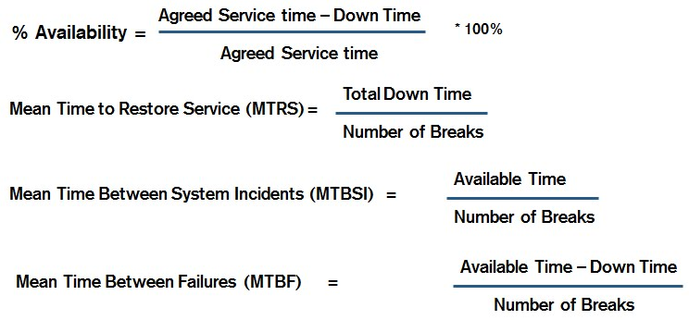

Please fill the blanks on the question as shown below.

___________________________ is my 1st/most critical metric, I want to **maximize** it!

___________________________ are my 2nd critical metrics. I want to **minimize** it!

13) For my next job at the IT Service Management Team of Company “XYZ”, I know many resources available for me to get started. These include: (Circle all correct answers):

1. An overall view of ITIL: <https://en.wikipedia.org/wiki/ITIL>
2. Templates of ITIL: <http://wiki.en.it-processmaps.com/index.php/ITIL-Checklists#ITIL_2011_Templates>
3. ITIL in details:

|  |  |
| --- | --- |
| **Core phase** | **Sub-processes and functions** |
| Service Strategy | 1. Financial Management  2. Service Portfolio Management  3. Demand Management  4. Strategy Generation |
| Service Design | 1. Service Level Management  2. Capacity Management  3. Availability Management  4. IT Service Continuity Management  5. Service Catalogue Management  6. Supplier Management  7. Information Security Management |
| Service Transition | 1. Change Management  2. Service Asset and Configuration Management  3. Release and Deployment Management  4. Service Validation and Testing  5. Evaluation  6. Knowledge Management  7. Transition Planning and Support |
| Service Operation | 1. Incident Management  2. Problem Management  3. Event Management  4. Request Fulfilment  5. Access Management  6. Service Desk Function  7. Technical Management Function  8. Application Management Function  9. IT Operations Management Function |
| Continual Service Improvement | 1. Seven-Step Improvement Process |

1. I want to study abroad/oversea.
2. I want to build a stronger, prosperous Greater China.
3. Shenzhen Polytechnic, we are in this together!