## Schedule of Course Activities: Session 1

## *[IS 470: IT Service Management]*

## *[Instructor: John C. Chan]*

|  |  |
| --- | --- |
| **Overview of Session** |  |
| We will answer the following questions: | 1. Introduction IT Service Management, class syllabus. 2. Format of the class presentation. 3. Introduction of the instructor. 4. How do we communicate for this class? |

## 

**Self-Introduction:**

* **Born and raised in China…**
* **US educated. UMass-Amherst, UPenn, UTexas-Austin.**
* **Work Experiences: IBM. Motorola, Zaiq, Intel, Marvell, AMD, EMC.**
* **My 1st thoughts about IT managements: Broad, Fire-fighting, Cloud Migration …**

**About you:**

* **My name is …**
* **I take this class because …**
* **By taking this class, I like to …**
* **…**

**What you will learn, from this class?**

* Know what is IT Service Management?
* What is my starting point, on new job, with an unknown IT task assignment?
* What are the building blocks, the main process, procedures that I can get reference?
* Where do I get the templates? (E.g. Service contracts)
* What are the tools that will help you to gain a competitive advantage in the profession?
* Cloud Computing and IT Service Management.
* Thought provoking questions that may inspire you to do something bold, different.
* …

**Class Syllabus Overview:**

**(Practical IT Service Management: A Concise Guide for Busy Executives**

**by Thejendra BS)**

|  |  |  |
| --- | --- | --- |
| [Chapter 1](http://library.books24x7.com.proxy.cityu.edu/assetviewer.aspx?bookid=34427&chunkid=275666177&rowid=4) | - | Introduction To IT Service Management |
| [Chapter 2](http://library.books24x7.com.proxy.cityu.edu/assetviewer.aspx?bookid=34427&chunkid=995391108&rowid=29) | - | ITIL Service Management Practices |
|  | | |
| [Chapter 3](http://library.books24x7.com.proxy.cityu.edu/assetviewer.aspx?bookid=34427&chunkid=258772993&rowid=87) | - | Service Desk Function |
| [Chapter 4](http://library.books24x7.com.proxy.cityu.edu/assetviewer.aspx?bookid=34427&chunkid=877242315&rowid=120) | - | Incident Management |
| [Chapter 5](http://library.books24x7.com.proxy.cityu.edu/assetviewer.aspx?bookid=34427&chunkid=660939466&rowid=148) | - | Problem Management |
| [Chapter 6](http://library.books24x7.com.proxy.cityu.edu/assetviewer.aspx?bookid=34427&chunkid=776963832&rowid=165) | - | Change Management |
| [Chapter 7](http://library.books24x7.com.proxy.cityu.edu/assetviewer.aspx?bookid=34427&chunkid=425171151&rowid=186) | - | Release And Deployment Management |
| [Chapter 8](http://library.books24x7.com.proxy.cityu.edu/assetviewer.aspx?bookid=34427&chunkid=931180617&rowid=215) | - | Service Asset And Configuration Management |
| [Chapter 9](http://library.books24x7.com.proxy.cityu.edu/assetviewer.aspx?bookid=34427&chunkid=268272043&rowid=255) | - | Service Level Management |
| [Chapter 10](http://library.books24x7.com.proxy.cityu.edu/assetviewer.aspx?bookid=34427&chunkid=644397207&rowid=287) | - | Service Catalogue Management |
| [Chapter 11](http://library.books24x7.com.proxy.cityu.edu/assetviewer.aspx?bookid=34427&chunkid=286932687&rowid=304) | - | Capacity Management |
| [Chapter 12](http://library.books24x7.com.proxy.cityu.edu/assetviewer.aspx?bookid=34427&chunkid=599927966&rowid=325) | - | Demand Management |
| [Chapter 13](http://library.books24x7.com.proxy.cityu.edu/assetviewer.aspx?bookid=34427&chunkid=552620921&rowid=336) | - | Availability Management |
| [Chapter 14](http://library.books24x7.com.proxy.cityu.edu/assetviewer.aspx?bookid=34427&chunkid=374273856&rowid=353) | - | Information Security Management |
| [Chapter 15](http://library.books24x7.com.proxy.cityu.edu/assetviewer.aspx?bookid=34427&chunkid=332674732&rowid=367) | - | Access Management |
| [Chapter 16](http://library.books24x7.com.proxy.cityu.edu/assetviewer.aspx?bookid=34427&chunkid=935166201&rowid=376) | - | IT Service Continuity Management |
| [Chapter 17](http://library.books24x7.com.proxy.cityu.edu/assetviewer.aspx?bookid=34427&chunkid=922826665&rowid=410) | - | Financial Management |
| [Chapter 18](http://library.books24x7.com.proxy.cityu.edu/assetviewer.aspx?bookid=34427&chunkid=130136372&rowid=427) | - | Supplier Management |
| [Chapter 19](http://library.books24x7.com.proxy.cityu.edu/assetviewer.aspx?bookid=34427&chunkid=815954219&rowid=446) | - | IT Operations Management Function |
| [Chapter 20](http://library.books24x7.com.proxy.cityu.edu/assetviewer.aspx?bookid=34427&chunkid=133580291&rowid=453) | - | General Tips And Advice For IT Service Management |

NOTES:

* A few words about the text book. 7+ years old; relevant; We are going to focus on practical aspect of it: Tools-For-IT
* We are going to think about Cloud Computing, and IT a lot…
* We are going to follow the Text Book closely in class presentation.

To access Text Book On-line:

1. <https://documents.cityu.edu/CourseDocuments/Course%20Resource%20Guide?name=IS470_C-09-0097-7_Active_Course%20Resource%20Guide.HTM>

(NOTE: CityU access permission may be required.)

1. Select the text book:

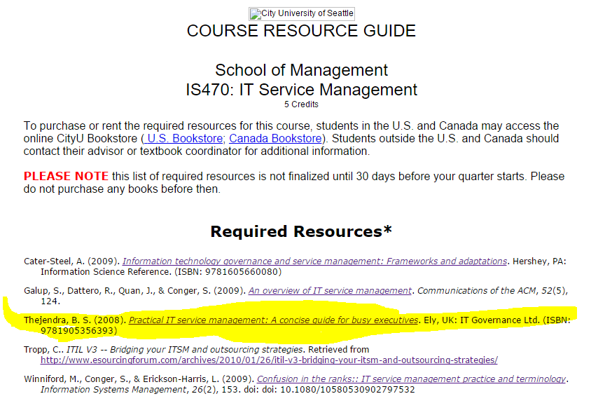

To download Class Materials:

<https://github.com/ra03680/IS470>

(A few words about: <https://github.com> Google, YouTube, and China…)

Class Project: Team Exercises.

NOTES:

* I will spend more time on the Yellow-colored entries, as it is quite relevant to the industry (based on my work experiences).
* The text book is excellent, despite that it is written 6+ years ago. Throughout this class presentation, you will find that I have augmented materials, but do NOT deviate far from the text book.
* Group/individual project, will be integral part of the class.
* I love to share, and learn the Best-Known-Methods with you!

**How do we communicate?**

I prefer the following ways to communicate for the class (in order of preference):

1. In class, open discussions. I will facilitate the forum, and actively engage on the conversations. Your participations are encouraged and expected.

.

1. Email. [john_c_chan@hotmail.com](mailto:john_c_chan@hotmail.com) ; Please feel free to do so.
2. WeChat: JohnC_Seattle
3. Skype: This is a great tool to communicate, if we are online at the same time (we can share computer screen, and take control etc. To help in collaborative mode!). Mt skype ID is: jcc4018.
4. Phone: I live in Seattle. My phone number is: 206.245.6919

Please don’t hesitate to reach me. Thank you.

## What is IT?

The use of technology for the storage, communication or processing of **information**. The technology typically includes computers, telecommunications, applications and other software. The information may include business data, voice, images, video, etc. Information technology is often used to support business processes through IT services.

[An introduction



]

[So, IT is essentially on information/knowledge/intelligence business, more?]

In practical terms, IT consists of:

1. Computers such as desktops, servers, laptops, mainframes, etc. and the data that they hold.
2. Software such as operating systems (Windows, Unix, Linux, Novell, specialised operating systems) and applications such as word processors, spreadsheets, databases, productivity tools, business applications, custom-built applications, etc.
3. Communication and telecom equipment such as pbx, lease lines, the Internet, telephone networks, local area and wide area networks, etc.
4. Other specialised IT equipment and software.

**[**Acronyms of IT/This Text Book:  This is like a dictionary lookup]