**What is Configuration Management System (CMS):**

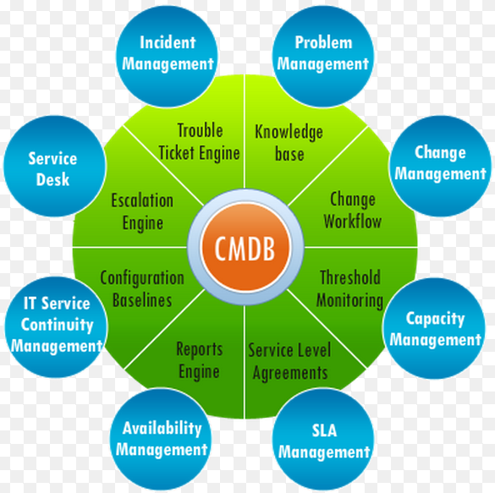

**CMDB is your IT Repository, Database:**

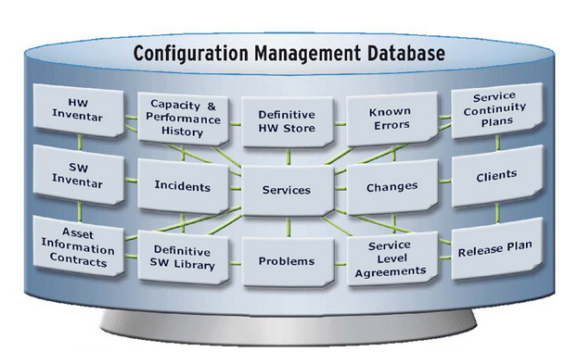

**What are the Inputs to CMDB:**

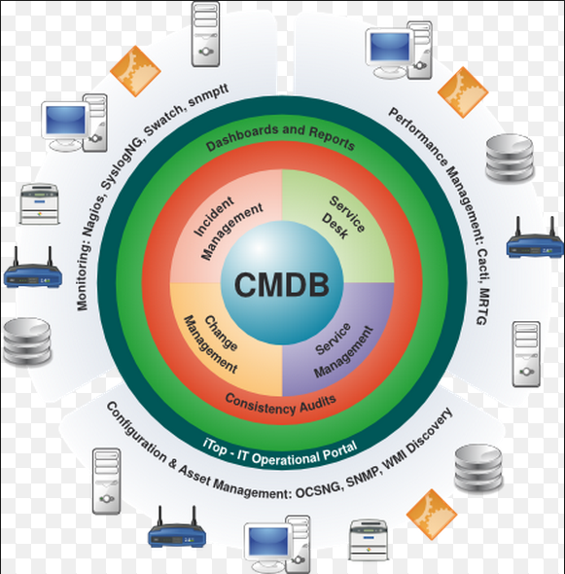

**What does Service Asset and Configuration Management do?**

* Managing the properly is key
* Provides Logical Model of Infrastructure and Accurate Configuration information
* Controls assets
* Minimised costs
* Enables proper change and release management
* Speeds incident and problem resolution
* Be sure we used qualified tools, equipment (v.s. Refurbished, To-be-Qualified CI).

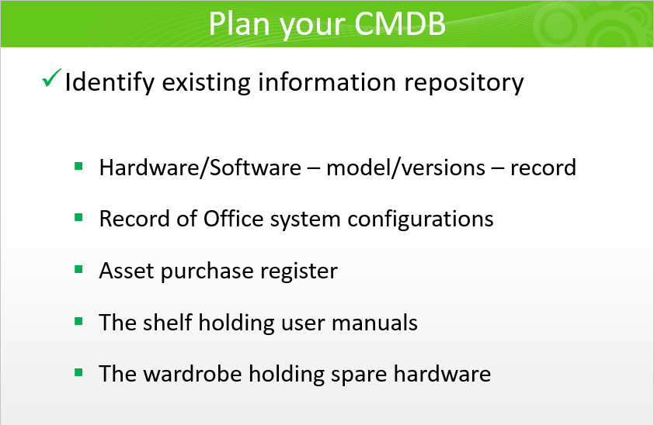

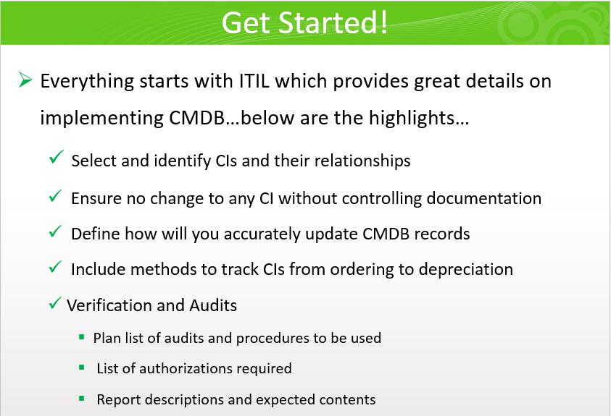

**Important questions about CI attributes:**

* Is the CI qualified? (e.g. a PC)
* What stage is CI’s qualification? (e.g. Refurbished CI allowed?)
* Where is the CI being used?
* Cost, Spec, and other collateral info about the CI.

**The business objective of CM and CMDB is to “Control CIs”.**

**A Usage Example of CMDB:**

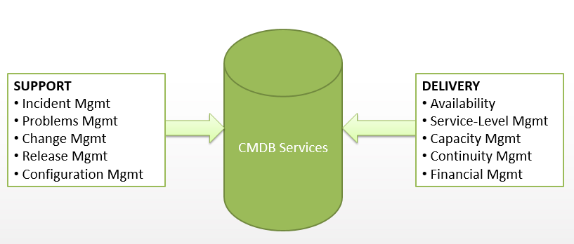

**Companies exist, by providing CMDB toolsets. A good example is Arena, a CMDB/Product Life Cycle Tool Company:**

[**http://www.arenasolutions.com/products/plm/**](http://www.arenasolutions.com/products/plm/)

(Excellent tool…. Very expensive)

**Who Supports CMDB (Example Roles)?**

* + Service Asset Manager
  + Service Knowledge Manager
  + Configuration Manager
  + Configuration Analyst
  + Configuration Librarian
  + CMS tools administrator

An Example of CMDB Usage Model:

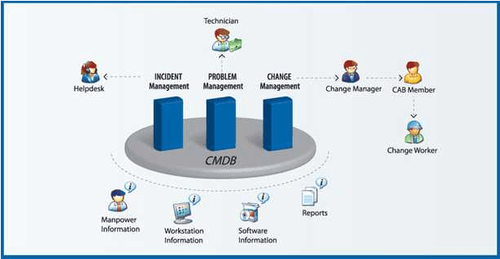

**A Few Hard Questions about CMDB:**

* **Why Apple is having so few product configurations?**
* **CMDB and Chinese Contract Manufacturers… a personal experiences…**
* **Who pays, or can afford to maintain the state-of-the-art CMDB?**
* **Cloud Computing and CMDB… Hadoop, Data Analytics, Internet-of-Things…**
* **IT’s role in CMDB, your thoughts…**