The Overall Picture:

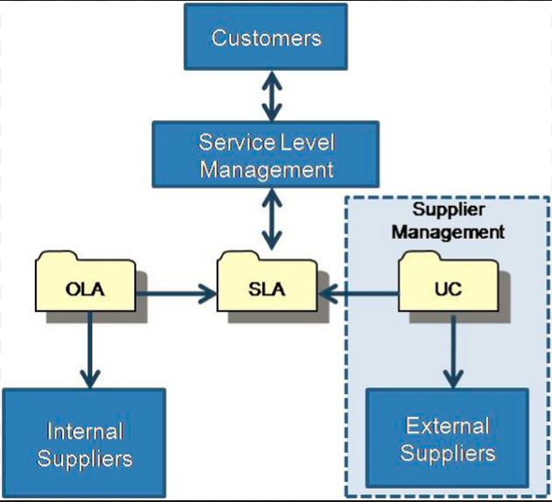

Service Level Management

* Service Level Agreement
  + Operational Level Agreements
    - Internal
  + Underpinning Contracts
    - External Organisation
    - Supplier Management
  + Can be an annexe to a contract
  + Should be clear and fair and written in easy-to-understand, unambiguous language
* Success of SLM (KPIs)
  + How many services have SLAs?
  + How does the number of breaches of SLA change over time (we hope it reduces!)?

**SLM, and SLA Usage models:**

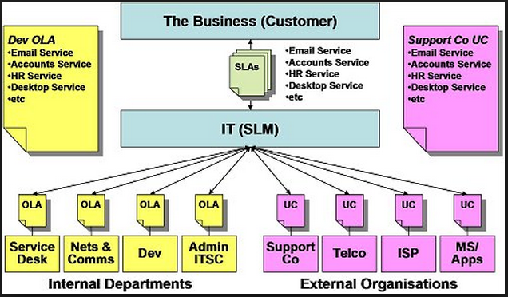

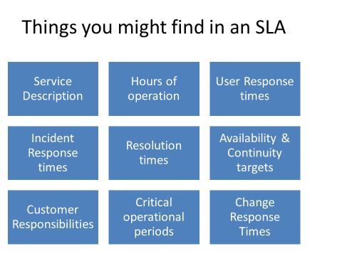

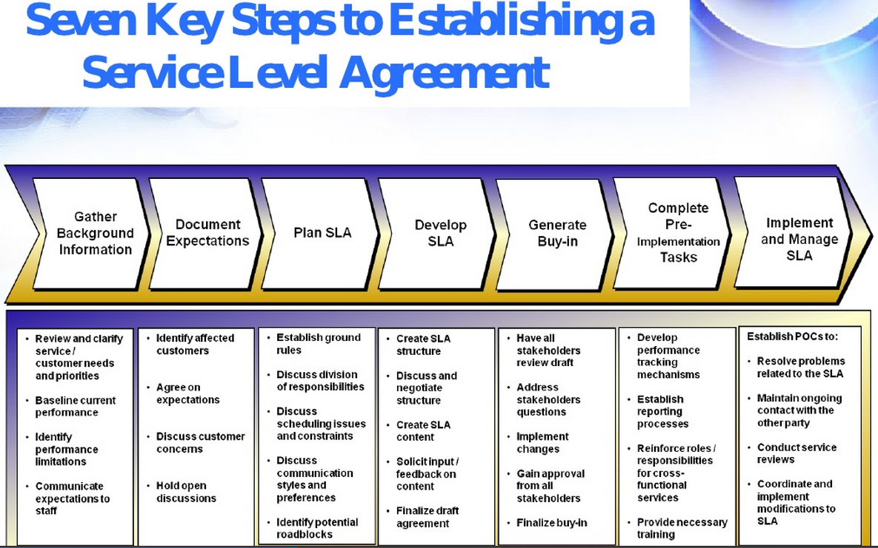

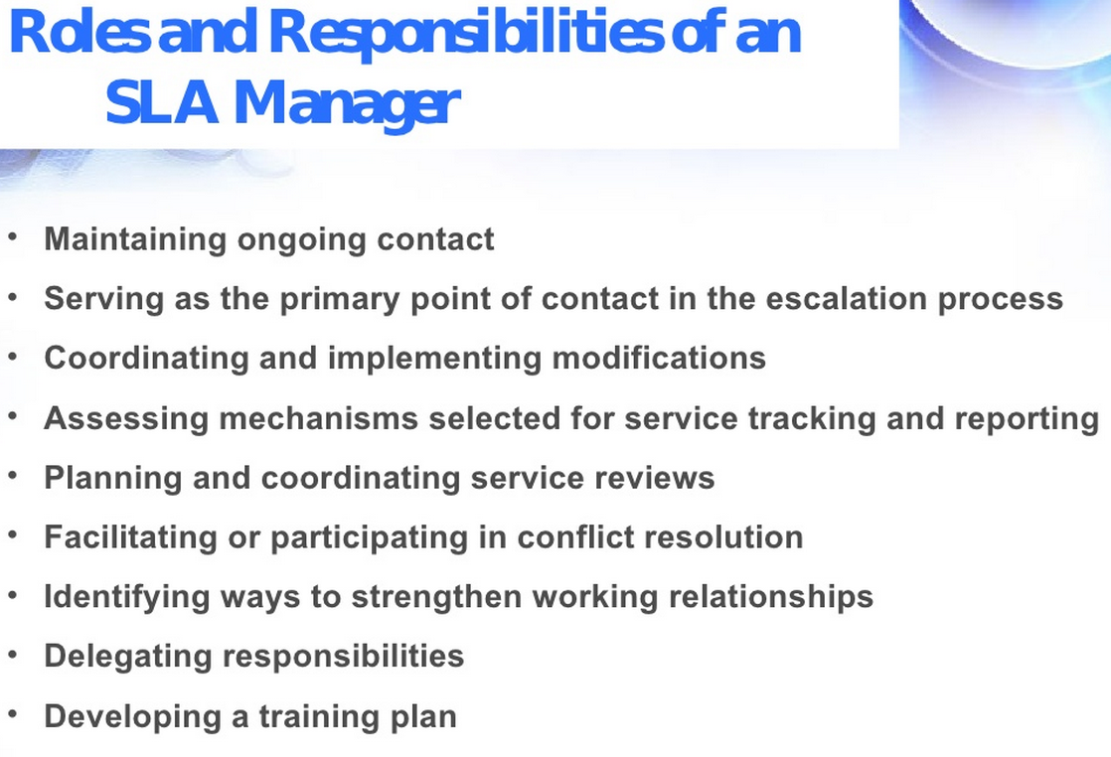

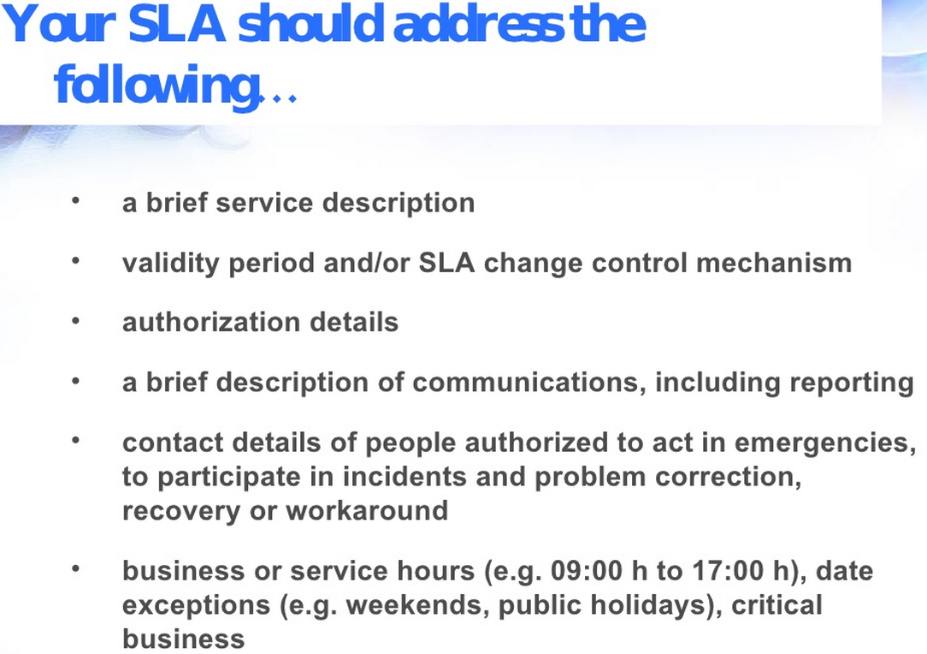

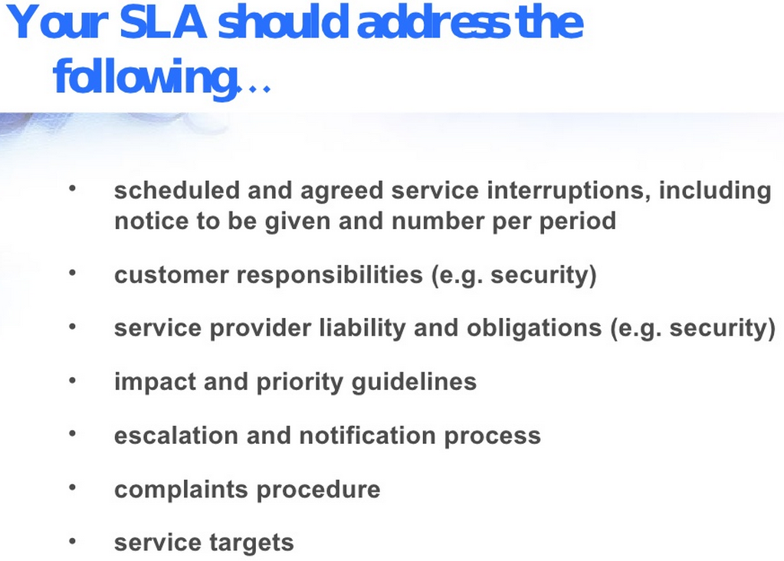

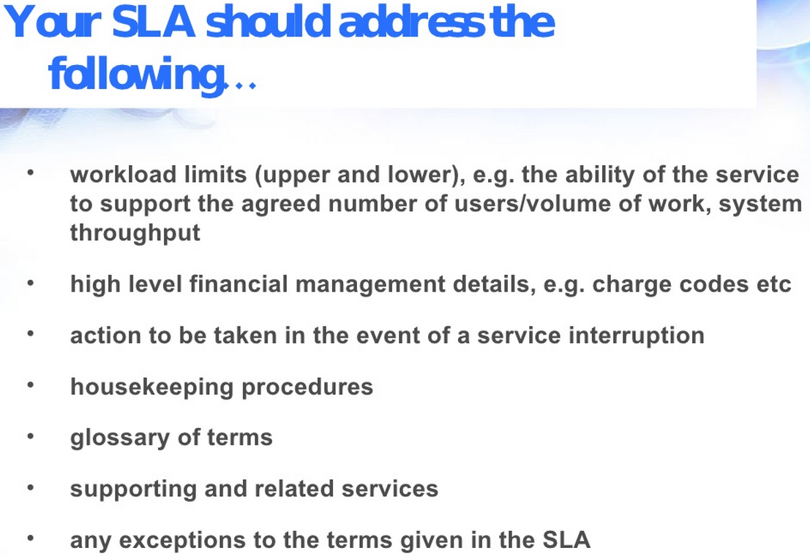

SLA is company/issue specific. Our class project’s outcome, is to produce an SLA for IT Cloud migration!

A Few Remarks on SLA:

* **Certainty**: How much do I want? How much am I willing to pay for it?
* **Un-Certainties**: e.g. Oil Price, the commodity, how do you handle it in an SLA? (Let this be a routine in your analysis, instead of apprehension…)
* What is the price for my trial-and-error run?
* …
* Dell just bought EMC, how long do you think to come up with the “Contract/SLA”? (I particularly interested on the escape clauses… what about you?)