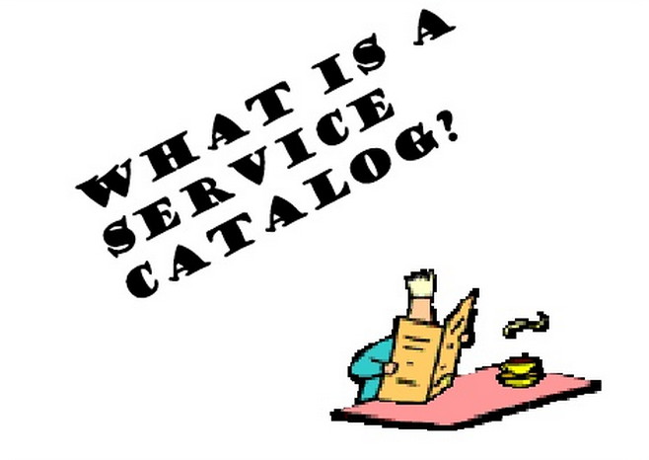

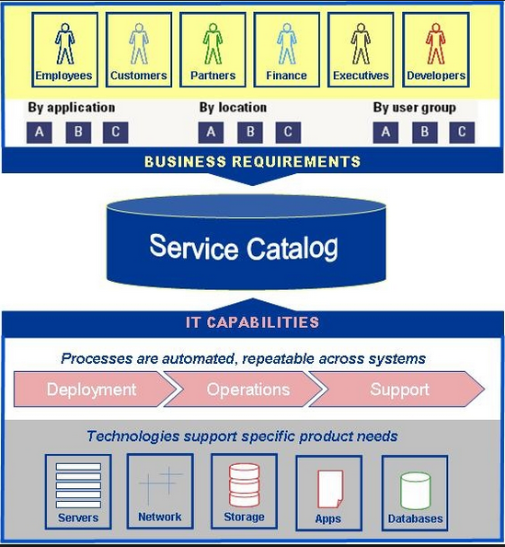

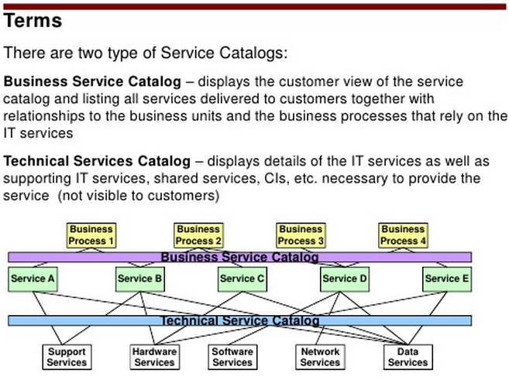

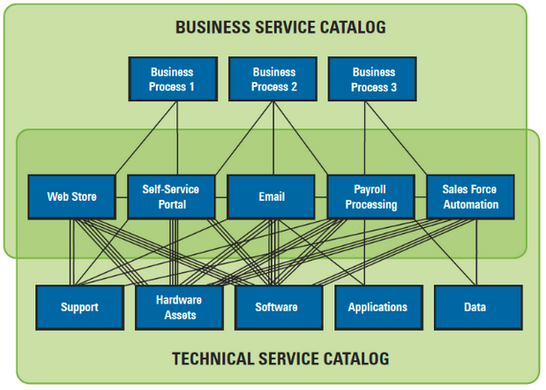

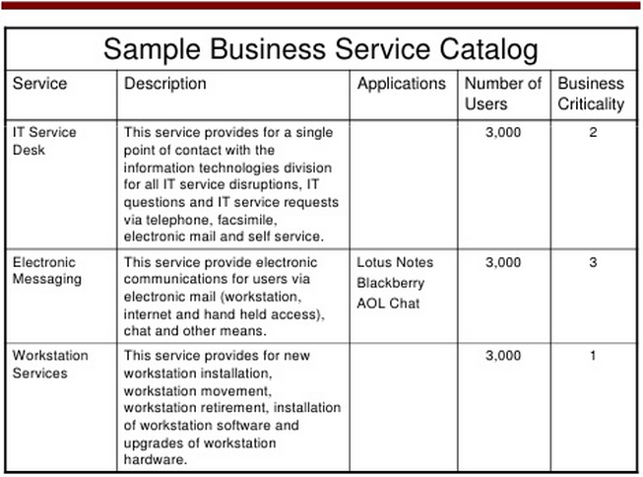

**Views Into The Service Catalog:**

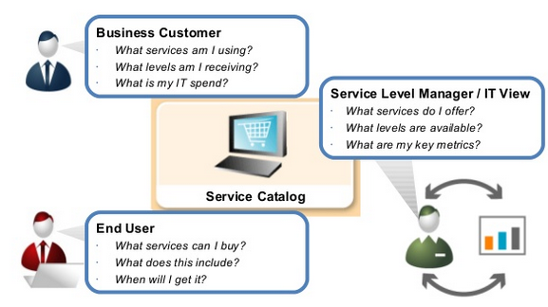

**An Example Usage Model of IT Service Catalog:**

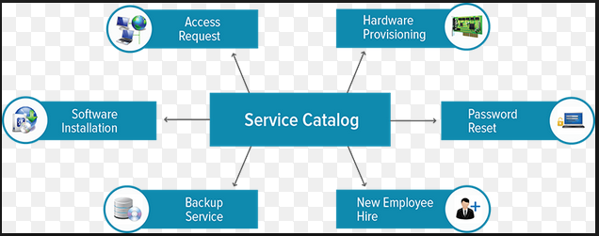

**Service Catalog, and Financial Management for IT Services.**

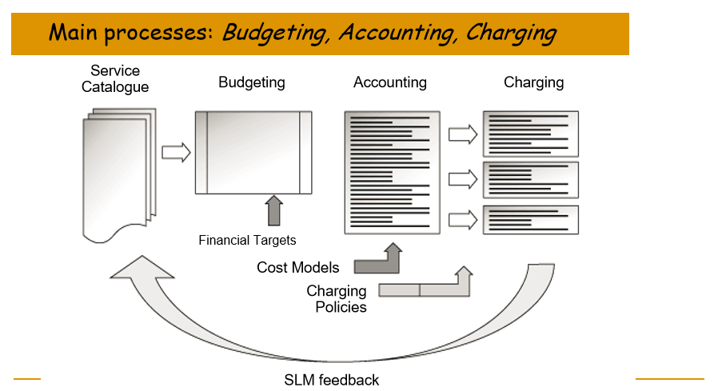

**Service Catalog: This is our service and/or product offerings.**

**A few Remarks on Service Catalogs:**

* **Yes: I have seen it in Amazon’s AWS, MS Azure etc. All Cloud Services related.**
* **No: I have NOT seen it within corporate America’s IT.**
* **Why I never get a response from my IT Help Desk (India’s team): We don’t provide service to my reported issue.**
* **…**