**What is Capacity Management?**

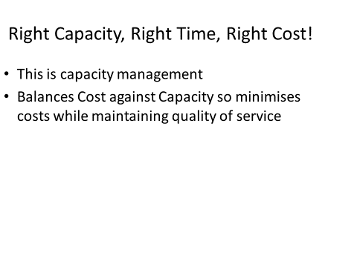

**Capacity Flow Diagram:**

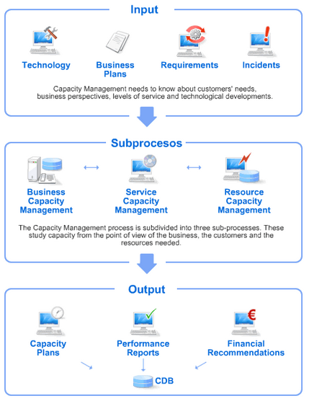

**Objectives of Capacity Management:**

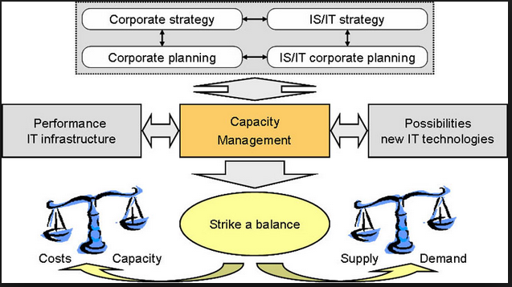

**Capacity Management Activities:**

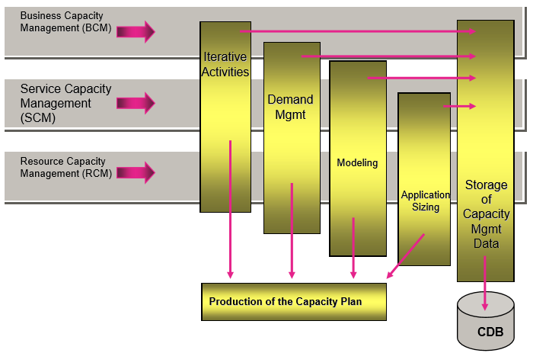

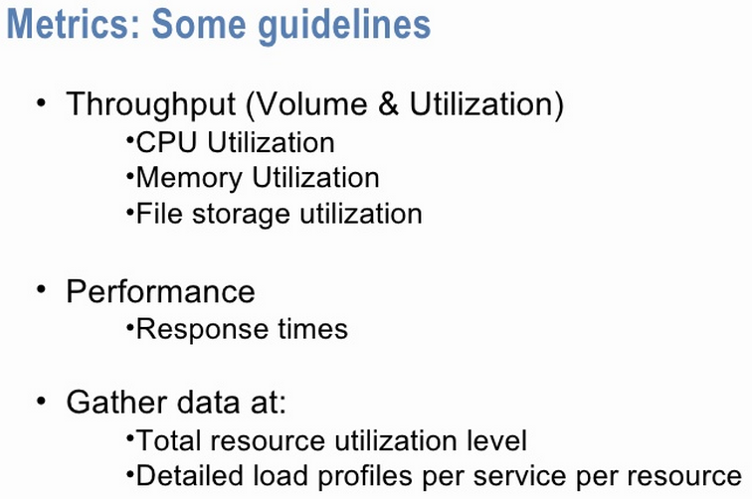

**Capacity Management: Dependecies**

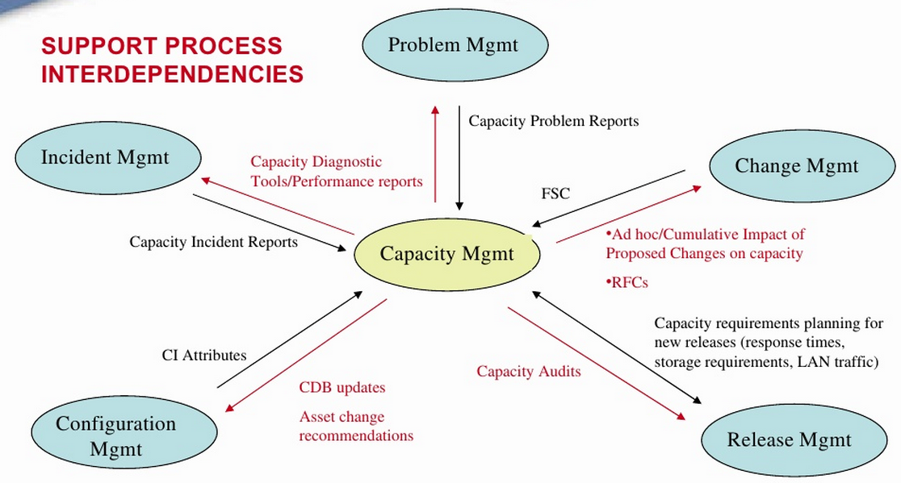

**Capacity Management: Dependecies**

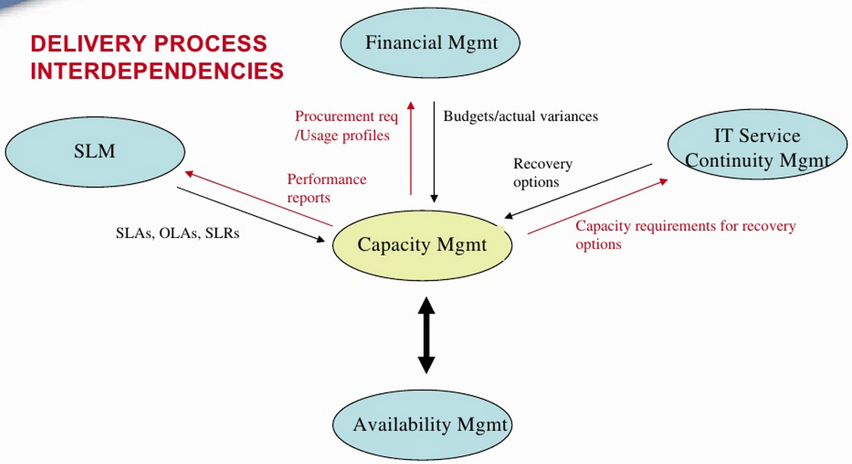

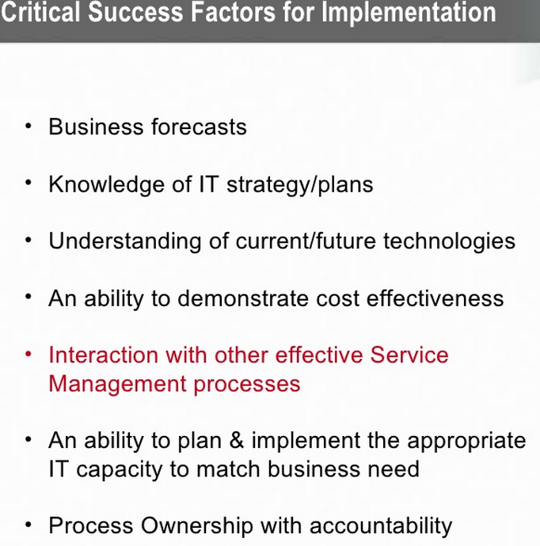

**A Few Remarks about Capacity Managements:**

* Few words from Jack Welch, GE’s CEO in the late 1990s…
* “Victim of Your Own Success”: Who said it? When, why, the story of chip business, printing money…
* Cloud Computing vs PC industry, and IT: “Victim of Your Own Success” a new Chapter?
* …