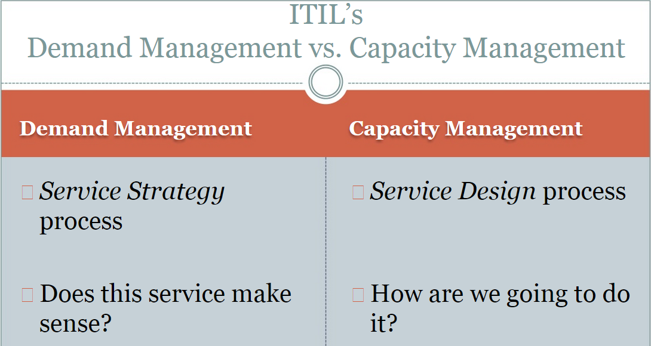

NOTE:

The slides are courtesy of “Higher Education IT Management LLC”. <http://www.heitmanagement.com/august>

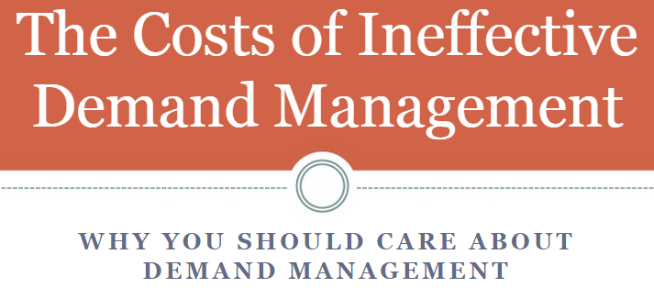

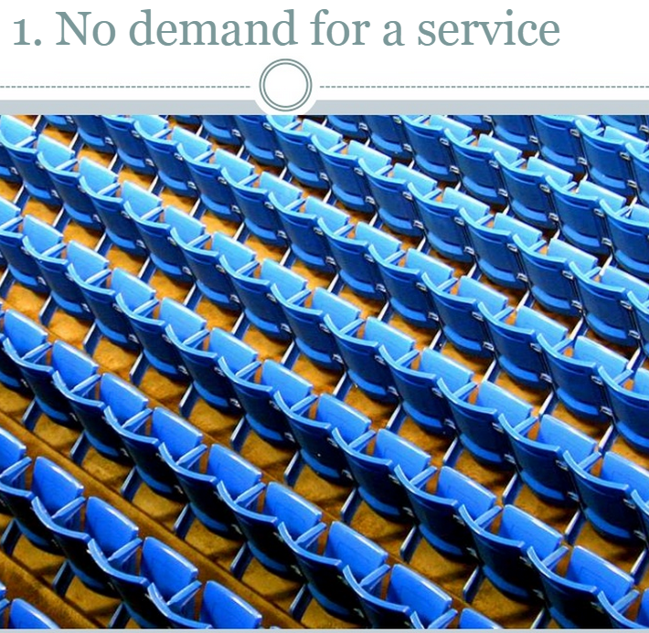

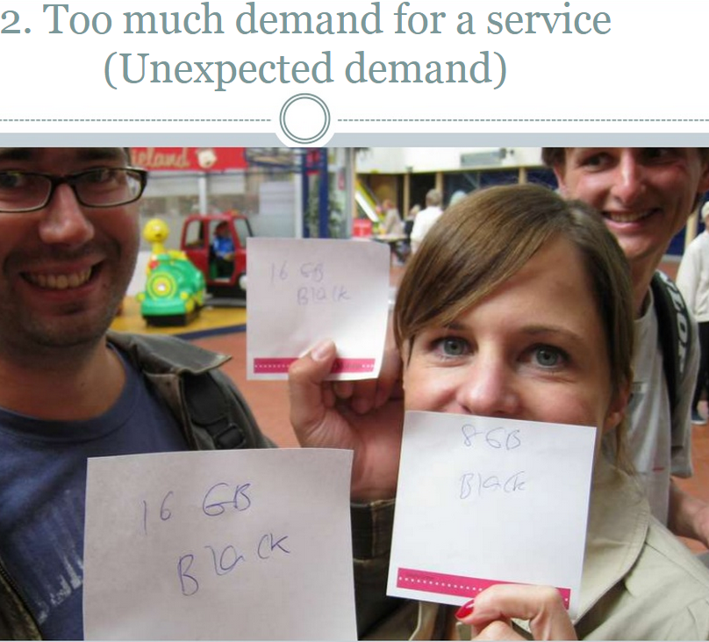

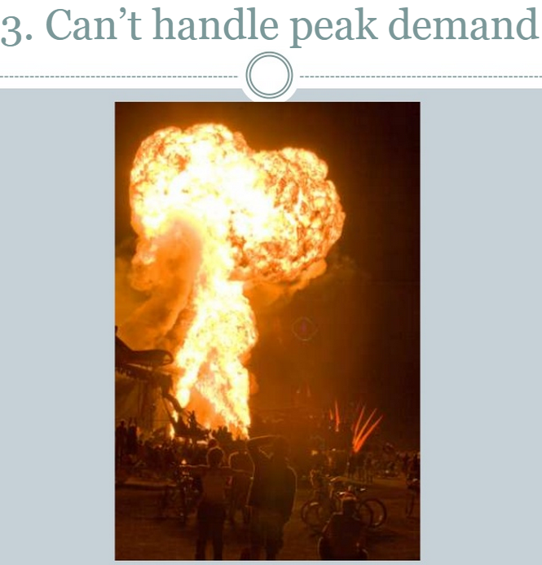

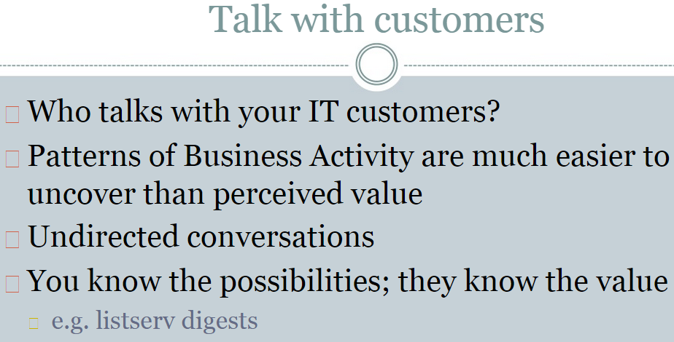

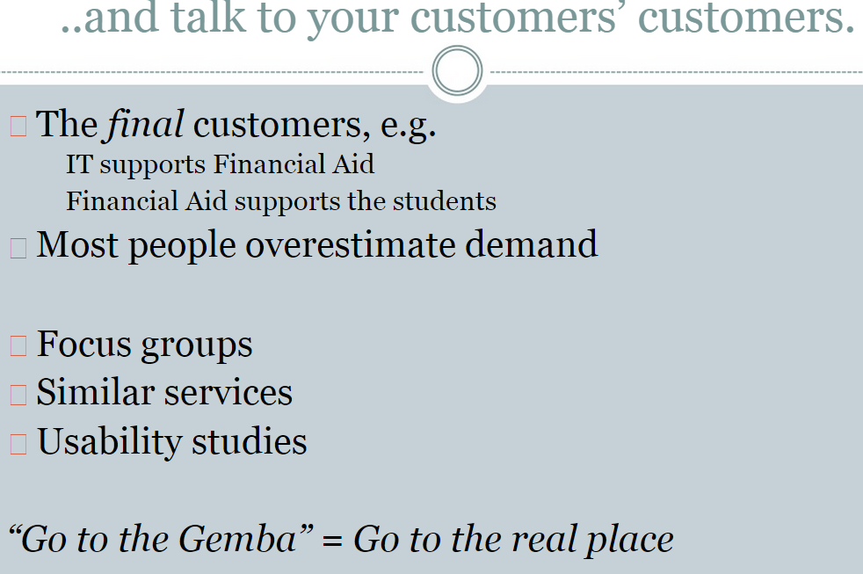

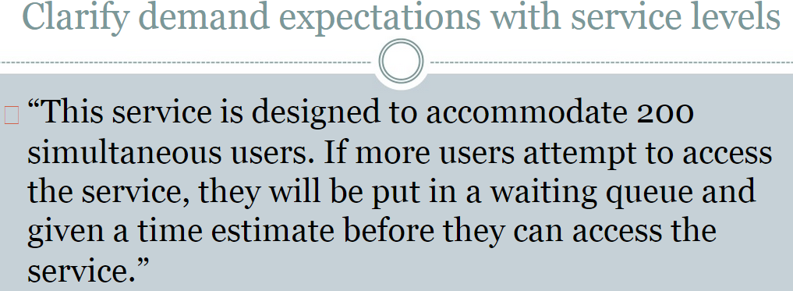

Planning for Demand:

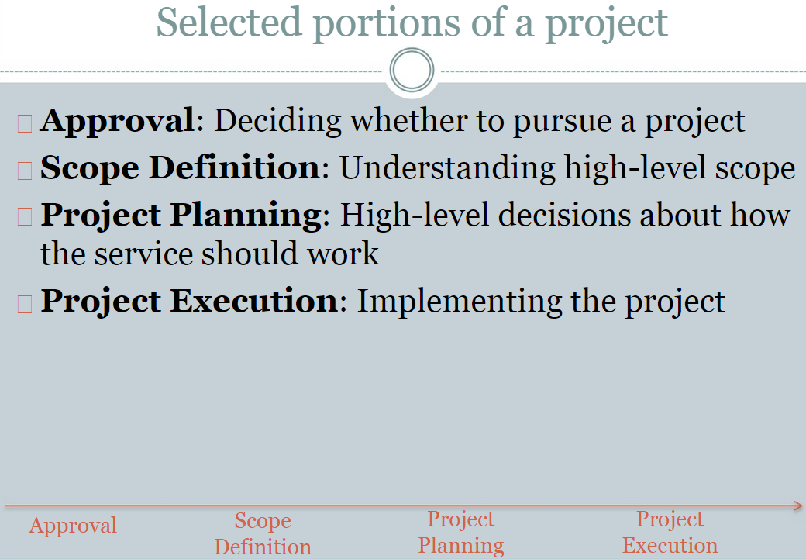

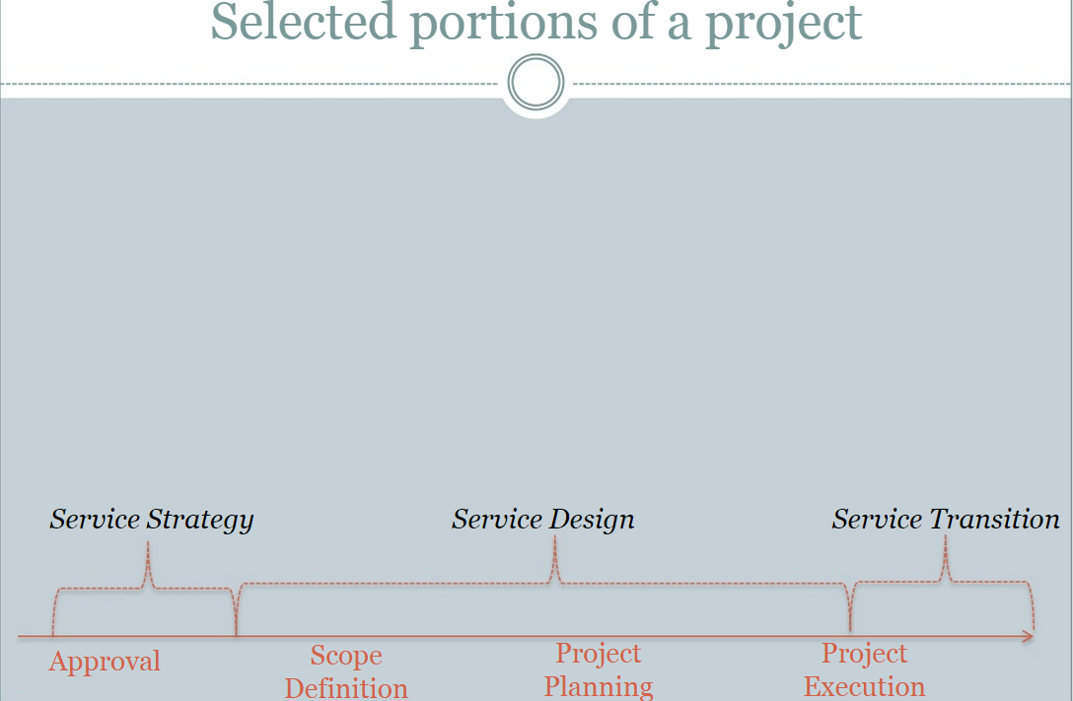

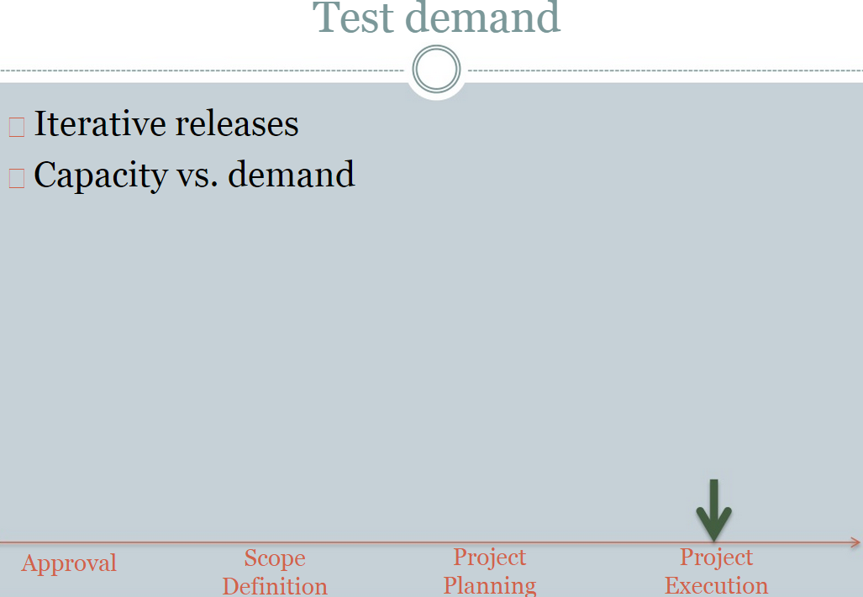

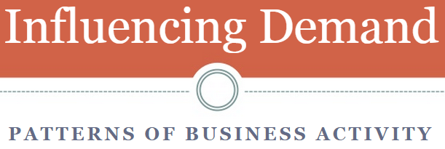

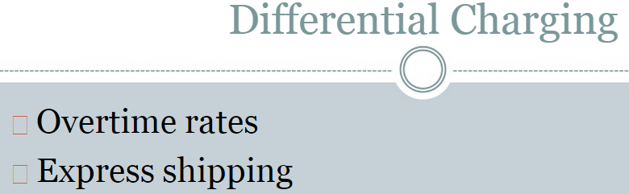

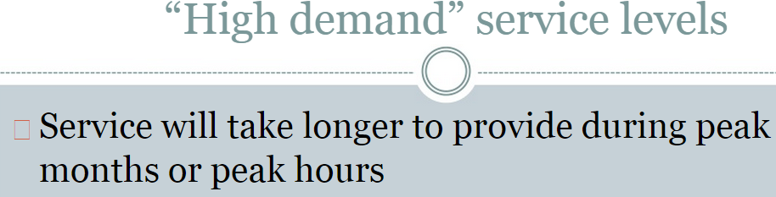

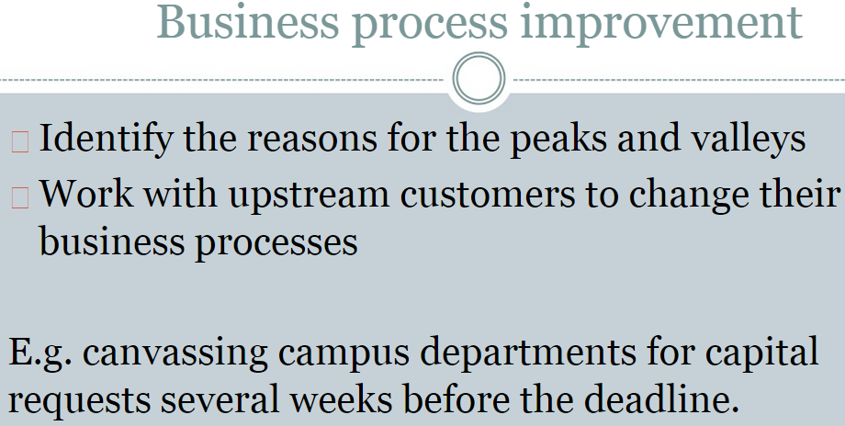

**Lifecycle of Demand Management:**

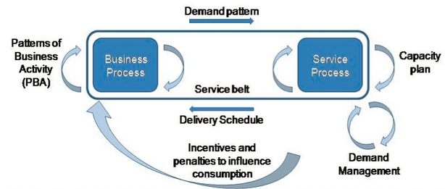

**Thoughts on Demand Managements:**

* **Demand analysis can be subjective?**
* **Let more people onto a problem, does it help/hurt to a solution? What is your IT experience on this?**
* **Techniques to handle unplanned demands?**
  + Data-driven demand forecast analysis.
  + Adequate staging of supplies, resources.
  + Emergency/Contingency supply agreement with the provider (Captured in SLA)?
  + Share resources with competitors (Captured in SLA)?
  + …
* **Tools:** [**http://www.salesforce.com/**](http://www.salesforce.com/)
* **…**