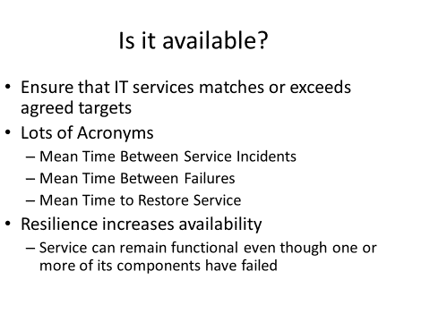

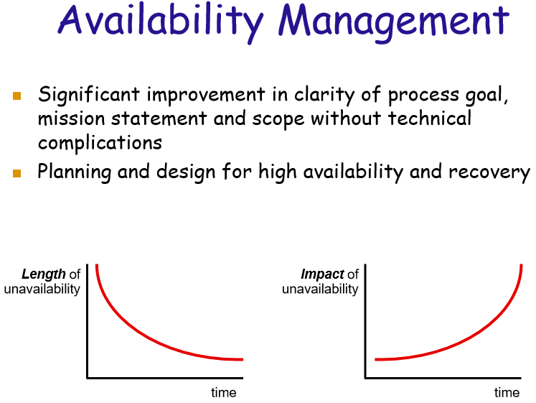

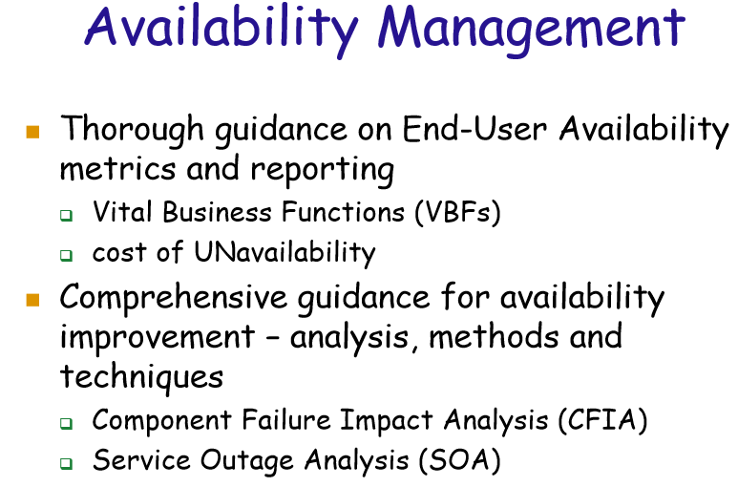

**Availability Management Results:**

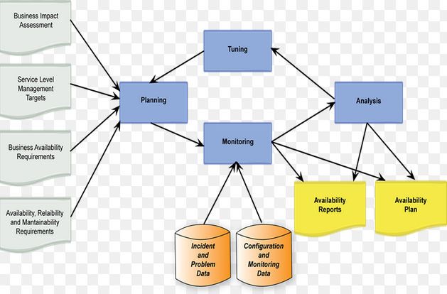

**Availability Management means “Control”, “Plan”, “and Schedule”.**

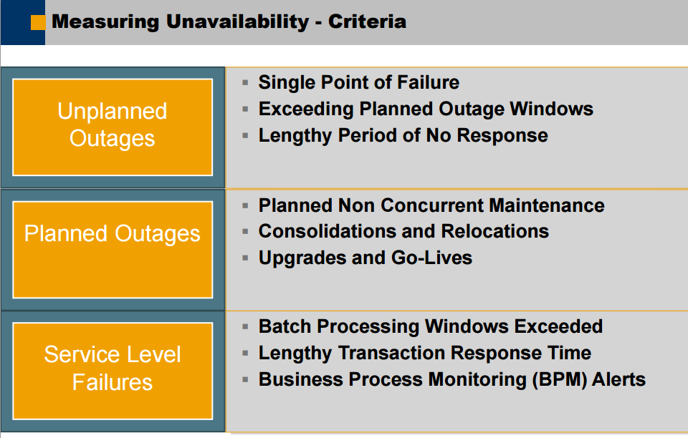

**Why system reboot is such an interruptive process?**

**Should end-user decide, when to execute system updates, or force updates?**

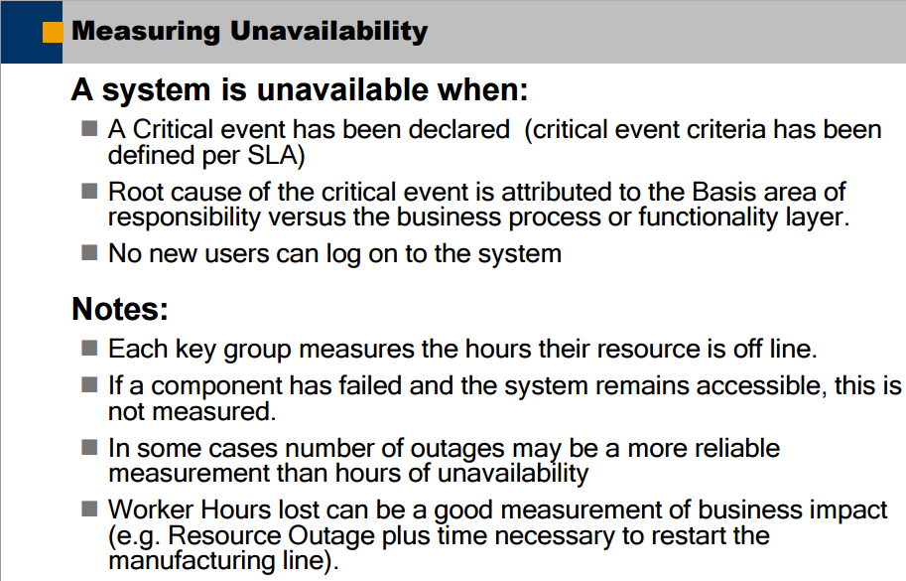

**Minimize Unplanned Service Interruptions:**

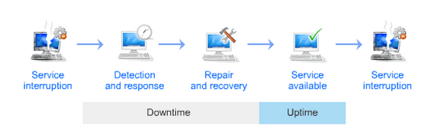

**Template of Availability Management Plan (Putting it all together…):**



**Additional Thoughts:**

* Critical IT Services: Data center, Internet backbone, others… Government Services?
* Internet outage: It is root cause to be due to hardware failure. What is the IT recovery plan?
  + Keep the organization posted on the latest?
  + Improvise Wi-fi plans, wireless phone hot-spot?
  + Capture how to handle such scenario in SLA?
  + …
* Cloud Migration: Availability is one of the driving force?