**What is IT Service Continuity Management?**

To counteract interruptions to business activities and to protect critical business process from the effects of major failures of information systems or disasters to ensure their timely resumption. Example of BCM tasks are:

* Information security in the BCM process
* Business continuity and risk assessment
* Developing and implementing continuity plans including
* Testing, maintaining and reassessing business continuity plans

**What Business Care Service Continuity the Most?**

* Utility Service Providers (Electric, Gas, Water, Waste Disposal).
* Internet Service Providers.
* Government Agencies.
* …

Perhaps, the question should be: Is there a business that Service Continuity is NOT important?

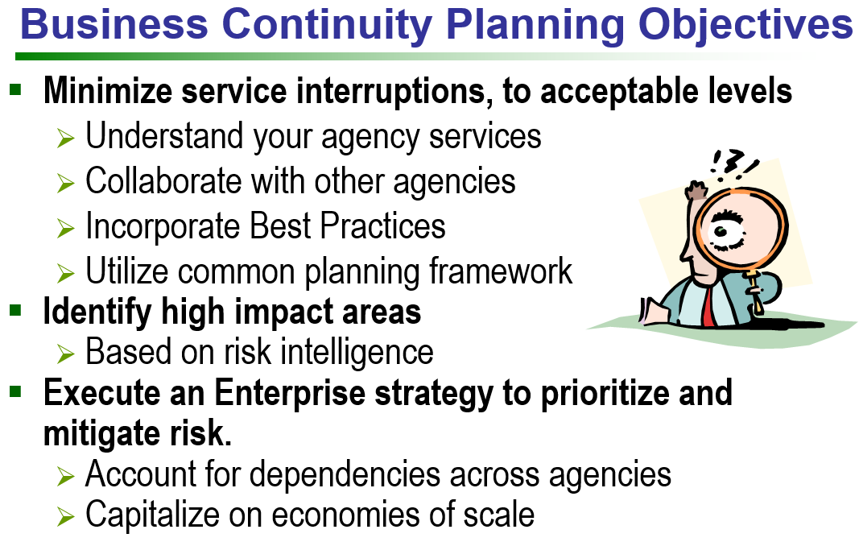

**Where to Start?**

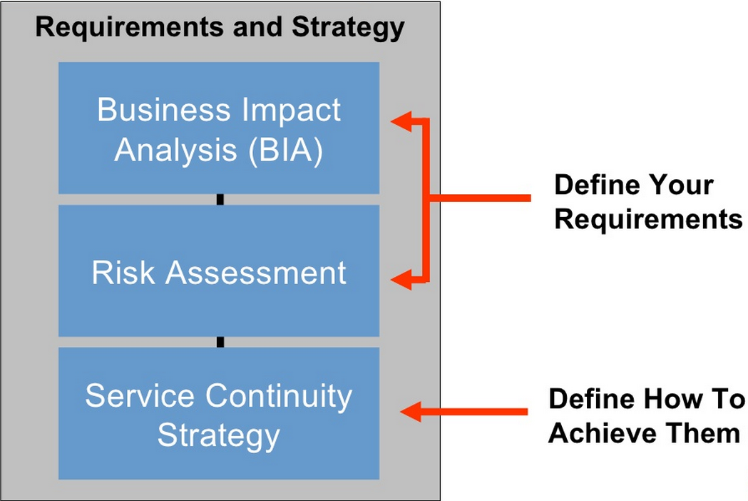

**Important Questions on BCM:**

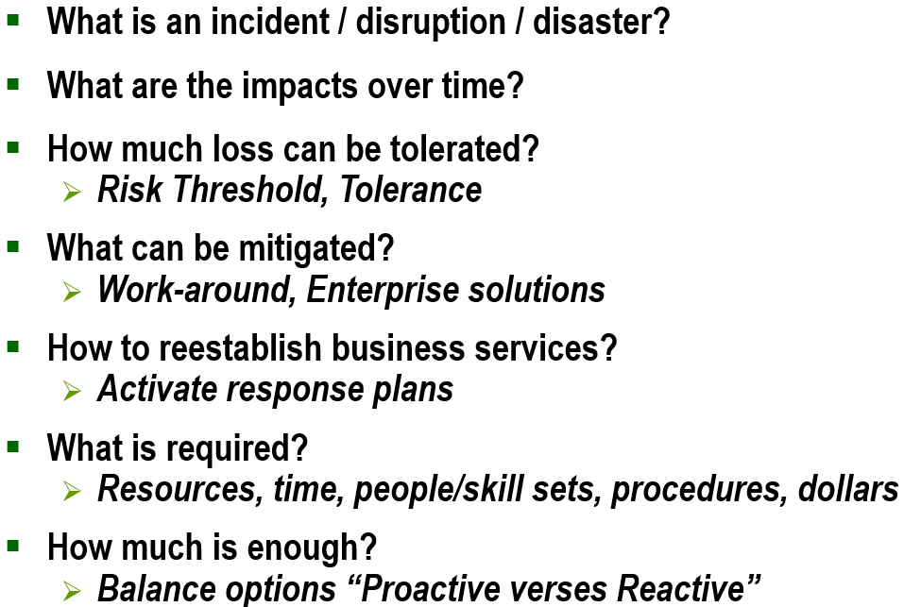

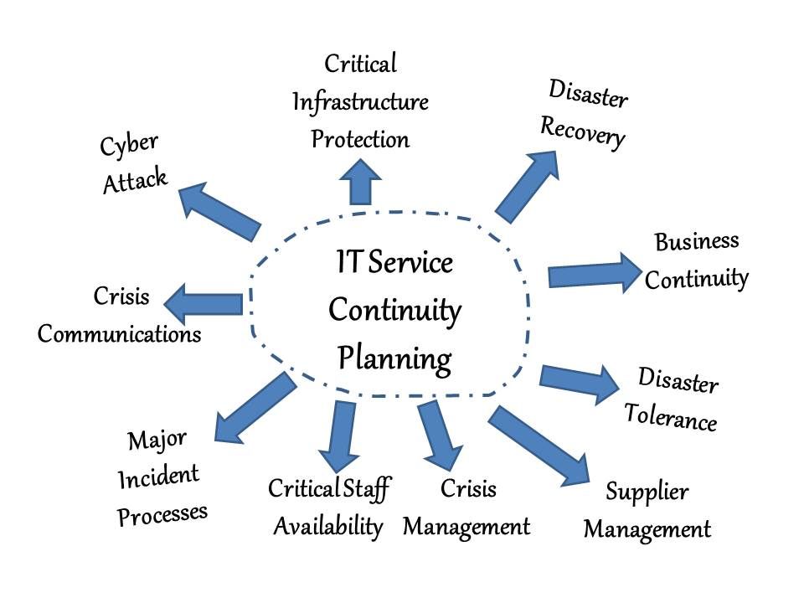

**The Service Continuity Lifecycle:**

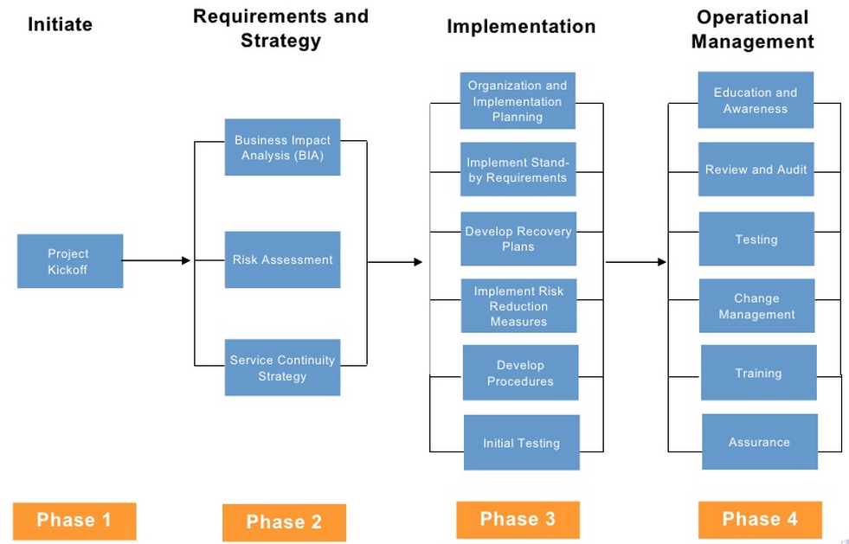

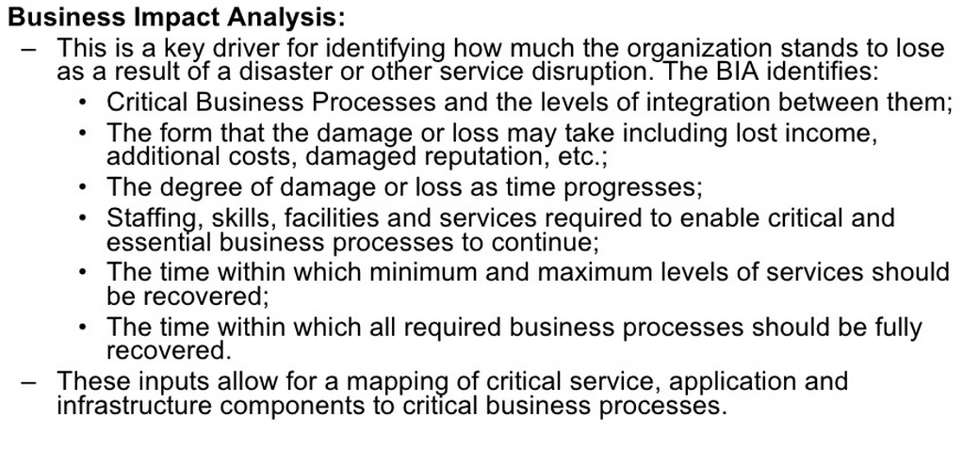

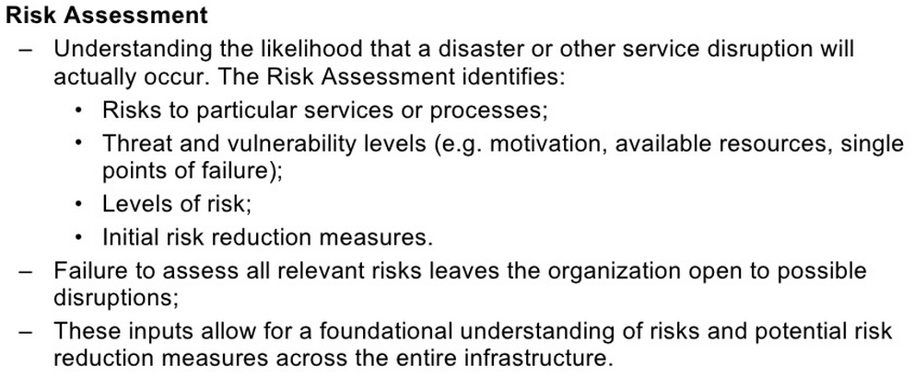

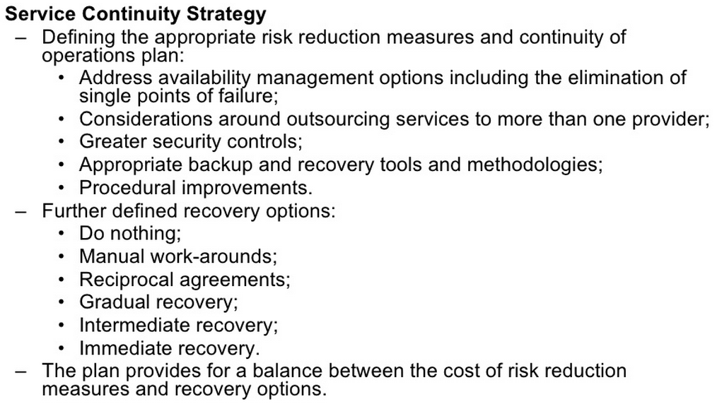

**Sample Tools:**

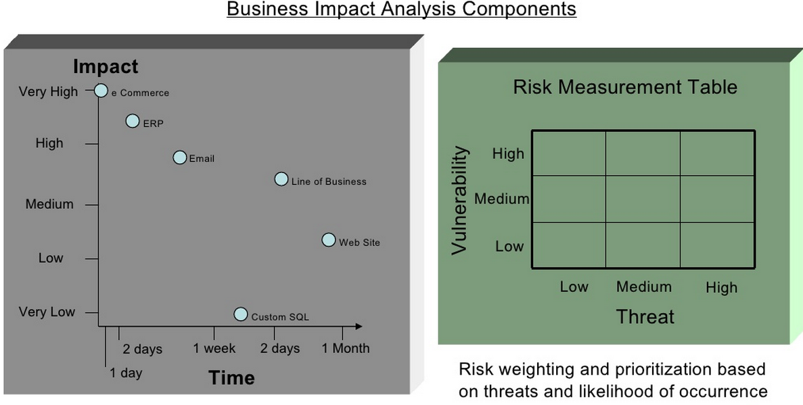

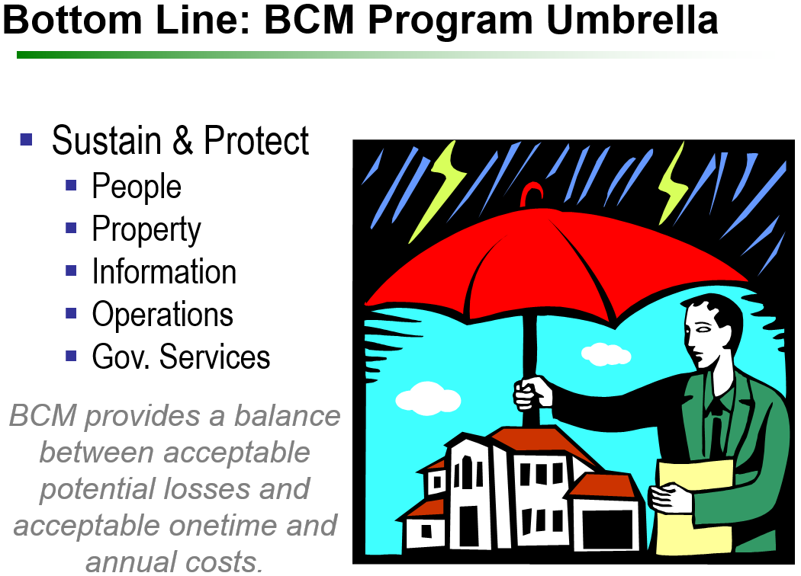

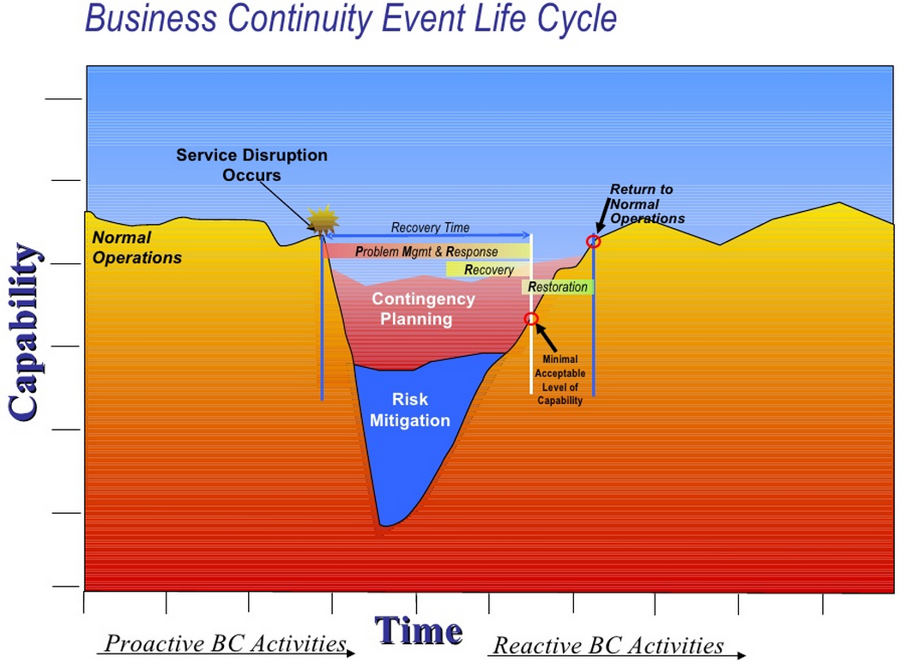

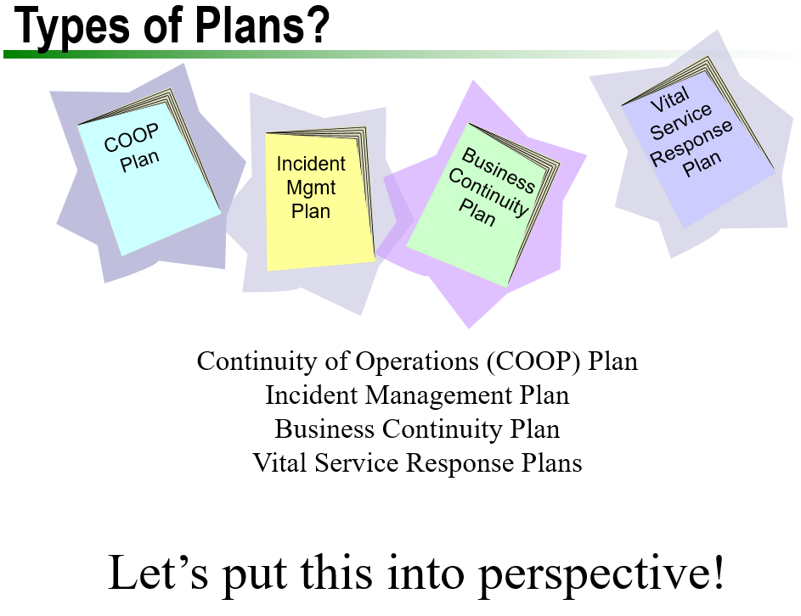

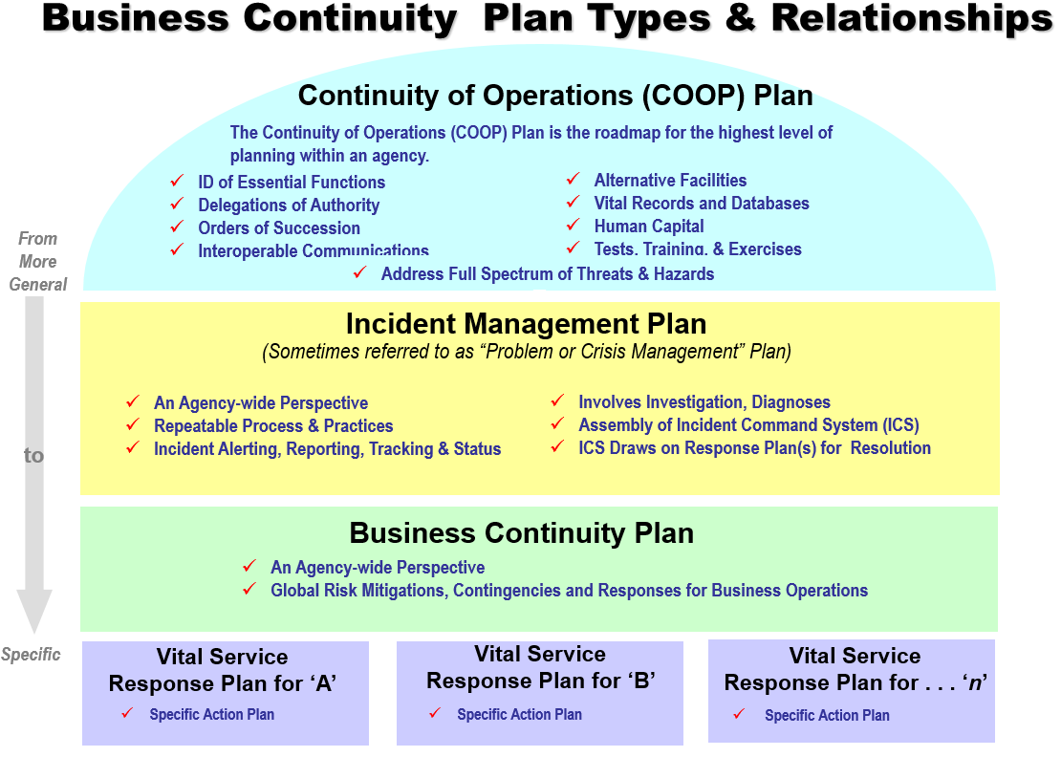

**Additional Thoughts:**

* Should IT encourage users to personally do regular backup. E.g. USB?
* What is IT’s position that a user decides to back up his critical data on the cloud?
* Examples of Good Practices:
  + What critical IT infrastructure to backup, e.g. data centre power?
  + File duplication, backup.
  + Redundancies: E.g. a disk fail in the data centre, ability to replace the failed disk live—without loss data, without shutting down the system when doing so?
  + …
* What are your ideas, if the Cloud is down? E.G. Web-site of your father’s restaurant is un-available?