**Financial management for IT services**

* **Financial Management for IT Services** is a Service Delivery element.
* Objective: Give accurate and cost effective account of IT assets and resources used in providing IT Services.
* Why: Plan, control and recover costs expended in providing the IT Services negotiated and agreed to in a service-level agreement (SLA).

## **Goal**

* Optimize the cost of IT Services while taking into account quality and risk factors.
* Cost Analysis against Risk Assessment: Create intelligent, metric-based cost optimization strategies.

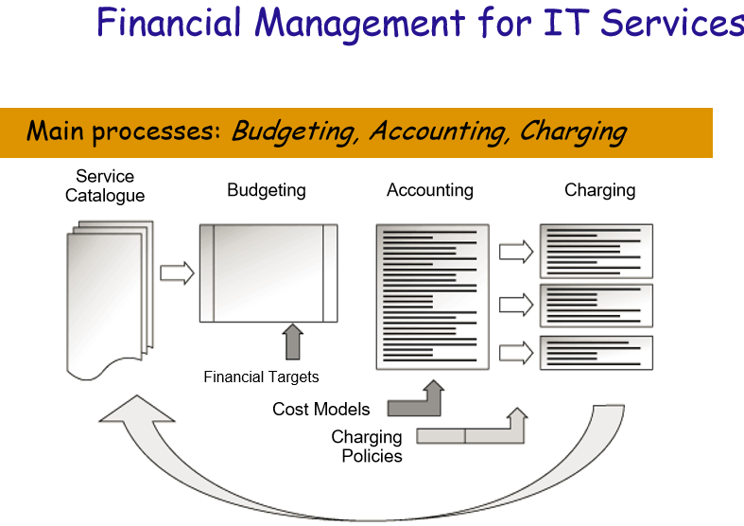

**Another View:**

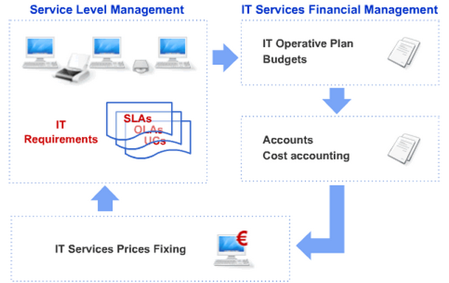

**Major Interfaces:**

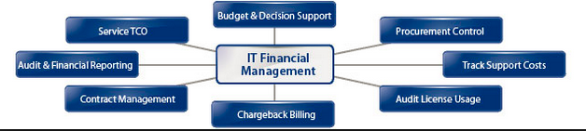

## **IT Financial Management Sub-processes**

* Budgeting
* IT Accounting
* Charging

### Sub-Process: Budgeting

* Plan future IT expenditures, reducing the risk of over-spending and ensuring the revenues are available to cover the predicted spend.
* Compare actual costs with, predicted costs in order to improve the reliability of budgeting predictions.

### Sub-Process: Accounting

* Know the amount of money spent in providing IT services.
* Gauge the efficiency of the IT service provision and determine areas where cost savings can be made.
* It provides financial transparency to aid management in the decision making process.

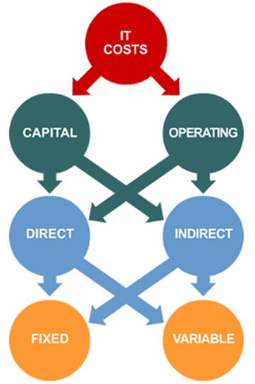

**Cost elements used in accounting:**

* Capital costs: e.g. hardware and building infrastructure.
* Operational costs: e.g. Day-to-day recurring expenses monthly electrical invoices and salaries.
* Direct costs: e.g. any costs that are directly attributed to one single or specific service or customer.
* Indirect costs: A fair example is the cost associated with a Local Area Network on which every customer is connected.
* Fixed costs: Any expenses established for long periods of time like annual maintenance contracts or a lease contracts.
* Variable Costs: Example, energy costs are variable based on the amount consumed.

### Sub-Process: Charging

* Charging provides the ability to assign costs of an IT Service proportionally and fairly to the users of that service.
* It may be used as a first step towards an IT organization operating as an autonomous business.
* It may also be used to encourage users to move in a strategically important direction. Example: subsidizing newer systems and imposing additional charges for the use of legacy systems.
* Transparency of charging. Example, a user might browse a dump on screen rather than printing it off.
* Charging policy needs to be simultaneously simple, fair and realistic.
* Charging need not necessarily mean money changing hands (full charging). Example: Let management know on the cost IT services (no charging), or may detail what would be charged if full charging were in place.

Another visit to ITIL Library Templates:

1. <http://wiki.en.it-processmaps.com/index.php/Main_Page>
2. <http://wiki.en.it-processmaps.com/index.php/ITIL-Checklists#Financial_Management>
3. <http://wiki.en.it-processmaps.com/index.php/Checklist_Financial_Analysis>

**Additional Thoughts:**

* Is IT service, moving to be cloud based? An example case:
  + Employee purchased PC, Phone directly from approved/designated supplier Portal.
  + Hardware services are delegated to the suppliers.
  + IT’s role:
    - Internet/Email outage;
    - Hardware equipment replacement;
    - Information security enforcement;
    - OS Updates, Patches.
    - …
    - What else in your organization?
* What is my “Value-Add”?