**What is Operations Management?**

The business function responsible for planning, coordinating, and controlling the resources needed to produce a company’s products and services.

(OM can also be one of the many important organizations in your company that IT will interact with.)

**What does Operations do?**

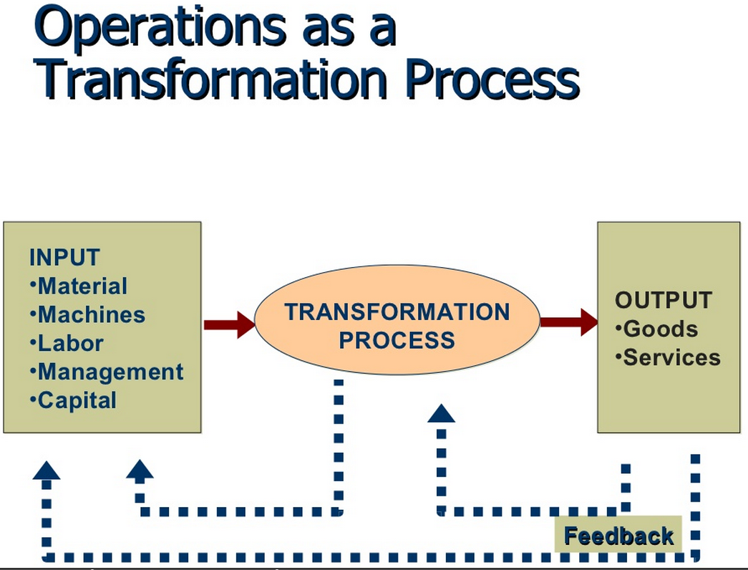

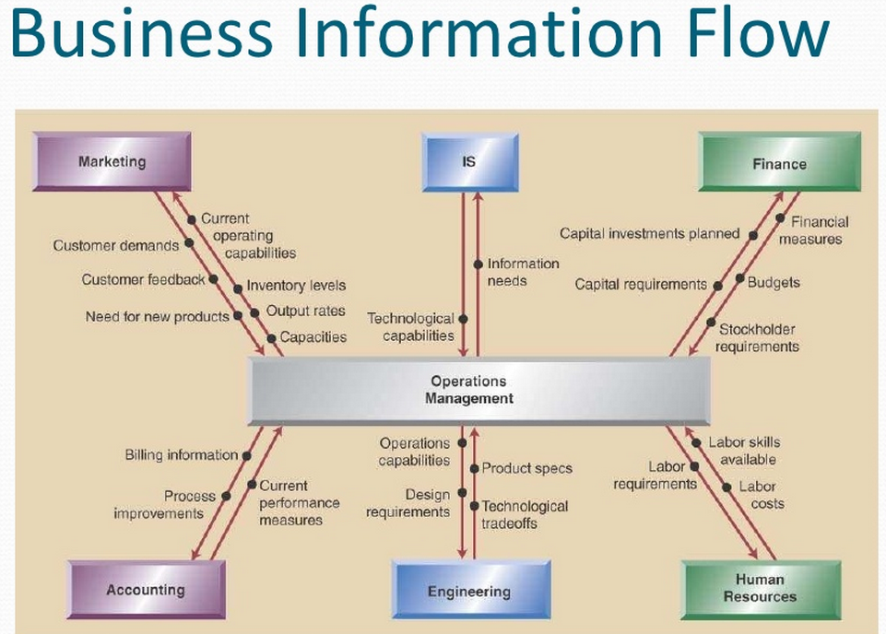

**IT, Rapid Responses to the Business:**

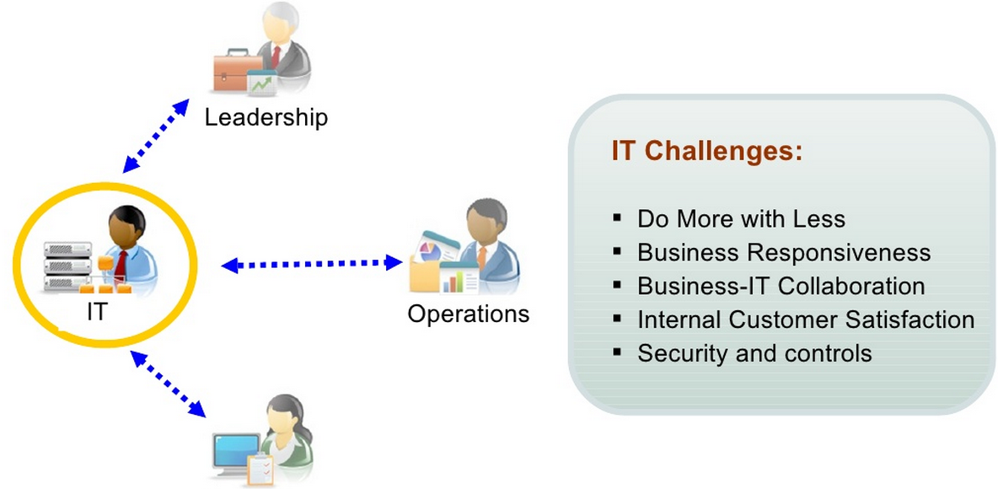

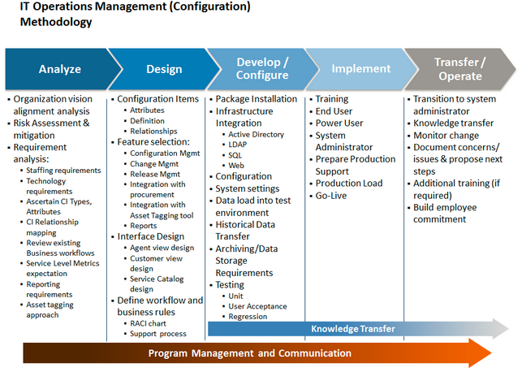

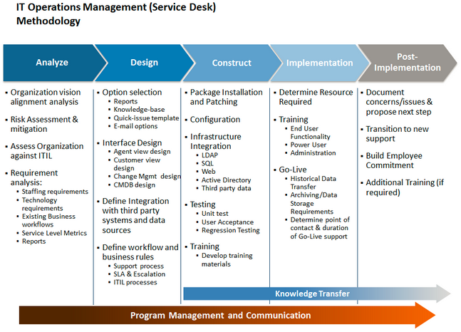

**An Example of IT Operation Structure:**

