**Remember, IT Service Management is Complex:**

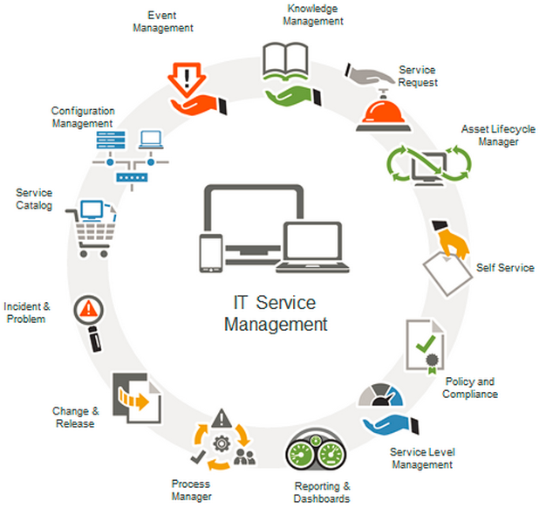

**Where do I start?**

|  |  |
| --- | --- |
| **Core phase** | **Sub-processes and functions** |
| Service Strategy | 1. Financial Management  2. Service Portfolio Management  3. Demand Management  4. Strategy Generation |
| Service Design | 1. Service Level Management  2. Capacity Management  3. Availability Management  4. IT Service Continuity Management  5. Service Catalogue Management  6. Supplier Management  7. Information Security Management |
| Service Transition | 1. Change Management  2. Service Asset and Configuration Management  3. Release and Deployment Management  4. Service Validation and Testing  5. Evaluation  6. Knowledge Management  7. Transition Planning and Support |
| Service Operation | 1. Incident Management  2. Problem Management  3. Event Management  4. Request Fulfilment  5. Access Management  6. Service Desk Function  7. Technical Management Function  8. Application Management Function  9. IT Operations Management Function |
| Continual Service Improvement | 1. Seven-Step Improvement Process |

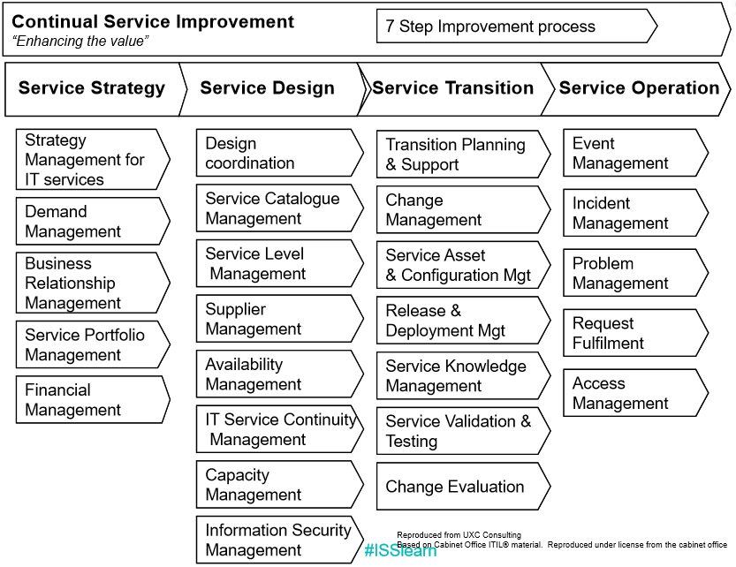

**Where do I find References?**

**ITIL Templates:**

<http://wiki.en.it-processmaps.com/index.php/ITIL-Checklists#ITIL_2011_Templates>

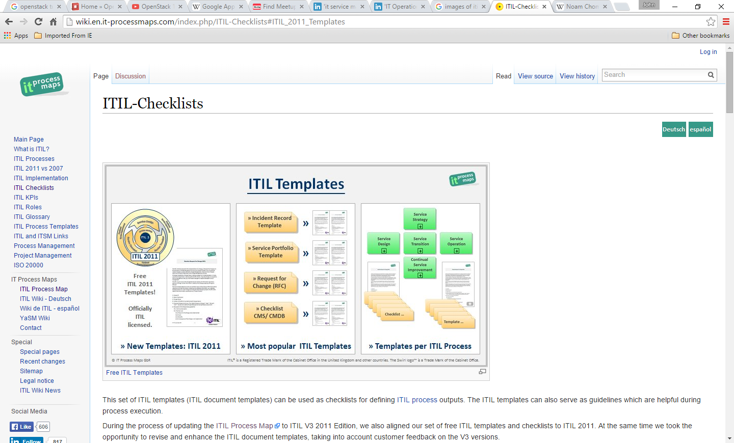

**Example: Incident Record**

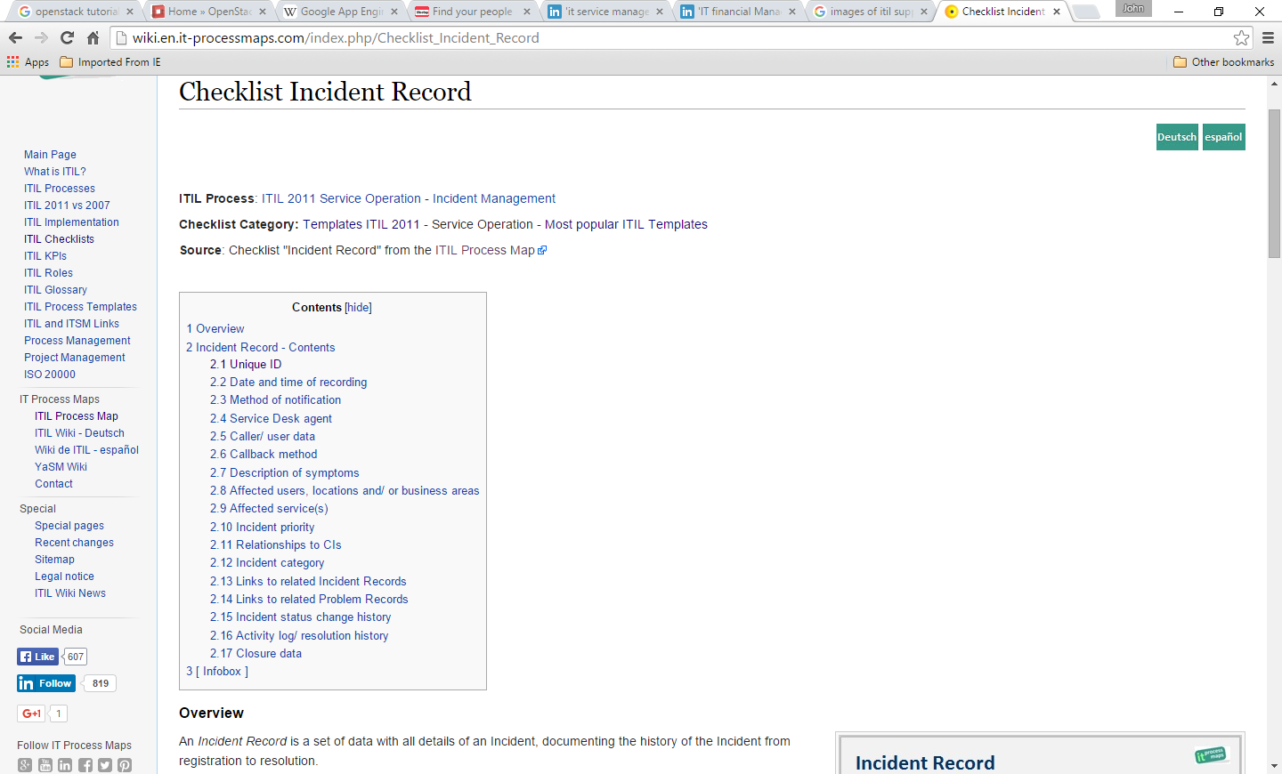

**Example: Incident Record-> Unique ID**

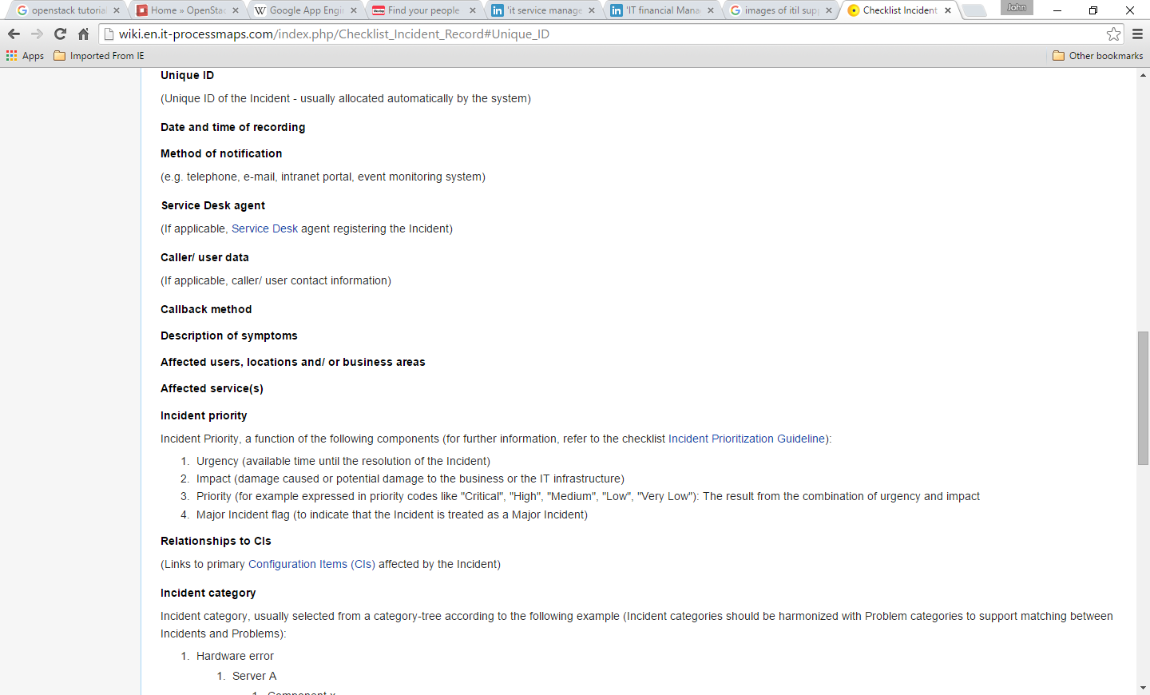

**Other Resources, Suggestions:**

* Text book used in this class, it has good high level information, reminders, tips. It sets your direction correct!
* ITIL Websites, e.g.

<http://wiki.en.it-processmaps.com/index.php/Main_Page>

* Internet searches. (Most of the materials in this presentation are derived from so.)

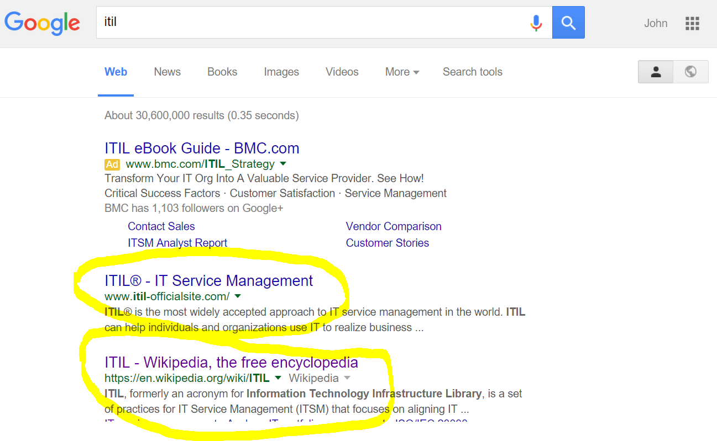

* Learn from yours and others: the success, and failures. Establish the feedback loops!
* Talk to your customers: external + internal. Establish the feedback loops!
* Share: We are in this together (Your customers, and your peers).
* NOT afraid to take risk: Innovation brings risk. Risk taking means rewards (No risk, little/no rewards).
* …

## The Story of “细水长流”.

## Chinese Version: Black and white, my oral citation…

## American Version: The Snake River, the Salmon, the Wild West, We-Are-In-This-Together… (Sorry, I lost my Idaho photos for now. But here is another set of photos, the Colorado… Smile..)

## <https://picasaweb.google.com/105873428407993878105/Colorado2009JChan>

Keep in touch:

[john_c_chan@hotmail.com](mailto:john_c_chan@hotmail.com)

[jcc4018@cityU.edu](mailto:jcc4018@cityU.edu)

Thanks!