**What is IT Service Management:**

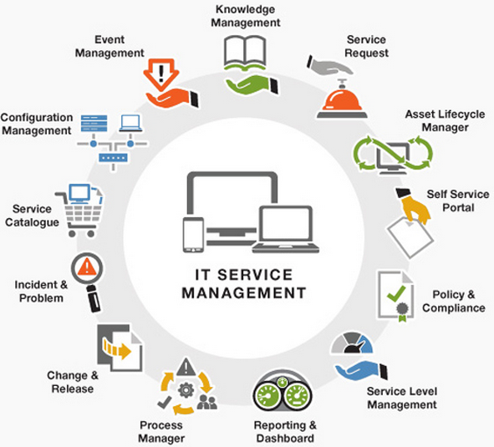

**What are the tools?**

**Cloud Migrations and IT?**

**An IT Service Model:**

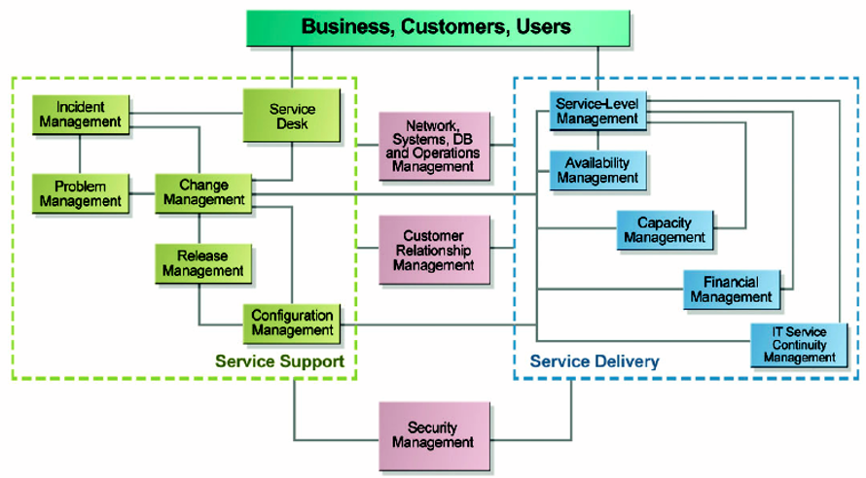

**Front-End: Service Support**

**Back-End: Service Delivery**

**Example of Services:**

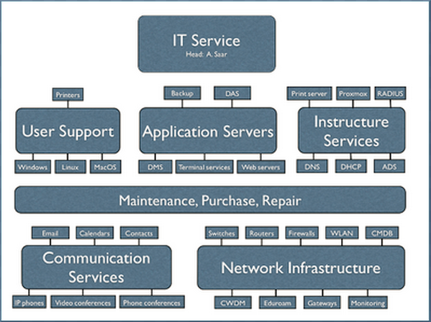

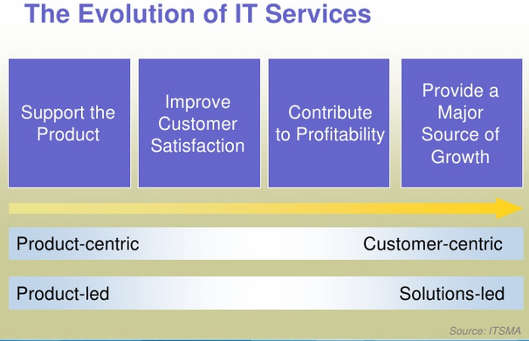

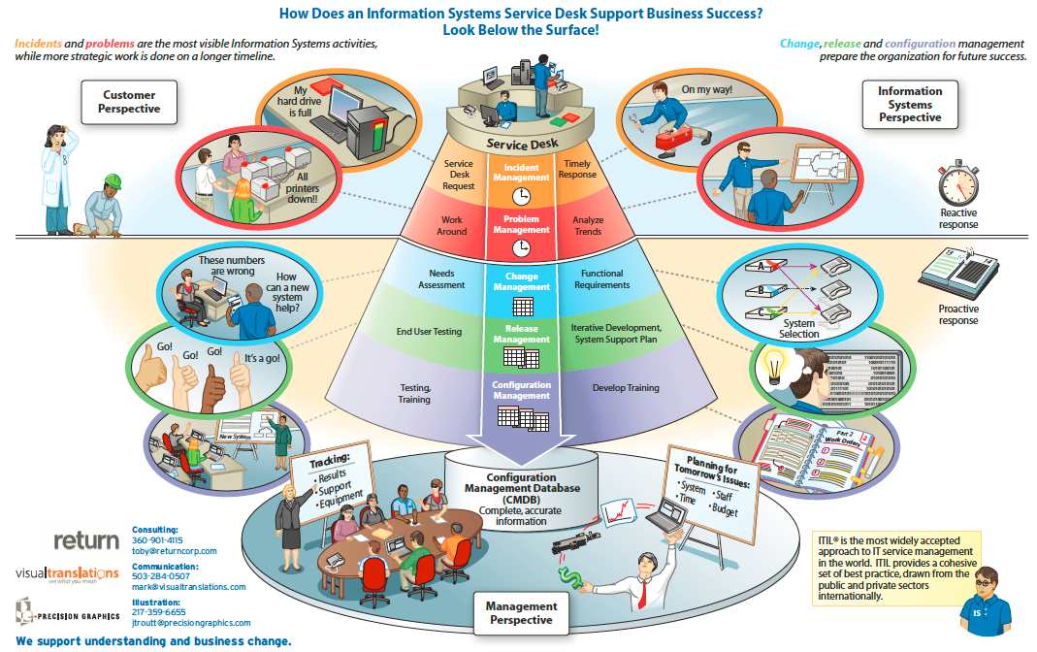

**NOTES:**

* **This is a “Happy” picture of IT.**
* **What is “ad-hoc”?**
* **What is firefighting?**

**How IT Services Help (Some examples):**

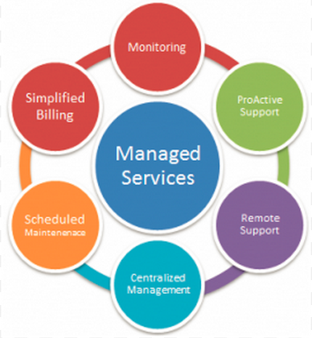

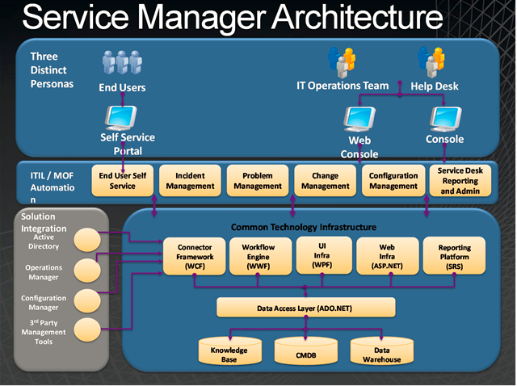

**Self-Helping KIOS, works?**

**Computing Resource, Budgets, Utilizations?**

**Cloud Migrations?**

**Example #1: How IT Service Management Help:**

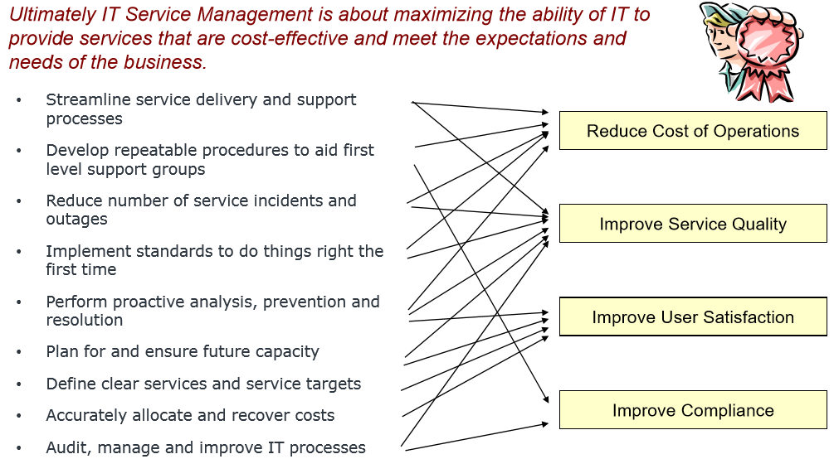

**Example #2: How IT Service Management Help:**

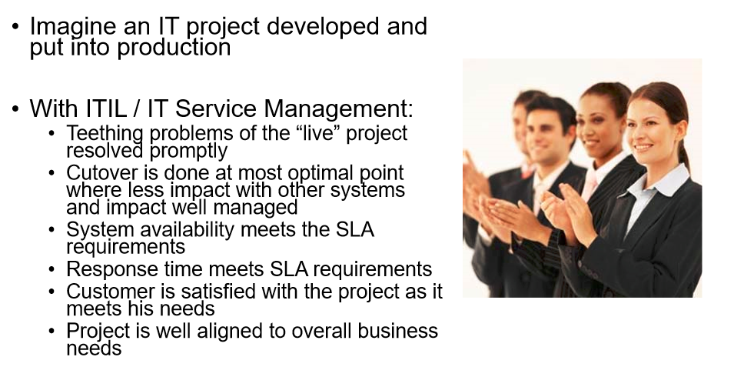

**Conceptual Phases of IT Services:**

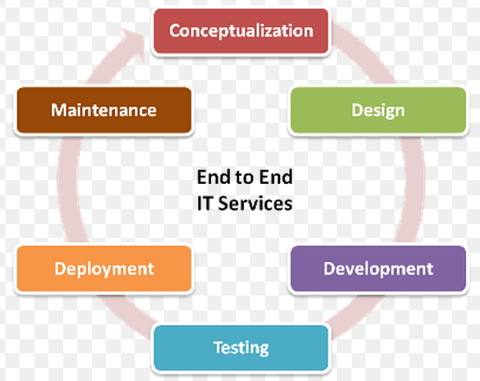

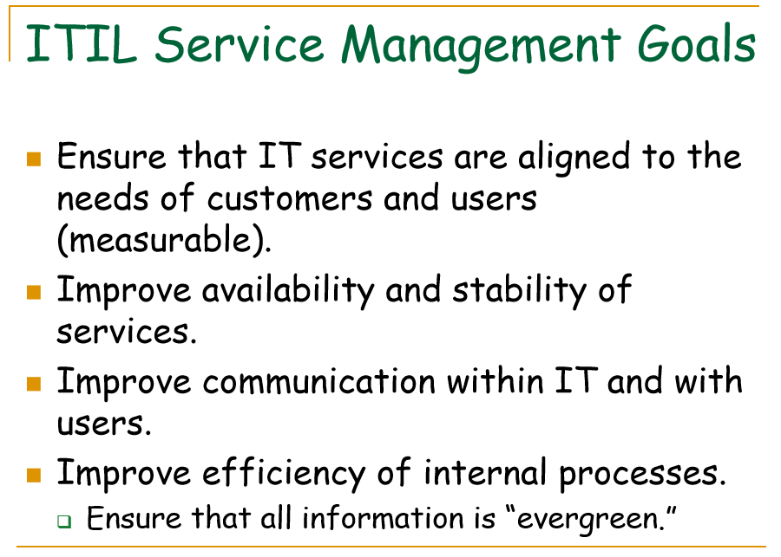

**NOTES:**

* **A brief ITIL history…**
* **How is ITIL being “regarded” in North America?**