**ITIL means, “We have a Process”:**

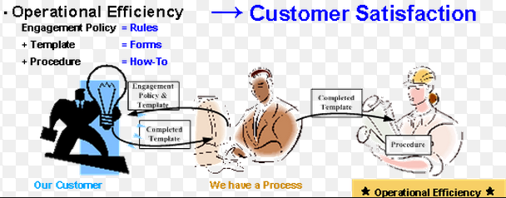

We will show the major process/Flows in the Class shortly.

**We have a functionsl Help-Desk:**

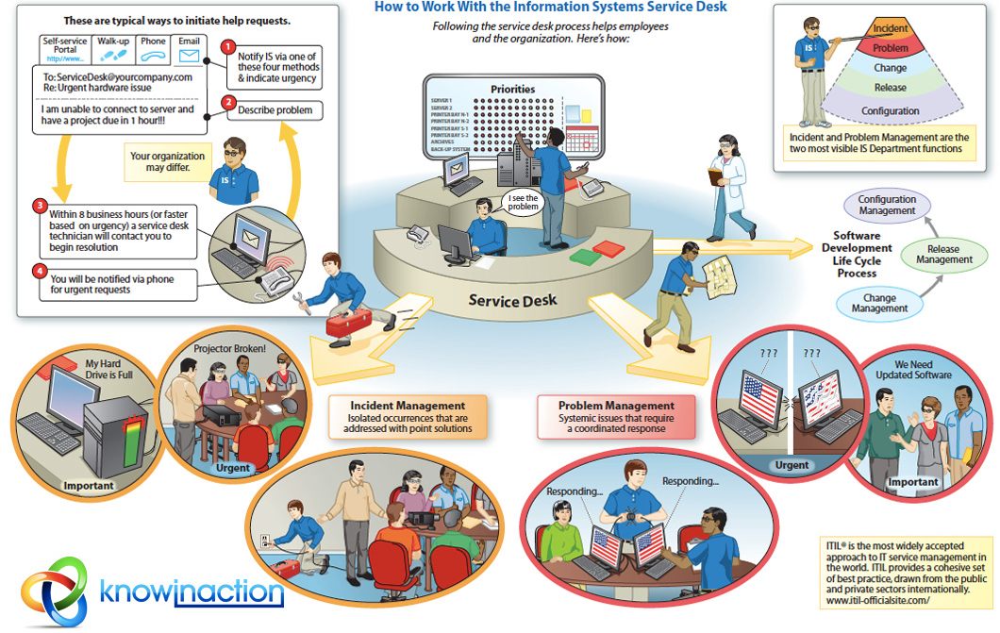

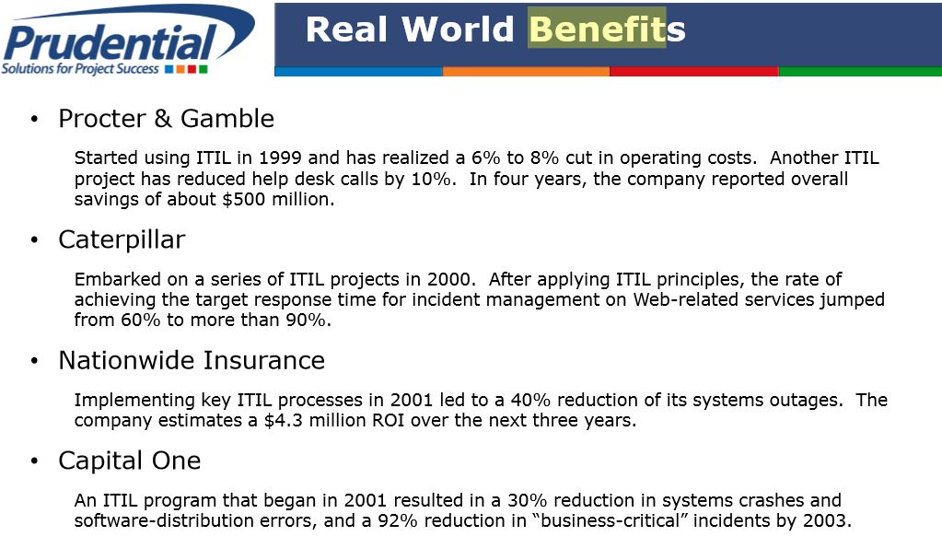

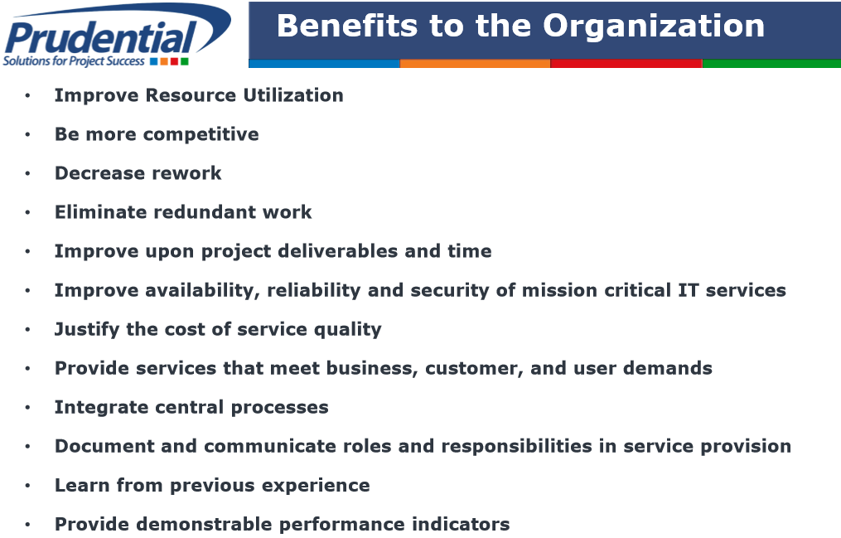

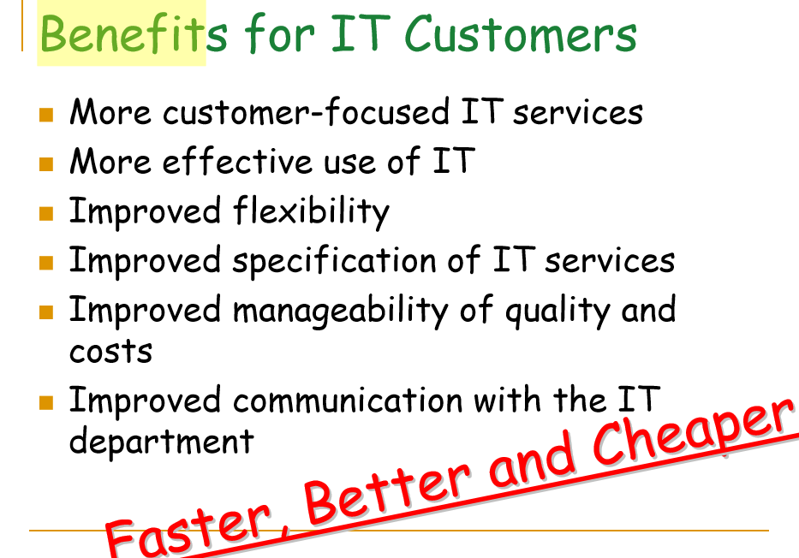

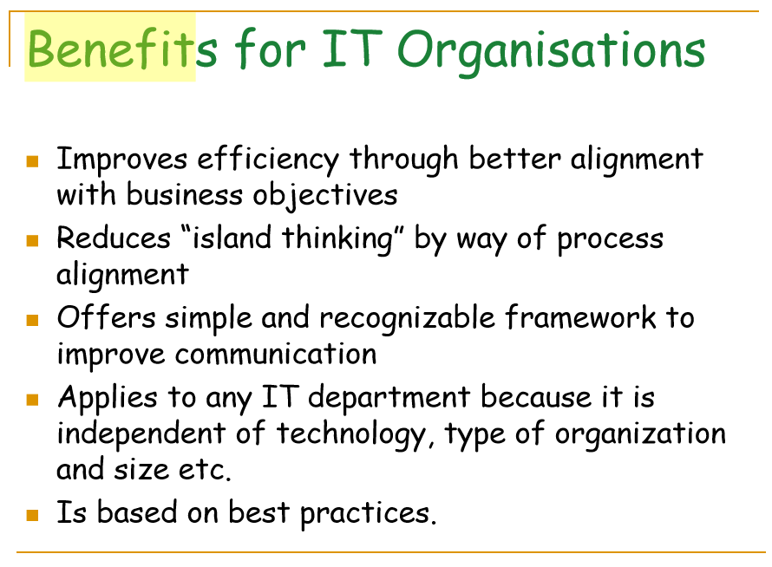

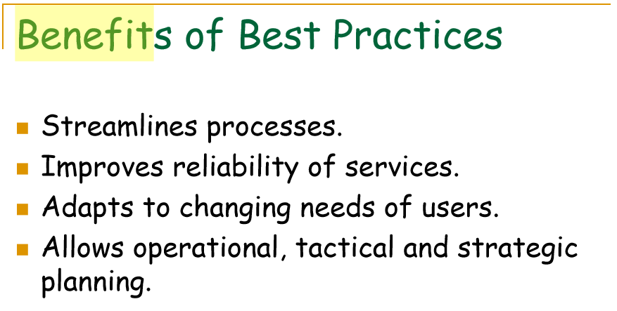

**Thoughts:**

* IT-Organizations in the 1990s, Prior to ITIL. Why ITIL was born?
* The State of IT-Organization in N. America, as I know it: Lenovo PC maintenance center; Expert Center?
* Outsourcing, India’s IT Support: My personal experience.
* Outsourcing, China’s IT Support: My personal experience.
* About the key phrase: “Value-Add”…
* Breadth vs Depth in your knowledge, where to focus?
* Can a country be strong, without “hardware”? (My China up brings…)
* America vs China, views of each other?
* Another few words about Google, YouTube, Facebook…Shh…
* My thoughts: Linux, Ubuntu, Apple, OpenSource, Microsoft Window… Yours?
* Where do you fit? Do you really want a job in the IT-Organization?