|  |  |
| --- | --- |
| **Core phase** | **Sub-processes and functions** |
| Service Strategy | 1. Financial Management  2. Service Portfolio Management  3. Demand Management  4. Strategy Generation |
| Service Design | 1. Service Level Management  2. Capacity Management  3. Availability Management  4. IT Service Continuity Management  5. Service Catalogue Management  6. Supplier Management  7. Information Security Management |
| Service Transition | 1. Change Management  2. Service Asset and Configuration Management  3. Release and Deployment Management  4. Service Validation and Testing  5. Evaluation  6. Knowledge Management  7. Transition Planning and Support |
| Service Operation | 1. Incident Management  2. Problem Management  3. Event Management  4. Request Fulfilment  5. Access Management  6. Service Desk Function  7. Technical Management Function  8. Application Management Function  9. IT Operations Management Function |
| Continual Service Improvement | 1. Seven-Step Improvement Process |

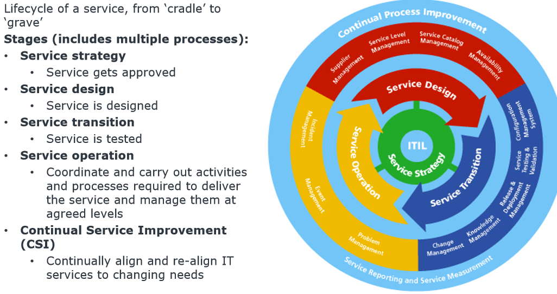

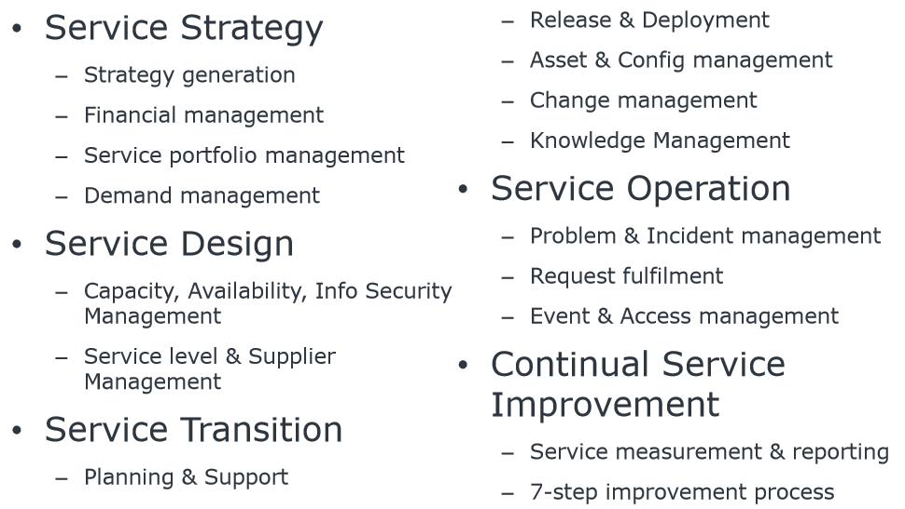

**Core ITIL v3 Library:**

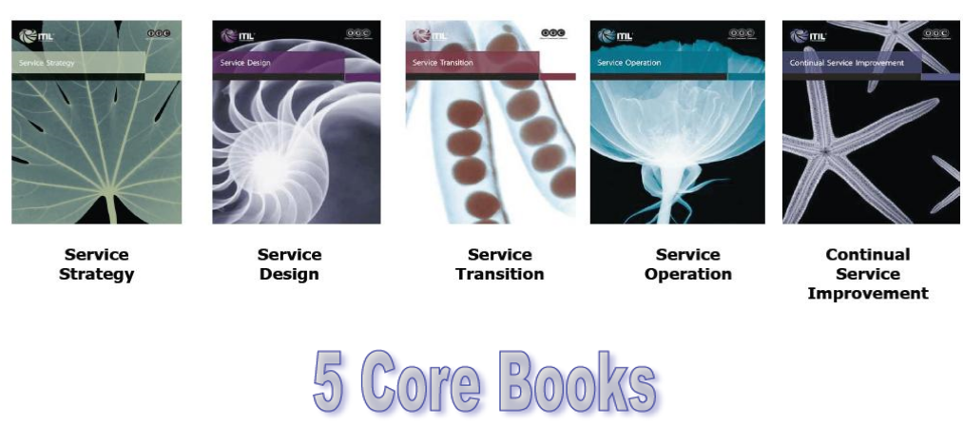

ITIL Websites:

<http://wiki.en.it-processmaps.com/index.php/Main_Page>

**Service Strategy:**

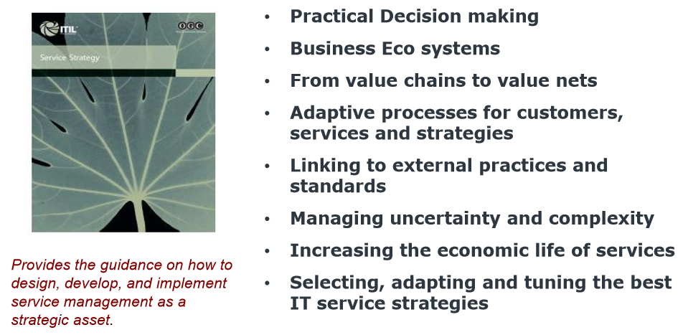

**Service Design:**

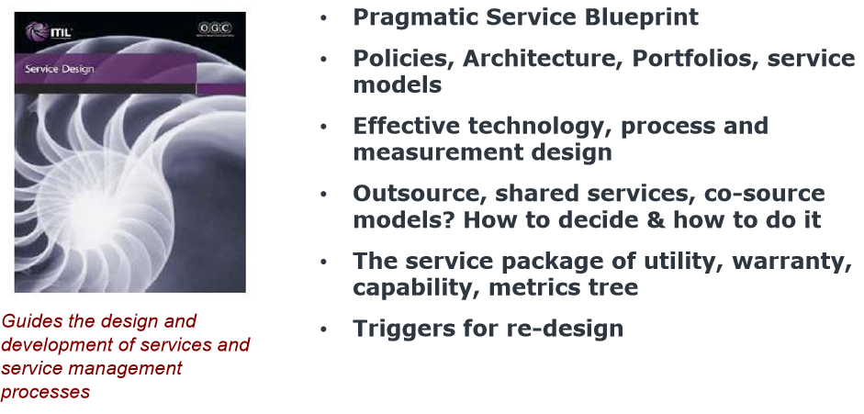

**Service Transition:**

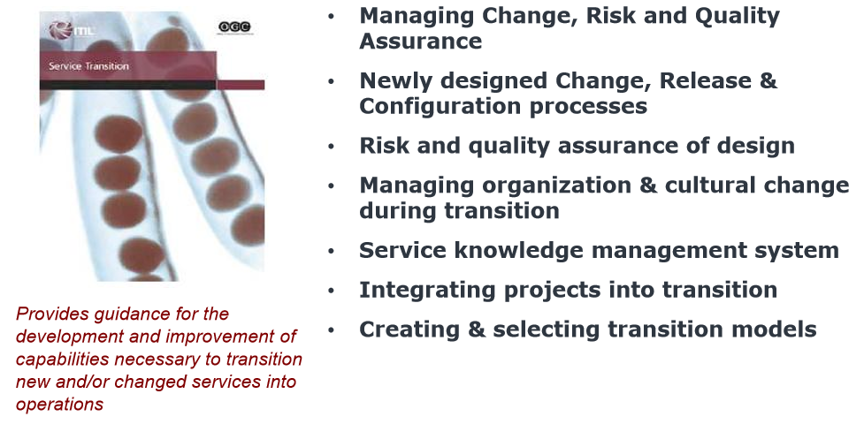

**Service Operation:**

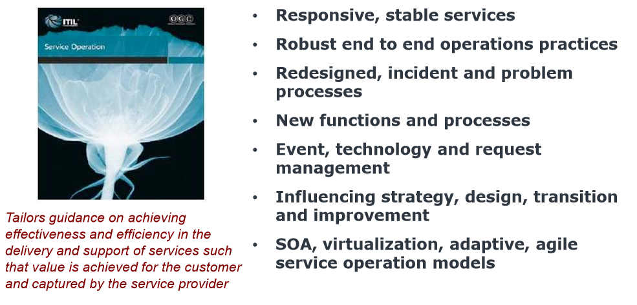

**Continue Service Improvement:**

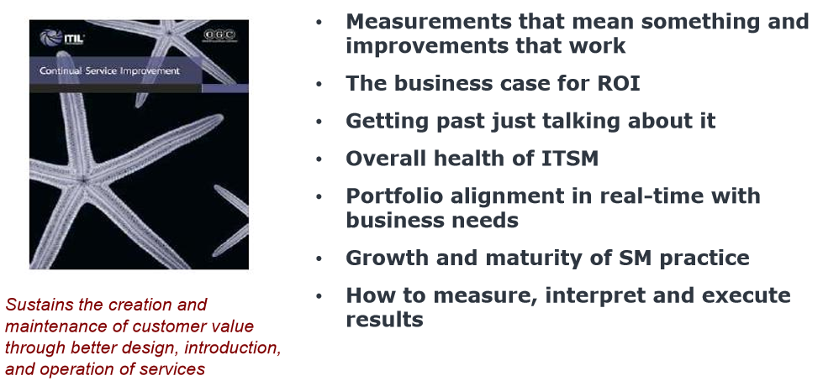

**About 6 Sigma…**

**Roles in ITIL:**

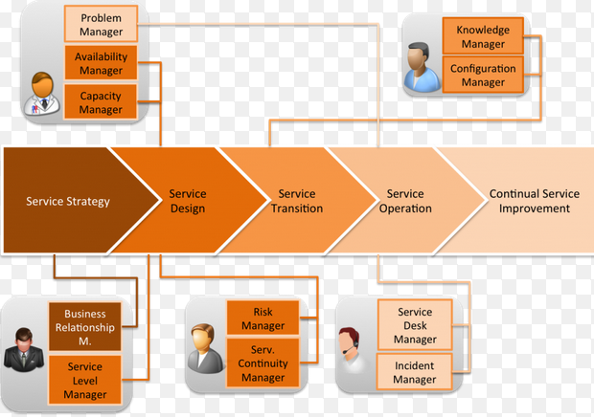

**Do you really pigeon-hole yourself to be one of the many manager?**

**Do We Need ITIL?**

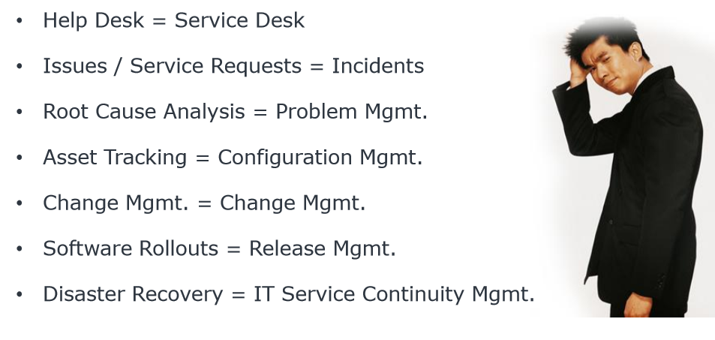

**British vs America? What is the difference?**

**What about China? 6-sigma and Japan…**

**Can we ever be: We-are-in-this-together?**

**About you and I…**