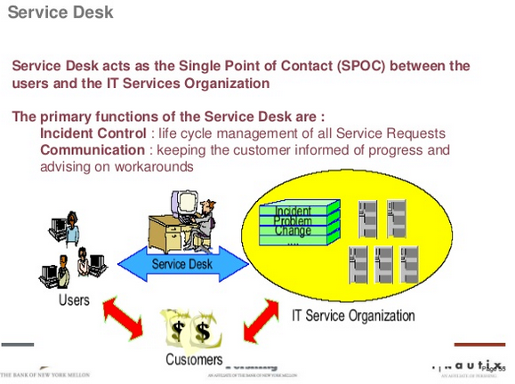

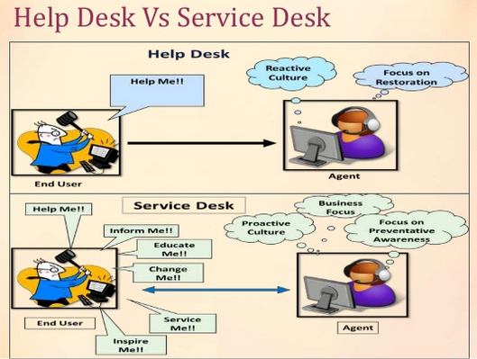

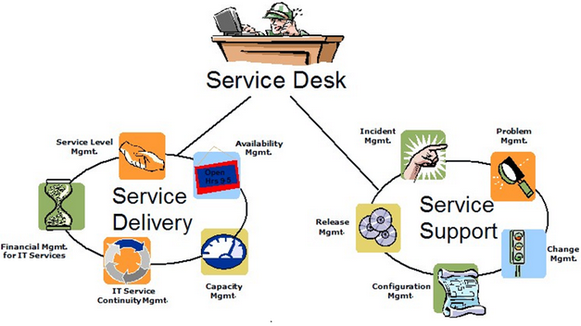

**Where does “Service Desk” sit in ITIL?**

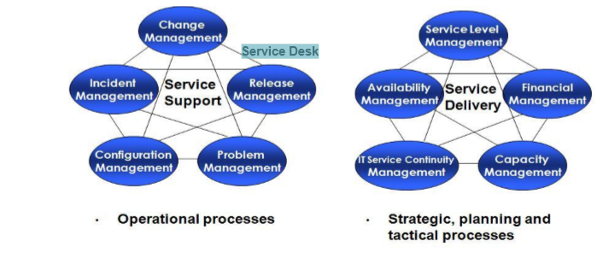

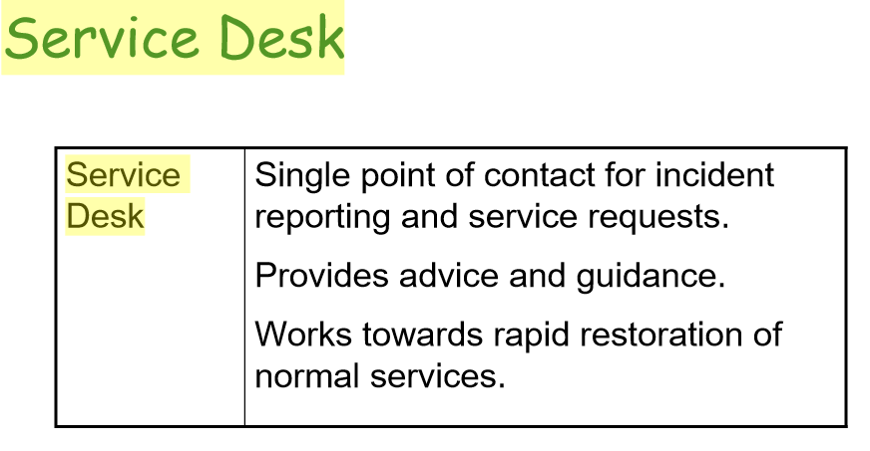

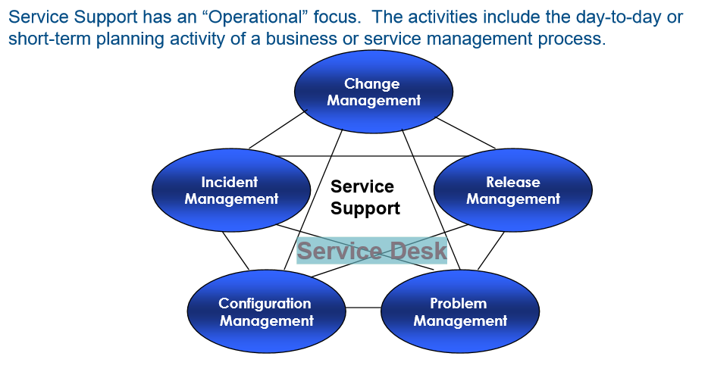

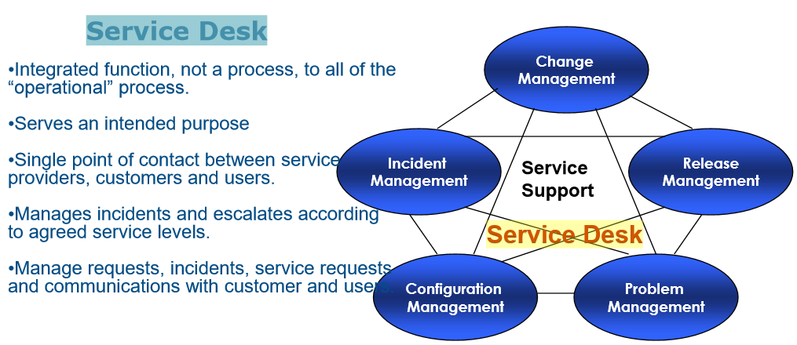

**What are the tools For Service Desks?**

* Example of useful tools for Service Desk? Remote Desktop. Skype, … ?
* What knowledge-based software, Bugzilla ?
  + Bugzilla: <https://www.bugzilla.org/>
  + Bug/ticket system, where you can search prior/historical incidents. Text only, good enough, why text-only?
* I/We have used RT Tracker: <https://www.bestpractical.com/rt/>
  + We like it, it is simple, email based.
  + The main reason: We have different contract manufacturers, they don’t want to see each other’s escalation!
* A few words about Text-Only ticketing system…
* A few words about Data Analytics, and Cloud Computing, the Internet-of-Things…