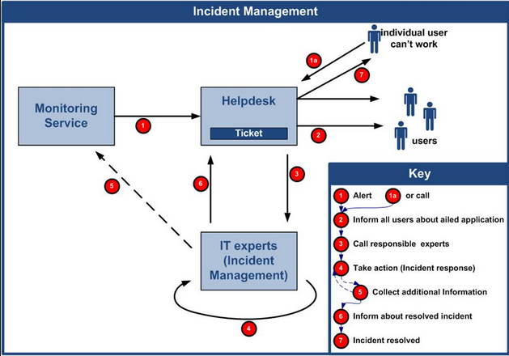

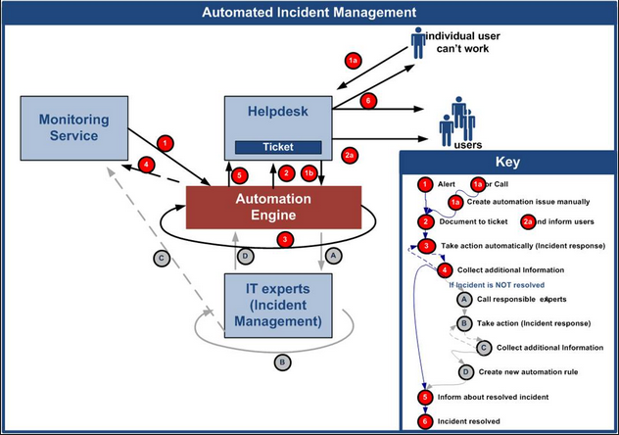

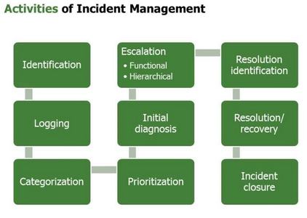

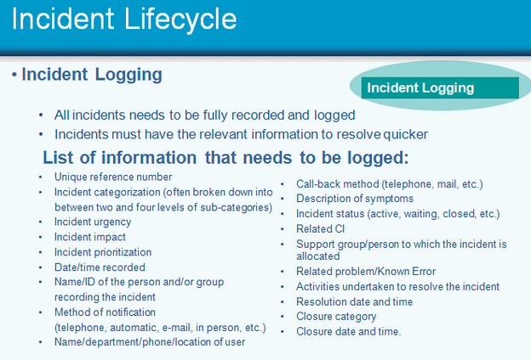

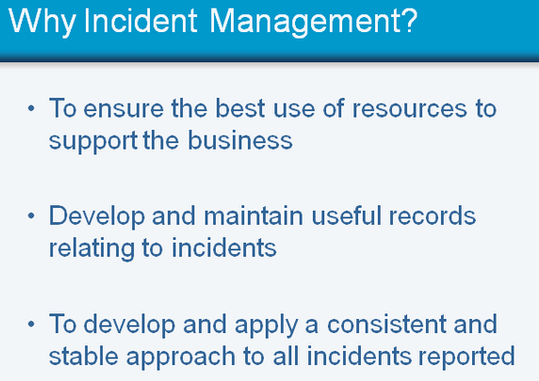

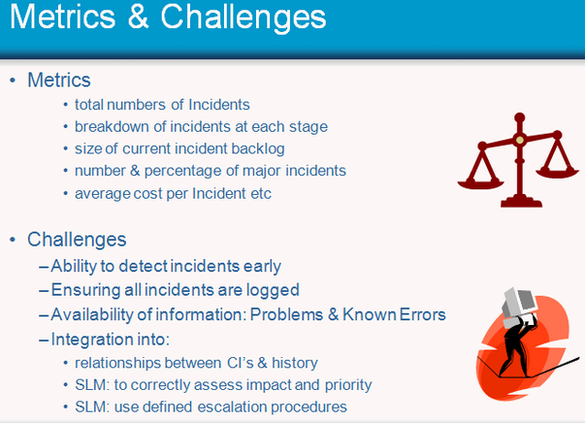

**Incident Management: An Example**

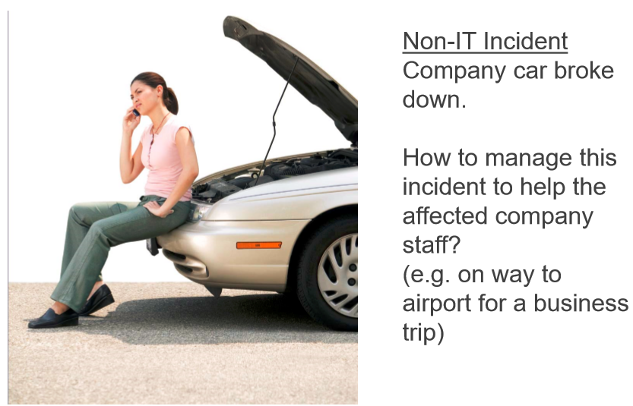

**ITIL Recommendation for Incident Management:**

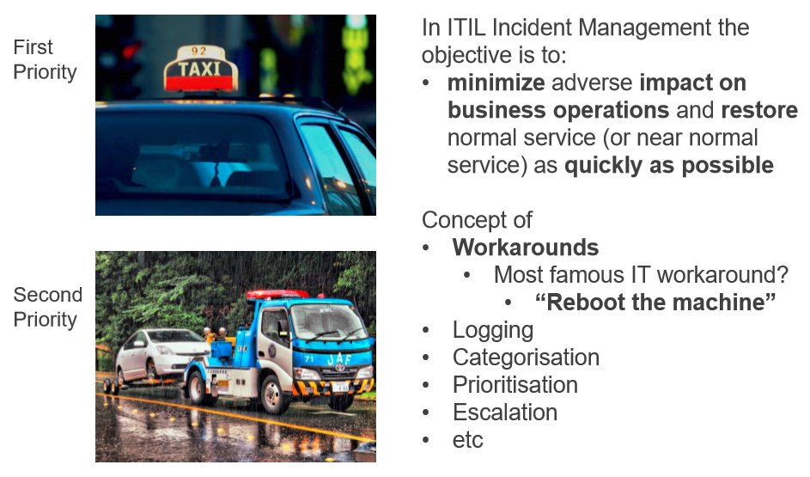

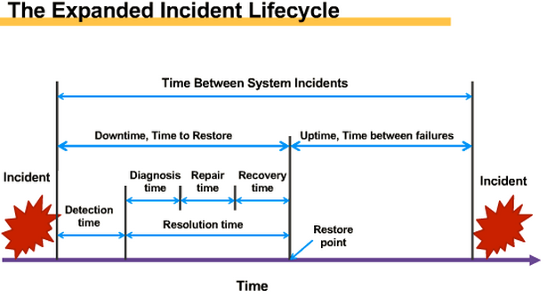

**An Example of Incident Management Flow Chart:**

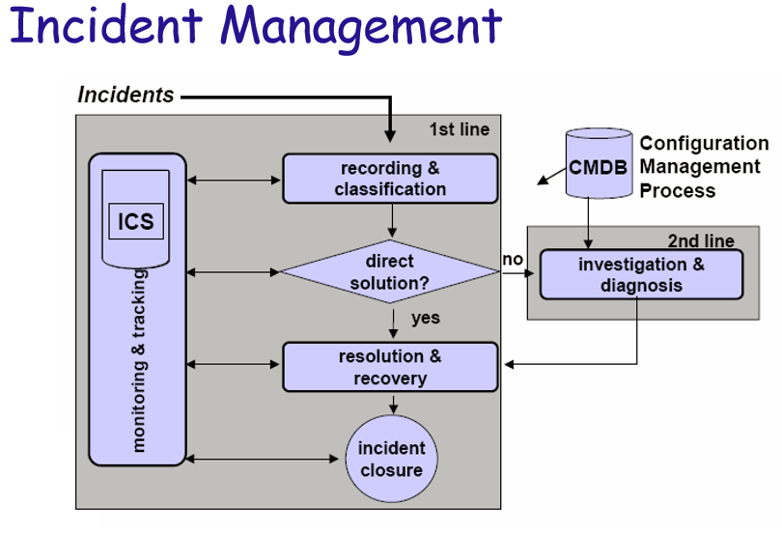

**An Example of Finding Resolutions, work-Arounds:**

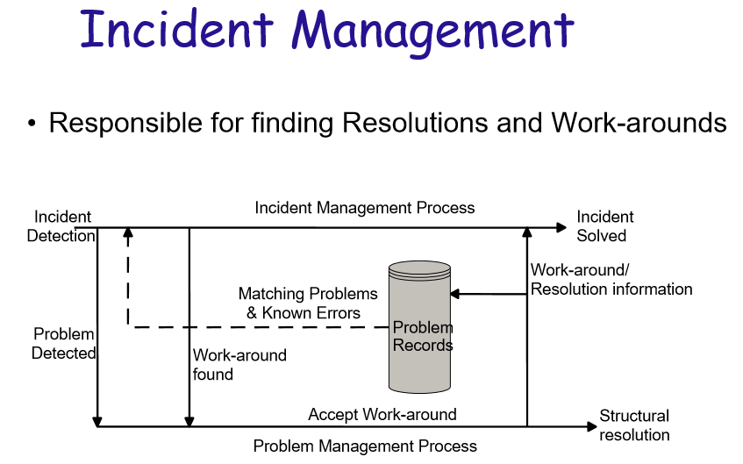

**What are the protocols of engagement on incident management?**

* **Version of the Software/OS/Firmware Releases?**
* **Hardware Configurations? (Window vs Mac vs Linux, Hardware model…)**
* **Collaterals? (Part Number, Serial Number, …)**
* **Data Logs?**
* **Do you define the incident reporting format, let it be known; or let your client to dump onto you?**
* **How much questions to ask to your client?**
* **Why is your client important?**
* **Why did we NOT catching the issue in-house? (Do you have all the product configurations tested?... uhhh…)**
* **What is your commutation link? Remote login? Remote Reimage? Remote Power-Cycle? …**
* **What is your feedback loop? How long does it take to get the needed info?**
* **Your experience on engaging the R&D team?**