**Problem Management:**

(Problem: the Root-Cause of an incident is UN-known)

* Aims to prevent problems and resulting incidents
* Minimises impact of unavoidable incidents
* Eliminates recurring incidents
* Proactive Problem Management
  + Identifies areas of potential weakness
  + Identifies workarounds
* Reactive Problem Management
  + Indentifies underlying causes of incidents
  + Identifies changes to prevent recurrence

**An Example flow chart:**

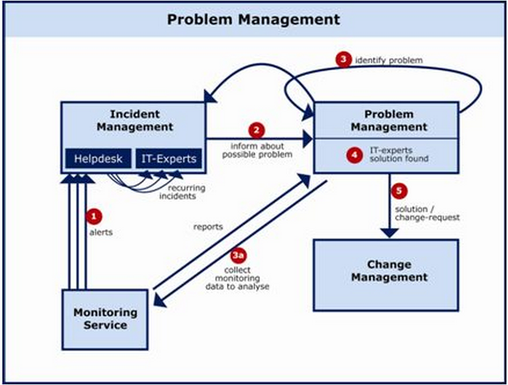

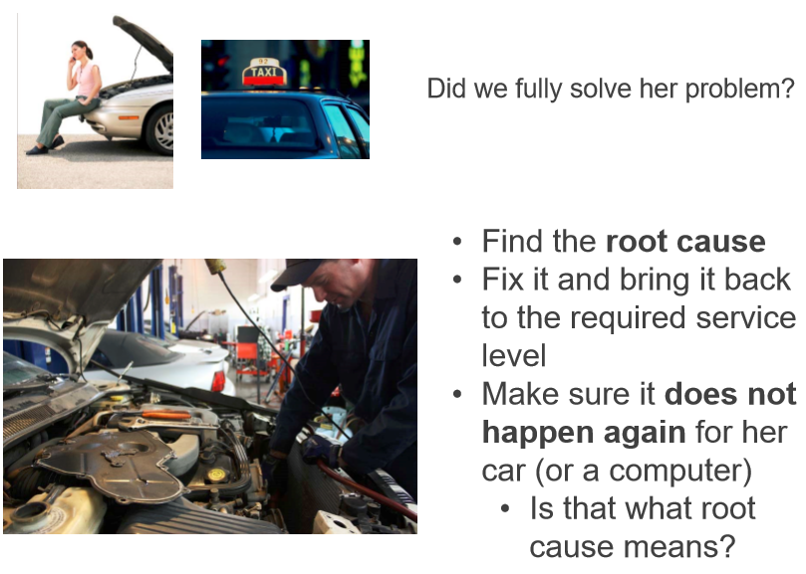

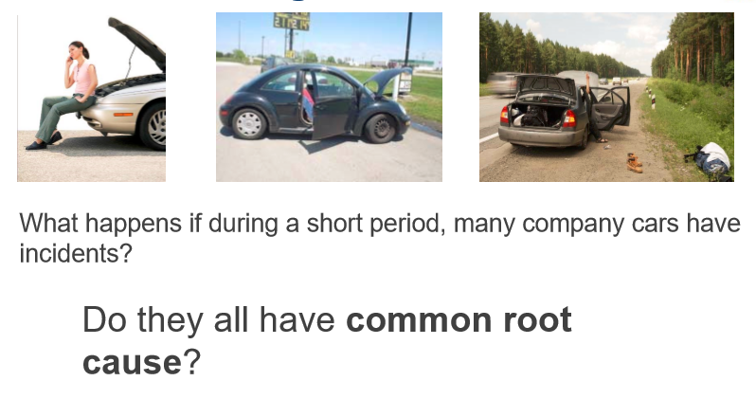

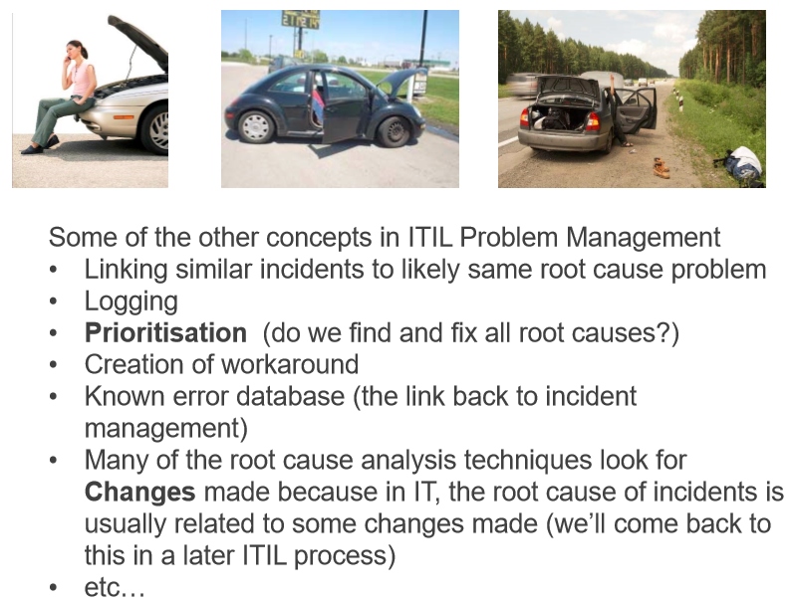

Problem Management: Avoid the Blame Game

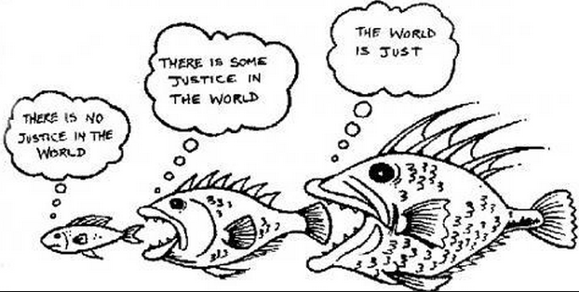

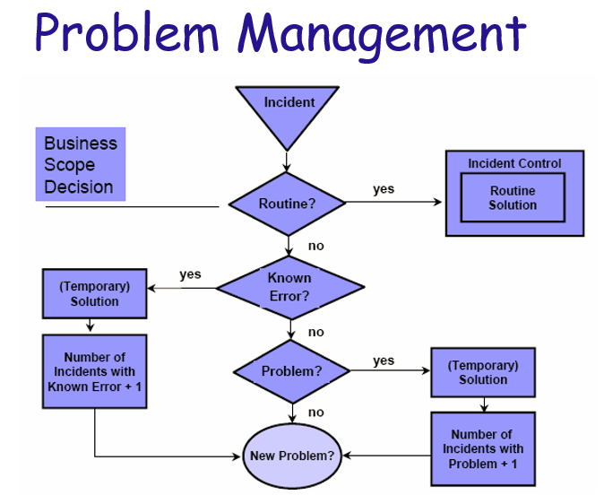

**Activities in Problem Management:**

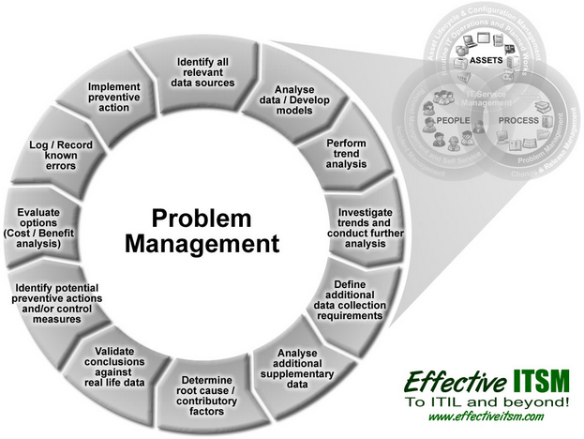

**Thoughts on Problem Management:**

* **How to know, when to escalate? Did you search thoroughly your knowledge data-based? How?**
* **Who to escalate the issue to?**
* **What are the collaterals in an escalation?**
* **Speak with the facts, be data-driven, the Bugzilla protocol. (Oh… Can I go back and change what I said earlier? ...).**
* **Being an issue facilitator, vs a problem solver?**
* **What-if-scenario: Punish the one who does the work? (Happened at post-mortem big meeting…)**
* **…**