**Change Management:**

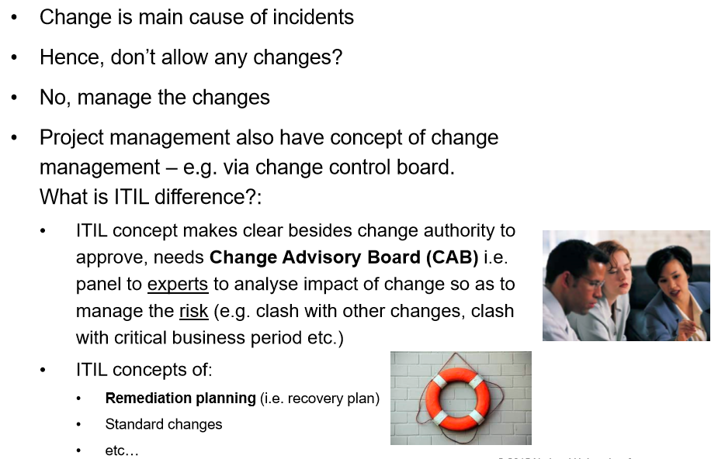

**Change Management process explained in ITIL**

* It is one of the most central and most important ITIL processes
* Everything that changes a status in a CI in CMDB in ITIL
* Change manager should have a good broad overview, some in-depth knowledge in key areas, and know lots of the local history.

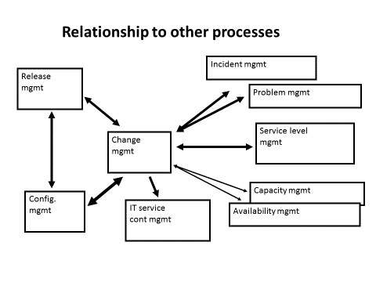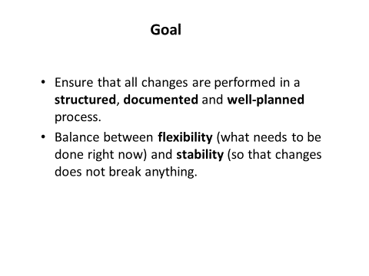

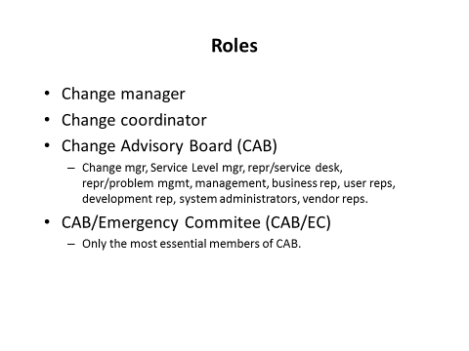

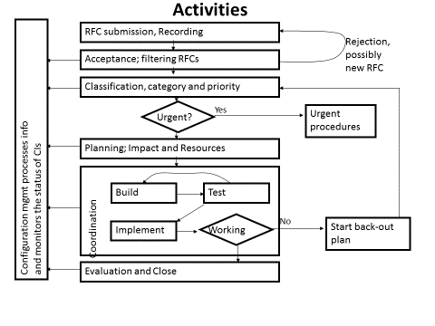

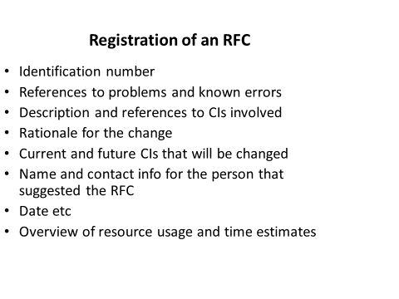

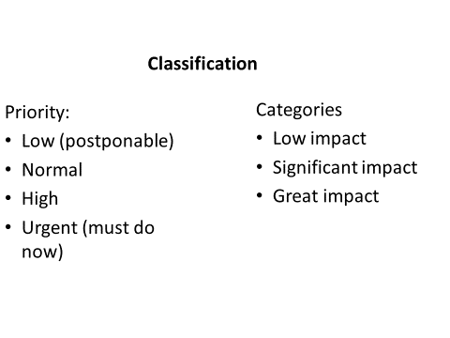

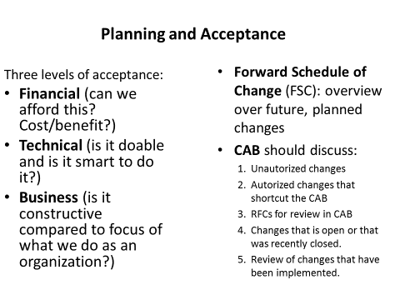

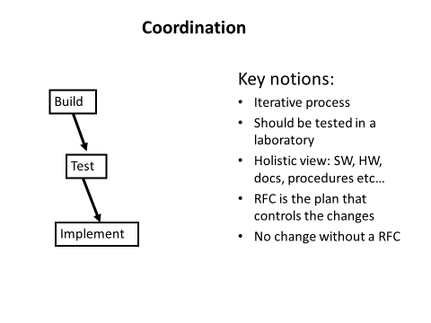

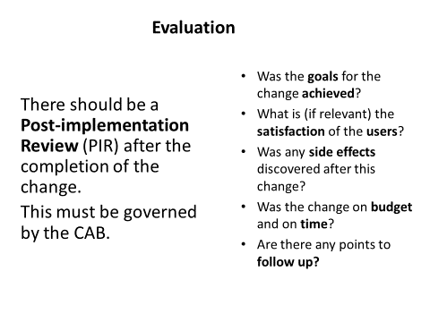

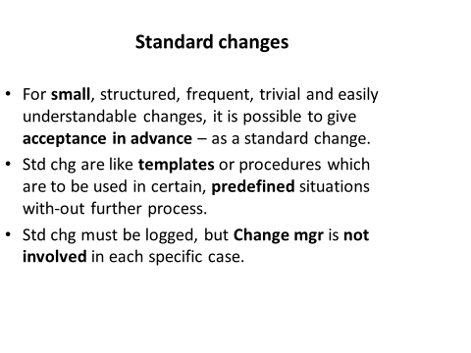

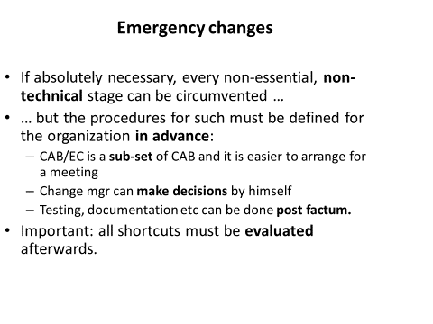

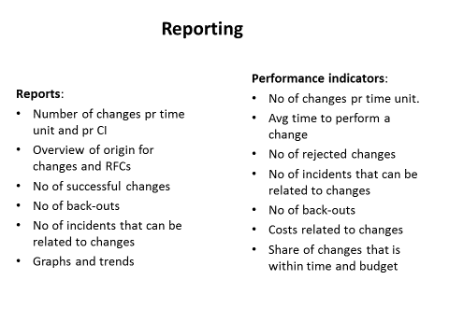

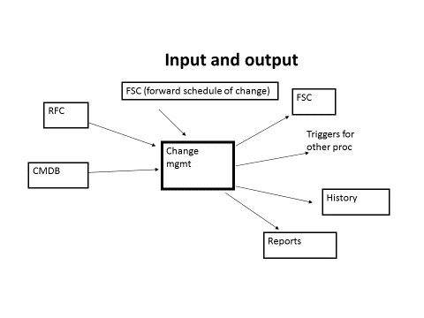

**Thoughts about “Change”:**

* What does it mean? A personal view… (Stress, risk, comfort, why, rewards vs regret!)
* “Change”, as I know it in America: the immigrants, jobs, outsourcing, housing-the-checks-and-balance…
* The US’s view about China on “Change”. The Carly Fiorina remarks…
* China’s view on “Change”: Your inputs… please!
* IT Changes: the approval board (good, and ugly, how is it tested it out? ...)
* …