**Lifecycle of Release Management:**

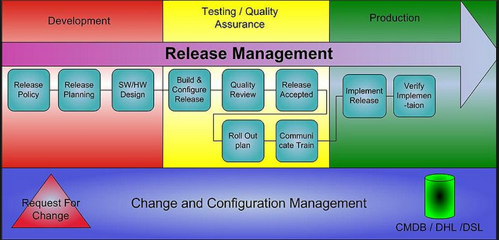

**Where is Release/Deploy:**

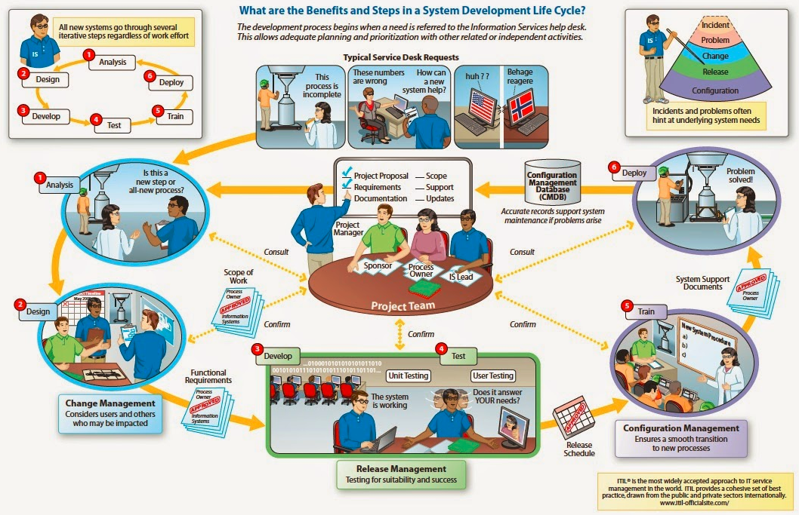

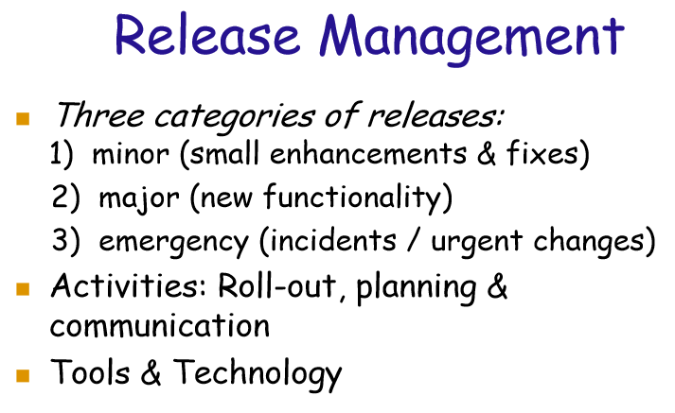

**Recovery Plan, in case nothing goes right?**

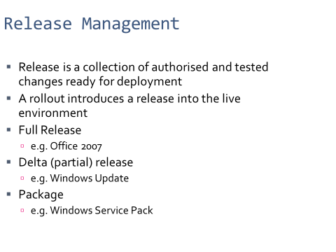

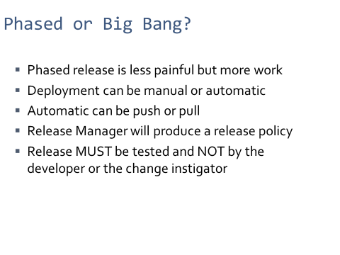

**Important Questions on Release Management:**

* All configurations are tested, and validated (Software x Hardware)?
* Test/Validation at the client environment (Beta Release), vs in-house?
* Recovery plan, in case all goes wrong?
* Do we support legacy, old code/products?
* What does it take to implement a patch/fix, in case we found an issue after deployment?
* How long does it take to get an emergency release approved?
* How often to make a release? (Often means good or bad?)
* Apple’s iPhone release: Who it excites? Why? How much you know about it? Please share Chinese flavor…
* Risk taking: The Western Virtual…
* …