Hi,

Today’s homework is highlighted below.

It is due this Wednesday/Friday Mid-night (12:00am). Please email your submission to our TA: [bangpanliang@gmail.com](mailto:bangpanliang@gmail.com)

Thanks.

------------------------------------------------------------------------------------------------------

Hi,

Our TA’s mail inbox is overwhelmed with assignment submissions. Due to this, below in the new way of submitting your assignments. Please do so accordingly. Thanks!

1. Upload your assignment contents to your Baidu Cloud Storage. An example is shown below:

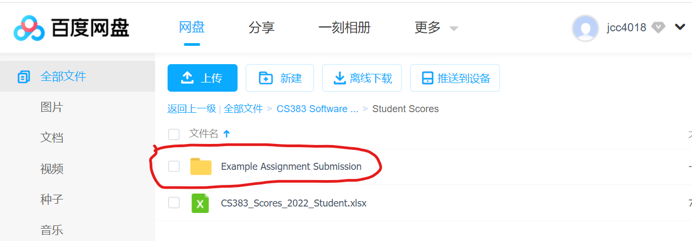

1. Share your Baidu Cloud link. Example:

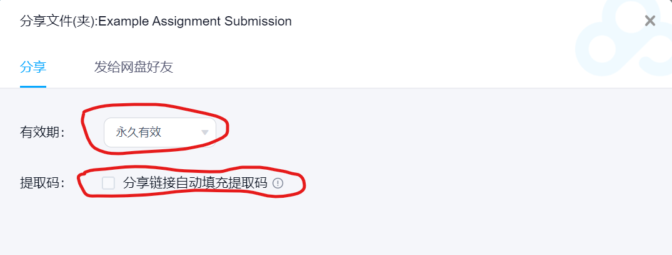

1. Capture the Link:

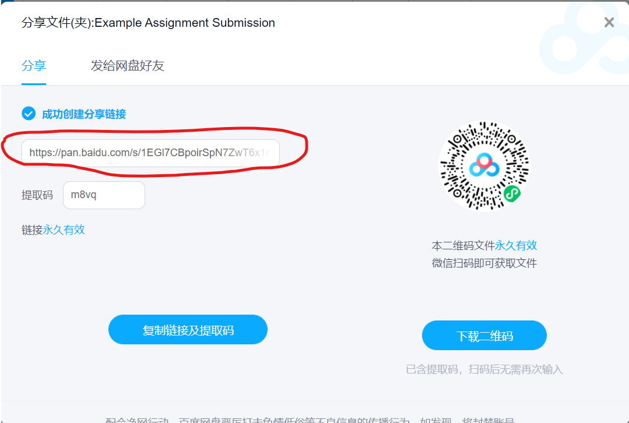

1. Email your link to our course TA for grading (bangpanliang@gmail.com). Example:

Email Subject: [Your StudentID, Assignment Name]

Email Content:

My assignment submission content link:

<https://pan.baidu.com/s/1EGl7CBpoirSpN7ZwT6x1cA>

Thanks….

Please do so for all subsequent assignment submissions. Thanks.

Hi, Good question. Please find my inputs below.1) The course project does require coding, testing. Eventually, I would like the project source codes and relevant documents be posted on GitHub, so it would be helpful for you when applying for job.

2) Your project source code do NOT need to be complex, and you do NOT need to start from scratch. Based on your team’s idea, I suggest to search GitHub for similar repository that you can understand. Then clone and make enhancement to it.

Hi,

Welcome to CS383-Software Engineering. I am the course instructor. I am so excited that you are taking this course. We are going to learn and explore together!

Please find the two important links below as we are going to start the 1st class session shortly.

Zoom Meeting Link:

<https://northeastern.zoom.us/j/95740195623>

Course Content Link:

<https://pan.baidu.com/s/1XWRPNk-4KQD0IcKb6svmAg?pwd=wgjh>

Thank you, and see you in class on Tuesday 😊

-------------------------------------------------------------------------------------------------------

Thank you 叶老师!

Your point is well taken. May be each class representatives can collect student’s assignment submissions, deposit it on Baidu cloud, then share the links to the TA for grading.

If we decide to take this approach, can you let me know the contact info for the two class representatives?

Thanks.

Yes, I withdraw the textbook from the Baidu Cloud. I hope the student will have access to the text book in due time.

I am ready to start teaching a class on Tuesday as plan. Please find the course Syllabus attached.

My presentation meets UI’s requirement on the course, and cover the chapters as you outlined.

As for the textbook, it is available on the internet for free download. <https://mycourses.aalto.fi/pluginfile.php/1177979/mod_resource/content/1/Sommerville-Software-Engineering-10ed.pdf>

So, there is no issue on releasing the electronic version of it.

We have a WeChat group setup for CS383 students. So students and me are in full contacts. Our course TA is fully engaged as well. I have communicated with him for readiness as well.

Yes, I am ready to start CS383 next week. Additional details:

Zoom Meeting Link:

<https://northeastern.zoom.us/j/95740195623>

Course Content Link:

<https://pan.baidu.com/s/1XWRPNk-4KQD0IcKb6svmAg?pwd=wgjh>

Yes, I can switch class meeting time to 8:40am-10:10am. Please confirm.

Thanks!

Today, I received RMB 50,172 for last Autumn’s CS240-Operating Systems course. I am very happy and looking forward to our next class!

Thank you 叶老师! :)

Yes, my Chinese Bank Routing information is the same (no change). Please let me know if you need the routing info again if needed.

Thanks!

--------------------------------------------------------------------------------------------------------

Please find my signed contract attached. The course is well prepared, and I am looking forward to engagement with our students.

For [CS240 Operating Systems, Fall 2021] that I just completed, I have NOT receive any payment. Could you let me know when can I expect the payment?

(Please let me know if you need my Chinese Bank Routing information.)

Thanks!

------------------------------------------------------------------------------------------------------------

I will take your suggestion, not to share the textbook .pdf file to the student.

As for textbook printing, your point is well taken. I recommend the following Textbook Chapters be printed for the students. [1-9, 15-16,25].

These chapters will be covered in detail during the course presentation. Hope this will reduce the # of pages to be printed significantly.

Thank you 叶老师!

I receive it. I will share the textbook with the students. The course contents are setup in Baidu Cloud. One can access it with this link: <https://pan.baidu.com/s/1XWRPNk-4KQD0IcKb6svmAg?pwd=wgjh>

I will share the course syllabus with you, our TA and students once the schedule is determined.

Thank you and have a great weekend. 😊

Please find the signed document attached. I am available for grading on students who need to take the 2nd attempt on the final exam.

I am well prepared for CS383-Software Engineering. Please let me know the schedule once available. My schedule is open in Beijing Time: Monday, Tuesday, Thursday.

(Wednesday, Friday is not available, as I commit to teach at another US university.)

I am looking forward to work with our TA again. Thank you. I love Suzhou/Jiangsu. I wish the pandemic could be over by summer this year.

Take care!

Happy New Year, 叶老师!

I got your reply on the CS240 final score results. I enjoy teaching the class, as most students work hard and learn.

I have been preparing for “CS383 Software Engineering” for the last couple weeks. Several students contacted me about the course. I am ready to teach the course as needed.

Thanks you and Happy New Year😊

--------------------------------------------------------------------------------------------------

Happy New Year, 叶老师!

Please find the CS240 Final score file attached. Additional details:

* Column-R has the final score. Most students did well, as most of them deliver homeworks.
* 5 students have score below 60%. I am ready to do the 2nd attempt grading as needed.
* Our course TA (梁邦盼) has done a great job. I will be glad to have him as TA again in the future.

I wish the pandemic will be over soon, so I can come to Suzhou and teach the classes in live session.

Thank you and happy New Year 2022 to you and your family! Take care!

-------------------------------------------------------------------------------------------------------

c

Looking at University of Idaho’s outline for the course: http://wiki.cs.uidaho.edu/index.php/CS_383

Yes, I can teach the course. It is essential that I have few weeks of time to prepare for it. I have taught many of the topics at other US universities. I don’t think it is a difficult course for 3rd year student.

What is the schedule for the course? For Spring, 2022, I am currently scheduled to teach two courses at a US University (Wednesday + Friday, China Time).

-----------------------------------------------------------------------------------------------------------------

Thank you 叶老师!

Can we schedule CS240 Final Exam for ***December 16 Thursday)***), using the class session times?

Details:

* Please find the Final Exam Questions/Answers files attached (A, B versions).
* The exam has 70 questions (50 multiple choice and 20 fill the blank questions).
* Exam time: ***10:30am – 12:00pm***. This should be sufficient to complete the exam.
* Students are allowed to bring 1 page of paper (A4).
* I will be available during the Exam, both on Zoom and WeChat.
* I will share the Exam Questions/Answers files with my TA. He has been doing a great job.

I am open to other suggestion or adjustments if needed. The class has been going well. I answer a lots questions from students via WeChat.

Thanks.

Monday, Nov 15 Class will be online via Zoom (Not in classroom 143)

Hi,

Monday, Nov 15 Class will be online via Zoom (Not in classroom 143). I injured my knee, and unable to walk/stand. Additional details:

* Zoom Meeting Link for the class: <https://northeastern.zoom.us/j/92871423987>
* This week, we are at Module 3 of the course. We are going to explore and learn SQL.

Thank you and see on Monday in our Zoom Meeting.

John C.

Got it. It is a good suggestion. Thank you 叶老师!

Please find an example of the final exam paper attached.

-------------------------------------------------------------------------

Thank you 叶老师!

Yes, I will announce the exam information to students this Thursday, along with the A4 paper. I also plan spend some time to review course content and prepare for students for the Mid-Term Exam. Thanks, 😊

-------------------------------------------------------------------------------------------------------------------

Yes, I will do so by telling students on Thursday’s class.

Thank you 叶老师!

Your points are well taken, especially on Wi-Fi and Laptop PC. So, forget about allowing Laptop/PC to the exam. For such constraints, I suggest allowing students to bring two pages of papers to the exam. In this course, it covers many Linux commands, it is hard to remember it all.

I have two suggestions:

1. The students can bring their Laptop PC to the exam, so they can search/practice for answers on exam questions that they are NOT sure.
2. I don’t recommend having internet access during the exam. This is to avoid exchanging answers among students.

Please find the updated pdf files attached. The school’s name is adjusted to “Suzhou City University”.

Yes, please let me know the exam. Date/time once confirmed by the school.

-------------------------------------------------------------------------------------------------------------------

CS240 Mid-Term Exam

Thank you 叶老师!

Can we schedule CS240 Mid-Term exam for ***November 4 (Next Thursday***), using the class session times?

Details:

* Please find the Mid-Term Exam Questions/Answers files attached.
* The exam has 55 questions (40 multiple choice and 15 fill the blank questions).
* Exam time: ***8:40am – 10:10am***. This should be sufficient to complete the exam.
* I will be available during the Exam, both on Zoom and WeChat.
* I will share the Exam Questions/Answers files with my TA. He has been doing a great job.

I am open to other suggestion or adjustments if needed. The class has been going well. I answer a lots questions from students via WeChat.

Thanks.

-------------------------------------------------------------------------------------------------------------------------

Thank you 叶老师!

Yes, I can change my class session as follows:

From: Wednesday session 3-4

To Thursday sessions 1-2.

I still plan to have class on Oct 9 (Makeup class) for National Holiday.

Please confirm the changes, so I can announce the changes to the students via our WeChat group.

I am aware that CS240 will have class on Oct 9 (Saturday, Beijing date). I am prepared for it.

Please let me know if Oct 8 (Friday, Beijing date) need to have class?

From Week 6, the schedule will resume to normal, as seen in your .xls document.

Thanks!

---------------------------------------------------------------------------------------------------------------

Thank you 叶老师!

Yes, I will do my best in the next couple days, and see if I can get QQ setup. I do have qq-email. I will let you know. Thanks!

Good information. I am having difficulty of creating a qq-account, as I don’t have a Chinese phone number currently, and “qq International” does not allow me to register a new account from the US. Hopefully I can resolve the issue before the class. I will let you know.

------------------------------------------------------------------------------------------------

Thank you 叶老师!

My WeChat ID is in the Syllabus. I will ask the Teaching Assistant to add me to the CS240 WeChat Group.

If every student can receive a copy of the CS240 Syllabus, then we are ready for the class.

Please see a copy of the Syllabus attached.

-------------------------------------------------------------------------------------------------

Thank you 叶老师!

Yes. I get the schedule. If you know the TA (Teaching Assistant) contact info. Please let me know.

Also, if there is WeChat Group for the upcoming CS240 class, it would be great. This way, I can communicate directly with the students. It serves as my office hours also.

Thanks!

------------------------------------------------------------------------------------------

Thank you 叶老师! I am glad to hear from you.

Yes, no problem. Below is the link that I have for CS121:

<https://pan.baidu.com/s/1BnLvEAEqQ0XfglAxB4b7Ww>

Pass Code: q83e

Please feel free to use/reference the materials.

I am ready for the upcoming CS240 class.

------------------------------------------------------------------------------------

Thank you 叶老师!

Yes, I will contact you again when the course is about to begin. Take care!

---------------------------------------------------------------------------

Thank you 叶老师!

It took a lot of your time and effort to prepare the documents, and this email! Please find my inputs as enumerated below:

* **Contract**: My Signed Contract is attached. Thanks! You/team put a lots effort into this.
* **Schedule**: The course schedule works for me. My other teaching opportunities will have to fit into this.
* **Course Syllabus** (CS240): Attached. It captures the course schedule as you outlined. Please let me know if there are any feedbacks. Please share this with the students as needed.
* **您会怎么给学生上课？**

Yes, it will be face-to-face class with students via Zoom, as did so last Autumn.

* **学校不建议给学生提供考试题库，以免学生对考试进行机械的记忆:**

Great suggestion. I have removed this from the course content in Baidu. I will adjust on sharing this knowledge to the students.

* **上课的视频:**

1. I will have my lecture recorded and shared with students via Baidu. This way, students can watch it again as needed.
2. About too much contents being shared with students in advance: *I will release the course contents incrementally as you suggested.* It is not easy to do so in the Baidu cloud. Most US universities have tools to facilitate this.
3. I have many videos by other authors. It is a *learning resource* for students. I guide students to watch it only after my lecture on the topics, so there is a 2nd perspective.

In last Autumn’s classes, I have WeChat contacts with about 30% of the students. This is my “office hours” with our students. I plan to do so again with the new students. If traveling to China is possible, I am ready to teach the class live, face-to-face 😊.

Thanks, and take care!

------------------------------------------------------------------------------------

Thank you 叶老师!

I appreciate your email, and thanks for the opportunity to teach CS240 Computer Operating Systems in the upcoming Autumn semester. I understand the competitiveness in students’ recruitments. From WeChat posting by several students, many of our students are taking college education seriously.

We know the US policy is quite antagonistic toward China. It is because China is strong and pose the real competition to the US. Despite all the rhetoric, American and Western Universities are desperate for Chinese students’ enrollments.

Teaching at Suzhou University has my highest interest and priority. Offering students’ an opportunity to study and work abroad, then returning to China is a win-win approach. Several of my Chinese students complete such path and are very happy 😊

Thank you again. My CS240 preparation is in a great shape. It can be seen in Baidu’s Cloud as shown below:

CS240 Course Content Link:

<https://pan.baidu.com/s/1mvnZo2-xe88ShmD2EdX5lQ>

Password: m4d9

Take care!

------------------------------------------------------------------------------------------------------

Thank you 叶老师!

Yes, I can teach CS240 Operating Systems instead for the Fall semester. I am very comfortable on teaching the course. I just finished teaching this course at another university in the US last month.

Please let me know once the change is confirmed. I am looking forward to the course schedule, and contract.

Thanks and take care.

------------------------------------------------------------------------------------------------------

Thank you 叶老师!

I am excited to learn Wenzheng College becomes an independent university. It is a great university with beautiful campus. I frequently visit its website (<http://www.sdwz.cn/main.htm>), and I recognize a couple of my students appear on the photos. I am proud of our university/student’s accomplishments 😊.

I appreciate the opportunity to teach CS121 in the upcoming semester. I will spend extra time/effort to make the course content/presentation more robust and engaging for the students. Thanks for the suggestions, I will make the course/exam more challenging, and motivate the students to study Computer Science and Engineering. Our students stand for the future of China.

By September/October, if the 2-week quarantine restriction is lifted, I will be glad to come to Suzhou, and teach the course live in classroom, with 1x1 interactions with students. I love Jiangsu/Suzhou, in my mind, it is the heartland of China.

Many thanks for your time in composing the detail email reply. I am fully aware there are still many uncertainties on foreign teachers and course delivery methods for the upcoming semester. I will be patient and stay engage!

---------------------------------------------------------------------------------------------------------

叶老师好!

Hope you are doing great. I am writing to explore the upcoming teaching opportunities at Wenzheng College. If I know the course subjects, I can do advanced preparations, as I did last year.

I have been Covid-19 vaccinated. I really hope to be able to *teach classes live*, at Wenzheng College for the upcoming Autumn semester. If that’s not possible, I am open to teach the classes online again, as we did last year.

With the new US President, it is allowing Chinese students to study in the America. I have a couple students from Shenzhen, just obtain their US Visa to study at American Universities. 😊

Have a great weekend, and thanks very much!

-----------------------------------------------------------------------------------------------------------

Thank you 叶老师!

Please find the graded Make-Up Exams attached.

For CS240 Operating Systems, all three students score above 60/100.

For CS121 Data Structures, 3 student’s score are still below 60.

I am hoping the Covid-19 pandemic be over by Autumn, then I can come to Suzhou in person to teach courses. I miss Suzhou, and miss the students.

I will contact you on May/June time frame to explore the teaching opportunity for the Autumn semester. Thanks and take care. 😊

----------------------------------------------------------------------------------------------------------------

Thank you 叶老师!

Yes, I will grade the Make-up Exams and return to you shortly, before April 8.

------------------------------------------------------------------------------------------------------------------

c

Please find my signed documents attached. For the students who do NOT pass the course, I will be glad to help and do the needed grading accordingly when needed.

Your points are well taken, it is very tough to teach a class remotely. I am so glad, Baidu Cloud and Zoom provide much needed accommodations. Overall. My students are quite satisfied with what they learned.

Let’s hope covid-19 goes away, so I can deliver class live with students at Suzhou, that is my aspiration😊!

--------------------------------------------------------------------------------------------------

Thank you 叶老师!

Your instruction is clear. I will be ready for my signature on the course grades.

I will let you know once I receive the class fee. Thanks for your time on your busy schedule!

--------------------------------------------------------------------------------------------------

Thank you 叶老师!

Please find the CS240 final grade file attached. Additional details:

1. “Column U” has the final overall score.
2. All the grading is done by our course Teaching Assistant. She did a good job.
3. Please let me know if there is any issue.

Also, my bank information is as follows:

ICBC Bank

Account No: 6212263602104441035

Branch #: 0966

广东省广州市府前路支行

Please let me know when I can expect to receive the payment as outlined in your contract. Many thanks!

---------------------------------------------------------------------------------------

Thank you 叶老师!

I understand your messages. Good points.

1. Yes, I will let you know if any students try to cheat on the Final Exam.
2. So far, I only share the CS 240 final exam to you. I do plan to give the example answer to our course TA for grading (after the exam).
3. One student asks me to narrow the focus on the possible exam questions. That is reasonable, I plan to do a course review, and a final exam preparation with students.
4. One student asked, if the final exam can be re-scheduled other times, as Dec. 31 is their travel time to home. I replied, let our head teacher decide.
5. Yes, I will not disclose the final exam scores with the students. This is how CS121 was handled. Student need to gain access to the info with our head teacher.
6. CS 240 Exam questions do not have question bank.
7. I think some of the students are a bit nervous on the exam, after I/We make the exam longer, requiring “explanations” in multiple choice questions. Again, I will do a final exam review with the students this Friday, or Monday. I said so in todays class with the students 😊

Please let me know if there is additional info/questions. Thanks!

P.S.

“Question Bank”: I think now I know what you mean upon more reflections. I do have a pool of questions with answers made available to students. It is meant for additional learning, explorations. In much of the lecture presentations, I did not have chance to ask students all the questions. This is my way to do additional sharing with students: asking questions and providing answers.

--------------------------------------------------------------------------------------------------

Thank you 叶老师!

1. Yes, I love to teach at Suzhou University/WenZheng College in Autumn, next year. I will contact you by May/June next year if not sooner.

1. I understand the constraints on curriculum for the students on Spring semester, 2021. The thoughts of the school officials are well taken. It is a good idea for students to take courses from different instructors, different perspectives…, not just me.
2. I am open to teach most CS Course at WenZheng College when it is needed, even as a backup. For the Winter/Spring semester, 2021, I committed to teach two courses at two US universities (Online, Covid-19 is bad in the Western World now).

Our students at WenZheng College are mostly good students. They stand for the future of China!

Thanks

叶老师好!

Please find the CS240 Final Exam [Questions + Answers] .pdf files attached. There are two versions of it (A, B).

Additional inputs:

1. The last day of class is Tuesday, Dec. 29. Please schedule the final exam accordingly and let me know the date/time.
2. 2-hour Exam time duration should be sufficient.
3. I will be available on WeChat during the Final Exam.

The class is going well. Students are learning useful and practical skills. Thanks for all your help!

-------------------------------------------------------------------------------------------------------------------------

叶老师好!

Please find the CS240 Midterm Exam [Questions + Answers] .pdf files attached. I WeChat you the files earlier. It is better send it to you again via email for record keeping.

Additional inputs:

1. Schedule the Mid-Term Exam on next Friday (December 4, 2020).
2. 1.5-hour Exam time duration should be stuffiest.
3. Using next Friday’s class session time would be the best.
4. I will be available on WeChat during the Mid-Term Exam.

The class is going well. Students are learning useful and practical skills. Thanks for all your help!

-------------------------------------------------------------------------------------------------------------------

Thank you! Good information.

Please find my inputs below.

1. I announced the new assignment submission rule to the students in yesterday’s class. I am going to update/re-emphasize the policy on today’s class with the policy statement you sent. The assignment submission format, the handling of the overdue homeworks as outlined in the policy statement are great.
2. My course TA is going a good job. She is responsive and helpful. I work well with her. Thanks for her contributions.
3. Great suggestion on the Mid-Term/Final Exam format. For CS 240, I already add more “Fill-the-Blank” questions. For multiple choice questions, I am going to adjust, and ask for “Explanations” as well.
4. I will send you an example of the updated CS240 exam. Shortly.

Thanks.

Thank you 叶翔主任.

I appreciate your contract offer. Please give me couple weeks to decide on this. The main reasons are travel restrictions. My current thoughts are listed below:

* Flights to Shanghai from Seattle are very limited and expensive. The cheapest airfair I can find is ~$1500.
* There is a 14-day qurantied in China upon arrival. I am not sure if this can be done at Wenzheng Colleage Faculty Dormitory. If so, I can deliver the class online for the 1st two weeks, then deliver live classes.
* I can teach the class online from Seattle using Zoom. But I know internet speed will be an issue. This may not be a viable option. Students will likely have issue with it.
* We can explore to teach the two courses in the Spring Semester 2021 (instead Autumn 2020) if that’s possibble.

Covid-19 seems to be deteriorating in the US. We can not do traveling between Canada and the US by land for the last 4-months. I know China is a much safer place than the US…

Many thanks,

John C. 😊

-----------------------------------------------------------------------------------------------

Thank you 叶翔主任! I appreciate your precious times and attention. I Your email is clear, and it is well written.

Yes, I can teach online for the two courses as you outlined. Please find additional details below:

* My signed contract is attached. It is for the Autumn/Fall semester. I agree to the pays and requirements.
* Yes, it would be great that we can extend the two classes into longer sessions: 9/07/2020 to 1/20/2021?
* Class Schedule/Time Constraint: Currently**, *I am not available to deliver class lectures on Tuesday morning (8:30am -12:00 noon, Suzhou times).*** The reason is that I committed to teach another course at Northeastern University of the US. This contraint last from 9/14/2020 to 10/24/2020 (6-weeks). It is a synchrounous online class as well. This is the only contraint. ***My schedule is open for the rest of times.***
* I will decline any other teaching engagements that conflicts with the two courses. Please let me know the teaching schedule for the two courses at your convenience.
* I have Zoom setup for online teaching. No limitation of on the number of participants. I have tested it with my WenZheng College student. It works. I will setup the recurring meetings in Zoom once our class schedule is determined.
* I have setup course presentations for both classes at the Baidu.com cloud. It should have easy access by students. The access credentials are as follows:

CS240 - Computer Operating Systems

Course Content Link: https://pan.baidu.com/s/1Aq1u78gl3JtPLe_y2ZiWoQ

Password: efyr

CS121 – Data Structures with C++, Autumn 2020

Course Content Link: https://pan.baidu.com/s/12ilUkS23tRgLQN4L-ll-gQ

Password: knk6

* If/When Covid-19 is subsided, I love to come to Suzhou, and meet 1x1 with my students. I love Jiangsu, Suzhou, Wuxi... My mother was borned in Nanjing. Her/my roots are tied to this region.

Lastly, both the US universitis that I have taught, its Autumn semster courses will be conducted online as well.

Many thanks…

John C. 😊

Thank you 叶翔主任!

I am looking forward to the two-course schedule/timetable from you. I think to teach CS121 and CS240 sequentially (with possible weeks overlap) is a good idea. This way, students can be more focus on the subject matter.

Thanks, John C.

--------------------------------------------------------------------------------------------------------------------------------------

Thank you 叶翔主任!

We will cover the following chapters for each course as shown below:

CS121 Textbook: Data Structures and Program Design in C++

Chapter 1 to 9, about 428 pages.

CS240 Textbook: Operating Systems

Chapter 1 to 9, about 426 pages.

It is about 426 pages in each case. If it is too much to print, just reducing the number of chapters accordingly (e.g. Just print Chapter 1 to Chapter 7). Students have the .pdf files, so it is not such a critical issue.