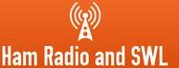
https://ra0sms.com/

Wi-Fi control console for antenna switches
Installation and setup guide

Specifications
Parameter | Value
Supply voltage | 5 to 45 V DC, depending on the voltage used in the antenna switch
Own current consumption | not more than 70 mA
Output current | up to 500 mA
Outputs | 8 outputs A1–A8; the output voltage is close to the supply voltage
Wi-Fi | 2.4 GHz only, range up to 50 m with an entry-level router
Case | 115 × 88 × 55 mm, ABS plastic, IP68, cable glands for 3–7 mm cable

Connections
- Screw terminals INPUT_VDC: power supply.
- Screw terminals OUT_TO_SWITCH: external antenna switch (pins 1–8: outputs, pin 9: GND).
- LED PWR: power is on. LED WIFI: connected to your Wi-Fi network. LEDs A1–A8: show which outputs are on.
After power-on all outputs are off. The previous state is not restored.

Default Wi-Fi settings
Parameter | Value
Console network name | RKconsole_XXXXXX, where XXXXXX is the unique number of the console
Password | 1234567890
Address on the console network | http://192.168.4.1
Address on your home network | http://rkconsole.local or the IP address assigned by your router

First start and connecting to your home network
Your router must have a 2.4 GHz network and DHCP enabled. Use any modern browser (Chrome, Firefox, Edge, Safari, Yandex). Internet Explorer is not supported.
- Power on the console and wait 5–10 seconds.
- On your phone or computer, connect to the Wi-Fi network RKconsole_XXXXXX with the password 1234567890.
- Most devices open the console page by themselves. If yours does not, open http://192.168.4.1 in a browser.
- Open the WiFi tab. The Available Networks list shows the networks found. Click your network to copy its name into the Network SSID field.
- Enter your network password in the Password field and press Connect. Your device may briefly lose connection to the console.
- After 10–20 seconds the WIFI LED lights up, and the WLAN Configuration section shows the IP address of the console on your network.
- Reconnect your device to your home network. The console is now available at http://rkconsole.local or at that IP address.
The address rkconsole.local works on Windows 10/11, macOS, iOS and Linux. Some Android devices cannot open it, so use the IP address there. You can also find the IP address in the list of DHCP clients of your router. To keep it from changing, reserve it for the console in the router settings.

Web interface
Tab | Address | Purpose
Home | / | connection status, uptime, firmware version
Switch | /switch | antenna switch mode: one output at a time
Toggle | /toggle | independent mode: several outputs at once
Labels | /label | names of the antennas
WiFi | /wifi | Wi-Fi settings

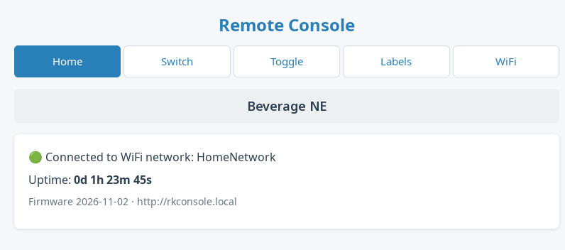

Switch and Toggle
The line at the top shows the antennas that are on. A green button means that the output is on. The page refreshes every 2 seconds, so changes made from another device appear by themselves. If the console cannot be reached, the line turns red and shows No connection to console.
Switch: pressing a button turns on this output and turns off all the others. Pressing the only active button again turns it off.
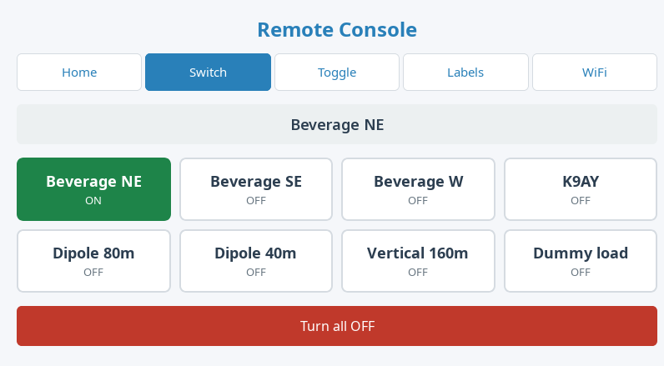
Toggle: each button turns its own output on or off, the other outputs do not change.
Turn all OFF turns off all outputs on both pages.
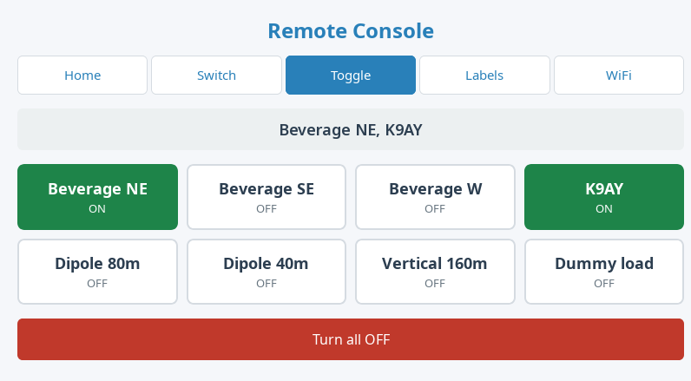

Labels
Each antenna can have its own name, up to 31 bytes: 31 Latin or about 15 Cyrillic letters. An empty field restores the default name (A1–A8). Press Save to store the names, Reset to restore all default names.
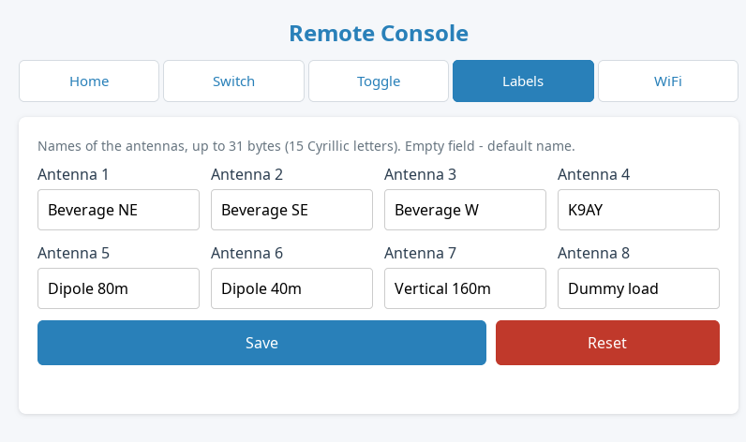

WiFi settings
- SoftAP Configuration: name, status and address of the access point of the console.
- Disable access point while connected to WLAN: by default the access point always stays on. With this option it turns off 30 seconds after the console connects to your network. It turns on again if the network is unavailable for 15 seconds, and it is always on after power-on until the connection is established.
- WLAN Configuration: saved network, connection status, IP address and signal level.
- Available Networks: networks found, sorted by signal level. Scan refreshes the list.
- Connect to Network: SSID up to 32 characters, password 8–64 characters (empty for an open network). To make the console forget the saved network, press Connect with an empty SSID.
If the network cannot be reached (router off, wrong password), the console retries every 60 seconds.
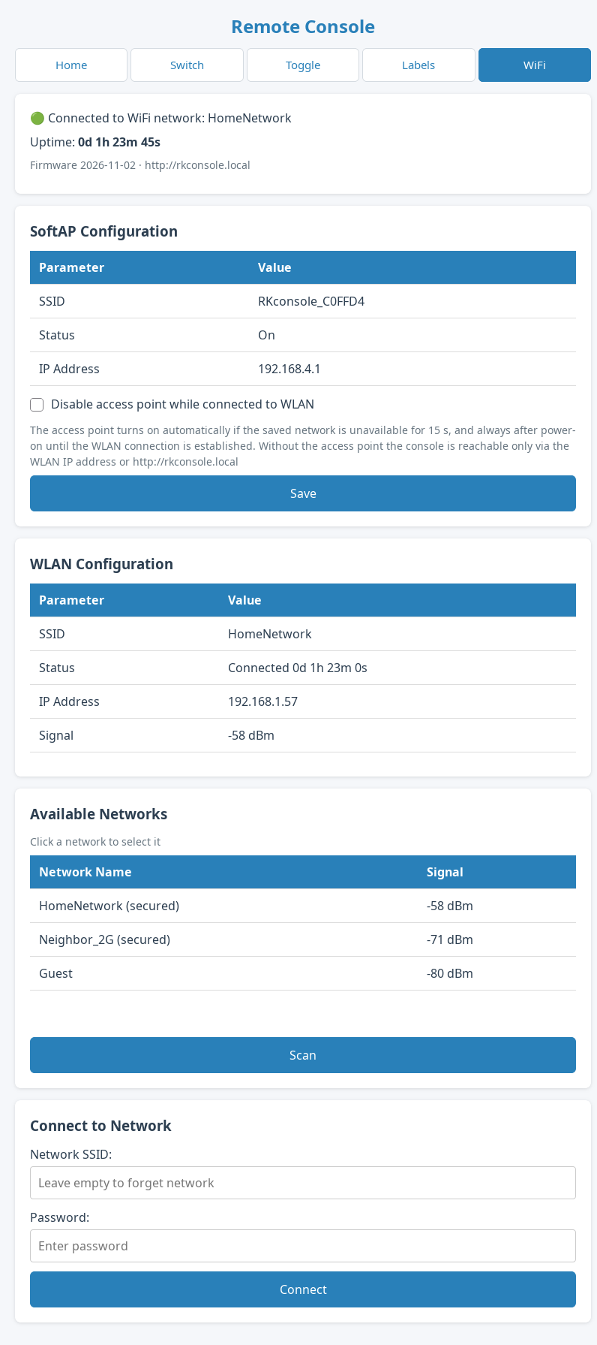

Control from scripts and logging software
Read the state: GET /api/state. Bit N of mask means that output N+1 is on.
{"mask":5,"labels":["A1","A2","A3","A4","A5","A6","A7","A8"]}
Change the state: POST /set. The response is the new state, an invalid value returns HTTP 400.
Parameter | Action
sel=0..7 | turn on only this output (0 = A1, 7 = A8), all others off
ch=0..7&on=0|1 | turn one output off or on, the others do not change
off=1 | turn all outputs off

curl -d "sel=2" http://rkconsole.local/set

Troubleshooting
Problem | What to do
Your network is not in the list | The console works on 2.4 GHz only. Enable a 2.4 GHz network on the router and press Scan.
WIFI LED stays off | Check the network name and password on the WiFi tab. Check that DHCP is enabled on the router.
rkconsole.local does not open | Use the IP address. It is shown on the WiFi tab and in the DHCP client list of the router.
No access after disabling the access point | Power-cycle the console and connect to RKconsole_XXXXXX: the access point is always on after power-on until the connection is established.

Schematic


