it SUPPORT INSTRUCTION
creating purchase requisitions

VERSION 1.0

2024

INTRODUCTORY PROVISIONS

GOALS
This instruction defines the procedure for an employee to follow providing advice on creating purchase requisitions.

TASKS
The main objectives of the instruction are:
- description of the steps to take when you need to create purchase requisitions.

PERIOD OF VALIDITY AND PROCEDURE FOR MAKING CHANGES
Changes to the instruction are made when new settings appear in the SOFTWARE, as well as when information on current settings is updated.
CREATING PURCHASE REQUISITIONS
Objective
After completing this lesson, you will be able to create a Purchase Requisition for Stock Item and Consumable Material
PURCHASE REQUISITIONS
As a long-term SAP user, you want to understand the usage of purchase requisitions in the purchase to pay business process as well as the usage of document types, item categories and account assignment for consumable items.
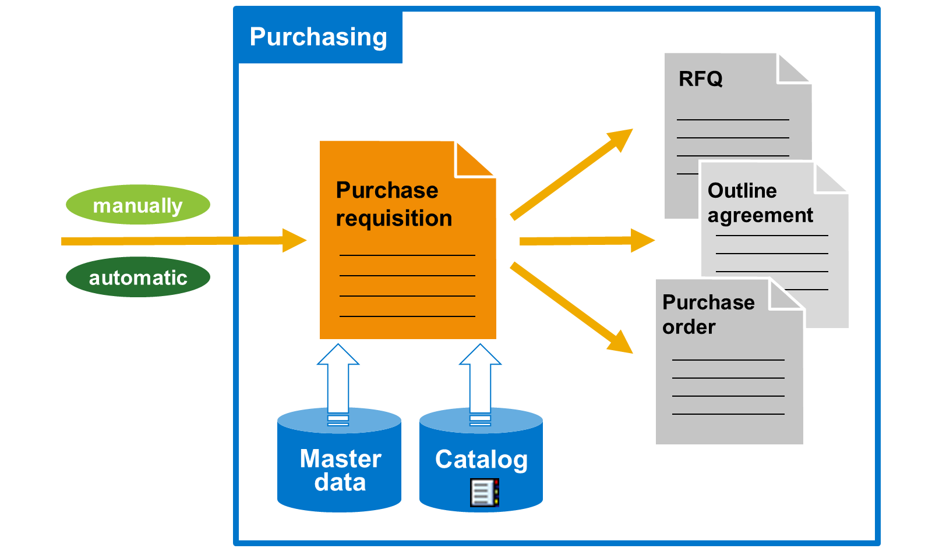
A purchase requisition is an internal document that the purchasing department uses to procure a particular quantity of a material or a service for a particular date.
A purchase requisition can be created directly or indirectly.
Directly
Directly means that a purchase requisition is created manually in the department that has the need. Whoever creates the purchase requisition determines which material or service in which quantity, and for which date have to be ordered.
Indirectly
Indirectly means that the purchase requisition from another component is created automatically. Purchase requisitions can be created automatically in the following ways:
- Material requirement planning (MRP)
- Maintenance orders
- Planned orders
- Networks
You can also initiate purchase requisitions from SAP Ariba.
When you create a purchase requisition for materials that have a material master record, the system transfers the data in the material master record to the purchase requisition. You also have the option to select items from a web-based catalog.
You can convert purchase requisitions into requests for quotations (RFQs), purchase orders (POs), or outline agreements.
Purchase Requisition Processing
ACCOUNT ASSIGNMENT OBJECTS
If you buy material, you procure it either for stock or for direct consumption.
You need to enter an account assignment for an item under the following circumstances:
- If you order a material that is not subject to value-based inventory management and post its value directly to consumption (pure consumable material)
- If you order an article that does not have a material master record
- If you order a service
If you want to procure a material as a consumable, you must specify an account assignment category and other account assignment data in the document item of the purchase requisition or purchasing document.
The account assignment category determines the account assignment object category that is to be charged. You must provide the account assignment data. The accounts are debited when the goods receipt or invoice is posted.
The following are the examples of account assignment objects:
- The account assignment object cost center (account assignment category K): When you make an account assignment to a cost center, you must enter the general ledger (G/L) account number of the consumption account. You must also enter the cost center for which the material will be procured on the account assignment data screen. You can specify that the system automatically proposes the number of the GL account to be charged in Customizing.
- The account assignment object asset (account assignment category A): If you use account assignment category A, you have to enter the asset number on the account assignment data screen. The system automatically determines the G/L account to charge based on the asset number you cannot enter manually.
PROCUREMENT FOR CONSUMPTION
When you procure a material directly for consumption, no material master record is necessary.
The characteristics of consumable materials with a master record are as follows:
- There is no value-based inventory management.
- The system automatically updates consumption in the material master record.
In SAP S/4HANA, the term "consumable material" is any material subject to procurement whose value is settled using cost element accounts or asset accounts. Therefore, a consumable material is procured directly for an account assignment object.
When procuring a consumable material without a material master record, you have to enter a short description, a material group, and a purchase order unit in the document manually. You have to do this because you cannot fetch this data from a master record. This is not true for a material with a master record. For these materials, the material type controls whether inventory management takes place on a value basis.
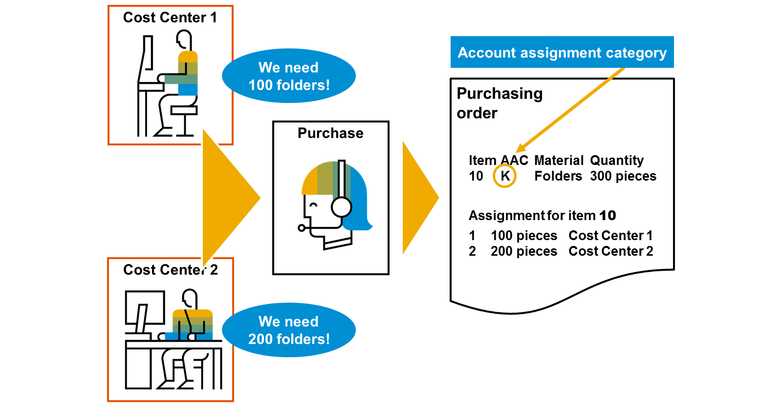
When you procure a consumable material, a material master record is not required, but can be used.
You can procure stock material for consumption. In all cases, you must specify an account assignment category and other dependent account assignment data, such as an account assignment object and a G/L account (consumption account). At the time of goods receipt or invoice receipt, the system debits the consumption account the purchase order specifies with the procurement value. Additionally, the system posts the amount to the account assignment object.
Creating a Purchase Requisition
A purchase requisition can be created from a MRP run. If a purchase requisition line item is a consumable for a cost object, then upon saving the purchase requisition, a commitment in Management Accounting is created. Please note: Commitment Management within Management Accounting needs to be activated.
Creating a Purchase Order
If a purchase order line item is a consumable for a cost object, then upon saving the purchase order, a commitment in Management Accounting is created. Please note: Commitment Management within Management Accounting needs to be activated.
Posting a Goods Receipt
When you save a goods receipt for stock materials, on hand inventory is increased.
If a change in material valuation occurred, then the system creates an accounting document in Financial Accounting.
If the purchase order was for consumable materials, the system not only creates an accounting document in Financial Accounting, but also creates a controlling document in Management Accounting and creates a document to update the Material Ledger.
If the organization is using Warehouse Management, then the system creates a transfer requirement.
Lastly, the system updates the purchase order history.
Posting an Invoice Receipt
When an invoice is posted, the system creates an accounting document, in Financial Accounting to record the liability owed to the vendor. The system, also creates an open item against the vendor’s account.
If the purchase order was for consumable materials, and the invoice amount differs from the purchase order amount, then the system creates a controlling document, in Management Accounting.
Outgoing Payment
When the outgoing payment is posted to the vendor, a Financial Accounting document is created. The open item against the vendor's account is cleared and our bank account pays the balance due. This can be performed manually or automatically.

