|  |
| --- |
| **it SUPPORT INSTRUCTION** |

**Trouble Shooting in Batch Determination**

VERSION 1.0

2024

INTRODUCTORY PROVISIONS

GOALS

This instruction defines the procedure for an employee to follow providing advice on trouble shooting in batch determination.

TASKS

The main objectives of the instruction are:

* description of the steps to take to trouble shooting in batch determination.

PERIOD OF VALIDITY AND PROCEDURE FOR MAKING CHANGES

Changes to the instruction are made when new settings appear in the SOFTWARE, as well as when information on current settings is updated.

**TROUBLE SHOOTING IN BATCH DETERMINATION**

**Purpose**

Get to know how to analyze the problem that occurs during batch determination.

**Overview**

**Batch determination is usually used in:**

* Inventory Management, like stock transfer order to determine the issuing batch of the issuing plant.
* Production process, like production order/process order to determine the issuing batch of the raw material during production.
* Sales process, like sales order and outbound delivery to determine the issuing batch of the goods that is ordered.
* Warehouse management.

**Analysis:**

**Main Screen of batch determination:**  
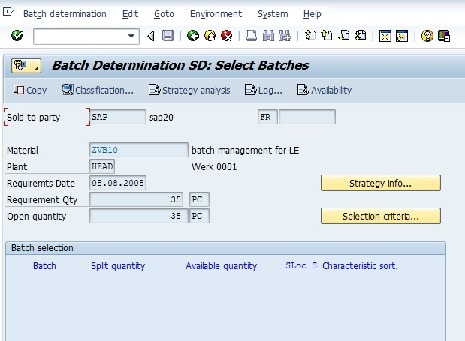

**Main mode of Batch determination:**

1. Automatically in background.
2. Manually in foreground.

**Mail problem during batch determination:**

1. The batch is not determined at all.
2. The determined batch is not desired.
3. The determined batch is correct but the split quantity is not correct.

**Normal Analysis process of batch determination:**

1. When there is a problem of the batch determination result, you first need to check if you can use manually batch determination in foreground, if you can, then trigger the batch determination manually with on-line process again to reach the main screen of batch determination. You need to aware that even if the batch determination carried out in badkground automatically, you still have the chance to repeat it on-line manually again. For example, in VL02N the processing of outbound delivery, the batch determination may happened already, but you still can go to the batch split view by clicking the "Batch Split" button and press the "Change Batch Determination" button to enter the main screen of the batch determination.
2. On the main screen of the batch determination, the batches that are listed in Batch selection section are the proposed sorted and selected batches, if the result here has a problem, then you need first checking the Log. On the main screen, click the "Log" button, there will be a popup:

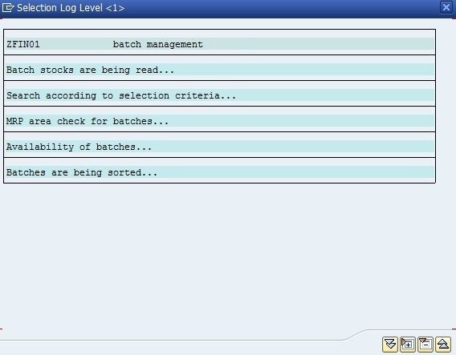

There is an "Expand" button, press it TWICE untill the list is expanded totally. On the expanded detail list, you will see the records of the whole batch determination process, there will be RED highlighted items, the cause of why certain batch is deleted at certain stage during the batch determination is clearly listed. From the records, you can see that, normally the batch stock selection will have no many problems as this step is to pick up all the related batches that has stocks unless there is stock determination involved. The problems normally occur at selection criteria stage and availability check stage, the batch you want to keep may be deleted but the batch you do not want to keep is kept wrongly.

1. If the problem occurs at selection criteria stage, then you need check the"Selection criteria", there will be another popup after you pressing this button, the charasteristics and characteristic values for the corresponding selection class of the batch search strategy will be shown in this popup. You can open another session and check the classification of the deleted batches in MSC3N to see if they do match the selection criteria you have defined.

But if the selection criteria on the "Selection criteria" popup is not the one you think it should be, then you need to analyze your batch search strategy. Press the "Strategy Analysis" button, you will enter another screen:

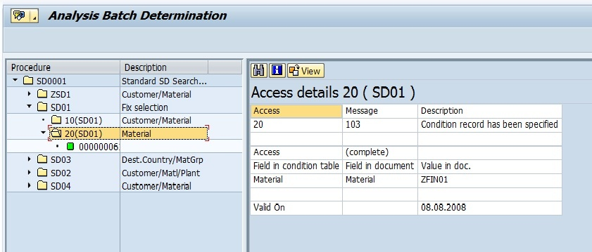

There wll be many strategy type and search strategy listed, you need to explode them to find one with GREEN traffic light, this is the search strategy used for this batch determination, it's easily to find out why this strategy will be used. In the Access details area, you can see what condition is considered when picking up this strategy, compare it with your real data, you may see normally the strategy is the only one qualified with the conditions. So if the search strategy or the selection class has a problem, then you may find the search condition from here and check if this is the reason of why certain batch is not selected, then you can adjust the characteristic value or the characteristic in the selection class, or adjust the batch classification data to make the batch picked by the batch determination process.

1. If the problem happens in "Availability", then you need to press the "Availability" button to goto the availability check screen. This is exactly the same with CO09, you can see why the picked out batch looks has stocks but deleted because of no enough stock. This is normally because that the whole batch stock or part of the batch stock is occupied by other orders or requirements, if you still hope this batch can be used, then you need to add more stockto this batch or release the stocks that are occupied by the other orders or requirements.
2. If the batch number and batch quantity are determined correctly by batch determination but only the sorting or the spliting of the selected batches has problem, then you need to check the details of the current batch search strategy, you can press the "Strategy info" button to check, in the new popup:

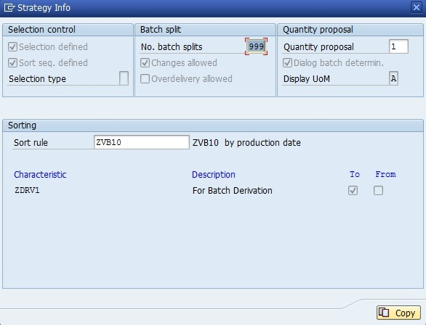

you can see how the batch spliting is defined and what is the sorting rule. You can manually sort the picked out batches base on the sort rule defined here, then you will see if the result is correct, normally, then problem is caused by the improper sort rule defination. You just need to adjust your sort rule to make it work.

**Related Transaction Code**

OCHA - Customizing  
MBC1/MBC2/MBC3 - Search strategy for inventory management  
COB1/COB2/COB3 - Search strategy for production/process order  
VCH1/VCH2/VCH3 - Search strategy for sales and distributions  
LS51/LS52/LS53 - Search strategy for warehouse management  
BMC1/BMC2/BMC3 - Maintain selection class  
CU70/CU71/CU72 - Maintain sorting rule