|  |
| --- |
| **it SUPPORT INSTRUCTION** |

**microphone FIX**

VERSION 1.0

INTRODUCTORY PROVISIONS

GOALS

This instruction defines the procedure for an employee to follow providing advice on fixing microphone parameters.

TASKS

The main objectives of the instruction are:

* description of the steps to take when microphone doesn’t work.

PERIOD OF VALIDITY AND PROCEDURE FOR MAKING CHANGES

Changes to the instruction are made when new settings appear in the SOFTWARE, as well as when information on current settings is updated.

If you are having trouble with your microphone features, or with the microphone on your headset or webcam, the following information can help you troubleshoot and resolve issues.

**CHECKING IF APPS HAVE ACCESS TO THE MICROPHONE**

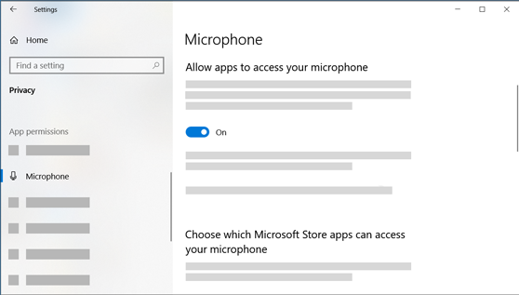

If your microphone isn't detected after updating Windows 11, you may need to give your apps permission to use it. Here's how:

1. Select **Start**> **Settings**> **Privacy & security**> **Microphone**and make sure **Microphone access**is turned on.
2. Make sure **Let apps access your microphone**is turned on, then choose which apps have access. Desktop apps won't appear in this list.

If you want to give access to desktop apps, make sure that **Let desktop apps access your microphone** is turned on. You can't turn off microphone access for individual apps.

If your camera contains a microphone, you might also need to give your apps permission to use your camera.  If so, select **Start**> **Settings**> **Privacy & security**> **Camera**and make sure **Camera**is turned on.