Intelligent Spam Filter
CSC 361 Artificial Intelligence Course Project Final Report
Project Type: Machine Learning Text Classification
Eyad alayed-445102058
Rayan Altasan - 445100846

1. Project Summary
This project implements an intelligent spam detection system that classifies email text as spam or not spam. The system uses supervised machine learning to learn patterns from a labeled dataset of email messages. The final application includes a trained model, a TF-IDF vectorizer, data visualizations, and a simple graphical user interface that allows users to test random samples or enter their own text for prediction.
The project fits the CSC 361 requirement because it focuses on an AI task rather than only a graphical interface. The main AI component is a text classification model trained to recognize spam-like language, word patterns, and message structure.

2. Motivation
Spam detection is an important real-world application of artificial intelligence. Email is widely used for communication, but unwanted spam messages can waste time, hide important messages, advertise scams, and sometimes expose users to fraud or harmful links. A manual approach to identifying spam is slow and unreliable, especially when the number of messages is large.
The motivation for this project is to build a small but practical AI system that can automatically detect suspicious email content. This gives the project a clear purpose: reducing unwanted messages by using machine learning to make predictions from text.

3. Background
Spam filtering is a common problem in natural language processing and machine learning. Since email messages are made of text, they must be converted into numerical features before a machine learning model can process them. One common approach is TF-IDF, which stands for term frequency-inverse document frequency. TF-IDF gives higher importance to words that are frequent in one message but less common across all messages.
After text is converted into features, a classification algorithm can be trained to predict whether each message belongs to the spam or not-spam class. This project uses Logistic Regression, a supervised learning algorithm that is often effective for binary classification problems such as spam detection.

4. Dataset
The dataset used in this project is stored in data/spam_or_not_spam.csv. It contains 3,000 labeled email records. The label 0 represents not spam, and the label 1 represents spam. The dataset contains 2,500 not-spam messages and 500 spam messages, so the data is imbalanced toward not-spam email.
Class | Meaning | Number of Records
0 | Not spam | 2,500
1 | Spam | 500
Total | All messages | 3,000

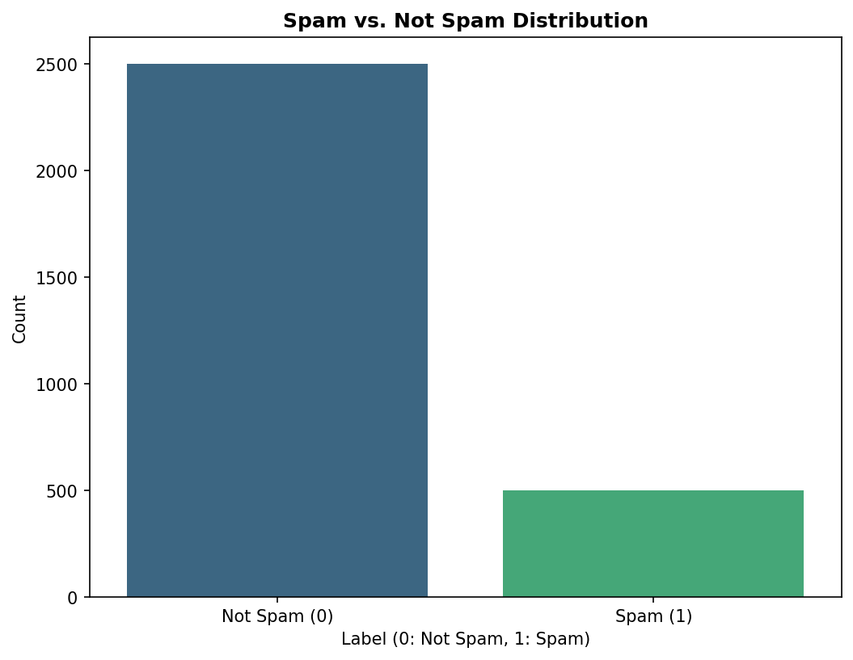
Figure 1. Distribution of spam and not-spam messages.

5. Proposed Approach
The system follows a standard supervised machine learning pipeline. First, the dataset is loaded and missing email values are handled by replacing them with empty strings. Next, the data is split into training and testing sets using an 80/20 split with stratification so that both classes remain represented in the test set.
The text is converted into numerical features using TF-IDF. The vectorizer is configured with a maximum of 5,000 features, English stop-word removal, and both unigram and bigram features. A Logistic Regression classifier is then trained on the vectorized training data. The class_weight='balanced' setting is used to reduce the effect of the class imbalance.
- Load and clean the labeled email dataset.
- Split the dataset into training and testing groups.
- Transform email text into TF-IDF features.
- Train a Logistic Regression classifier.
- Save the trained model and vectorizer as reusable joblib artifacts.
- Load the saved artifacts in the GUI and use them for prediction.

6. Implementation
The implementation is written in Python. The main training logic is located in src/training_code.py, the dataset loading class is in src/SpamNotSpamDataset.py, configuration paths are stored in src/config.py, and the graphical interface is implemented in src/gui.py.
The GUI allows the user to generate a random sample from the dataset, view its true label, enter or edit email text, and run the trained model. The prediction result is displayed as either SPAM or SAFE, along with a confidence value when probability output is available.
File or Folder | Purpose
data/ | Contains the email dataset and generated analytics images.
models/ | Contains the saved TF-IDF vectorizer and trained spam detector model.
src/training_code.py | Loads data, trains the model, evaluates it, and saves artifacts.
src/gui.py | Provides the Tkinter graphical interface for testing predictions.
src/plot.py | Generates analytics plots for data exploration.
run_gui.bat | Starts the GUI on Windows.

7. Results
The model was evaluated on a held-out test set of 600 email messages. The test set contained 500 not-spam messages and 100 spam messages. The classifier achieved an overall accuracy of 98.5 percent.
Metric | Not Spam (0) | Spam (1) | Overall
Precision | 0.986 | 0.979 | -
Recall | 0.996 | 0.930 | -
F1-score | 0.991 | 0.954 | -
Accuracy | - | - | 0.985

Actual Class | Predicted Not Spam | Predicted Spam
Not Spam | 498 | 2
Spam | 7 | 93

The confusion matrix shows that the model correctly classified 498 not-spam messages and 93 spam messages. It incorrectly marked 2 not-spam messages as spam and missed 7 spam messages by classifying them as not spam.
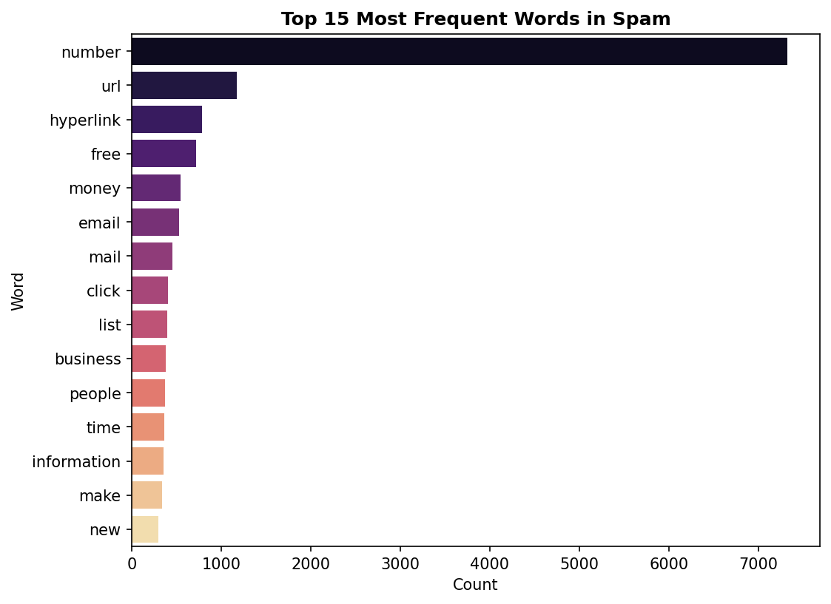
Figure 2. Common words found in spam messages.
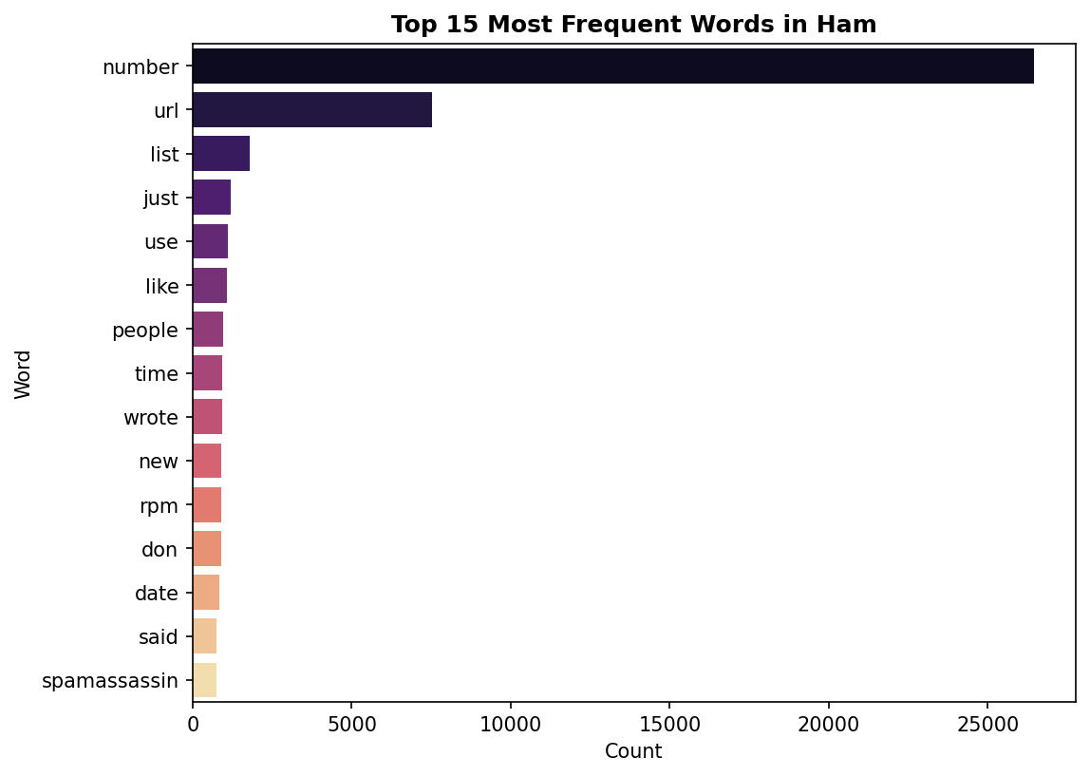
Figure 3. Common words found in not-spam messages.

8. Discussion
The results show that the TF-IDF and Logistic Regression approach performs very well on this dataset. The high precision for spam means that when the model predicts spam, it is usually correct. The spam recall of 0.930 means that most spam messages are found, although a small number are still missed.
One important limitation is that the dataset is imbalanced, with many more not-spam messages than spam messages. Although balanced class weights were used during training, the model may still perform differently on new real-world email data. Another limitation is that the project relies mainly on word patterns, so unusual spam messages or messages written in a different style may be harder to classify.

9. Conclusion
This project successfully demonstrates an AI-based spam detection system. It includes a supervised learning pipeline, trained model artifacts, data visualizations, and a user interface for testing predictions. The model achieved 98.5 percent accuracy on the test set, which indicates that the selected AI technique is effective for this dataset.
Future improvements could include testing additional models, adding more training data, improving preprocessing, showing more evaluation charts in the GUI, and adding support for live email input. Overall, the project satisfies the main AI implementation goal by building an intelligent artifact that performs automatic text classification.

10. References
- Project dataset: data/spam_or_not_spam.csv
- Scikit-learn documentation for TF-IDF vectorization and Logistic Regression
- CSC 361 Artificial Intelligence course project instructions

