**WIL Report Management System**

Software design

­­­

By

**Ms. Phinthip Samutloiwon 552115050**

**Mr. Veerapat In-ongkarn 562115055**

Department of Software Engineering

College of Arts, Media and Technology

Chiang Mai University

Project Advisor

**Dr. Prompong Sugunnasil**

# Chapter I | Introduction

# Purpose

# Scope

# Acronyms and Definition

# Chapter II | System Architecture

# Chapter III | Detailed design

## Class diagram

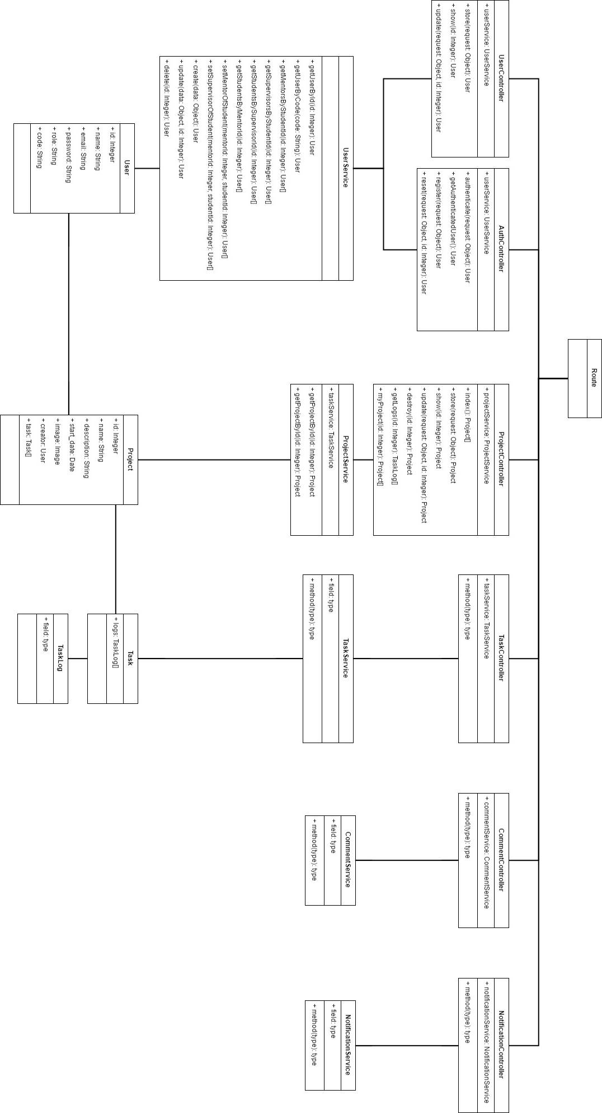

## **Class diagram description**

### **Users**

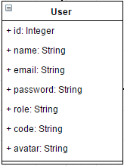

**Entities**

|  |  |  |  |
| --- | --- | --- | --- |
| **ID** | **Name** | **Description** | **Type** |
|  | id | Storing an id for identifying the user | Integer |
|  | name | Storing a name of the user | String |
|  | email | Storing an email of the user | String |
|  | password | Storing a password of the user | String |
|  | role | Storing the role of user | String |
|  | code | Storing the code of the user | String |
|  | avatar | Storing the path of profile image | String |

### **Project**

### **C:\Users\Dell\AppData\Local\Monosnap\Temp\Untitled Diagram.html - draw.io - Google Chrome 2017-03-09 23.22.58.png**

**Entities**

|  |  |  |  |
| --- | --- | --- | --- |
| **ID** | **Name** | **Description** | **Type** |
|  | id | Storing an id for identifying the project | Integer |
|  | name | Storing a name of the project | String |
|  | description | Storing description of the project | String |
|  | start_date | Storing the start date of the project | Date |
|  | image | Storing an image of the project | image |
|  | creator | Storing an creator name of the project | User |
|  | task | Storing list of tasks | Task array |

### **Task**

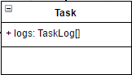

**Entities**

|  |  |  |  |
| --- | --- | --- | --- |
| **ID** | **Name** | **Description** | **Type** |
|  | logs | Storing the history of the task | TaskLog array |

### **TaskLog**

**Entities**

|  |  |  |  |
| --- | --- | --- | --- |
| **ID** | **Name** | **Description** | **Type** |
|  |  |  |  |

### **UserService**

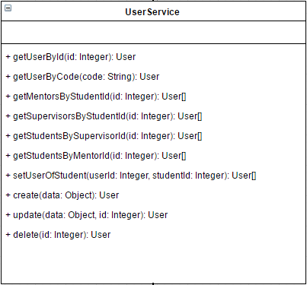

**Method Detail**

|  |  |  |  |
| --- | --- | --- | --- |
| **Method name** | **Description** | **Parameters** | **Return** |
| getUserById(id: Integer): User | This method uses for getting the id of user. | id: integer | User Object |
| getUserByCode(code: String): User | This method uses for getting the user object by the code of user | code: string | User Object |
| getMentorsByStudentId(id: Integer): User[] | This method uses for getting the list of mentors by the student ID | id: integer | User Array |
| getSupervisorsByStudentId(id: Integer): User[] | This method uses for getting the list of supervisors by the student ID | id: integer | User Array |
| getStudentsBySupervisorId(id: Integer): User[] | This method uses for getting the list of students by the supervisor ID | id: integer | User Array |
| getStudentsByMentorId(id: Integer): User[] | This method uses for getting the list of students by Mentor ID | id: integer | User Array |
| setUserOfStudent(userId: Integer, studentId: Integer): User[] | This method uses for matching mentor and supervisor with student by inputting user ID(mentor and supervisor) and Student ID | Userid: integer  studentId: integer | User Array |
| create(data: Object): User | This method uses for creating the user object. | data: Object | User Object |
| update(data: Object, id: Integer): User | This method uses for updating the user object. | data: Object  id: Integer | User Object |
| delete(id: Integer): User | This method uses for deleting the user object. | id : integer | User Object |

### **ProjectService**

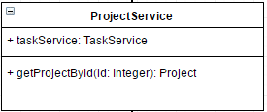

**Entities**

|  |  |  |  |
| --- | --- | --- | --- |
| **ID** | **Name** | **Description** | **Type** |
|  | taskService | Storing the task service in the project | TaskService Object |

**Method Detail**

|  |  |  |  |
| --- | --- | --- | --- |
| **Method name** | **Description** | **Parameters** | **Return** |
| getProjectById(id: Integer): Project | This method uses for getting the project object by id of the project. | id: integer | Project object |

### **TaskService**

**Entities**

|  |  |  |  |
| --- | --- | --- | --- |
| **ID** | **Name** | **Description** | **Type** |
|  |  |  |  |

**Method Detail**

|  |  |  |  |
| --- | --- | --- | --- |
| **Method name** | **Description** | **Parameters** | **Return** |
|  |  |  |  |

### **CommentService**

**Entities**

|  |  |  |  |
| --- | --- | --- | --- |
| **ID** | **Name** | **Description** | **Type** |
|  |  |  |  |

**Method Detail**

|  |  |  |  |
| --- | --- | --- | --- |
| **Method name** | **Description** | **Parameters** | **Return** |
|  |  |  |  |

### **NotificationService**

**Entities**

|  |  |  |  |
| --- | --- | --- | --- |
| **ID** | **Name** | **Description** | **Type** |
|  |  |  |  |

**Method Detail**

|  |  |  |  |
| --- | --- | --- | --- |
| **Method name** | **Description** | **Parameters** | **Return** |
|  |  |  |  |

### **UserController**

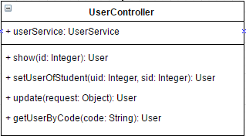

**Entities**

|  |  |  |  |
| --- | --- | --- | --- |
| **ID** | **Name** | **Description** | **Type** |
|  | userService | Object of userService, it uses to manage the user object by calling methods from userService class. | UserService Object |

**Method Detail**

|  |  |  |  |
| --- | --- | --- | --- |
| **Method name** | **Description** | **Parameters** | **Return** |
| show(id: Integer): User | This method uses for displaying the user object. | Id: the id of user | User Object |
| update(request: Object): User | This method uses for updating the new data of the user. | request: the object which contains the input data from user | User Object |
| getUserByCode(code: String): User | This method uses to get the user object by inputting the code of supervisor or mentor. | Code: the code of mentor or supervisor | User Object |
| setUserOfStudent(uid: Integer, sid: Integer): User | This method uses to set the mentor and supervisor of the student. | uid: the mentor and supervisor id  sid: the student id | User Object |

### **AuthController**

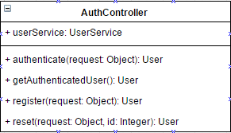

**Entities**

|  |  |  |  |
| --- | --- | --- | --- |
| **ID** | **Name** | **Description** | **Type** |
|  | userService | Object of userService, it uses to manage the user object by calling methods from userService class. | UserService Object |

**Method Detail**

|  |  |  |  |
| --- | --- | --- | --- |
| **Method name** | **Description** | **Parameters** | **Return** |
| authenticate(request: Object): User | This method uses for receiving username and password from ‘request object’, then find the use from database. | request | User Object |
| getAuthenticatedUser(): User | This method uses for getting the authenticated user object | - | User Object |
| register(request: Object): User | This method uses to receive the user information which called ‘request’, then create the user object in the database. | request | User Object |
| reset(request: Object, id: Integer): User | This method uses to reset the password. | request: Object | User Object |

### **ProjectController**

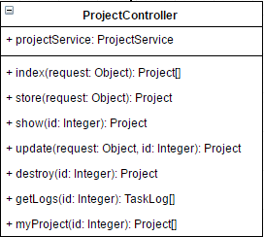

**Entities**

|  |  |  |  |
| --- | --- | --- | --- |
| **ID** | **Name** | **Description** | **Type** |
|  | projectService | Object of projectService, it uses to manage the project object by calling methods from projectService class. | ProjectService Object |

**Method Detail**

|  |  |  |  |
| --- | --- | --- | --- |
| **Method name** | **Description** | **Parameters** | **Return** |
| index(request: Object): Project[] | This method uses to get all project lists of the user. | request: the object which contain the owner data. | Project Array |
| store(request: Object): Project | This method uses to store the project data which called ‘request’ object in the database. | request: Object | Project Object |
| show(id: Integer): Project | This method uses to display the project object data which are project name, project description, start date, image, creator name, and tasks. | id: integer | Project Object |
| update(request: Object, id: Integer): Project | This method uses to update the project object data. | request: Object  id: integer | Project Object |
| destroy(id: Integer): Project | This method uses to remove the project object. | id: integer | Project Object |
| getLogs(id: Integer): TaskLog[] | This method uses to get the history of tasks. | id: integer | TaskLog Array |
| myProject(id: Integer): Project[] | This project uses to get the list of the projects of the owner. | id: integer | Project Array |

### **TaskController**

### **CommentController**

### **NotificationController**

## Sequence diagram

### 3.3.1 Feature 1

### 3.3.2 Feature 2

### 3.3.3 Feature 3

### 3.3.4 Feature 4

# Chapter IV | UI Design