**WIL Report Management System**

Project Proposal

­­­

By

**Ms. Phinthip Samutloiwon 552115050**

**Mr. Veerapat In-ongkarn 562115055**

Department of Software Engineering

College of Arts, Media and Technology

Chiang Mai University

Project Advisor

**Dr. Prompong Sugunnasil**

**Document History**

|  |  |  |  |  |  |  |  |
| --- | --- | --- | --- | --- | --- | --- | --- |
| **Document Name** | **Version** | **Status** | | **Date** | **Viewable** | **Reviewer** | **Responsible** |
| **Documents** | | | | | | | |
| WIL project-based report System Proposal_V.0.1.docx | - Add Chapter 1   - Introduction & Background - Add Chapter 2  - Literature Review  - Business Review  - Business Tools   - Software review  - Technology Review  - Development Tool Review - Add Chapter 3  - Quality Standards - Add Chapter 4  - Project Plan  - Motivation  - Aims and Objectives  - Software Architecture  - Deliverables and Limits  - Schedule & Milestones - Add Chapter 5  - References   - Add Abstract | | Draft | 10-01-2017 | PS,VI | PS,VI | PS,VI |
| WIL project-based report System Proposal_V.0.2.docx | - Adjust Chapter 4  - Project Plan  - Aims and Objectives  - Deliverables and Limits - Add Chapter 3  - Quality Standards | | Draft | 15-01-2017 | PS,VI | PS,VI | PS,VI |
| WIL project-based report System Proposal_V.0.3.docx | - Add Chapter 2  - Literature Review  - Business Review  - Business Tools | | Draft | 20-01-2017 | PS,VI | PS,VI | PS,VI |
| WIL project-based report System Proposal_V.0.4.docx | - Add Chapter 2  - Software review  - Technology Review | | Draft | 23-01-2017 | PS,VI | PS,VI | PS,VI |
| WIL project-based report System Proposal_V.0.5.docx | - Add Chapter 2  - Technology Review  - Development Tool Review | | Draft | 25-01-2017 | PS,VI | PS,VI | PS,VI |
| WIL project-based report System Proposal_V.0.6.docx | - Add Chapter 4  - Project Plan  - Motivation  - Aims and Objectives  - Software Architecture  - Deliverables and Limits  - Schedule & Milestones | | Draft | 26-01-2017 | PS,VI | PS,VI | PS,VI |
| WIL project-based report System Proposal_V.0.7.docx | - Add Chapter 1   - Introduction & Background | | Draft | 27-01-2017 | PS,VI | PS,VI | PS,VI |
| WIL project-based report System Proposal_V.0.8.docx | - Add Chapter 5  - References | | Draft | 28-01-2017 | PS,VI | PS,VI | PS,VI |
| WIL project-based report System Proposal_V.0.9.docx | - Add Chapter 2  - Business Review  - Business Tools   - Software review  - Technology Review  - Development Tool Review | | Draft | 29-01-2017 |  |  |  |

**\*PS = Phinthip Samutloiwon  
*VI = Veerapat In-ongkarn  
*PSU= Prompong Sugunnasil**

# **Abstract**

**Table of Contents**

Abstract 3

Chapter One| Introduction and Background 5

Chapter Two | Literature Review 6

2.1 Business Review 6

2.2 Business Tools and Software Review 7

2.3 Technology Review 11

2.4 Development Tool Review 18

Chapter Three | Quality Standard 20

3.1 ISO29110 for Very Small Entity (VSE) 20

3.1.1 Project Management process 20

3.1.2 Software Implementation process 20

Chapter Four | Project Plan 21

4.1 Motivation 21

4.2 Aims and Objectives 21

4.3 Software architecture 22

4.4 Deliverables and Limits 23

Chapter Five | References 27

# **Chapter One| Introduction and Background**

Many documentations have to be done in the final year of studying for WIL 8 months internship program. In this year, there are three documentation have to be delivered, which are senior project documentation, weekly report, and corporative learning report. The weekly report seems to be the simplest in those documentation. It is free-style writing which students have to report what they did in each week. However, Mentors and supervisor have to comments in each week as well. Normally, the students write what they have done in each week. They print it out. After that they give it to mentors, and then supervisor. It takes a lot time which is inefficient.

The aim of this project was to create a web application for creating WIL weekly report on project-based. The system shall create English sentences based on tasks of projects as well as display the statistics and time line of tasks. The export file follows the template of WIL report. The project combines the project management with report export system. It helps users for less workload, less time consume, and less effort. In other words, it is easier, more convenient, and more efficiency.

# **Chapter Two | Literature Review**

This chapter consist of business review of project-based WIL report System, business tools and software review on three web applications which similar to this project. In addition, there are seven types of technologies review, and two types of development tools review.

## **Business Review**

**Overview**

Project-based WIL report system is a web application for 8 months SE intern students, stakeholder, and supervisors. Students are able to create weekly and monthly reports for WIL center. Mentors and supervisors are able to give comments to each week or months depending on report type. All users are able to view the statistics of each task label, tasks board, and reports. The report will be generated in full sentences and follow the WIL report form. The application is only available in English.

This part should emphasis some technical requirements of the project which we will discuss in the technology review. For example, the web application should be responsive. So, the user can open and write their report anywhere.

**Target**

The primary target users of this project are SE students, mentors, and supervisors who involve in WIL 8 months internship. The main target of this web application are to create a report for WIL center. The report will be described in English sentences which similar to natural language.

**Benefit**

* Students are convenient to create a report for WIL center.
* Students are able to view tasks statistics and grant chart of all projects.
* Mentors and supervisors are convenient to comment on weekly reports.

## **Business Tools and Software Review**

**2.2.1 Zoho: The operating system for business (**[**https://zoho.com**](https://zoho.com)**)**

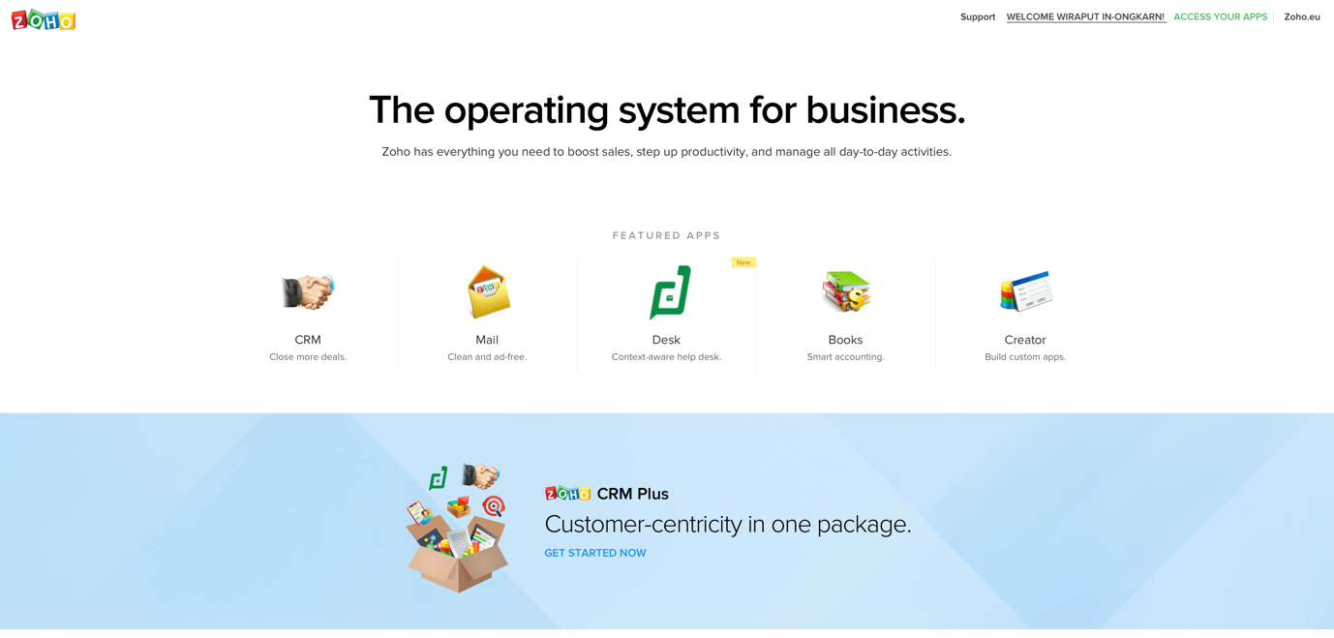

Figure 1 Home page of Zoho

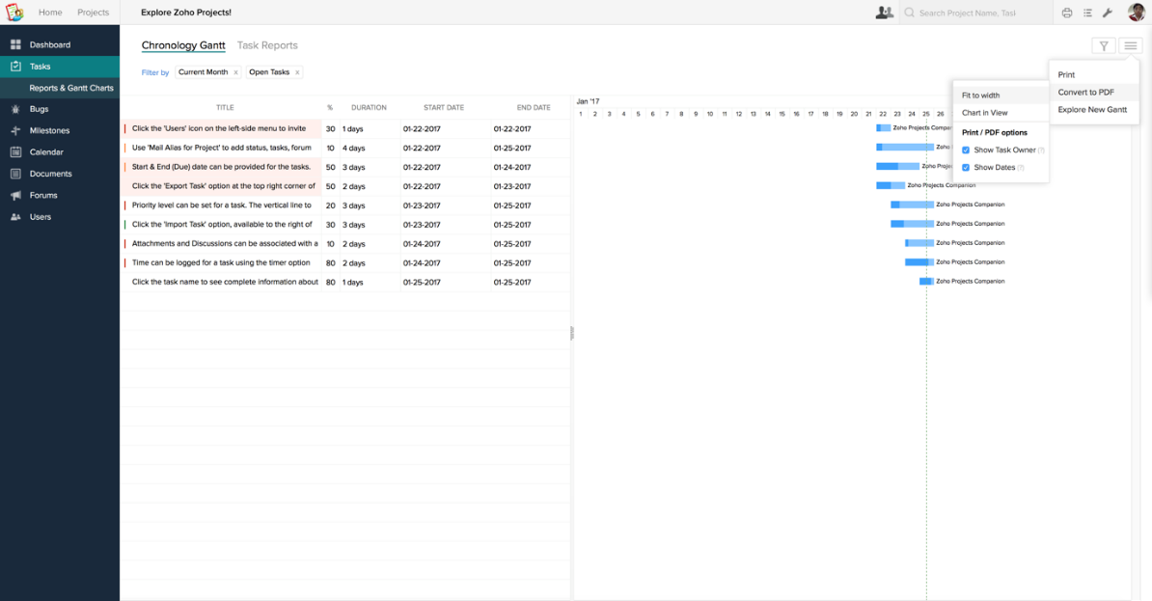

Figure 2 Tasks report of Zoho

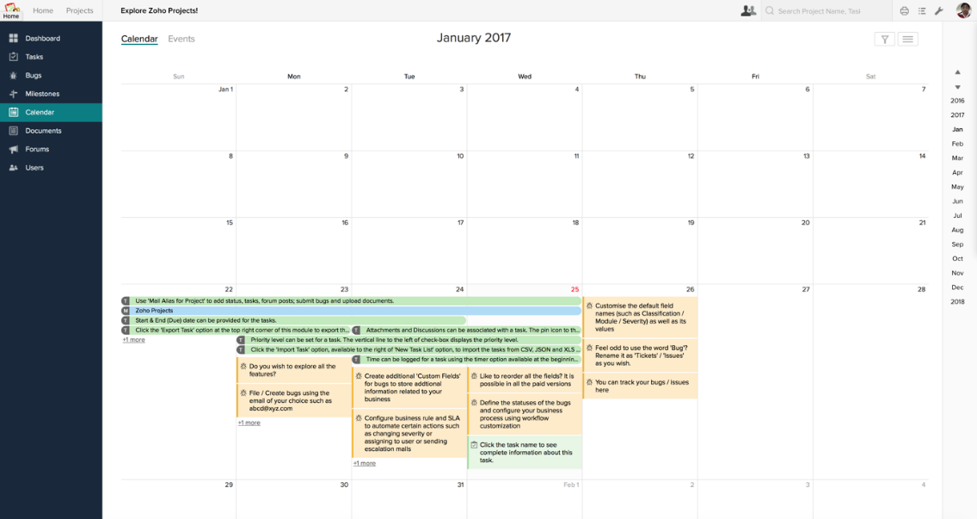

Figure 3 Calendar of Zoho

Zoho is software to solve business problems. Over the past decade, the Zoho suite has emerged to be a leader in the cloud and on your devices. They invest more in product development and customer support than in sales and marketing. In an industry where technology changes at a relentless and dizzying pace, Zoho value persistence and endurance as highly as adaptability. [1]

**Advantages**

**Disadvantages**

**2.2.2 Aceproject (**[**https://aceproject.com**](https://aceproject.com)**)**

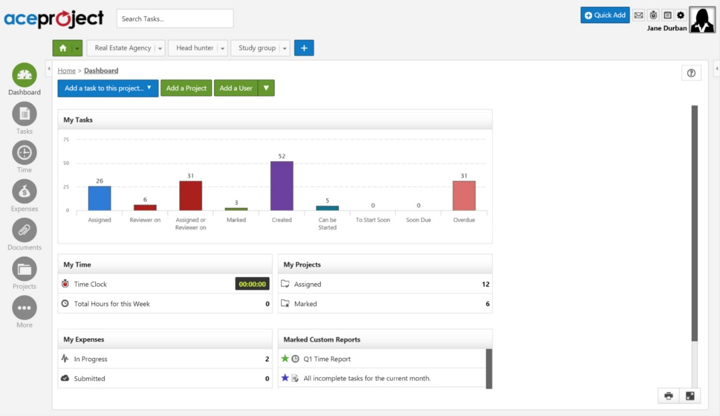

Figure 4 Dashboard of aceproject

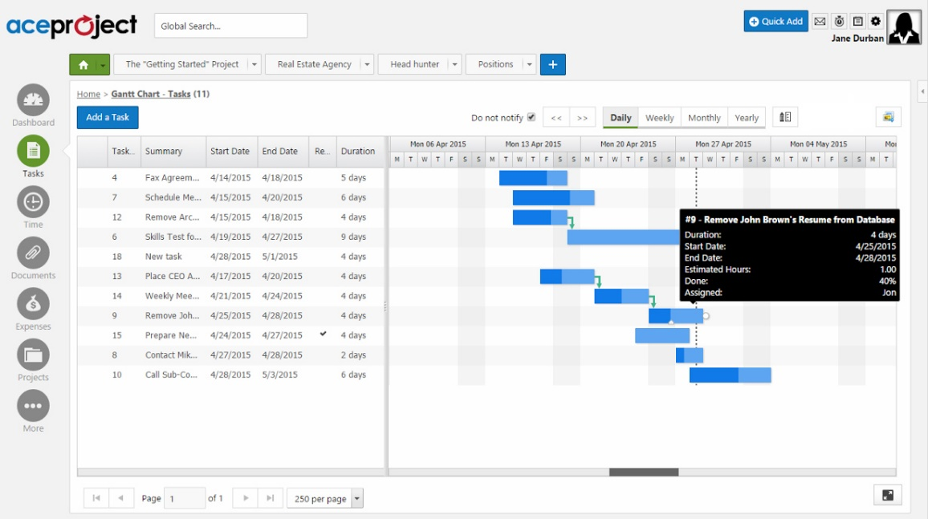

Figure 5 Gantt chart of aceproject

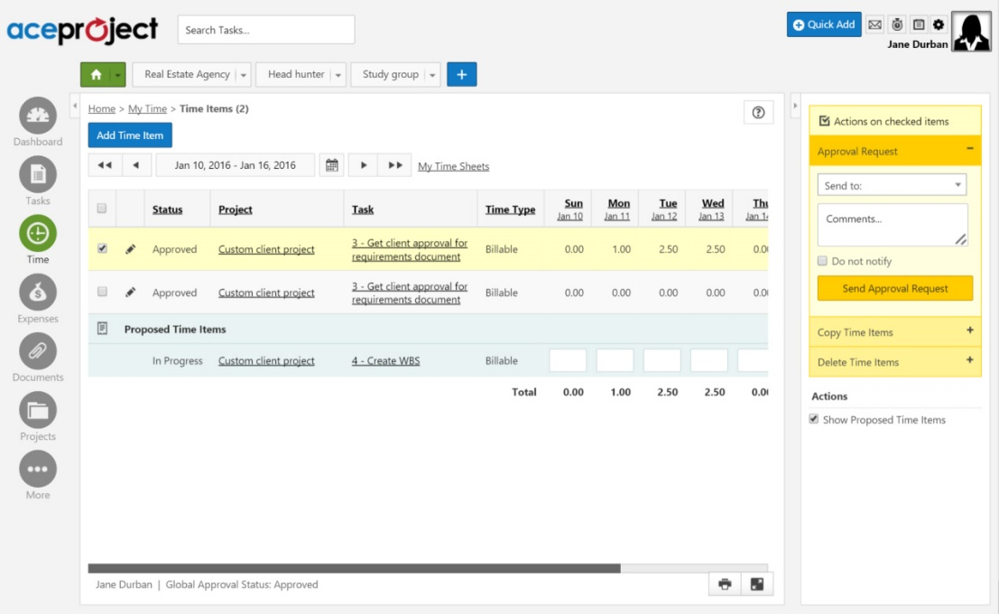

Figure 6 Timesheet of aceproject

AceProject is a web-based application that contains tasks management, timesheets, documents, and expenses for simple-to-intermediate project management. They provide an intuitive and simplified user experience. They also provide dynamically place, modify task dates, and set dependencies between tasks. Gantt charts allow a way to visually interact with your tasks with the ability to modify the progression. Time tracking functionality is included. Moreover, users stay connect to application through email notification. [2]

**Advantages**

**Disadvantages**

## **Technology Review**

**2.3.1 HTML5**



Figure 7 HTML5 logo

**Technology Detail**

HTML5 is a markup language used for structuring and presenting content on the World Wide Web. It is the fifth and current version of the HTML standard. It includes detailed processing models to encourage more interoperable implementations; it extends, improves and rationalizes the markup available for documents, and introduces markup and application programming interfaces (APIs) for complex web applications. For the same reasons, HTML5 is also a candidate for cross-platform mobile applications, because it includes features designed with low-powered devices in mind. Furthermore, HTML5 contains powerful capabilities for Web-based applications with more powerful interaction, video support, graphics, more styling effects, and a full set of APIs. HTML5 adapts to any device, whether desktop, mobile, tablet, or television. HTML5 is an open platform developed under royalty free licensing terms. [3] [4]

**Alternative Technology**

* XHTML 2.0

**The selection of this technology**

HTML5 is the next HTML standard. All new HTML features will be added there, and we'll have to use it eventually if we want to take advantage of them. [5] It is the main tool of website development which browsers are able read and support.

**2.3.2 CSS3**



Figure 8 CSS3 logo

**Technology Detail**

CSS3 is the latest standard for CSS. It is completely backwards-compatible with earlier versions of CSS. It contains the "old CSS specification" (which has been split into smaller pieces). In addition, new modules are added. [6] CSS most often separate the structure from the content and instead of separating the presentation from the structure. The style includes colors, fonts, layout, and other. [7]

**Alternative Technology**

No alternative technology [8]

**The selection of this technology**

CSS3 allows to specify the virtual elements of the website. All style have to set only in one file which is convenient and fast. In addition, we use less code in CSS which affect to performance of the website. The page will load faster.

**2.3.3 JavaScript**



Figure 9 JavaScript logo

**Technology Detail**

JavaScript is the programming language of HTML and the Web which used to make web pages interactive.[9] [10] On other words, it is a high-level, dynamic, untyped, and interpreted programming language. It is one of the three core technologies of World Wide Web content production. The majority of websites employ it, and all modern Web browsers support it without the need for plug-ins. [11] It runs on the visitor's computer and doesn't require constant downloads from your website. [10]

**Alternative Technology**

1. CoffeScript

2. TypeScript

3. Babel

**The selection of this technology**

JavaScript is allows to make things happen in the user's browser without sending messages back and forth to the server. It used alongside HTML in the browser, which is able to add some dynamic and interactive features.  [12] Furthermore, JavaScript is simple to learn. The syntax is not complicated and there are prewritten functionalities, which pay less effort for scripting.

**2.3.4 Angular2**



Figure 10 Angular 2 logo

**Technology Detail**

Angular 2 is the new improved version of AngularJS. It improves many of its existing parts in AngularJS and promotes a component based architecture while leveraging new features of ES2015 (or TypeScript) like classes and modules. In addition, it condenses the number of concepts within the framework into a more cohesive unit with less redundant components. For example, unifying services and factories, and providing a much better way to create components and directives. [13] [14]

**Alternative Technology**

1. AngularJS

2. EMBER.JS

**The selection of this technology**

Angular 2 emphasize on binding-data. It divides code into component, service, view which the developers can see the code in clearly concept. Moreover, there are many plugin support for example; Angular CLI – generating file, building, testing project through command line.

**2.3.5 JQuery**



Figure 11 jQuery logo

**Technology Detail**

jQuery is a cross-platform JavaScript library designed to simplify the client-side scripting of HTML. It is a fast, small, and feature-rich JavaScript library which makes things like HTML document traversal and manipulation, event handling, animation, and Ajax much simpler with an easy-to-use API that works across a multitude of browsers. It is free, open-source software licensed under the MIT License. [15] [16]

**Alternative Technology**

* No alternative technology

**The selection of this technology**

There are variety plugin supported. jQuery is famous for managing DOM and quick response of client and elements which is well fulfil the disadvantages of Angular2.

**2.3.6 Laravel**



Figure 12 Laravel logo

**Technology Detail**

Laravel is a MVC framework with bundles, migrations, and Artisan CLI. Laravel offers a robust set of tools and an application architecture that incorporates many of the best features of frameworks like CodeIgniter, Yii, ASP.NET MVC, Ruby on Rails, Sinatra, and others. It is an Open Source framework and has a very rich set of features which will boost the speed of Web Development. Laravel will make the task easier and save a lot time for developing a website from scratch. Not only that, the website built in Laravel is also secure. It prevents the various attacks that can take place on websites. [17] [18]

**Alternative Technology** [19]

1. Zend 2
2. Symfony
3. CakePHP
4. CodeIgniter
5. Yii

**The selection of this technology**

Laravel is popular PHP framework. It has many plugin supported as well as authentication system supports. There are Eloquent ORM for managing model, and relation from database which does not follow sql commands.

**2.3.7 MySQL**



Figure 13 MySQL logo

**Technology Detail**

MySQL is a fast, easy-to-use RDBMS being used for many small and big businesses. It is developed, marketed, and supported by MySQL AB, which is a Swedish company. It is an open-source license and very powerful program in its own right. It handles a large subset of the functionality of the most expensive and powerful database packages. [20] MySQL is also used in many high-profile, large-scale websites, including Google (though not for searches), Facebook, Twitter, Flickr, and YouTube. [21]

**Alternative Technology** [22]

1. MariaDB
2. PostgreSQL
3. SQLite

**The selection of this technology**

The installation of MySQL is simple. It is also very friendly to php and no charge. In addition, it uses a standard form of the well-known SQL data language.

## **Development Tool Review**

**2.4.1 Atom**



Figure 14 Atom logo

**Technology Detail**

Atom is a free and open-sourcentext and source code editor for macOS, Linux, and Windows with support for plug-ins written in Node.js, and embedded Git Control, developed by GitHub. Atom is a desktop application built using web technologies. Most of the extending packages have free software licenses and are community-built and maintained. Atom is based on Electron (formerly known as Atom Shell), a framework that enables cross-platform desktop applications using Chromium and Node.js. It is written in CoffeeScript and Less. It can also be used as an integrated development environment (IDE). [23]

**Alternative Technology** [24]

1. Notepad++
2. Sublime
3. Visual Code Studio
4. Vim

**The selection of this technology**

Atom is an open source software which has small size. It contains many extension plugin.

**2.4.2 phpmyadmin**



Figure 15 phpmyadmin logo

**Technology Detail**

phpMyAdmin is a free and open source tool written in PHP intended to handle the administration of MySQL or MariaDB with the use of a web browser. It can perform various tasks such as creating, modifying or deleting databases, tables, fields or rows; executing SQL statements; or managing users and permissions. [25]

**Alternative Technology**

* No alternative technology

**The selection of this technology**

Phpmyadmin is simple for installation and manage hosting environment. We can access to the database easily in any computer because it work by web-based.

# **Chapter Three | Quality Standard**

## **3.1 ISO29110 for Very Small Entity (VSE)**

ISO29110 is the Software Life Cycle Profiles and Guidelines for Very Small Entities (VSEs) standards and technical reports are targeted at Very Small Entities (VSEs). A Very Small Entity (VSE) is an enterprise, organization, department or project having up to 25 people. ISO 29110 concerns on project management process and software implementation process.

### **Project Management process**

The purpose of the Project Management process is to establish and carry out in a systematic way the tasks of the software implementation project, which allows complying with the project’s objectives in the expected quality, time and cost. There are 4 activities as following:

1. Project Planning Process
2. Project Plan Execution Process
3. Project Assessment and Control Process
4. Project Closer Process

### **Software Implementation process**

The purpose of the Software Implementation process is the systematic performance of the analysis, design, construction, integration and tests activities for new or modified software products according to the specified requirements. There are 6 activities as following:

1. Software Implementation Initiation Process
2. Software Requirements Analysis Process
3. Software Architectural and Detailed Design Process
4. Software Construction Process
5. Software Integration and Test Process
6. Software Delivery Process

# **Chapter Four | Project Plan**

## **4.1 Motivation**

WIL 8 months internship program requires 3 documentations; weekly report, senior project, internship projects report. It was a hard time to work after day end. During a busy time, you could forget to fill up your weekly task in a report. It would be difficult on next week to recall your memory what have you done. The weekly report is not difficult to create, but it requires routine write. Moreover, Mentors and Supervisors have to give comments and feedback on weekly report. It takes time and inefficient to wait their comments and pass them a paper of weekly report in every week. In addition, usually record their task and activities as a project. It called project-based report.

The documents are important for students, therefore recording efficiency becomes to the main a significant method. It would be a big challenge to make a tool which helps increasing workload productivity.

## **4.2 Aims and Objectives**

**4.2.1 Aims**

The aim of this project is to develop a web application which helps WIL students to manage tasks and export WIL reports. The system eliminates the complicated steps, makes a systematic steps of creating report, and saves times.

**4.2.2 Objectives**

**The objective is to develop a web application using tools SDLC…… The web application must deliver the following features**

**…….**

## **4.3 Software architecture**

  

Students Mentor Supervisor

  

Internet browser

Socket Transfering data



Transfering data

 

Cloud Server

Figure 16 Software Architecture

## **4.4 Deliverables and Limits**

**4.4.1 Deliverables**

**1. Features:**

**Feature #1: Login and Logout**

1.1. Users can login into the system.

1.2. Users can logout from the system.

**Feature #2: Task management**

2.1. Users (Students, Mentor, Supervisor) can view activities of a project.

2.2. Students can add activities of a project.

2.3. Students can edit activities of a project.

2.4. Students can delete activities of a project.

2.5. Mentor can view comments in student’s report.

2.6. Mentor can add comments in student’s report.

2.7. Mentor can edit comments in student’s report.

2.8. Mentor can delete comments in student’s report.

**Feature #3: Document export**

3.1. Users can view a daily report.

3.2. Users can view weekly report.

3.3. Users can view monthly report.

3.5. Users can generate a printable file of daily report.

3.6. Users can generate a printable file weekly report.

3.7. Users can generate a printable file monthly report.

**Feature #4: Web and Email notification**

4.1. Users can receive activities notification message via Web application.

4.2. Users can receive activities receive notification message via email.

**2. Documents and other material**

2.1. Proposal

2.2. Project plan

2.3. Quality plan

2.4. Software requirement specification

2.5. Traceability record

2.6. Software design document

2.7. Testing document

2.8. Test plan

2.9. Unit test report

2.10. System Test report

2.11. 1 CD-ROM stores all source code; relate file, all documents and poster files in PDF format.

**4.5 Schedule and Milestone**

**4.5.1 Software Process**

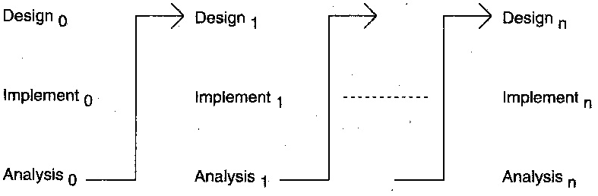

Figure 17 The iterative model

The iterative development process model combines the benefits of Prototyping and Waterfall model. The basic idea is that the software is developed in increments, each increment adding some functional capability to the system until the full system is implemented.[26] This model does not attempt to start with full specification of requirements.[27] Instead, development begins by specifying and implementing just part of the software, which is then reviewed in order to identify further requirements. This process is then repeated, producing a new version of the software at the end of each iteration of the model.[28]

The reasons we selected this models are that some functionalities can be early and fast developed in the software life cycle. As we mention above, this model does not required full specification of requirements, so that we create a high level design before building and designing an entire system. Later on, we design and built a structure and design based on what we had built. Furthermore, we are able to build and improve the system step by step to avoid the defects at early stages.

**4.5.2 Schedule plan**

There are 4 phases to develop this project:

1.) Proposal phase: creating proposal document

2.) 1st progress phase: deliver some features and documentation

Feature #1: Login and logout

Feature #2: Task management

Creating Development plan, Quality plan, Software Requirement Specification (SRS), Software Design Document (SDD) and some part of Test document.

3.) 2nd progress phase

Feature #3: Document export

Feature #4: Web and Email notification

80% of the overall system is done. Some features are integrated. Test document is continue.

4.) 3rd progress phase

The system is completed. All documents is done.

**4.5.2 Milestone**

// gantt chart

# **Chapter Five | References**

|  |  |
| --- | --- |
| [1] | Zoho, "About me," Zoho, [Online]. Available: https://www.zoho.com/aboutus.html. [Accessed 26 1 2017]. |
| [2] | aceproject, "ACEPROJECT," aceproject, [Online]. Available: http://www.aceproject.com/tour/. [Accessed 26 1 2017]. |
| [3] | Wikipedia, "HTML5," [Online]. Available: https://en.wikipedia.org/wiki/HTML5. [Accessed 26 1 2017]. |
| [4] | W3C, "FAQs," 7 12 2012. [Online]. Available: https://www.w3.org/html/wiki/FAQs. [Accessed 28 1 2017]. |
| [5] | Mediawiki, "HTML5," 15 5 2016. [Online]. Available: https://www.mediawiki.org/wiki/HTML5. [Accessed 28 1 2017]. |
| [6] | w3schools, "CSS3 Introduction," [Online]. Available: http://www.w3schools.com/css/css3_intro.asp. [Accessed 28 1 2017]. |
| [7] | Wikipedia, "CSS," 16 1 2017. [Online]. Available: https://en.wikipedia.org/wiki/Cascading_Style_Sheets. [Accessed 28 1 2017]. |
| [8] | Stacoverflow, "Is there an alternative to CSS?," 28 5 2009. [Online]. Available: http://stackoverflow.com/questions/925653/is-there-an-alternative-to-css. [Accessed 28 1 2017]. |
| [9] | w3schools, "Learn JavaScript," [Online]. Available: http://www.w3schools.com/js/default.asp. [Accessed 28 1 2017]. |
| [10] | S. Chapman, "What is JavaScript?," 25 7 2016. [Online]. Available: http://javascript.about.com/od/reference/p/javascript.htm. [Accessed 28 1 2017]. |
| [11] | Wikipedia, "JavaScript," 17 1 2017. [Online]. Available: https://en.wikipedia.org/wiki/JavaScript. [Accessed 28 1 2017]. |
| [12] | stackoverflow, "What is the Use of Javascript," 16 8 2010. [Online]. Available: http://stackoverflow.com/questions/3497115/what-is-the-use-of-javascript. [Accessed 28 1 2017]. |
| [13] | barbarianmeetscoding, "Angular 2 Wiki," 19 2 2016. [Online]. Available: https://www.barbarianmeetscoding.com/wiki/angular-2/. [Accessed 28 1 2017]. |
| [14] | A. University, "AngularJs vs Angular 2 - An In-Depth Comparison," 18 5 2015. [Online]. Available: http://blog.angular-university.io/introduction-to-angular2-the-main-goals/. [Accessed 28 1 2017]. |
| [15] | jQuery foundation, "What is jQuery?," [Online]. Available: https://jquery.com/. [Accessed 28 1 2017]. |
| [16] | Wikipedia, "jQuery," 28 1 2017. [Online]. Available: https://en.wikipedia.org/wiki/JQuery. [Accessed 28 1 2017]. |
| [17] | D. Rees, "Code Bright: Getting Started," [Online]. Available: https://daylerees.com/codebright-getting-started/. [Accessed 28 1 2017]. |
| [18] | Tutorialspoint, "Laravel - Overview," [Online]. Available: https://www.tutorialspoint.com/laravel/laravel_overview.htm. [Accessed 28 1 2017]. |
| [19] | H. Davis, "6 Best PHP Frameworks in 2016," 26 9 2016. [Online]. Available: https://medium.com/@helendavis/6-best-php-frameworks-in-2016-93457543a70e#.lejsrskqu. [Accessed 28 1 2017]. |
| [20] | Tutorialpoint, "MySQL Introduction," [Online]. Available: https://www.tutorialspoint.com/mysql/mysql-introduction.htm. [Accessed 28 1 2017]. |
| [21] | Wikipedia, "MySQL," 12 1 2017. [Online]. Available: https://en.wikipedia.org/wiki/MySQL. [Accessed 28 1 2017]. |
| [22] | J. Champagne, "3 Standout MySQL Alternatives," 17 8 2016. [Online]. Available: http://blog.capterra.com/3-standout-mysql-alternatives/. [Accessed 28 1 2017]. |
| [23] | Wikipedia, "Atom (text editor)," 13 1 2017. [Online]. Available: https://en.wikipedia.org/wiki/Atom_(text_editor). [Accessed 28 1 2017]. |
| [24] | Github, "Alternatives to Atom for all platforms," [Online]. Available: http://alternativeto.net/software/atom/. [Accessed 28 1 2017]. |
| [25] | Wikipedia, "phpmyadmin," [Online]. Available: https://en.wikipedia.org/wiki/PhpMyAdmin. [Accessed 28 1 2017]. |
| [26] | M. RACHMADI, "Software Engineering: COURSE MATERIAL OF SOFTWARE ENGINEERING," 22 FEBRUARY 2010. [Online]. Available: http://rpl-blog.blogspot.com/2010/02/233-iterative-development.html. |
| [27] | ISTQB, "What is Iterative model- advantages, disadvantages and when to use it?," [Online]. Available: http://istqbexamcertification.com/what-is-iterative-model-advantages-disadvantages-and-when-to-use-it/. [Accessed 21 1 2017]. |
| [28] | Tutorialpoint, "SDLC - Iterative Model," [Online]. Available: https://www.tutorialspoint.com/sdlc/sdlc_iterative_model.htm. [Accessed 21 1 2017]. |