**WIL Report Management System**

Project Proposal

­­­

By

**Ms. Phinthip Samutloiwon 552115050**

**Mr. Veerapat In-ongkarn 562115055**

Department of Software Engineering

College of Arts, Media and Technology

Chiang Mai University

Project Advisor

**Dr. Prompong Sugunnasil**

**Document History**

|  |  |  |  |  |  |  |  |
| --- | --- | --- | --- | --- | --- | --- | --- |
| **Document Name** | **Version** | **Status** | | **Date** | **Viewable** | **Reviewer** | **Responsible** |
| **Documents** | | | | | | | |
| WIL project-based report System Proposal_V.0.1.docx | - Add Chapter 1   - Introduction & Background - Add Chapter 2  - Literature Review  - Business Review  - Business Tools   - Software review  - Technology Review  - Development Tool Review - Add Chapter 3  - Quality Standards - Add Chapter 4  - Project Plan  - Motivation  - Aims and Objectives  - Software Architecture  - Deliverables and Limits  - Schedule & Milestones - Add Chapter 5  - References | | Draft | 10-01-2017 | PS,VI | PS,VI | PS,VI |
| WIL project-based report System Proposal_V.0.2.docx | - Adjust Chapter 4  - Project Plan  - Aims and Objectives  - Deliverables and Limits - Adjust Chapter 3  - Quality Standards | | Draft | 15-01-2017 | PS,VI | PS,VI | PS,VI |
| WIL project-based report System Proposal_V.0.3.docx | - Adjust Chapter 2  - Literature Review  - Business Review  - Business Tools | | Draft | 20-01-2017 | PS,VI | PS,VI | PS,VI |
| WIL project-based report System Proposal_V.0.4.docx | - Adjust Chapter 2  - Software review  - Technology Review | | Draft | 23-01-2017 | PS,VI | PS,VI | PS,VI |
| WIL project-based report System Proposal_V.0.5.docx | - Adjust Chapter 2  - Technology Review  - Development Tool Review | | Draft | 25-01-2017 | PS,VI | PS,VI | PS,VI |
| WIL project-based report System Proposal_V.0.6.docx | - Adjust Chapter 4  - Project Plan  - Motivation  - Aims and Objectives  - Software Architecture  - Deliverables and Limits  - Schedule & Milestones | | Draft | 26-01-2017 | PS,VI | PS,VI | PS,VI |
| WIL project-based report System Proposal_V.0.7.docx | - Adjust Chapter 1   - Introduction & Background | | Draft | 27-01-2017 | PS,VI | PS,VI | PS,VI |
| WIL project-based report System Proposal_V.0.8.docx | - Adjust Chapter 5  - References | | Draft | 28-01-2017 | PS,VI | PS,VI | PS,VI |
| WIL project-based report System Proposal_V.0.9.docx | - Adjust Chapter 2  - Business Review  - Business Tools   - Software review  - Technology Review  - Development Tool Review | | Draft | 29-01-2017 | PS,VI, PSU | PS,VI | PS,VI |
| WIL project-based report System Proposal_V.0.10.docx | - Adjust Chapter 2  - Literature Review  - Business Review  - Business Tools   - Software review  - Technology Review  - Development Tool Review - Adjust Chapter 4  - Project Plan  - Motivation  - Aims and Objectives  - Software Architecture  - Deliverables and Limits  - Schedule & Milestones - Adjust Chapter 5  - References | | Draft | 30-01-2017 | PS,VI | PS,VI | PS,VI |
| WIL project-based report System Proposal_V.0.11.docx | - Adjust Chapter 2  - Business Review - Adjust Chapter 4  - Adjust Milestone - Adjust Abstract | | Draft | 31-01-2017 | PS,VI | PS,VI | PS,VI |
| WIL project-based report System Proposal_V.0.12.docx | - Adjust Chapter 2  - Literature Review  - Business Review  - Adjust Chapter 4  - Adjust Milestone  - Adjust Abstract | | Draft | 01-02-2017 | PS,VI | PS,VI | PS,VI |
| WIL project-based report System Proposal_V.0.13.docx | - Adjust Chapter 4  - Motivation  - Deliverables and Limits | | Draft | 03-02-2017 | PS,VI | PS,VI | PS,VI |

**\*PS = Phinthip Samutloiwon  
*VI = Veerapat In-ongkarn  
*PSU= Prompong Sugunnasil**

**Abstract**

One of the most important documents which WIL center requires from 8 months internship students is a weekly report. It includes reviews and comments from mentors and supervisors. The purpose of this project is to eliminate the complicated steps and make systematic steps of creating a weekly report. We develop a web application for report management using iterative software development method. The report management system shall display task statistics, manage tasks, and generate those tasks into sentences. In the future, the system could be more open. In other words, it could extend to other faculty and university.

**Table of Contents**

Chapter One | Introduction and Background 6

Chapter Two | Literature Review 7

2.1 Business Review 7

2.2 Business Tools and Software Review 8

2.3 Technology Review 12

2.4 Development Tool Review 20

Chapter Three | Quality Standard 22

3.1 ISO29110 for Very Small Entity (VSE) 22

3.1.1 Project Management process 22

3.1.2 Software Implementation process 22

Chapter Four | Project Plan 23

4.1 Motivation 23

4.2 Aims and Objectives 23

4.3 Software architecture 24

4.4 Deliverables and Limits 25

**Table of Figures**

Figure 1 Home page of Zoho 8

Figure 2 Tasks report of Zoho 8

Figure 3 Calendar of Zoho 9

Figure 4 Dashboard of aceproject 10

Figure 5 Gantt chart of aceproject 10

Figure 6 Timesheet of aceproject 11

Figure 7 HTML5 logo 12

Figure 8 CSS3 logo 13

Figure 9 JavaScript logo 14

Figure 10 Angular 2 logo 15

Figure 11 jQuery logo 16

Figure 12 Laravel logo 17

Figure 13 MySQL logo 18

Figure 14 Firebase logo 19

Figure 15 Atom logo 20

Figure 16 phpmyadmin logo 21

Figure 17 Software Architecture 24

Figure 18 The iterative model 26

Figure 19 Proposal Milestone 28

Figure 20 Progress 1 Milestone 29

Figure 21 Progress 2 Milestone 30

Figure 22 Final progress Milestone 31

# **Chapter One | Introduction and Background**

Many documentations have to be done in the final year of studying for WIL 8 months internship program. In this year, there are three documentations have to be delivered, which are senior project documentation, weekly report, and corporative learning report. The weekly report seems to be the simplest in those documentations. It is freestyle writing which students have to report what they did in each week. However, Mentors and supervisor have to comments in each week as well. Normally, the students write what they have done in each week. They print it out. After that, they give it to mentors, and then supervisor. It takes a lot of time which is inefficient.

The aim of this project was to create a web application for creating WIL weekly report on project-based. The system shall create English sentences based on tasks of projects as well as display the statistics and timeline of tasks. The export file follows the template of WIL report. The project combines the project management with report export system. It helps users for less workload, less time consume, and less effort. In other words, it is easier, more convenient, and more efficiency.

# **Chapter Two | Literature Review**

This chapter consists of a business review of project-based WIL report System, business tools and software review on three web applications which similar to this project. In addition, there are seven types of technologies review, and two types of development tools review.

## **Business Review**

**Overview**

Project-based WIL report system is a web application for 8 months SE intern students, stakeholder, and supervisors. The web application is accessible anytime and anywhere. Users can easily access the application from any computer connected to the Internet using standard browsers which are Google chrome, Safari, and Opera. Notification message will be in a real-time system. Furthermore, the application requires databases to store tasks and other information of users.

**Target**

The primary target users of this project are SE students, mentors, and supervisors who involve in WIL 8 months internship. The main target of this web application is to create a report for WIL center. The report will be described in English sentences.

**Benefit**

* Students are convenient to create a report for WIL center.
* Students are able to view tasks statistics and grant chart of all projects.
* Mentors and supervisors are convenient to comment on weekly reports.

## **Business Tools and Software Review**

**2.2.1 Zoho: The operating system for business (**[**https://zoho.com**](https://zoho.com)**)**

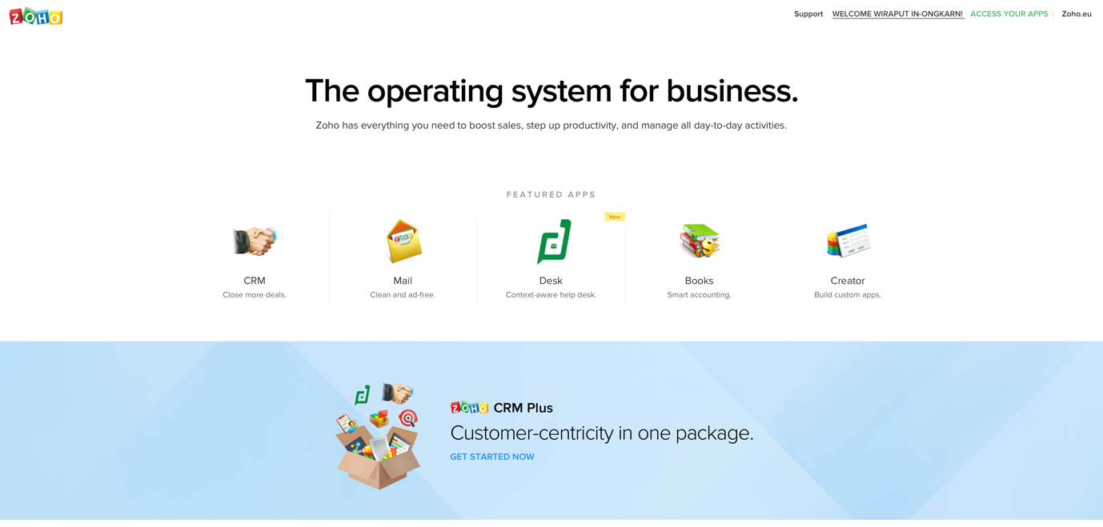

Figure 1 Home page of Zoho

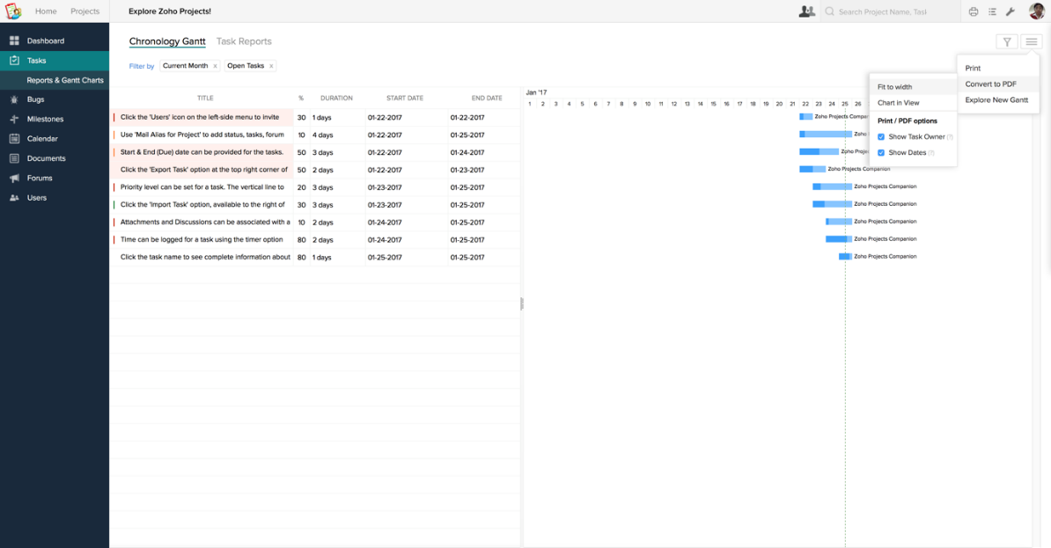

Figure 2 Tasks report of Zoho

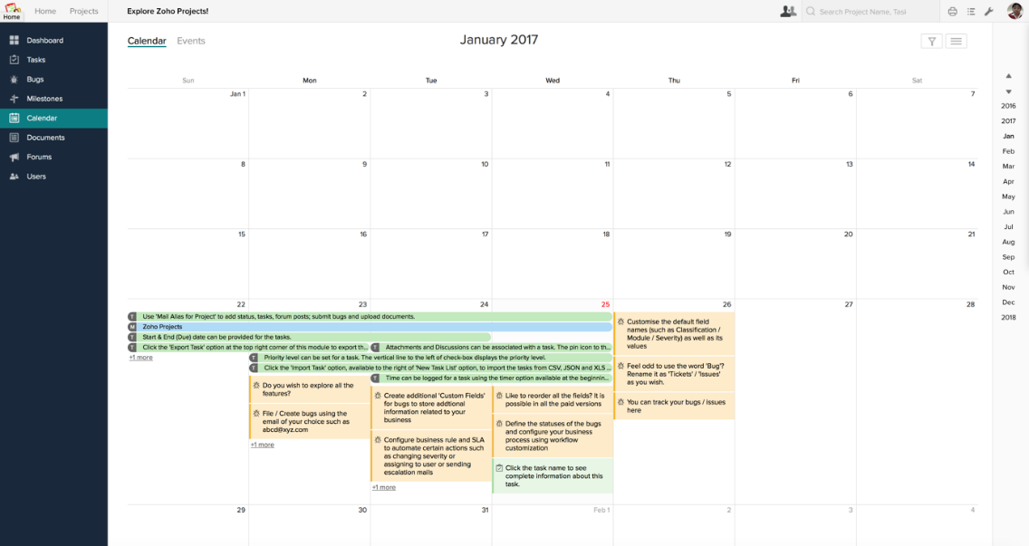

Figure 3 Calendar of Zoho

Zoho is software to solve business problems. Over the past decade, the Zoho suite has emerged to be a leader in the cloud and on your devices. They invest more in product development and customer support than in sales and marketing. In an industry where technology changes at a relentless and dizzying pace, Zoho value persistence and endurance as highly as adaptability. [1]

**Advantages**

Zoho provides the following advantages:

* Project management
* Unlimited creating tasks and updating activities
* Displaying overview of tasks
* Showing the calendar for planning
* Adding members of a team
* Creating documentations for each project
* Exporting reports to several file format
* Simple user interface

**Disadvantages**

* The system is too large and complicated for user needs.
* The system only exports a report as a list of tasks or Gantt chart picture.

**2.2.2 Aceproject (**[**https://aceproject.com**](https://aceproject.com)**)**

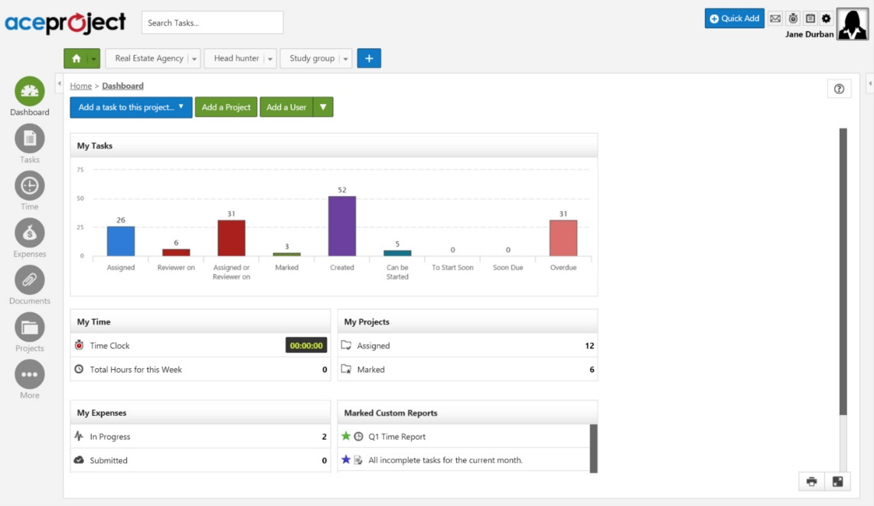

Figure 4 Dashboard of aceproject

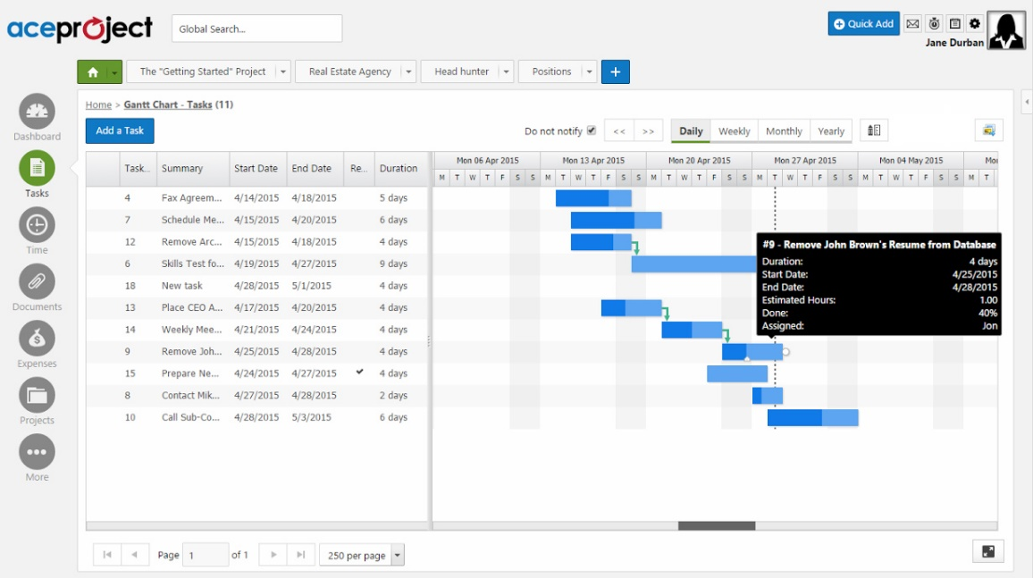

Figure 5 Gantt chart of aceproject

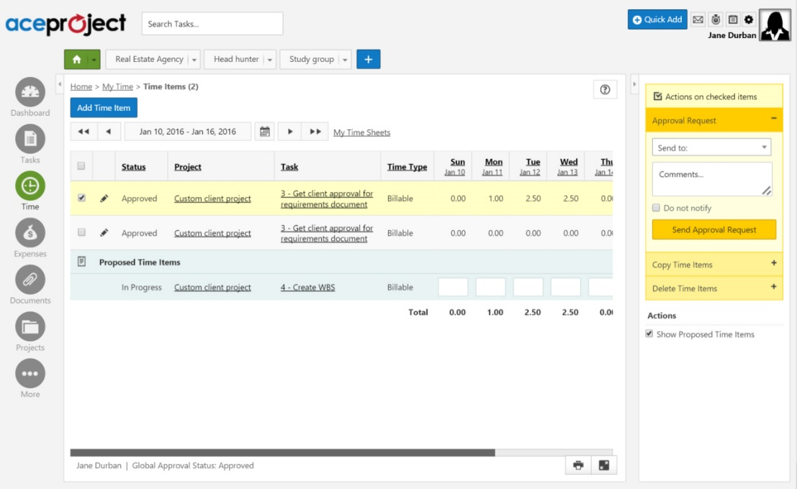

Figure 6 Timesheet of aceproject

AceProject is a web-based application that contains tasks management, timesheets, documents, and expenses for simple-to-intermediate project management. They provide an intuitive and simplified user experience. They also provide dynamically place, modify task dates, and set dependencies between tasks. Gantt charts allow a way to visually interact with your tasks with the ability to modify the progression. Time tracking functionality is included. Moreover, users stay connect to application through email notification.[2]

**Advantages**

AceProject provides the following advantages:

* Project management
* Scheduling tasks by Gantt chart
* Displaying overview and statistics of tasks
* Adding members in a project
* Creating documentations for each project

**Disadvantages**

* The system is too large and complicated for user needs.
* The system only exports a report as a list of tasks or Gantt chart picture.
* Unfriendly user interface

## **Technology Review**

**2.3.1 HTML5**



Figure 7 HTML5 logo

**Technology Detail**

HTML5 is a markup language used for structuring and presenting content on the World Wide Web. It is the fifth and current version of the HTML standard. It includes detailed processing models to encourage more interoperable implementations; it extends, improves and rationalizes the markup available for documents, and introduces markup and application programming interfaces (APIs) for complex web applications. For the same reasons, HTML5 is also a candidate for cross-platform mobile applications, because it includes features designed with low-powered devices in mind. Furthermore, HTML5 contains powerful capabilities for Web-based applications with more powerful interaction, video support, graphics, more styling effects, and a full set of APIs. HTML5 adapts to any device, whether desktop, mobile, tablet, or television. HTML5 is an open platform developed under royalty free licensing terms. [3][4]

**Alternative Technology**

* XHTML 2.0

**The selection of this technology**

HTML5 is the next HTML standard. All new HTML features will be added there, and we'll have to use it eventually if we want to take advantage of them.[5] It is the main tool of website development which browsers are able to read and support.

**2.3.2 CSS3**



Figure 8 CSS3 logo

**Technology Detail**

CSS3 is the latest standard for CSS. It is completely backwards-compatible with earlier versions of CSS. It contains the "old CSS specification" (which has been split into smaller pieces). In addition, new modules are added.[6] CSS most often separate the structure from the content and instead of separating the presentation from the structure. The style includes colors, fonts, layout, and other. [7]

**Alternative Technology**

No alternative technology [8]

**The selection of this technology**

CSS3 allows specifying the virtual elements of the website. All style have to set only in one file which is convenient and fast. In addition, we use less code in CSS which affect to performance of the website. The page will load faster.

**2.3.3 JavaScript**



Figure 9 JavaScript logo

**Technology Detail**

JavaScript is the programming language of HTML and the Web which used to make web pages interactive.[9][10] On other words, it is a high-level, dynamic, untyped, and interpreted programming language. It is one of the three core technologies of World Wide Web content production. The majority of websites employ it, and all modern Web browsers support it without the need for plug-ins.[11] It runs on the visitor's computer and doesn't require constant downloads from your website.[10]

**Alternative Technology**

1. CoffeScript

2. TypeScript

3. Babel

**The selection of this technology**

JavaScript allows making things happen in the user's browser without sending messages back and forth to the server. It used alongside HTML in the browser, which is able to add some dynamic and interactive features. [12] Furthermore, JavaScript is simple to learn. The syntax is not complicated and there are prewritten functionalities, which pay less effort for scripting.

**2.3.4 Angular2**



Figure 10 Angular 2 logo

**Technology Detail**

Angular 2 is the new improved version of AngularJS. It improves many of its existing parts in AngularJS and promotes a component based architecture while leveraging new features of ES2015 (or TypeScript) like classes and modules. In addition, it condenses the number of concepts within the framework into a more cohesive unit with less redundant components. For example, unifying services and factories, and providing a much better way to create components and directives.[13][14]

**Alternative Technology**

1. AngularJS

2. EMBER.JS

**The selection of this technology**

Angular 2 emphasize on binding-data. It divides code into component, service, view which the developers can see the code in clear concept. Moreover, there are many plugin support for example; Angular CLI – generating a file, building, testing project through a command line.

**2.3.5 JQuery**



Figure 11 jQuery logo

**Technology Detail**

jQuery is a cross-platform JavaScript library designed to simplify the client-side scripting of HTML. It is a fast, small, and feature-rich JavaScript library which makes things like HTML document traversal and manipulation, event handling, animation, and Ajax much simpler with an easy-to-use API that works across a multitude of browsers. It is free, open-source software licensed under the MIT License. [15][16]

**Alternative Technology**

* No alternative technology

**The selection of this technology**

There are variety plugins supported. jQuery is famous for managing DOM and quick response of client and elements. It fulfils the disadvantages of Angular2.

**2.3.6 Laravel**



Figure 12 Laravel logo

**Technology Detail**

Laravel is a MVC framework with bundles, migrations, and Artisan CLI. Laravel offers a robust set of tools and an application architecture that incorporates many of the best features of frameworks like CodeIgniter, Yii, ASP.NET MVC, Ruby on Rails, Sinatra, and others. It is an Open Source framework and has a very rich set of features which will boost the speed of Web Development. Laravel will make the task easier and save a lot time for developing a website from scratch. Not only that, the website built in Laravel is also secure. It prevents the various attacks that can take place on websites.[17][18]

**Alternative Technology** [19]

1. Zend 2
2. Symfony
3. CakePHP
4. CodeIgniter
5. Yii

**The selection of this technology**

Laravel is popular PHP framework. It has many plugins supported as well as authentication system supports. There are Eloquent ORM for managing model and relation from database which does not follow SQL commands.

**2.3.7 MySQL**



Figure 13 MySQL logo

**Technology Detail**

MySQL is a fast, easy-to-use RDBMS being used for many small and big businesses. It is developed, marketed, and supported by MySQL AB, which is a Swedish company. It is an open-source license and very powerful program in its own right. It handles a large subset of the functionality of the most expensive and powerful database packages. [20] MySQL is also used in many high-profile, large-scale websites, including Google (though not for searches), Facebook, Twitter, Flickr, and YouTube. [21]

**Alternative Technology** [22]

1. MariaDB
2. PostgreSQL
3. SQLite

**The selection of this technology**

The installation of MySQL is simple. It is also very friendly to PHP and no charge. In addition, it uses a standard form of the well-known SQL data language.

**2.3.8 Firebase**



Figure 14 Firebase logo

**Technology Detail**

Firebase is a mobile and web application platform with tools and infrastructure designed to help developers build high-quality apps. It made up of complementary features that can mix-and-match to user needs.[23] Firebase's initial product was a realtime database, which provides an API that allows developers to store and sync data across multiple clients. Over time, it has expanded its product line to become a full suite for app development. [24]

**Alternative Technology** [25]

1. Hoodie
2. Firehorse
3. remoteStorage
4. Sockethub

**The selection of this technology**

Firebase is a fast real-time database. It is suitable for our web application which requires the real-time data synchronization. Furthermore, firebase reduces the development time and avoid messing with server and data storage.

## **Development Tool Review**

**2.4.1 Atom**



Figure 15 Atom logo

**Technology Detail**

Atom is a free and open-sourcentext and source code editor for macOS, Linux, and Windows with support for plug-ins written in Node.js, and embedded Git Control, developed by GitHub. Atom is a desktop application built using web technologies. Most of the extending packages have free software licenses and are community-built and maintained. Atom is based on Electron (formerly known as Atom Shell), a framework that enables cross-platform desktop applications using Chromium and Node.js. It is written in CoffeeScript and Less. It can also be used as an integrated development environment (IDE). [26]

**Alternative Technology** [27]

1. Notepad++
2. Sublime
3. Visual Code Studio
4. Vim

**The selection of this technology**

Atom is an open source software which has a small size. It contains many extension plugin.

**2.4.2 phpmyadmin**



Figure 16 phpmyadmin logo

**Technology Detail**

phpMyAdmin is a free and open source tool written in PHP intended to handle the administration of MySQL or MariaDB with the use of a web browser. It can perform various tasks such as creating, modifying or deleting databases, tables, fields or rows; executing SQL statements; or managing users and permissions. [28]

**Alternative Technology**

* No alternative technology

**The selection of this technology**

Phpmyadmin is simple for installation and manage hosting environment. We can access the database easily on any computer because it works by web-based.

**2.4.3 Github**



Figure 17 GitHub logo

**Technology Detail**

GitHub is a web-based Git or version control repository and Internet hosting service. It offers all of the distributed version control and source code management (SCM) functionality of Git as well as adding its own features. It provides access control and several collaboration features such as bug tracking, feature requests, task management, and wikis for every project. [29]

**Alternative Technology** [30]

* Bitbucket
* GitLab
* FogBugz Kiln/DevHub
* Beanstalk

**The selection of this technology**

GitHub is an open source. It makes all of the code is easily inspected, as is its entire history. We can collaborate and track changes in code and documents across version.

**2.4.4 Trello**



Figure 18 Trello logo

**Technology Detail**

Trello is a web-based project management application**.**

**Alternative Technology** [30]

* Bitbucket
* GitLab
* FogBugz Kiln/DevHub
* Beanstalk

**The selection of this technology**

GitHub is an open source. It makes all of the code is easily inspected, as is its entire history. We can collaborate and track changes in code and documents across version.

# **Chapter Three | Quality Standard**

## **3.1 ISO29110 for Very Small Entity (VSE)**

ISO29110 is the Software Life Cycle Profiles and Guidelines for Very Small Entities (VSEs) standards and technical reports are targeted at Very Small Entities (VSEs). A Very Small Entity (VSE) is an enterprise, organization, department or project having up to 25 people. ISO 29110 concerns on project management process and software implementation process.

### **Project Management process**

The purpose of the Project Management process is to establish and carry out in a systematic way the tasks of the software implementation project, which allows complying with the project’s objectives in the expected quality, time and cost. There are 4 activities as following:

1. Project Planning Process
2. Project Plan Execution Process
3. Project Assessment and Control Process
4. Project Closer Process

### **Software Implementation process**

The purpose of the Software Implementation process is the systematic performance of the analysis, design, construction, integration and tests activities for new or modified software products according to the specified requirements. There are 6 activities as following:

1. Software Implementation Initiation Process
2. Software Requirements Analysis Process
3. Software Architectural and Detailed Design Process
4. Software Construction Process
5. Software Integration and Test Process
6. Software Delivery Process

# **Chapter Four | Project Plan**

## **4.1 Motivation**

WIL 8 months internship program requires 3 documentations; weekly report, senior project, internship projects report. It was a hard time to work after day end. During a busy time, you could forget to fill up your weekly task in a report. It would be difficult on next week to recall your memory what have you done. The weekly report is not difficult to create, but it requires routine write. Moreover, Mentors and Supervisors have to give comments and feedback on the weekly report. It takes time and inefficient to wait for their comments and pass them a paper of weekly report in every week. In addition, usually, record their task and activities as a project. It called project-based report.

The documents are important for students, therefore recording efficiency becomes to the main a significant method. It would be a big challenge to make a tool which helps increasing workload productivity.

## **4.2 Aims and Objectives**

**4.2.1 Aims**

The aim of this project is to develop a web application which helps WIL students to manage tasks and export WIL reports. The system eliminates the complicated steps, makes systematic steps of creating a report, and saves times.

**4.2.2 Objectives**

The objective of this project is to develop a web application using tools; GitHub, Source tree, and Trello. We use iterative development method which is increment adding some functional capability to the system until the full system is implemented. The web application have to deliver the following features:

1. Login and Logout
2. Task management
3. Document export
4. Web and email notification

## **4.3 Software architecture**

  

Students Mentor Supervisor

  

Internet browser

Socket Transfering data



Transfering data

 

Cloud Server

Figure 19 Software Architecture

## **4.4 Deliverables and Limits**

**4.4.1 Deliverables**

**1. Features:**

**Feature #1: Login and Logout**

1. Users can login into the system.
2. Users can logout from the system.

**Feature #2: Task management**

1. Users (Students, Mentors, Supervisor) can view tasks overview of a project.
2. Users (Students, Mentors, Supervisor) can view the statistics of tasks.
3. Students can add tasks of a project.
4. Students can edit tasks of a project.
5. Students can delete tasks of a project.
6. Students can move tasks of a project.
7. Mentor can view comments in student’s report.
8. Mentor can add comments in student’s report.
9. Mentor can edit comments in student’s report.
10. Mentor can delete comments in student’s report.
11. Supervisor can view comments in student’s report.
12. Supervisor can add comments in student’s report.
13. Supervisor can edit comments in student’s report.
14. Supervisor can delete comments in student’s report.

**Feature #3: Report export**

1. Users can view weekly report.
2. Users can view monthly report.
3. Users can generate a printable weekly report file.
4. Users can generate a printable monthly report file.

**Feature #4: Web and Email notification**

1. Users can receive activities notification message on Web application.
2. Users can receive activities receive notification message via email.

**2. Documents and other material**

1. Proposal
2. Project plan
3. Quality plan
4. Software requirement specification
5. Traceability record
6. Software design document
7. Testing document
8. Test plan
9. Unit test report
10. System Test report
11. 1 CD-ROM stores all source code; relate file, all documents and poster files in PDF format.

**4.5 Schedule and Milestone**

**4.5.1 Software Process**

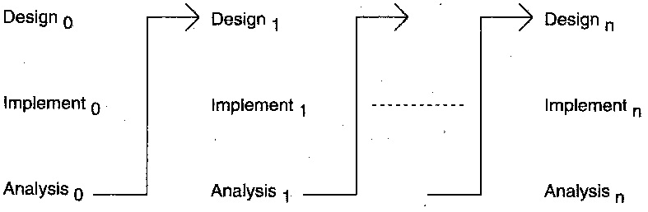

Figure 20 The iterative model

The iterative development process model combines the benefits of Prototyping and Waterfall model. The basic idea is that the software is developed in increments, each increment adding some functional capability to the system until the full system is implemented. [29] This model does not attempt to start with a full specification of requirements. [30] Instead, development begins by specifying and implementing just part of the software, which is then reviewed in order to identify further requirements. This process is then repeated, producing a new version of the software at the end of each iteration of the model. [31]

The reasons we selected this model are that some functionalities can be early and fast developed in the software life cycle. As we mention above, this model does not require full specification of requirements, so that we create a high-level design before building and designing an entire system. Later on, we design and built a structure and design based on what we had built. Furthermore, we are able to build and improve the system step by step to avoid the defects at early stages.

**4.5.2 Schedule plan**

There are 4 phases to develop this project:

1.) Proposal phase: creating proposal document

2.) 1st progress phase: deliver some features and documentation

Feature #1: Login and logout

Feature #2: Task management

Creating Development plan, Quality plan, Software Requirement Specification (SRS), Software Design Document (SDD) and some part of Test document.

3.) 2nd progress phase

Feature #3: Document export

Feature #4: Web and Email notification

80% of the overall system is done. Some features are integrated. Test document is continue.

4.) 3rd progress phase

The system is completed. All documents is done.

**4.5.2 Milestones**

Figure 21 Proposal Milestone

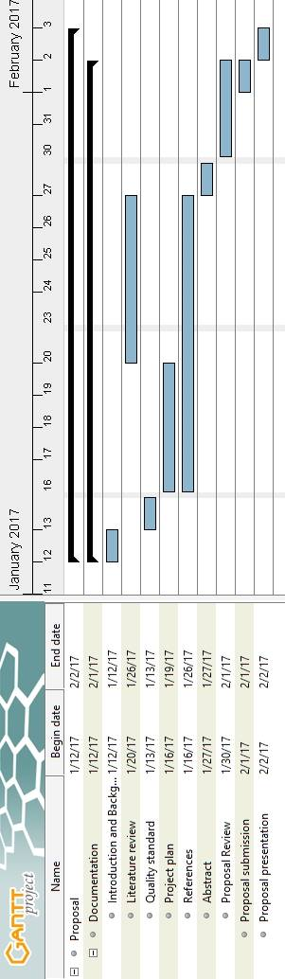

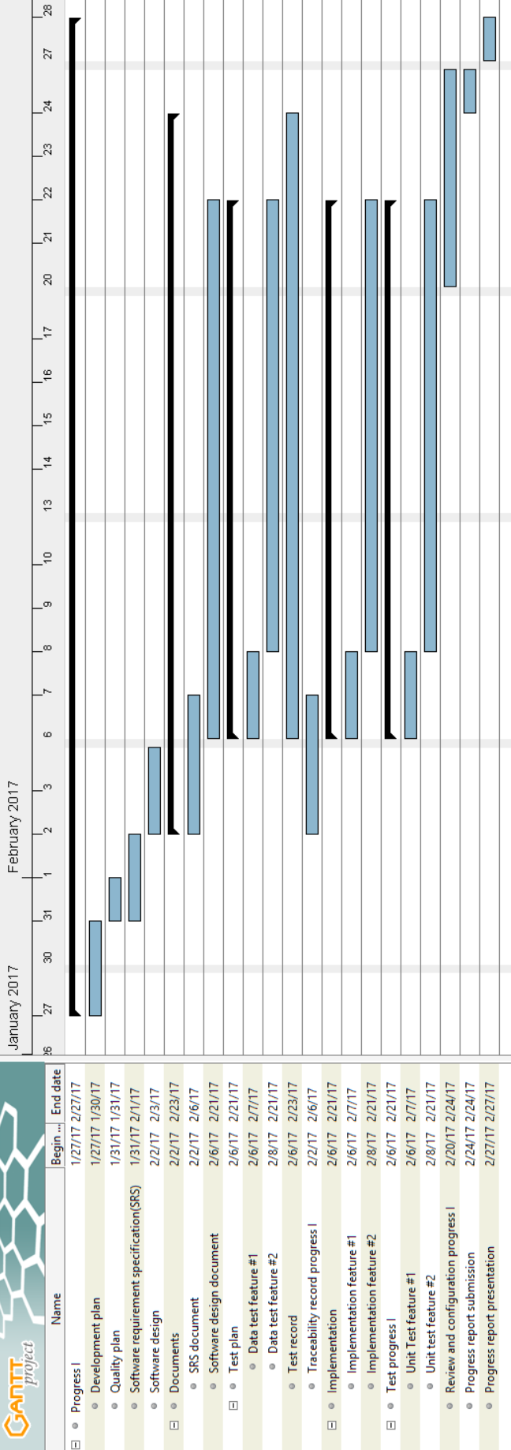

Figure 22 Progress 1 Milestone

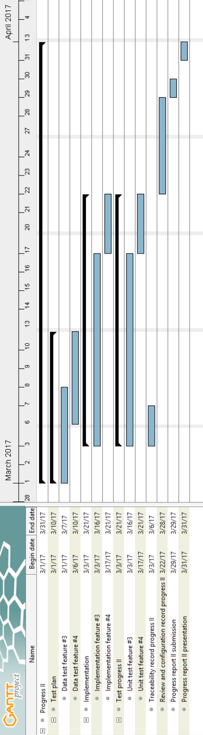

Figure 23 Progress 2 Milestone

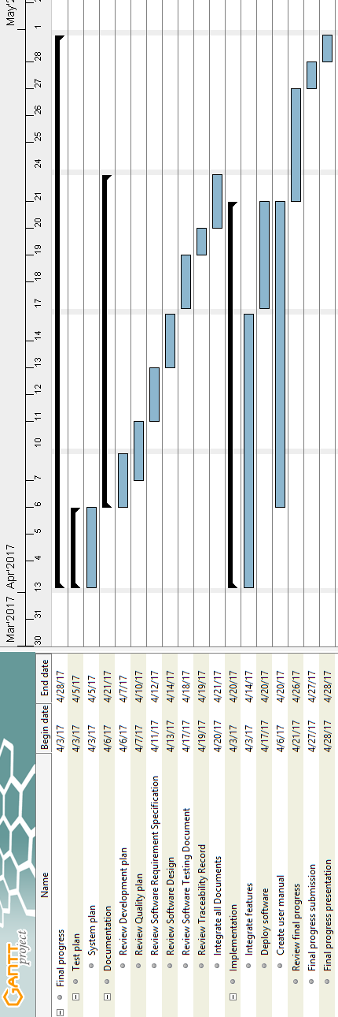

Figure 24 Final progress Milestone

**Chapter Five | References**

|  |  |
| --- | --- |
| [1] | Zoho, “About me,” Zoho, [Online]. Available: https://www.zoho.com/aboutus.html. [Accessed 26 1 2017]. |
| [2] | aceproject, “ACEPROJECT,” aceproject, [Online]. Available: http://www.aceproject.com/tour/. [Accessed 26 1 2017]. |
| [3] | Wikipedia, “HTML5,” [Online]. Available: https://en.wikipedia.org/wiki/HTML5. [Accessed 26 1 2017]. |
| [4] | W3C, “FAQs,” 7 12 2012. [Online]. Available: https://www.w3.org/html/wiki/FAQs. [Accessed 28 1 2017]. |
| [5] | Mediawiki, “HTML5,” 15 5 2016. [Online]. Available: https://www.mediawiki.org/wiki/HTML5. [Accessed 28 1 2017]. |
| [6] | w3schools, “CSS3 Introduction,” [Online]. Available: http://www.w3schools.com/css/css3_intro.asp. [Accessed 28 1 2017]. |
| [7] | Wikipedia, “CSS,” 16 1 2017. [Online]. Available: https://en.wikipedia.org/wiki/Cascading_Style_Sheets. [Accessed 28 1 2017]. |
| [8] | Stacoverflow, “Is there an alternative to CSS?,” 28 5 2009. [Online]. Available: http://stackoverflow.com/questions/925653/is-there-an-alternative-to-css. [Accessed 28 1 2017]. |
| [9] | w3schools, “Learn JavaScript,” [Online]. Available: http://www.w3schools.com/js/default.asp. [Accessed 28 1 2017]. |
| [10] | S. Chapman, “What is JavaScript?,” 25 7 2016. [Online]. Available: http://javascript.about.com/od/reference/p/javascript.htm. [Accessed 28 1 2017]. |
| [11] | Wikipedia, “JavaScript,” 17 1 2017. [Online]. Available: https://en.wikipedia.org/wiki/JavaScript. [Accessed 28 1 2017]. |
| [12] | stackoverflow, “What is the Use of Javascript,” 16 8 2010. [Online]. Available: http://stackoverflow.com/questions/3497115/what-is-the-use-of-javascript. [Accessed 28 1 2017]. |
| [13] | barbarianmeetscoding, “Angular 2 Wiki,” 19 2 2016. [Online]. Available: https://www.barbarianmeetscoding.com/wiki/angular-2/. [Accessed 28 1 2017]. |
| [14] | A. University, “AngularJs vs Angular 2 - An In-Depth Comparison,” 18 5 2015. [Online]. Available: http://blog.angular-university.io/introduction-to-angular2-the-main-goals/. [Accessed 28 1 2017]. |
| [15] | jQuery foundation, “What is jQuery?,” [Online]. Available: https://jquery.com/. [Accessed 28 1 2017]. |
| [16] | Wikipedia, “jQuery,” 28 1 2017. [Online]. Available: https://en.wikipedia.org/wiki/JQuery. [Accessed 28 1 2017]. |
| [17] | D. Rees, “Code Bright: Getting Started,” [Online]. Available: https://daylerees.com/codebright-getting-started/. [Accessed 28 1 2017]. |
| [18] | Tutorialspoint, “Laravel - Overview,” [Online]. Available: https://www.tutorialspoint.com/laravel/laravel_overview.htm. [Accessed 28 1 2017]. |
| [19] | H. Davis, “6 Best PHP Frameworks in 2016,” 26 9 2016. [Online]. Available: https://medium.com/@helendavis/6-best-php-frameworks-in-2016-93457543a70e#.lejsrskqu. [Accessed 28 1 2017]. |
| [20] | Tutorialpoint, “MySQL Introduction,” [Online]. Available: https://www.tutorialspoint.com/mysql/mysql-introduction.htm. [Accessed 28 1 2017]. |
| [21] | Wikipedia, “MySQL,” 12 1 2017. [Online]. Available: https://en.wikipedia.org/wiki/MySQL. [Accessed 28 1 2017]. |
| [22] | J. Champagne, “3 Standout MySQL Alternatives,” 17 8 2016. [Online]. Available: http://blog.capterra.com/3-standout-mysql-alternatives/. [Accessed 28 1 2017]. |
| [23] | Google, “Firebase,” [Online]. Available: https://firebase.google.com/?hl=th. [Accessed 30 1 2017]. |
| [24] | Wikipedia, “Firebase,” 25 1 2017. [Online]. Available: https://en.wikipedia.org/wiki/Firebase. [Accessed 30 1 2017]. |
| [25] | B. Yoskovitz, “What's the closest open-source alternative to Firebase?,” 3 10 2013. [Online]. Available: https://www.quora.com/Whats-the-closest-open-source-alternative-to-Firebase. [Accessed 30 1 2017]. |
| [26] | Wikipedia, “Atom (text editor),” 13 1 2017. [Online]. Available: https://en.wikipedia.org/wiki/Atom_(text_editor). [Accessed 28 1 2017]. |
| [27] | Github, “Alternatives to Atom for all platforms,” [Online]. Available: http://alternativeto.net/software/atom/. [Accessed 28 1 2017]. |
| [28] | Wikipedia, “phpmyadmin,” [Online]. Available: https://en.wikipedia.org/wiki/PhpMyAdmin. [Accessed 28 1 2017]. |
| [29] | M. RACHMADI, “Software Engineering: COURSE MATERIAL OF SOFTWARE ENGINEERING,” 22 FEBRUARY 2010. [Online]. Available: http://rpl-blog.blogspot.com/2010/02/233-iterative-development.html. |
| [30] | ISTQB, “What is Iterative model- advantages, disadvantages and when to use it?,” [Online]. Available: http://istqbexamcertification.com/what-is-iterative-model-advantages-disadvantages-and-when-to-use-it/. [Accessed 21 1 2017]. |
| [31] | Tutorialpoint, “SDLC - Iterative Model,” [Online]. Available: https://www.tutorialspoint.com/sdlc/sdlc_iterative_model.htm. [Accessed 21 1 2017]. |