# TER-302: internal endurance operation test

**Description:**

lifetime testing

measurement data stored at the following folder: N:!Projects\130_Testing##### neue Ordnerstruktur #####Lebensdauer Brennschrank

**Conditions:**

Ambient: 25°C ± 5 K

Voltage: 14.5V

Duration: testing time see module/color related test procedure

L70B10 = LW5: 5000h; LY5: 2000h; L1: 5000h; LR5: 4000h; LR4: 4000h; CLR5: 4000h; LRR8: 10000h;

Operation mode: continuous operation and LY5 blinking mode

**Criteria:** From 0h - 1000h: - V-I measurement: Within initial ± 10% from 9V to 16V. - Luminous flux: Within initial ± 10% - No abnormal appearance (e.g. no parts and plastic delamination). - intermediate measurement: every 1000h

From 1001h - 10000h: - V-I measurement: Within initial ± 30% from 9V to 16V. - Luminous flux: Within initial ± 30% - No abnormal appearance (e.g. no parts and plastic delamination). - intermediate measurement: 1000h, 2000h, 3000h, 4000h

# TER-301: Einstecktest

**Description:**

The test should be performed with the following test data on a Zwick/Roell machine

**Condition:**

The XLS module to be tested should be clamped in place and a Molex connector fitted.

The machine then presses the connector onto the module and the corresponding force

should also be applied. The following values should be preset:

pre-load: 0,5N

test speed: 1 mm/s

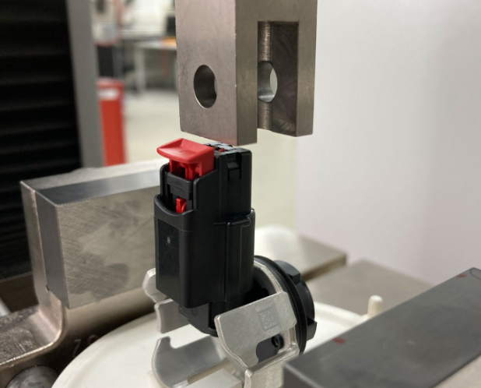

**Criteria:**

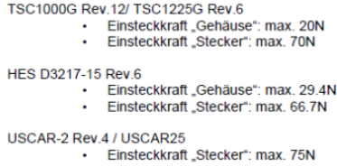

Connector shall be mechanical stable during plugging process (insertion force)

Connector shall not break and be damaged during plugging process (in & out)

# TER-299: MMC condensation test

**Description:**

**Procedure:** - LY5 Gen2 - Voltage: 13.0±0.1V - PCB: Temp=50±3℃, Humidity=more than 50mg/L ( can be set by the cartridge heater and the amount of water in housing - in our case 5ml) - Heatsink: Temp=10±3℃, Humidity=65±10% ( can be set by the climatic chamber) - (Needed to separately set temp/humidity condition between PCB and heatsink) - Lighting condition: 1 cycle: Off for 3h / On for 10 min.(90 times/min., Blinking), total 100cycles

**Criteria:**

After above test Module should be lighting up without flickering at 8~16V range. (normal U/I curve measurement)

To confirm with a microscope that there are no traces of adhesion or migration of corrosive organisms on the circuit board and show photos as evidence

# TER-298: Leakage test (bubble)

**Description:**

This check shall verify the seal integrity according to DVM 14455.

**Conditions:**

Connect lamp using appropriate vehicle mating connectors with all power, ground and signal lines as required by vehicle electrical architecture so all lamp functions can be exercised per test schedule.

**Procedure:**

5.1 Set water temperature to 23 +/- 5 Degrees C.

5.2 **[STEP 1]** For vented lamps, seal off all vent openings. Seal off bulb & sockets at the connector interface.

5.3 **[STEP 2]** The test sample shall be completely submerged under laboratory ambient temperature water at a depth of 50mm to 175mm as measured from the top of the lamp assembly.

5.4 **[STEP 3]** Apply a minimum internal air pressure of 70 mbar (1 PSI) for vented lamps or **minimum 150 mbar** for non-vented lamps.

5.5 **[STEP 4]** The test time under water with steady state pressure must be a minimum of one (1) minute. There must not be any secondary hand or fixture support of bulb access caps, boots, sockets, etc. that does not match vehicle environment.

5.6 **[STEP 5]** The test shall be repeated at the worst-case attachment tolerance extremes as determined by Dimensional Variation Analysis (DVA).

**Criteria:**

R&D + QM No visible bubbles.

MF leakage rate <0,8cm³/min.

# TER-297: RE 321: EMF - Radiated Electromagnetic Emission (Ford FMC1278 Rev.4)

**For explicit test description and set-up please refere to FMC1278 Rev.4 for individual details!**

**According Ford specification a Testplan needs to be prepared and released by Ford EMC department prior DV/PV testing.**

Currently these requirements are specifically applicable to LV and HV components used to directly facilitate thermal heating to the driver and passengers (e.g. heated seat mats and steering wheels)

**–> not relevant for XLS application**

# TER-296: RE 320: EMF - Radiated Electromagnetic Emission (Ford FMC1278 Rev.4)

**For explicit test description and set-up please refere to FMC1278 Rev.4 for individual details!**

**According Ford specification a Testplan needs to be prepared and released by Ford EMC department prior DV/PV testing.**

These requirements are applicable to components/subsystems packaged within the passenger compartment excluding heated seat mats, steering wheels and similar thermal heating devices. See RE 321 for requirements for those specific components.

**–> most likely not relevant for XLS application**

# TER-294: recording U/I curve before and after test

**Description:**

recording of U/I curve before and after test

**Condition:**

voltage: 0-20V

temperature: 23°C± 2,5K

Ramp speed: 3,4s

**Criteria:**

V-I measurement: Within initial ± 10% from 9V to 16V

Only for design verification

# TER-293: Steady State U/I Curve over Temperature

**Description:**

This test is performed to investigate the current draw at different voltages and temeratures.

The test is carried out in the climate control cabinet. The current consumption of the module is measured.

**Condition:**

Ambient temperature range: -40°C to +105°C increased in 5K steps Operation voltage range: 5V - 20V increased in 0,5V steps; additional 13,2V

Stabilization Time: 15 minutes

Burn In Time: 15 Minutes

**Criteria:**

–

(Test for information purposes only)

# TER-292: Resistance to heat warpage

| Resistance to heat warpage Specification: RQT-170000-010975, 17.00.E-4765 (DVM-0013-EX) | 1 | before/after performance checktemperatures: 23°C (1 hour at 14V) & 70°C (2 hours at 14V) |
| --- | --- | --- |

# TER-291: Vibration Endurance

| Vibrationen endurance Specification: RQT-170000-010971, 17.00.E-4762 (DVM-0009-EX) | 1 | before/after performance check + leakage testDUTs active per duty cycle according DVO 325054temperatures: -40°C; 23°C & 50°CFrequency: 10 to 250HzTolerance limit: ± 3dBdirections: sequence, vertical & horizontaltotal duration of test: 20h |
| --- | --- | --- |

# TER-290: Sub-Group H3 (test leg)

| Performance checkSpecification:FORD CETP: 00.00-E-412 (2011-07) | 1 | photometrical measurement 13.5V @23°C (1min. / 15min.) + U/I curve from 0V until 20V @23°C + performance evaluation in climatic chamber @ 8V ; 13.5V & 16V with -40°C ; 23°C & 85°C (voltage, current & power) |
| --- | --- | --- |
| Thermal Shock Endurance Specification:FORD CETP: 00.00-E-412 (2011-07) | 2 | DUTs passiveUpper temperature +95°CLower temperature -40°CDwell time: 0.5 h at each temperature1000 shock cycles = 1000 hFunctional test and inspection of solder joints after 500h and 1000h |
| Performance checkSpecification:FORD CETP: 00.00-E-412 (2011-07) | 3 | photometrical measurement 13.5V @23°C (1min. / 15min.) + U/I curve from 0V until 20V @23°C + performance evaluation in climatic chamber @ 8V ; 13.5V & 16V with -40°C ; 23°C & 85°C (voltage, current & power) |

# TER-289: Sub-Group H2 (test leg)

| 15 | Performance checkSpecification:FORD CETP: 00.00-E-412 (2011-07) | 1 | photometrical measurement 13.5V @23°C (1min. / 15min.) + U/I curve from 0V until 20V @23°C + performance evaluation in climatic chamber @ 10V ; 13.5V & 15V with -40°C ; 23°C & 85°C (voltage, current & power) |
| --- | --- | --- | --- |
| 16 | High Temperature Endurance Specification:FORD CETP: 00.00-E-412 (2011-07) | 2 | DUTs active, VN=13.5 VTemperature +85°CDuration time = 1000hintermediate measurement @500h (performance check) |
| 17 | Performance checkSpecification:FORD CETP: 00.00-E-412 (2011-07) | 3 | photometrical measurement 13.5V @23°C (1min. / 15min.) + U/I curve from 0V until 20V @23°C + performance evaluation in climatic chamber @ 10V ; 13.5V & 15V with -40°C ; 23°C & 85°C (voltage, current & power) |

# TER-288: Voltage Range for luminous flux

**Procedure:** 1. Measure luminous flux ɸ{}V-100{} at room temperature and 12.8 V with a 1 minute warm up period 1. Measure lumious flux ɸ at room temperature for 6 V , 8 V and 10 V

**Criteria:** - ɸ(10 V) > 0.45 * ɸ{}V-100{} - ɸ(8 V) > 0.25 * ɸ{}V-100{} - ɸ(6 V) > 0.05 * ɸ{}V-100{}

# TER-287: Battery Line Transients (GMW3172 / March 2023 - 9.2.20)

**Description:**

This test shall verify the robustness of the component to the resulting transients that occur on all battery lines during a relay switching. Applicability: All components that have power supplied by the vehicle battery 12 V wiring system, either directly or through an external component.

**Condition:** - Connect the component to the power supply through an electronically controllable switching unit with a switching time ≤ 1 μs. The switches of the switching unit shall be high impedance when opened. Control the switching unit with a signal as shown in Figure 32. **Note:** The switching unit consists of two switches which are controlled by the same pulse signal. Switch 2 is synchronized with Switch 1, but is negated to it (i.e., Switch 2 closes after Switch 1 is opened completely, and Switch 1 closes after Switch 2 is opened completely). This simulates transients on all battery lines that occur during relay switching.

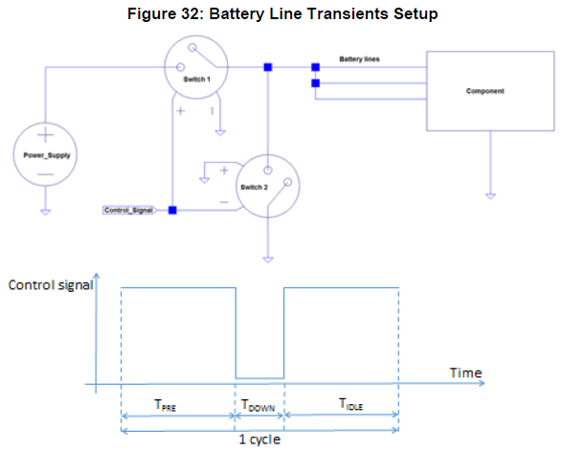 - Test setup definitions and parameters: - TPRE = Pre-energizing period = 5 s (Switch 1 closed, Switch 2 opened). - TDOWN = 100 μs (Switch 1 opened, Switch 2 closed). - TIDLE = 5 s: Transient completed, component in stable state and enough time for abbreviated functional check (Switch 1 closed, Switch 2 opened). - Number of cycles = 5. - Short to ground resistance including Switch 2 ≤ 100 mΩ. - If the component has both Switched Battery and Permanent Battery lines the test shall be repeated in three different scenarios: - Apply the switching only to permanent battery lines (the switched battery lines being connected to constant power supply). - Apply the switching only to switched battery lines (the permanent battery lines being connected to constant power supply). - Apply the switching to permanent and switched battery lines simultaneously.

**Criteria:**

FSC shall be A when required by the CTS, CTRS, SSTS, and/or other relevant requirements document, otherwise FSC shall be C.

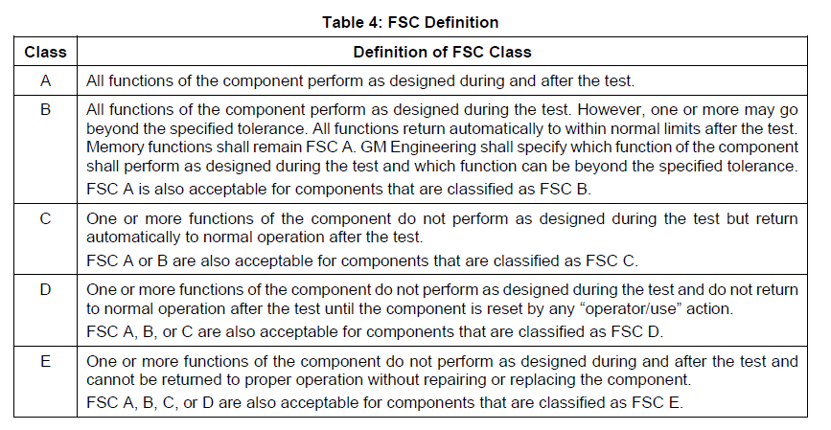

# TER-286: Switched Battery Lines (GMW3172 / March 2023 - 9.2.19)

**Description:**

This test shall verify the robustness of the component to switched battery lines contact bouncing. It is intended for components with electronic circuits powered through switched battery lines switched with a contact. This test shall also be used for microprocessor-based components to quantify the robustness of the design to contact bouncing. Applicability: All components that have switched power supplied by the vehicle battery 12 V wiring system, either directly or through an external component.

**Condition:** - Connect the component to UB to represent a vehicle battery. Connect the component to the power supply through a controllable switch with a switching time ≤ 200 ns. Control the switch with a signal as shown in Figure 31. **Note:** The switch shall conduct only unidirectional current and shall be high impedance when off.

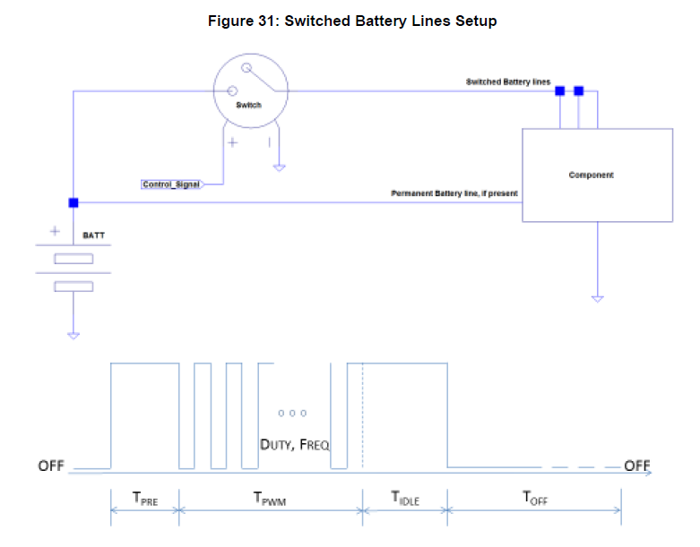 - Test setup definitions and parameters: - TPRE = Pre-energizing period = 25 μs, 50 μs, 125 μs, 500 μs, 1 ms. - TPWM = Relay emulated bouncing period = 50 μs, 100 μs, 250 μs, 500 μs, 1 ms. - PWM frequency = 5 kHz, 10 kHz, 20 kHz, 50 kHz, 100 kHz. - PWM duty cycle = 20%, 50%, 80%. - TIDLE ≥ 100 ms: Transient completed, component in stable state and enough time for abbreviated functional check. - TOFF ≥ 5 s: Off state time. - Number of PWM cycles ≥ 5. - Stabilize the component at Tmin. - Apply test pulse waveform sweeping timing and frequency parameters using listed values. - This test shall be performed in each parameter combination that leads to a minimum of 5 PWM cycles which is defined by TPWM ≥ 5 × (1/PWM frequency). This results in 15 pairs of the TPWM and PWM frequency values. These pairs are combined with the 15 permutations of the TPRE and PWM Duty Cycle. This results in a total of 225 different required parameter combinations, as shown in Table 30. - Each parameter combination shall be repeated 180 times. - An abbreviated functional check (which verifies the component completed power up initialization) shall be performed during TIDLE after each parameter combination. - Repeat Step 4 at Troom and Tmax.

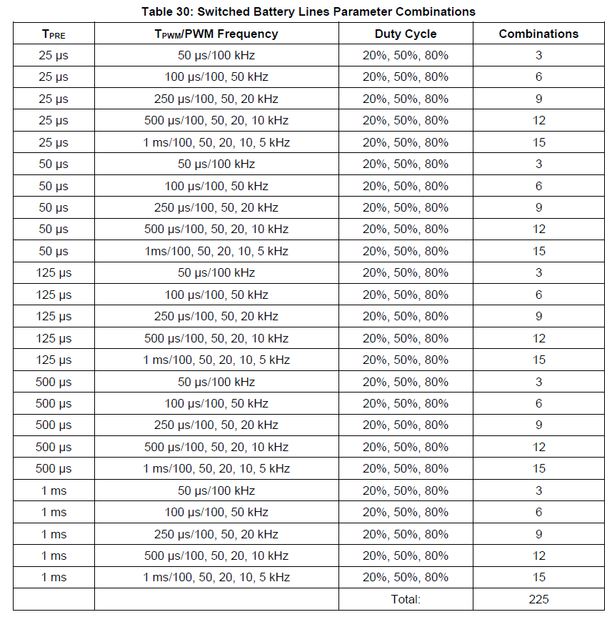

**Criteria:**

FSC shall be C.

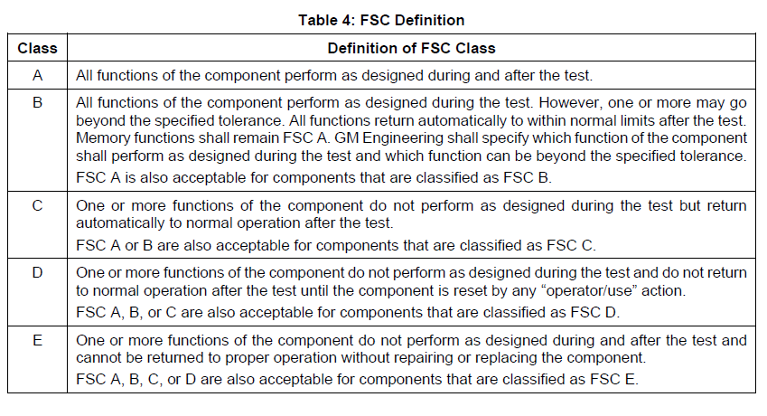

# TER-285: AutoStart Voltage Transient (GMW3172 / March 2023 - 9.2.18)

**Description:**

This test shall verify the functional capability and durability of components subjected to AutoStart transient waveforms that are generated by conventional starters controlled by the AutoStart system.

Applicability: All components that will be subjected to the AutoStart pulses on the power line supplied by the vehicle battery 12 V wiring system (both battery and/or ignition inputs).

**Condition:**

Subject the component to the waveforms defined in Table 28 using the default number of cycles defined in Table 29. Note: - The required number of cycles may be modified in agreement with the ENV SME. - The AutoStart Waveform Functional Test Cycles (Table 29) are required for all components. - The AutoStart Waveform Durability Test Cycles (Table 29) are required only where there is a durability concern (i.e., electromechanical movement due to crank) and when it is not covered by another component specific test procedure (as determined in 9.2.17 Crank Pulse Capability and Durability). - 10% of the AutoStart Waveform Durability Test Cycles (Table 29) shall be performed at Tmin and 10% of the AutoStart Waveform Durability Test Cycles (Table 29) shall be performed at Tmax. - The cycle time between pulses shall be adequate to verify function (abbreviated 1-Point Functional/Parametric Check) after each pulse in the AutoStart Waveform Functional Test Cycles (Table 29) and adequate to not create any failures due to an unrealistic pulse frequency.

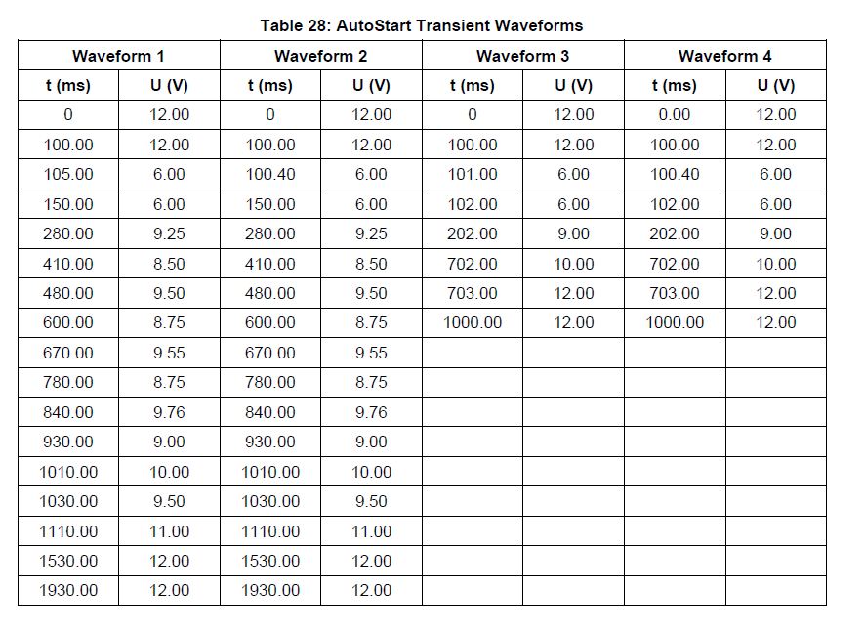

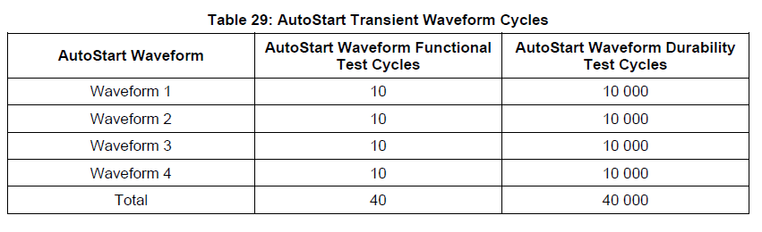 1. Perform all the AutoStart Waveform Durability Test Cycles (Table 29) first, if applicable. 1. After the completion of each individual row of the AutoStart Waveform Durability Test Cycles (Table 29), perform a 1-Point Functional/Parametric Check (total of 4 1-Point Functional/Parametric Checks). 1. Perform the AutoStart Waveform Functional Test Cycles (Table 29). 1. After the completion of each individual waveform of the AutoStart Waveform Functional Test Cycles (Table 29), perform an abbreviated 1-Point Functional/Parametric Check (total of 40 abbreviated 1-Point Functional/Parametric Checks).

Note: - The time between durability test cycles shall be such that the internal voltages in the component shall have had time to stabilize. - While the waveform voltage is at 12 V, the component shall be in Operating Type 3.2. When at 12 V after the pulse, a 1-Point Functional/Parametric Check shall be performed.

**Criteria:** - FSC shall be A. - The component shall be capable of full functional operation at system voltages unless exceptions are approved by the 12 V StopStart Feature Owner, currently Scott J Chynoweth, for approval of exceptions.

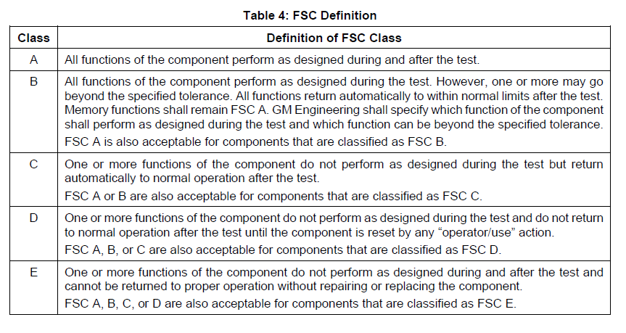

# TER-284: Crank Pulse Capability and Durability (GMW3172 / March 2023 - 9.2.17)

**Description:**

This test shall verify the functional capability and durability of components subjected to crank pulses that are generated by conventional starters.

Applicability: All components that will be subjected to a crank pulse from a power line supplied by a 12 V source from either a battery and/or an ignition input that can originate from a vehicle starter either directly or through an external component. Operating Type: 2.1 (off mode)/3.2 (after start)

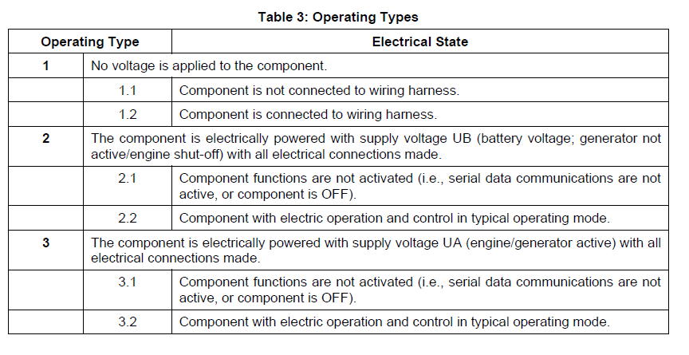

**Condition:**

Subject the component to the waveforms defined in Table 24, Table 25/Figure 29, and Table 26/Figure 30 using the default number of cycles defined in Table 27. **Note:** - The required number of cycles may be modified in agreement with the ENV SME. - The Crank Waveform Functional Test Cycles (Table 27) are required for all components. - The Crank Waveform Durability Test Cycles (Table 27) are required only where there is a durability concern (i.e., electromechanical movement due to crank) and when it is not covered by another component specific test procedure. - 10% of the Crank Waveform Durability Test Cycles (Table 27) shall be performed at Tmin and 10% of the Crank Waveform Durability Test Cycles (Table 27) shall be performed at Tmax. - The cycle time between pulses shall be adequate to verify function (abbreviated 1-Point Functional/Parametric Check) after each pulse in the Crank Waveform Functional Test Cycles (Table 27), and adequate to not create any failures due to an unrealistic pulse frequency.

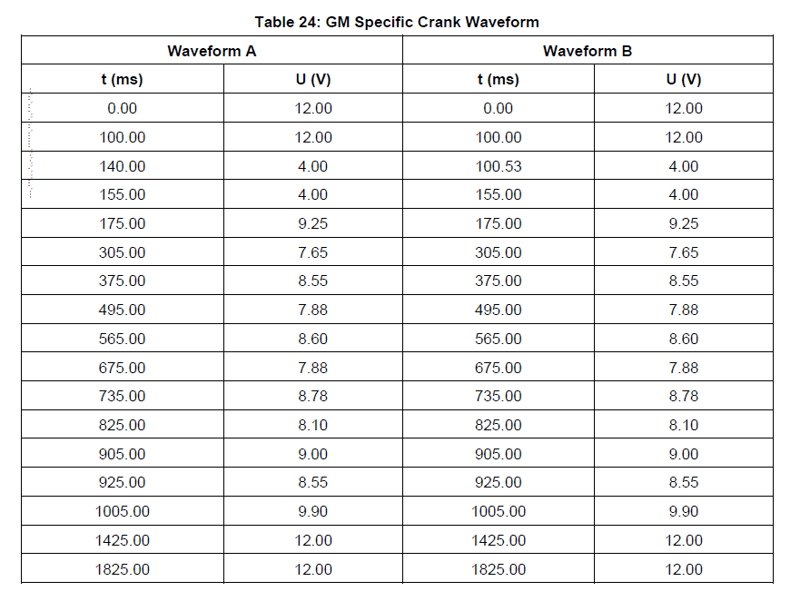

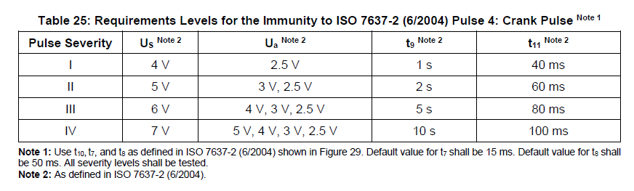

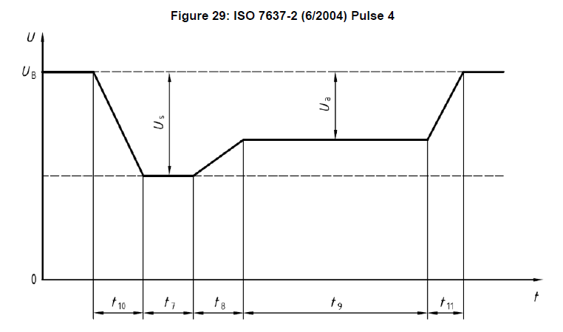

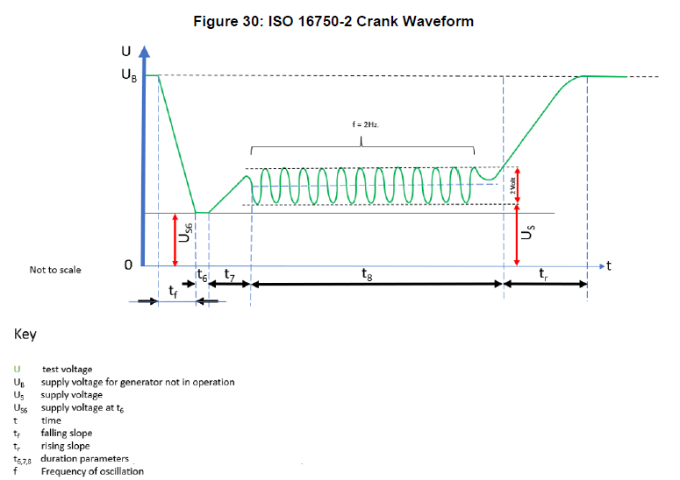

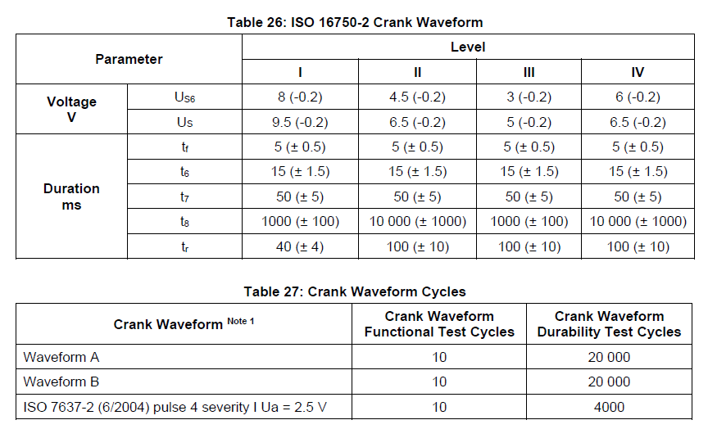

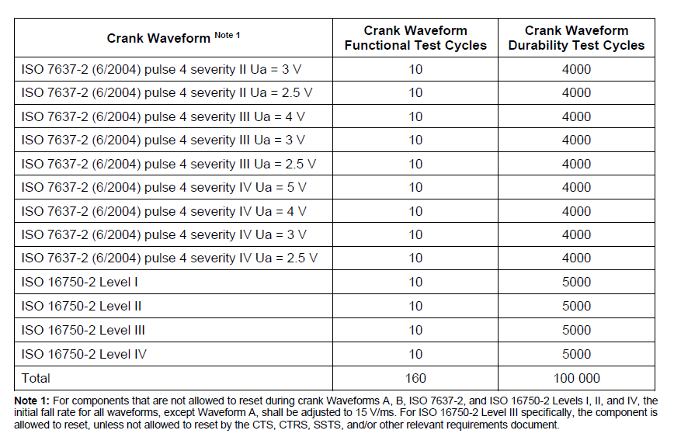 1. Perform all the Crank Waveform Durability Test Cycles (Table 27) first, if applicable. 1. After the completion of each individual row of the Crank Waveform Durability Test Cycles (Table 27), perform a 1-Point Functional/Parametric Check (total of 16 1-Point Functional/Parametric Checks). 1. Perform the Crank Waveform Functional Test Cycles (Table 27). 1. After the completion of each individual waveform of the Crank Waveform Functional Test Cycles (Table 27), perform an abbreviated 1-Point Functional/Parametric Check (total of 160 abbreviated 1-Point Functional/Parametric Checks).

**Note:** - The time between durability test cycles shall be such that the internal voltages in the component shall have had time to stabilize. - While the waveform voltage is at 12 V, the component shall be in Operating Type 3.2. When at 12 V after the pulse, a 1-Point Functional/Parametric Check shall be performed.

**Criteria:** - FSC shall be A, except for the ISO 16750-2 Level III waveform (see note following). - Temporary functional deviations (or resets) are only accepted if defined by the CTS, CTRS, SSTS, and/or other relevant requirements document.

**Note:** The FSC shall be C for the ISO 16750-2 Level III waveform but the component is allowed to reset, unless not allowed by the CTS, CTRS, SSTS, and/or other relevant requirements document.

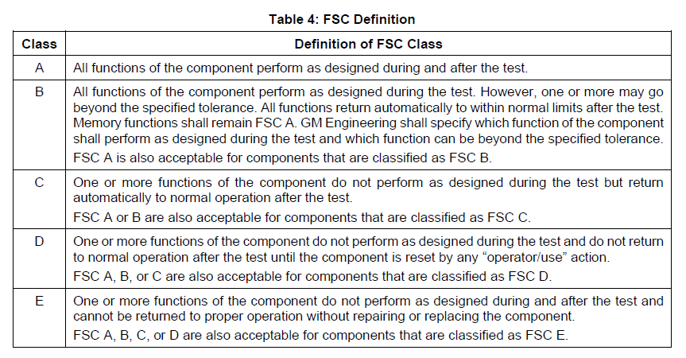

# TER-283: Multiple Power and Multiple Ground Short Circuit including Pass Through (GMW3172 / March 2023 - 9.2.8)

**Description:**

This test shall verify that the component does not show a dangerous behavior when a short circuit fault current is drawn through the component. It is not intended to test the vehicle wire harness, connector, and fuse. Fusing shall be replaced with a short and the power supply shall be set to provide enough current to represent the worst-case condition of the fuse prior to opening. An opened switch shall represent the opened fuse. Applicability: This test applies to the following components: - Containing multiple power lines. - Containing interconnected multiple power lines, only one side connected to battery, without any internal current limiting elements (power line pass through circuit). - Containing multiple ground lines. - Containing interconnected multiple ground lines, only one side connected to ground, without any internal current limiting elements (ground pass through circuit). - All pins that are not deemed to be an I/O line.

**Note:** If the multiple power (ground) lines are isolated from each other inside the module as shown in Figure 21 and Figure 22 (i.e., > 100 k-ohm as measured between the Battery/Ground lines), then this test can be “validated by analysis”. The circuit design shall be reviewed with the ENV SME, or Test Plan Approver if no ENV SME is assigned to the component, to verify that this test can be validated by analysis.

Two test scenarios represent real vehicle short circuit failure modes: - Low Resistive Short Circuit (i.e., current limit at 250% of the anticipated fuse rating). - High Resistive Short Circuit (i.e., current limit at 130% of the anticipated fuse rating).

**Condition:**

Low Resistive Short Circuit: - Set up a power supply to Umax with a current limit at 250% of the anticipated fuse rating. The wires used shallhave a resistance < 35 mΩ and be capable of handling the rated current. All inputs/outputs shall be connected to their specified loads.

* + For power lines, consider the largest anticipated fuse rating in vehicle applications (default value: 15 A for input ratings ≤ 10 A, 30 A for input ratings > 10 A).
  + For ground lines, consider a 30 A fuse rating.
* At t = 0 s, turn on the component and operate it for 300 s.
* At t = 300 s:
  + For power lines, apply a short to ground according to Figure 23 for a duration of 300 ms and setresistance to 0 Ω (e.g., a shunt). Note that in the test set-up that is shown in Figure 23, an open switch is used to represent the opened fuse that occurs due to the shorting event.
  + For ground lines, apply a short to battery according to Figure 24 for a duration of 300 ms and set resistance to 0 Ω (e.g., a shunt). Note that in the test set-up that is shown in Figure 24, an open switch is used to represent the opened fuse that occurs due to the shorting event.
* Repeat Step 1 through Step 3 for all applicable lines

**Note:** The tested samples are not allowed to perform the High Resistive Short Circuit test. New samples shall be used for the High Resistive Short Circuit test.

High Resistive Short Circuit: - Set up a power supply to Umax with a current limit at 130% of the anticipated fuse rating. The wires used shall have a resistance < 35 mΩ and be capable of handling the rated current. All inputs/outputs shall be connected to their specified loads. - For power lines, consider the largest anticipated fuse rating in vehicle applications (default value: 15 A for input ratings ≤ 10 A, 30 A for input ratings > 10 A). - For ground lines, consider a 30 A fuse rating. - At t = 0 s, turn on the component and operate it for 300 s. - At t = 300 s: - a For power lines, apply a short to ground according to Figure 23 for a duration of 10 minutes and set resistance to > 0 Ω to obtain a current of 130% of fuse rating. Note that in the test set-up that is shown in Figure 23, an open switch is used to represent the opened fuse that occurs due to the shorting event. - For ground lines, apply a short to battery according to Figure 24 for a duration of 10 minutes and set resistance to > 0 Ω to obtain a current of 130% of fuse rating. Note that in the test set-up that is shown in Figure 24, an open switch is used to represent the opened fuse that occurs due to the shorting event. - Repeat Step 1 through Step 3 for all applicable lines.

**Note:** The same sample may be used repeatedly if damage does not invalidate the test on other pass through circuits.

**Criteria:** 1. For the Low Resistive Short Circuit test: a FSC shall be D. b During the Visual Inspection and Dissection - DRBTR, there shall be no evidence of overheating. 1. For the High Resistive Short Circuit test: a FSC shall be E. b During the Visual Inspection and Dissection - DRBTR, minor amounts of carbon may appear near the open circuit. A safety critical behavior (e.g., smoke, fire, melted plastics, etc.) is not allowed.

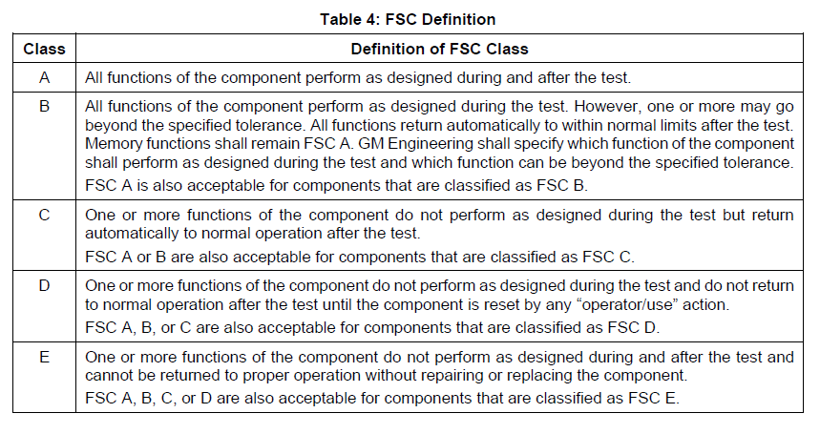

# TER-282: Pulse Superimposed Voltage (GMW3172 / March 2023 - 9.2.5)

**Description:**

This test shall verify the component immunity to supply voltage pulses that occur on battery supply in the normal operating voltage range. These voltage pulses will simulate a sudden high current load change to the battery supply line, causing a voltage drop or voltage rise at switch on or off. This test simulates loads with inrush current behavior such as motors, incandescent bulbs, or long wire harness resistive voltage drops modulated by Pulse Width Modulation (PWM) controlled high loads. Applicability: All components that have power supplied by the vehicle battery 12 V wiring system, either directly or through an external component. Operating Type: 3.2

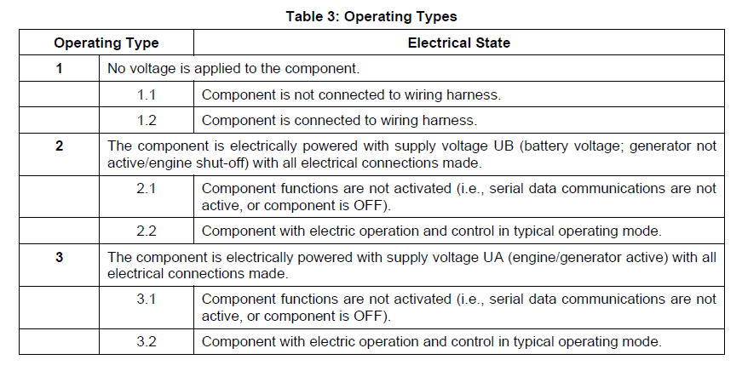

**Condition:**

Procedure: Refer to Figure 18, including the test setup definitions and parameters shown in Figure 18. 1. Connect the component to the Uo output. 1. Stabilize component at temperature Troom. 1. Set Us = Umax - 2 V. 1. Perform 5 continuous frequency sweep cycles while continuously monitoring for intermittent faults. 1. Decrease Us by 1 V. 1. Repeat Step 4 and Step 5 until (Us = Umin + 2 V).

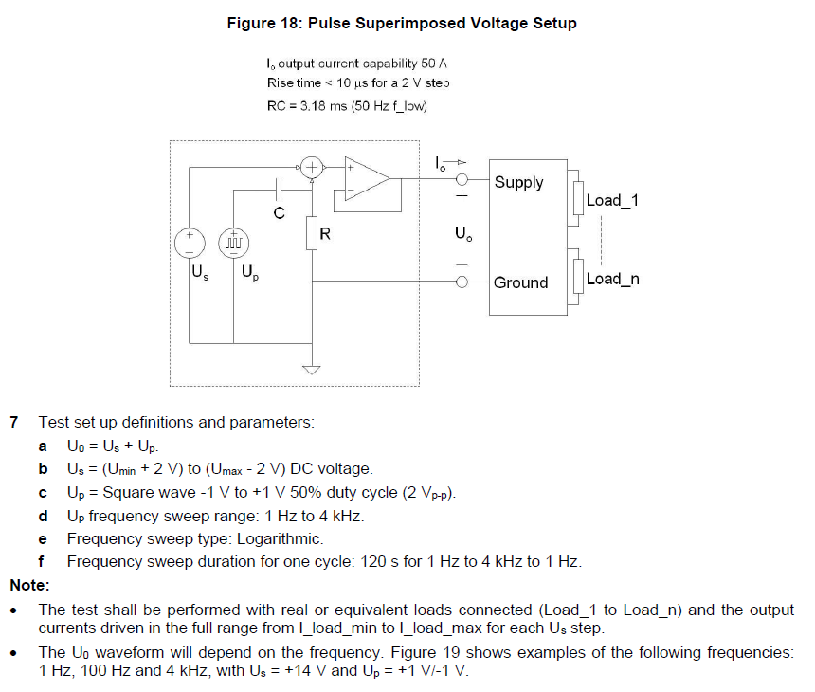

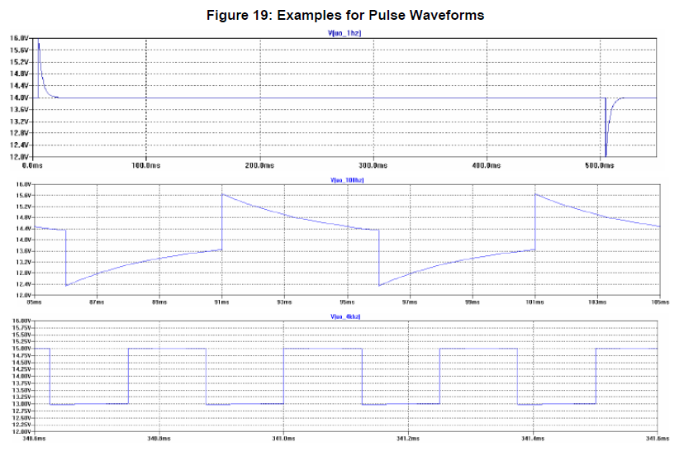

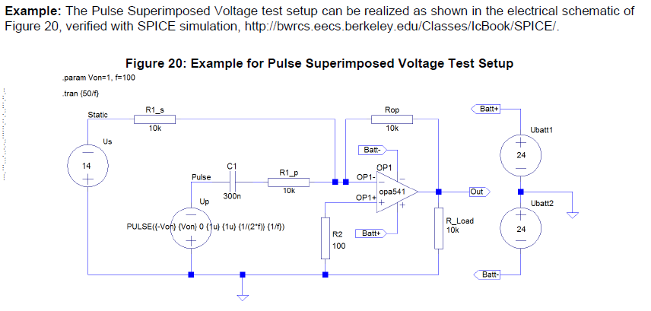

**Criteria:**

FSC shall be A.



# TER-281: Sinusoidal Superimposed Voltage (GMW3172 / March 2023 - 9.2.4)

**Description:**

This test shall verify the component immunity to generator output ripple voltage due to rectified sinusoidal generator voltage. Applicability: All components that have power supplied by the vehicle battery 12 V wiring system, either directly or through an external component. Operating Type: 3.2, with voltage levels as defined in ISO 16750-2 “Superimposed alternating voltage with severity Level 2”

**Condition:**

Use the test methods according to ISO 16750-2 “Superimposed alternating voltage with severity Level 2” (4 Vp-p).



**Criteria:**

FSC shall be A{**}.{**}

