**Name: Rakibul Islam**

**Id: 18201014**

**Report**

**Problem Statement:**

Implement the Multivariable Linear Regression Using Open-Source Dataset with and without SK-Learn.

**Multiple Linear Regression**

Multiple Linear Regression is one of the important regression algorithms which models the linear relationship between a single dependent continuous variable and more than one independent variable. The goal of multiple linear regression is to model the linear relationship between the explanatory (independent) variables and response (dependent) variables.

By looking at a linear regression model, analysts can make predictions about the dependent variable based on data gleaned from multiple independent variables.

**Formula and Calculation of Multiple Linear Regression.**

*yi*​= *β*0​ + *β*1​*xi*1​ + *β*2​*xi*2 ​+ ... + *βp*​*xip* ​+ *ϵ*

**where, for***i*=*n***observations:**

*yi*​ = dependent variable

*xi*​ = explanatory variables

*β*0​ = y-intercept (constant term)

*βp* = slope coefficients for each explanatory variable

*ϵ*=the model’s error term (also known as the residuals)​

**Tools and Languages**

* **Programing Language**: Python
* **IDE**: Jupyter Notebook

**Linear Regression With SK-Learn: Output and prediction of box office.**

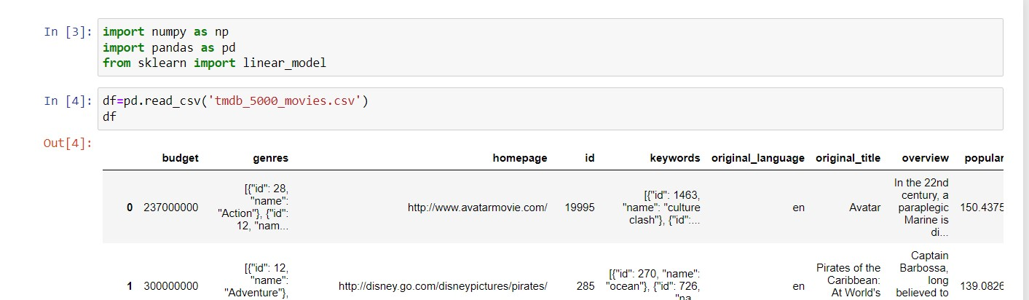

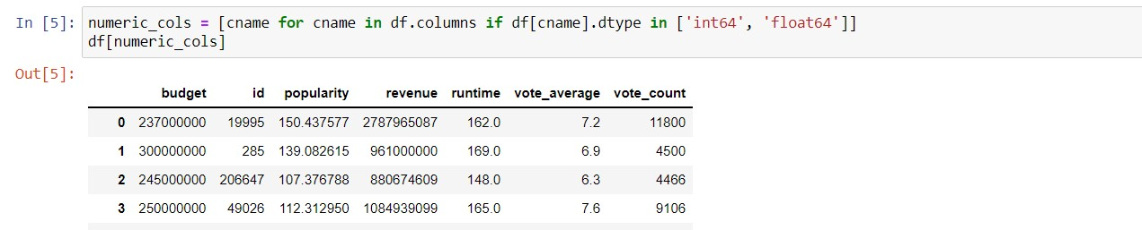

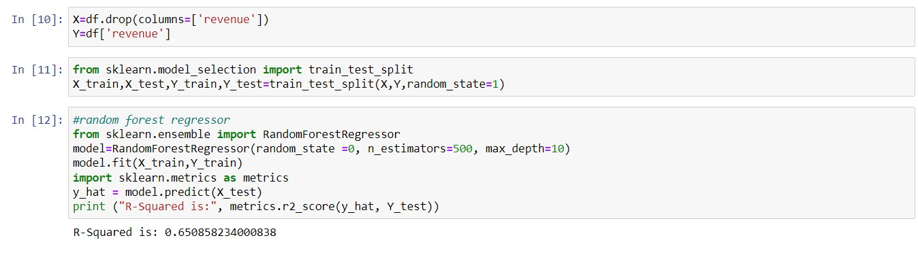

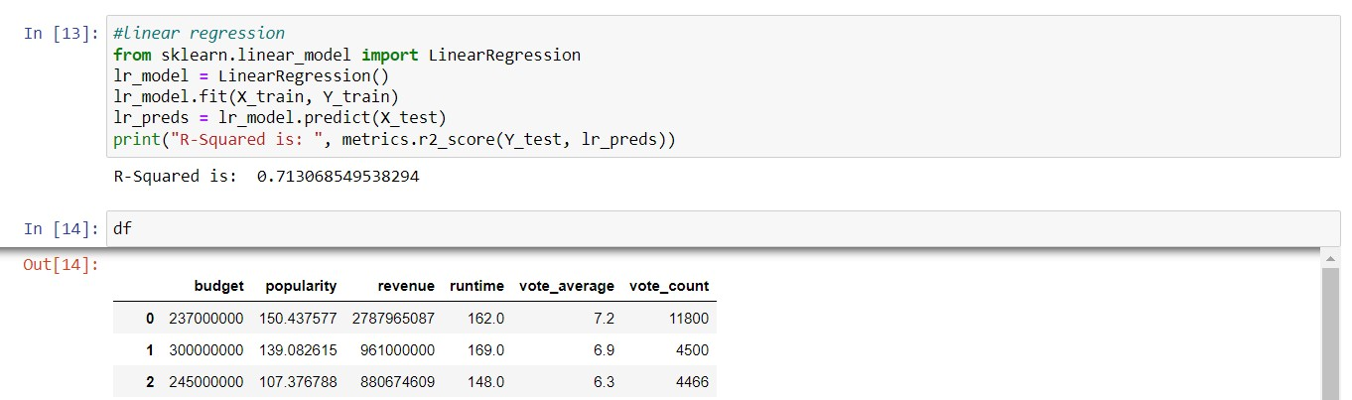

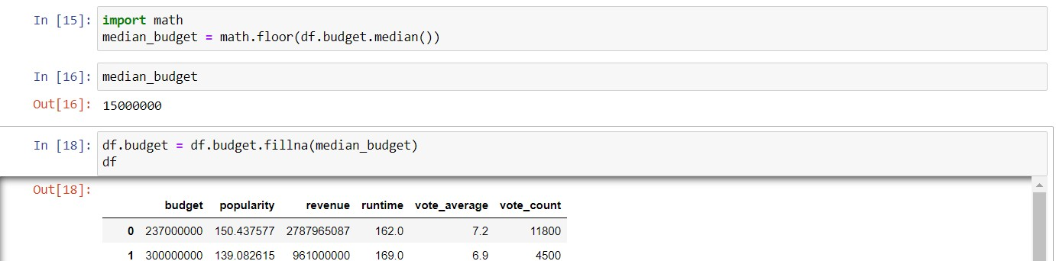

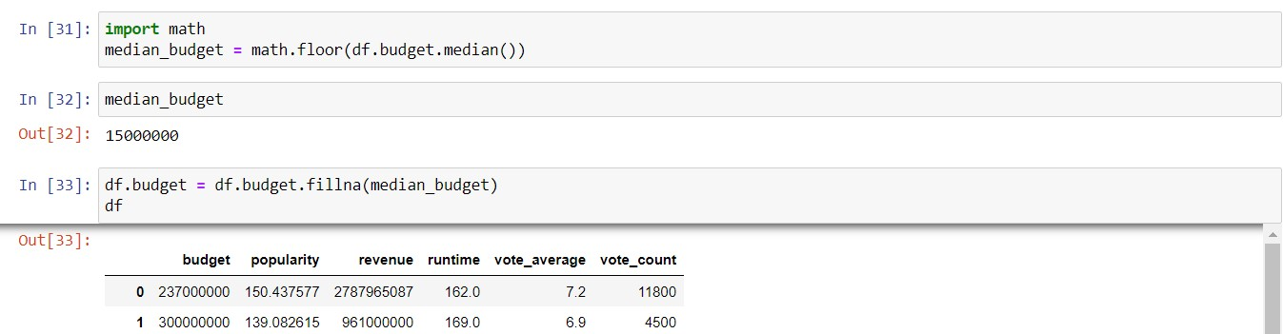

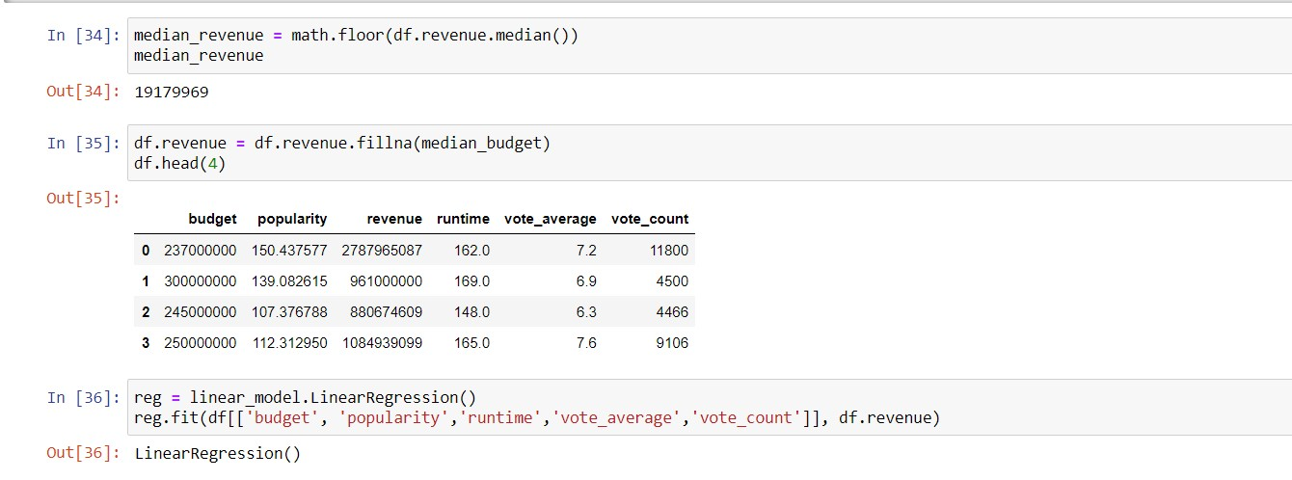

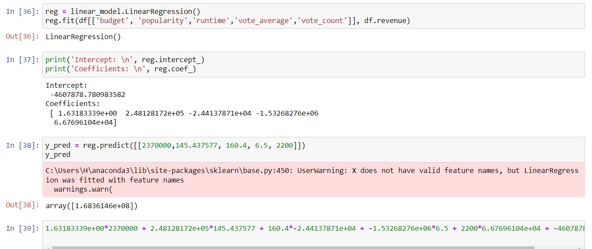

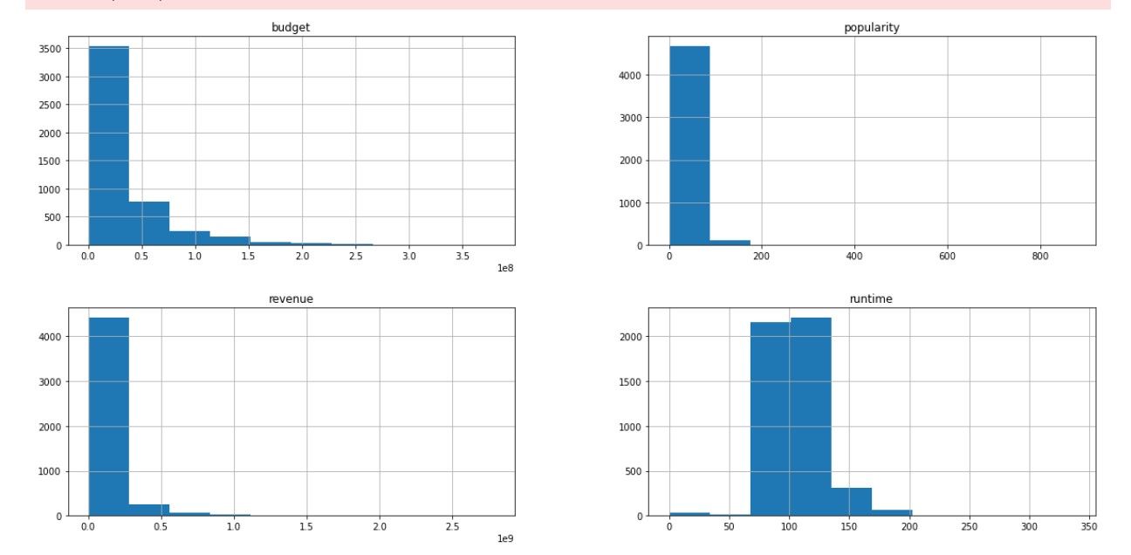

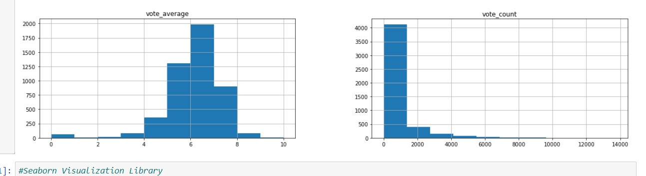

**Linear Regression Without SK-Learn: Output and prediction of box office.**

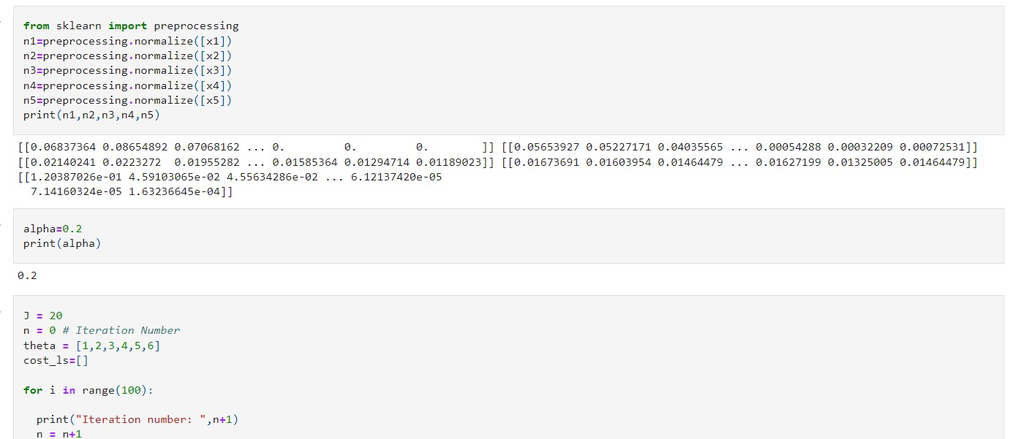

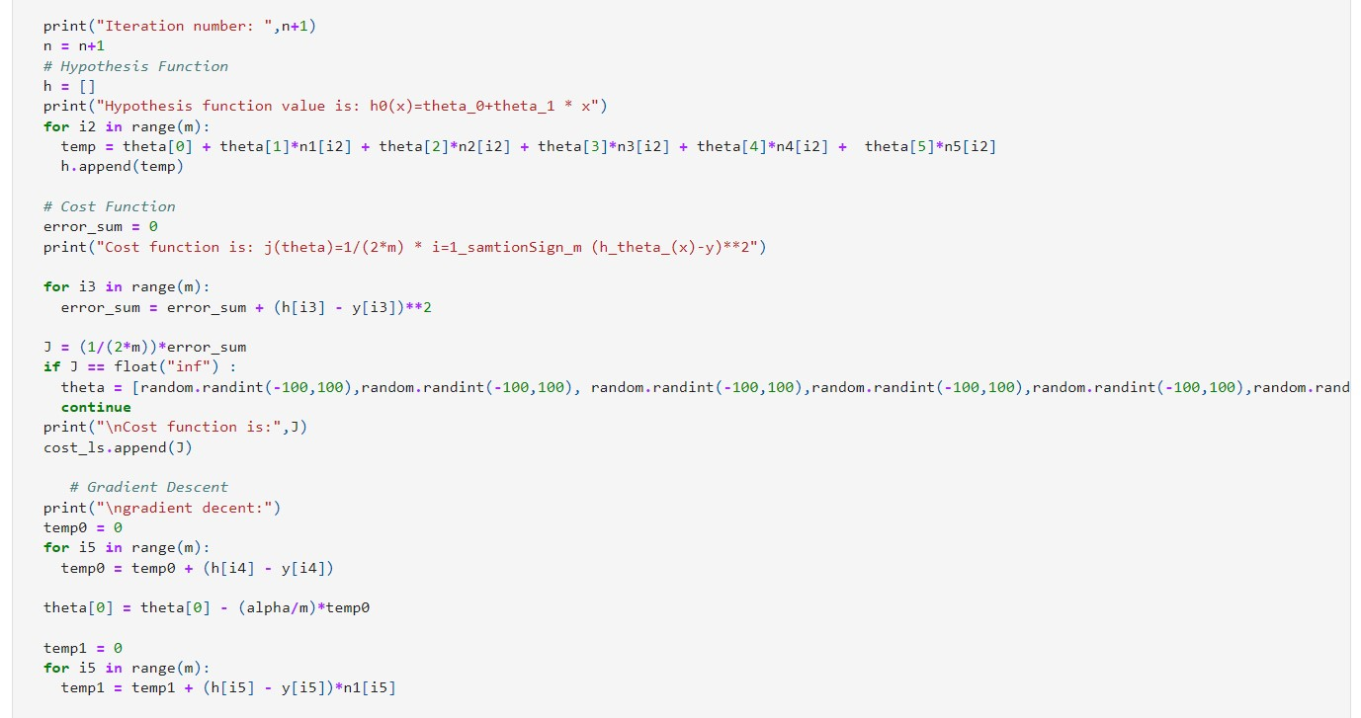

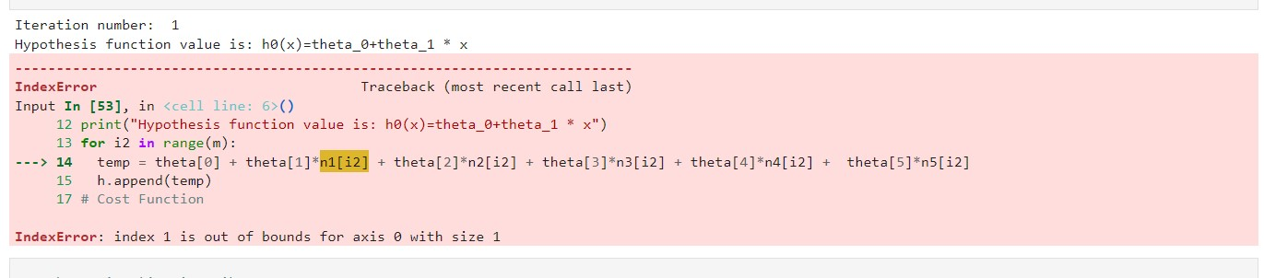

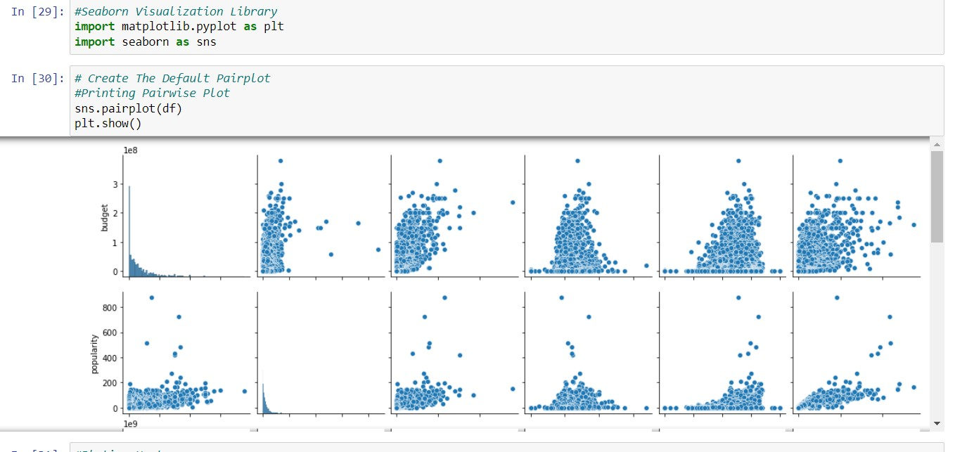

**Plotting Heatmap**

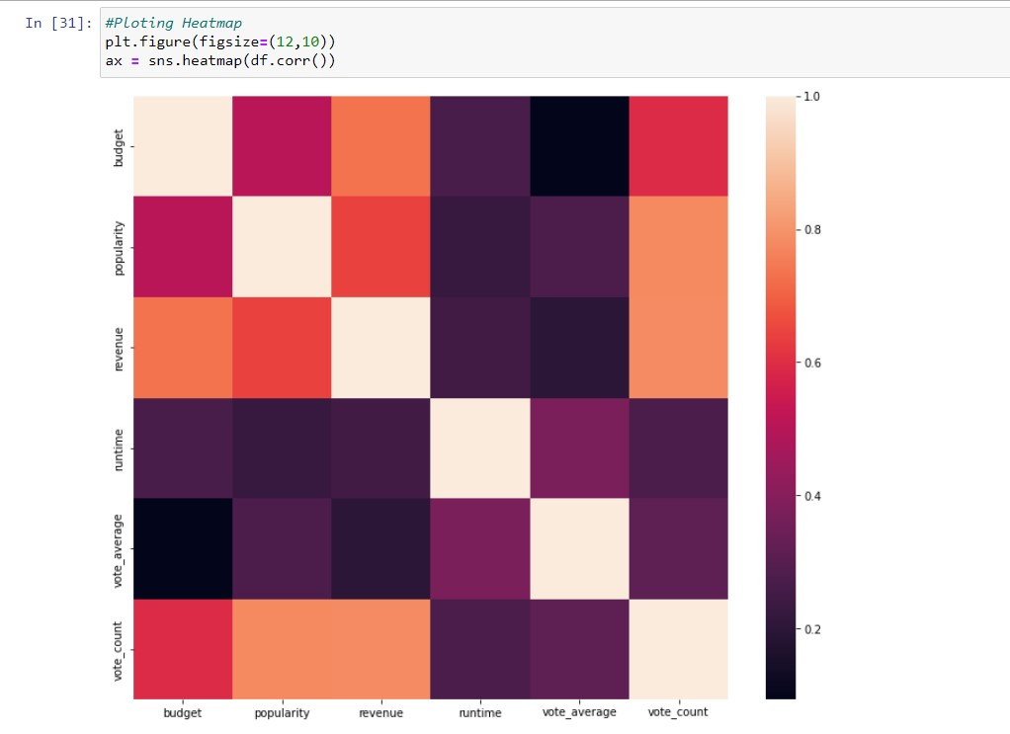

**Conclusion:** Multiple regression is an extension of simple linear regression. In this project, after successful implementation, I’ve a brief knowledge about linear regression. Multiple linear regression models are useful in helping an enterprise to consider the impact of multiple independent predictors and variables on a dependent variable and can be beneficial for forecasting and predicting results. So, the outcome knowledge of this project will help me a lot to real-life problem predicting and solving on various field.

GitHub link of this code: <https://github.com/raakibulislam/Box-Office-Prediction>