

TDS 3401 PROJECT REPORT

PROJECT TITLE:

**Overall Trends of Crime Rates in Malaysia from 2010 - 2015**

Group Members:

Muhammad Aliff Mustaqim bin Abd Rahman 1151104153 (TT03)

Mohamad Haziq bin Mohamad Faizul 1161102647 (TT03)

Raden Ameer Hanafi bin Hambali 1171302475 (TT01)

# Proposed Storyboard

The proposed storyboard prior to actual implementation of the project using d3:

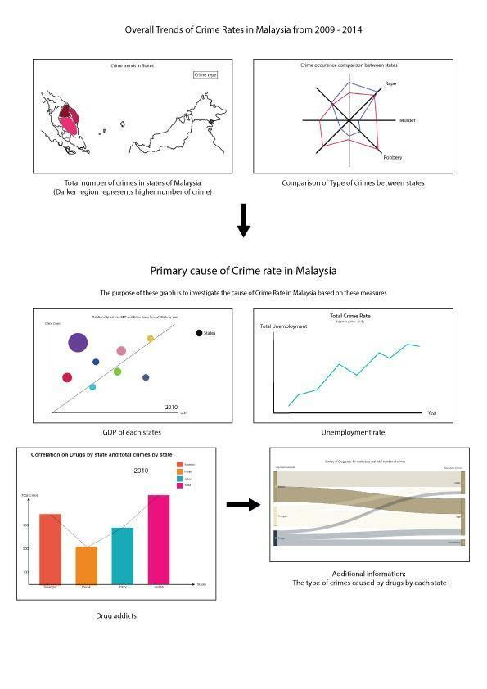

# Dataset Description

Source:

1. <https://www.data.gov.my/data/ms_MY/dataset/statitisk-jenayah-indeks-seluruh-malaysia-mengikut-jenis-jenayah-negeri-dan-tahun>
2. <http://www.data.gov.my/data/ms_MY/dataset/labour-force-statistics-malaysia-1092>
3. <http://www.data.gov.my/data/en_US/dataset/gdp-per-capita-by-state-at-current-prices-rm>
4. <https://www.data.gov.my/data/ms_MY/dataset/jumlah-penagih-mengikut-negeri/resource/e828896c-1de1-4ec6-b32b-917bf35bccd3>
5. <http://www.data.gov.my/data/en_US/dataset/population-by-sex-administrative-district-and-state-malaysia-2010>

For our project we will be using 5 different datasets:

- Total Number of Different Crimes by State

- Unemployment Rate by State

- Total Drug Addicts by State

- Gross Domestic Product (GDP) Per Capita by State

- Population by State

The datasets contain:

- Total number of different crimes such as murder and rape for each state from 2009-2015

- Rate of unemployment for each state in Malaysia from 1982 to 2016

- Total number of drug addicts for each state from 2010 to 2016

- GDP per capita for each state from 2005 to 2015

- The population for every state in Malaysia from 2010 until 2015

# Task Distribution

The group members are each given a task to complete two visualizations for the storyboard. The first two visualizations were done by Mohamad Haziq bin Mohamad Faizul, and other four visualizations that describe the factors are being done by Muhammad Aliff Mustaqim bin Abd Rahman and Raden Ameer Hanafi bin Hambali.

Table below shows the details of task distribution:

|  |  |
| --- | --- |
| Students Name | Visualizations |
| Haziq Faizul | 1) Overall trend crime by state (Line Graph)  2) Comparison between states for different types of crime (Radar chart) |
| Aliff Mustaqim | 1) Relationship between Population and Total Crime by States (Bubble chart)  2) Relationship between Number of Drug Addicts and Total Crime by States (Dual axis graph - bar chart + line chart) |
| Raden Ameer | 1) GDP (Connected scatter plot)  2) Unemployment Rate (Circular Barplot)  3) Overall Dashboard |

# Overall Dashboard

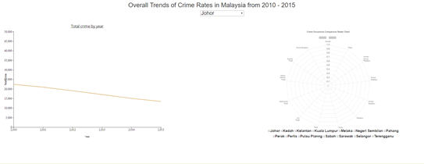

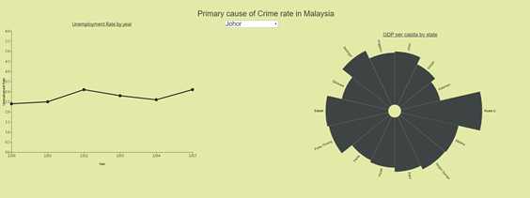

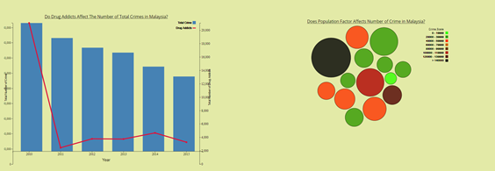

# Explanation of Visualizations

5.1 Line Graph for crime rate for each state from 2010 to 2015 (Made by Mohamad Haziq bin Mohamad Faizul)

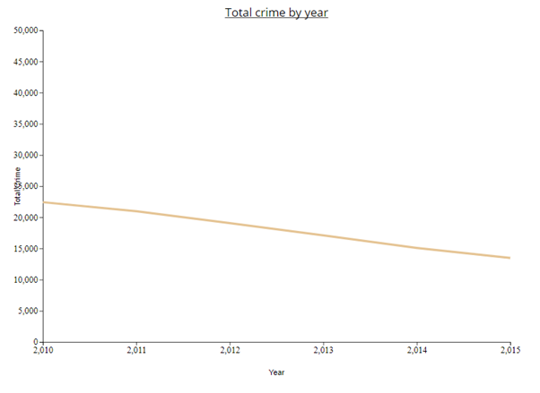

The initial plan for this particular segment was to make a choropleth map to show the crime rates throughout the Malaysian map. Due to time constraint and inability to complete such graph even after more than 50+ accumulated hours, an alternative graph was made at the last minute to compensate for the absence of the choropleth map. This line graph is a simple graph to show the trend of the overall crime rates in Malaysia from 2010 to 2015. It can be seen from the graph that all the states have a lesser amount of crime as time goes by. A filter selection is also included to see the trend of each individual state. The labeling on the x-axis and the y-axis as well as the graph title will be included in the final storyboard

5.2 Radar Chart for crime rate for each state from 2010 to 2015 (Made by Mohamad Haziq bin Mohamad Faizul)

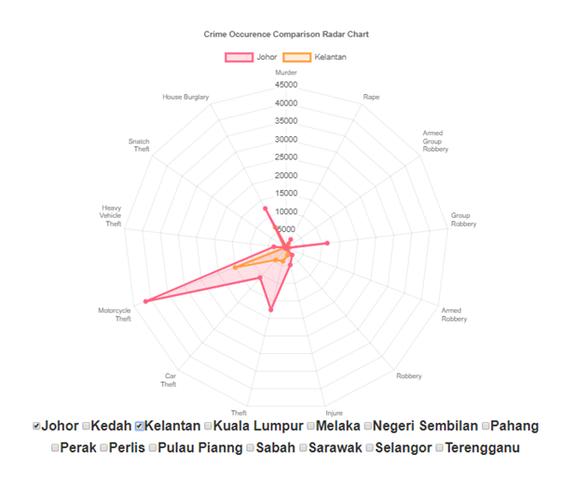

The radar chart that was made according to the plan of the proposal. The time taken to attempt to complete this graph is more than 3 consecutive days. Due to the incompetence and lack of experience, the graph is incomplete. An alternative plan could not be made as the deadline is catching up. Only the filters for the states Johor, Kedah and Kelantan could be used in the graph. This chart was made as a comparison between states for different types of crime from 2010 to 2015.

5.3 Unemployment Rate by year chart using connected scatter plot (Raden Ameer Hanafi bin Hambali) 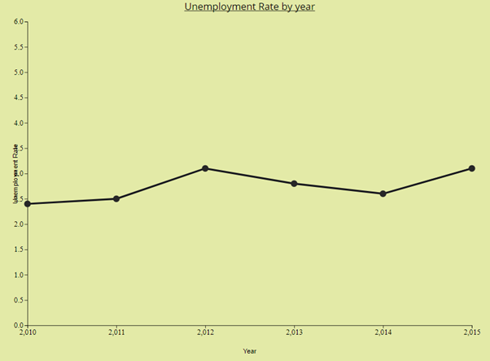

The chart visualizes the Unemployment Rate number for every state in Malaysia from 2010 until 2015. The interaction happened for this chart is when the user is able to select a specific state. It will change the chart based on the specific state and its unemployment rate.

5.4 GDP per capita by state chart using circular bar plot (Raden Ameer Hanafi bin Hambali)

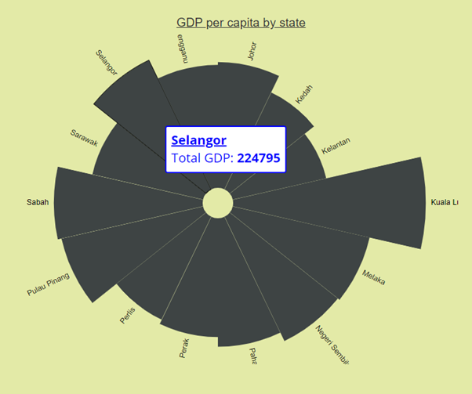

The chart visualizes the Gross domestic products (GDP) number for every state in Malaysia from 2010 until 2015. The interaction happened for this chart is when the user hover the mouse on any bar chart. It will pop up the tooltip that shows the description of Total GDP number and the name of the state.

5.5 Comparison between Total Number of Drug Addicts and Total Number of Crime (Muhammad Aliff Mustaqim bin Abd Rahman)

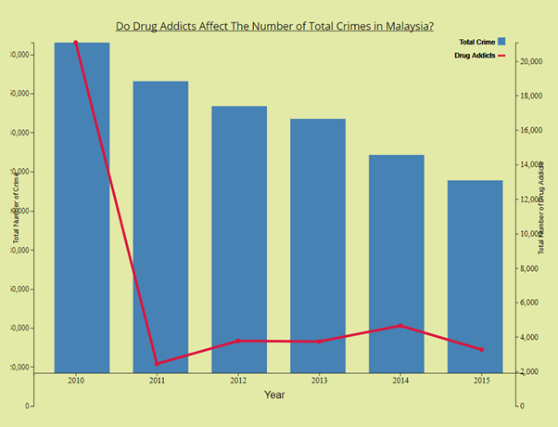

The objective of this dual axis graph is to compare the rate for the number of drug addicts and crime rate in Malaysia. For this graph, the blue bar chart represents the total number of crime happened each year, while the red line is for the total number of drug addicts each year. We can conclude that there is no correlation between drug addicts and number of crime as the rate of crime is decreasing each year while number of drug addicts increased. We can debunk the perception of Malaysian citizen that claimed crime happened because of drug addicts in Malaysia.

5.6 Correlation between Total Number of Population and Total Number of Crime (Muhammad Aliff Mustaqim bin Abd Rahman)

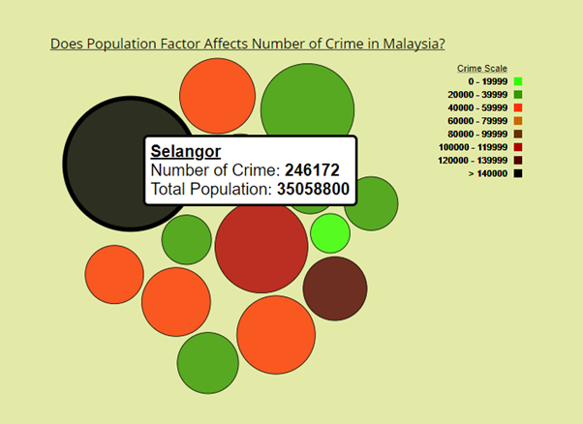

This graph uses Bubble chart to represent the relationship between total population and total crime in Malaysia for every state. The purpose of this chart is to study if the population number is affecting the number of crimes in each state. The size of a circle represents the scale of total population, which means the higher the population number, the bigger the size of circle. While different set of color represent the degree for number of crimes with black color is the highest and light green is the lowest. This chart provides users to drag the circle and compare it with other circles for easier comparison. It also provides tooltip for each circle that give more details about the statistics.

# Conclusion

From this project, we can conclude that the factors studied do have a correlation and effect on the crime rates. The crime rates for every state decrease from 2010 to 2015. It can also be seen that motorcycle theft has the highest occurrence among other crimes. The unemployment rate for the states has the highest correlation and impact on the crime rates, followed by GDP, and population. The number of drug addicts however does not correlate to the crime rate for different states in Malaysia.