

TDS 3401 PROJECT REPORT

PROJECT TITLE:

**Overall Trends of Crime Rates in Malaysia from 2010 - 2015**

Group Members:

Muhammad Aliff Mustaqim bin Abd Rahman 1151104153 (TT03)

Mohamad Haziq bin Mohamad Faizul 1161102647 (TT03)

Raden Ameer Hanafi bin Hambali 1171302475 (TT01)

# Proposed Storyboard

The proposed storyboard prior to actual implementation of the project using d3:

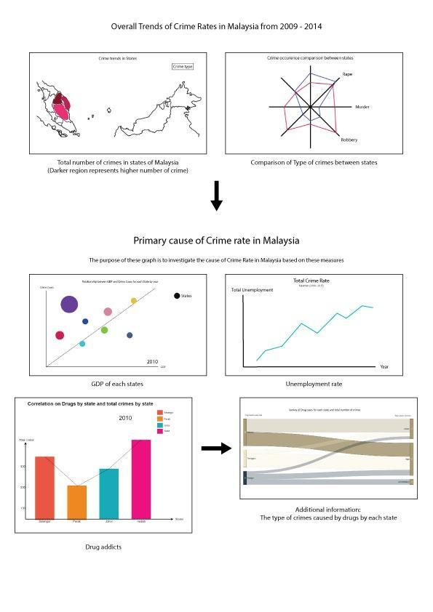

# Dataset Description

Source:

1. <https://www.data.gov.my/data/ms_MY/dataset/statitisk-jenayah-indeks-seluruh-malaysia-mengikut-jenis-jenayah-negeri-dan-tahun>
2. <http://www.data.gov.my/data/ms_MY/dataset/labour-force-statistics-malaysia-1092>
3. <http://www.data.gov.my/data/en_US/dataset/gdp-per-capita-by-state-at-current-prices-rm>
4. <https://www.data.gov.my/data/ms_MY/dataset/jumlah-penagih-mengikut-negeri/resource/e828896c-1de1-4ec6-b32b-917bf35bccd3>
5. <http://www.data.gov.my/data/en_US/dataset/population-by-sex-administrative-district-and-state-malaysia-2010>

For our project we will be using 5 different datasets:

- Total Number of Different Crimes by State

- Unemployment Rate by State

- Total Drug Addicts by State

- Gross Domestic Product (GDP) Per Capita by State

- Population by State

The datasets contain:

- Total number of different crimes such as murder and rape for each state from 2009-2015

- Unemployment rate for each state from 1982 to 2016

- Total number of drug addicts for each state from 2010 to 2016

- GDP per capita for each state from 2005 to 2015

- The population for every state

# Task Distribution

The group members are each given a task to complete two visualizations for the storyboard. The first two visualizations were done by Mohamad Haziq bin Mohamad Faizul, and other four visualizations that describe the factors are being done by Muhammad Aliff Mustaqim bin Abd Rahman and Raden Ameer Hanafi bin Hambali.

Table below shows the details of task distribution:

|  |  |
| --- | --- |
| Students Name | Visualizations |
| Haziq Faizul | 1) Overall trend crime by state (Line Graph)  2) Comparison between states for different types of crime (Radar chart) |
| Aliff Mustaqim | 1) Relationship between Population and Total Crime by States (Circle Packing Layout)  2) Relationship between Number of Drug Addicts and Total Crime by States (Dual axis graph - bar chart + line chart) |
| Raden Ameer | 1) GDP (Connected scatter plot)  2) Unemployment Rate (Circu) |

# Overall Dashboard

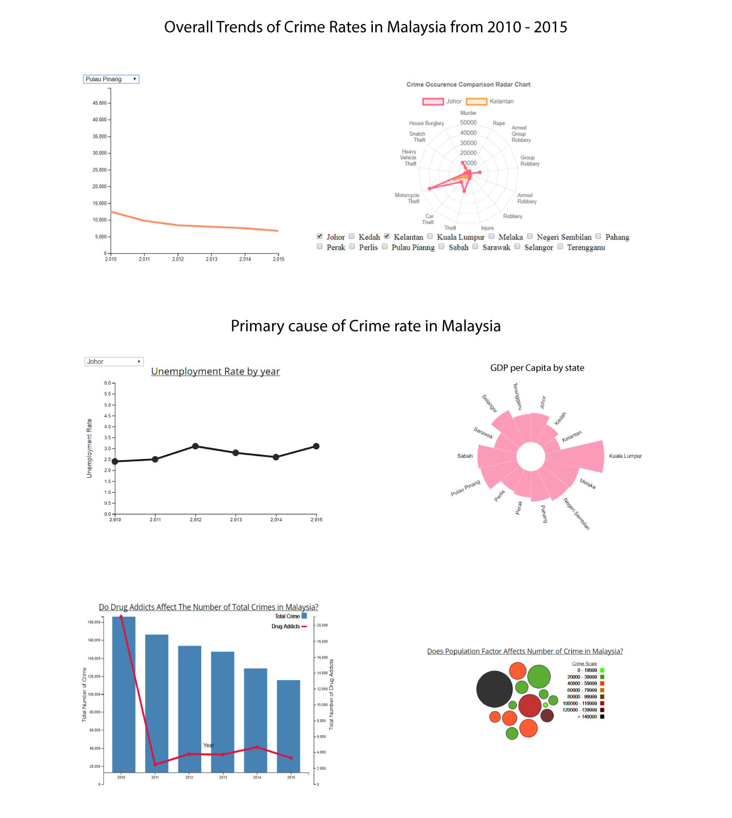

# Explaination of Visualizations

5.1 Line Graph for crime rate for each state from 2010 to 2015 (Made by Mohamad Haziq bin Mohamad Faizul)

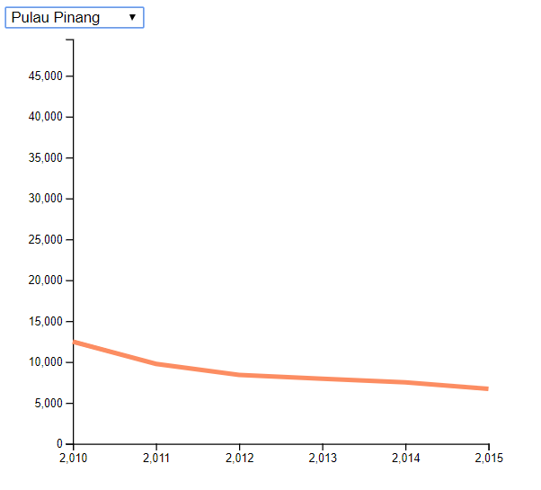

The initial plan for this particular segment was to make a choropleth map to show the crime rates throughout the Malaysian map. Due to time constraint and inability to complete such graph even after more than 50+ accumulated hours, an alternative graph was made at the last minute to compensate for the absence of the choropleth map. This line graph is a simple graph to show the trend of the overall crime rates in Malaysia from 2010 to 2015. It can be seen from the graph that all the states have a lesser amount of crime as time goes by. A filter selection is also included to see the trend of each individual state.

5.2 Radar Chart for crime rate for each state from 2010 to 2015 (Made by Mohamad Haziq bin Mohamad Faizul)

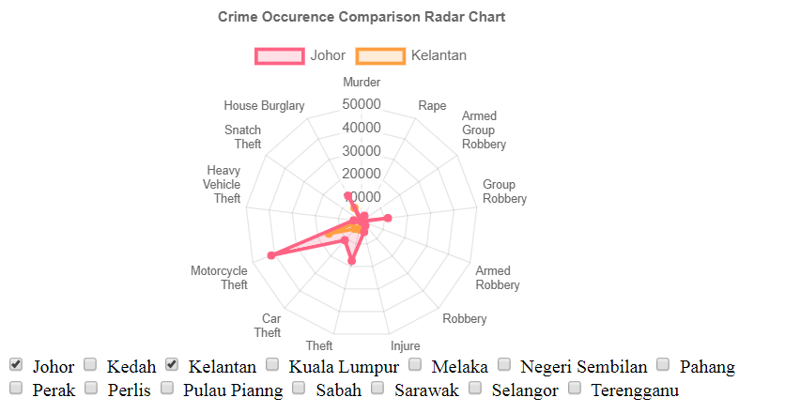

The radar chart that was made according to the plan of the proposal. The time taken to attempt to complete this graph is more than 3 consecutive days. Due to the incompetence and lack of experience, the graph is incomplete. The graph could also not be included in the storyboard due to problems with merging the graph. An alternative plan could not be made as the deadline is catching up. Only the filters for the states Johor, Kedah and Kelantan could be used in the graph. This chart was made as a comparison between states for different types of crime from 2010 to 2015.