# 1. Run nginx image detached with param -p 80:80 named mynginx1
docker run -d -p 80:80 --name mynginx1 nginx
# 2. Check that the nginx page (localhost:80)
curl http://localhost:80
# 3. Run a shell without stopping the Container
docker exec -it mynginx1 /bin/bash
# 4.Update the file
docker exec mynginx1 sh -c 'echo "<h1>Hello from My Awesome Container!</h1>" > /usr/share/nginx/html/index.html'
# 5. Check that the nginx page has been updated (localhost:80)
curl http://localhost:80
# 6. Create a transitive image named my_awsome_image
docker commit mynginx1 my_awsome_image
# 7. Run the new image
docker stop mynginx1
docker run -d -p 80:80 --name test_awesome my_awsome_image
# 8. Check that the modifications are still present (localhost:80)
curl http://localhost:80
# 9. Check the layer with the docker history command
docker history my_awsome_image
## Upload our image
# 1 . Tag your image with the tag <dockerHubId>/my_awsome_image:1.0
docker tag my_awsome_image hachemboudoukha/my_awsome_image:1.0
# 2. List your docker images
docker images
# 4. Push your image
docker push hachemboudouka/my_awsome_image:1.0
# suppression
docker stop test_awesome mynginx1
docker rm test_awesome mynginx1
docker rmi my_awsome_image hachemboudoukha/my_awsome_image:1.0 nginx
1 et 2
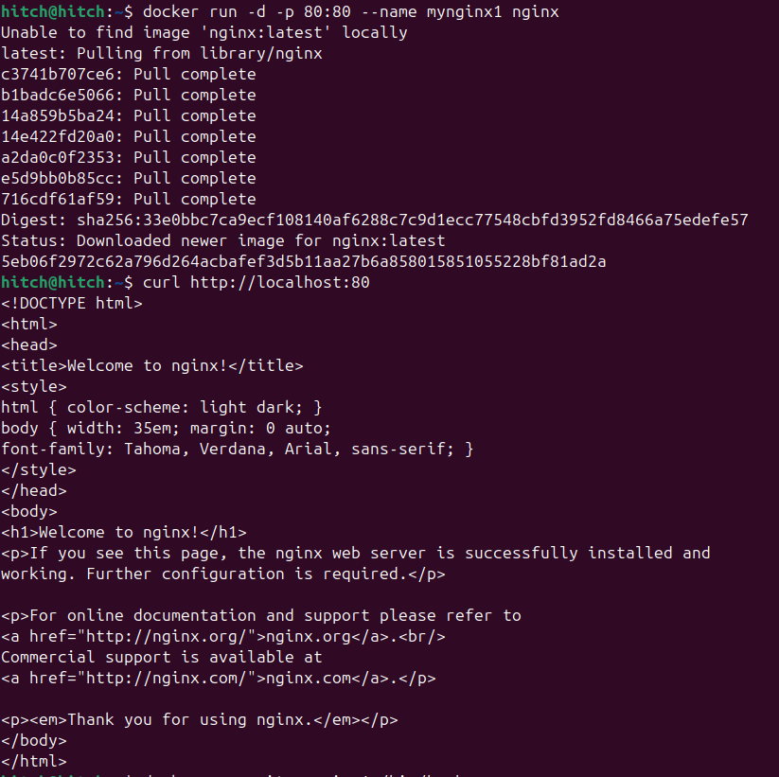
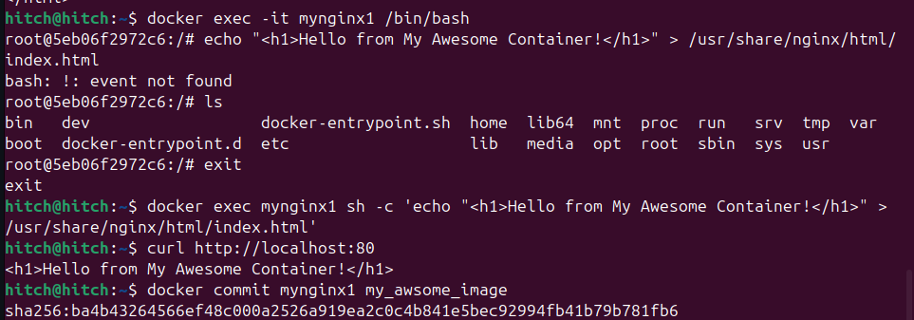
3 , 4 , 5 et 6

7, 8, ET 9
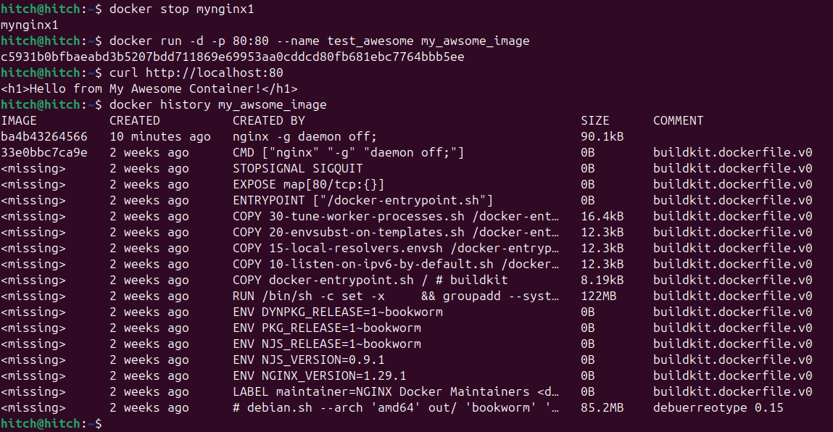
tag et push et suppression

