**Introduction**

Road safety is a critical concern globaly, with distracted driving being a major cause of accidents. Vehicle insurance companies are exploring innovative solutions to enhance monitoring and reduce accident rates. Implementing cameras on insured vehicles presents a promising approach. This project investigates the feasibility, methodology, and potential benefits of deploying camera systems in insured vehicles to monitor driver behavior, improve real-time response, and facilitate efficient claims processing.

**Objective**

The objective of this project is to develop and implement a camera-based monitoring system for insured vehicles. The goals are to:

1. Enhancing real-time monitoring of driver behavior.
2. Improving accuracy in identifying causes of accidents.
3. Facilitating efficient claims processing and fraud detection.
4. Promoting safer driving habits among policyholders.

**Problem Description**

**What**

Distracted driving is a significant contributor to road accidents, leading to severe injuries and fatalities. Traditional methods of monitoring driver behavior rely heavily on manual observation, which is labor-intensive, time-consuming, and often prone to human error. The lack of real-time capabilities in these methods further exacerbates the problem, as immediate intervention is crucial in preventing accidents.

**Why**

The implementation of cameras on insured vehicles addresses several critical issues in road safety and insurance management. Automated monitoring systems provide continuous surveillance, enabling real-time detection and response to unsafe driving behaviors. This not only enhances road safety but also assists insurance companies in accurately identifying the causes of accidents, thereby improving the efficiency of claims processing and reducing fraudulent claims. Additionally, promoting safer driving habits among policyholders can lead to lower accident rates and reduced insurance premiums.

**Methodology**

**Approach and Methods**

The project employs an Artificial Neural Network (ANN)-based model to analyze images captured by the cameras. The methodological approach involves several key steps, each designed to ensure the accuracy and efficiency of the system:

1. **Loading Dataset**: Collecting a diverse dataset of driver behaviors from various sources, ensuring a wide range of driving conditions and behaviors are represented.
2. **Normalizing**: Standardizing the image data to ensure consistency in input, which is critical for the effective training of the neural network.
3. **Class Mapping**: Categorizing different types of distracted driving behaviors into predefined classes. This step is essential for the model to accurately classify and predict driver behaviors.
4. **Implementing Model**: Building the ANN model involves defining the architecture, including convolutional layers for feature extraction, pooling layers for downsampling, dropout layers to prevent overfitting, and dense layers for classification.
5. **Model Training**: Training the model on the collected dataset to optimize the weights and biases, ensuring high accuracy in classifying driver behaviors.
6. **Testing**: Evaluating the model's performance on a separate test dataset to validate its accuracy and generalizability.
7. **Prediction**: Using the trained model to predict driver behaviors in real-time, providing continuous monitoring.
8. **Deployment**: Implementing the camera and model system in insured vehicles, integrating with existing insurance company infrastructure for continuous monitoring and data analysis.

**Model Implementation and Working**

The ANN model employed in this project consists of several key components:

1. **Convolutional Layers**: These layers are responsible for extracting local features from the input images. Each convolutional layer applies a set of filters to the input, producing feature maps that capture patterns such as edges, textures, and shapes.
2. **MaxPooling Layers**: MaxPooling layers reduce the spatial dimensions of the feature maps, retaining only the most important features. This downsampling process helps in reducing computational complexity and mitigating overfitting.
3. **Dropout Layers**: Dropout is a regularization technique used to prevent overfitting by randomly setting a fraction of the input units to zero during training. This helps in making the model more robust and generalizable.
4. **Flatten Layer**: This layer converts the 2D feature maps into a 1D vector, which can be fed into the dense layers for classification.
5. **Dense Layers**: The dense layers are fully connected layers that apply weights and biases to the input vector, using activation functions to make the final class predictions. The output layer uses a softmax activation function to produce probabilities for each class.

**Project Scope**

The project focuses on implementing a camera system for real-time monitoring of driver behavior in insured vehicles. The system stores data for 15 days, with an additional 5 days for compensation and deduction purposes. The boundaries include:

* Real-time video capture and processing.
* Classification of driver behaviors into predefined categories.
* Limited to vehicles insured by participating insurance companies.
* Data storage and retrieval for up to 20 days.

**Privacy Concerns**

Ensuring the privacy and security of collected data is paramount. The data is stored securely within the organization and accessed only for authorized purposes, such as claims processing and fraud detection. Measures include:

* **Encryption**: All data is encrypted during transmission and storage.
* **Access Control**: Strict access controls to prevent unauthorized access.
* **Data Anonymization**: Personal identifiers are anonymized to protect the identity of individuals.
* **Compliance**: Adherence to data protection regulations, such as GDPR.

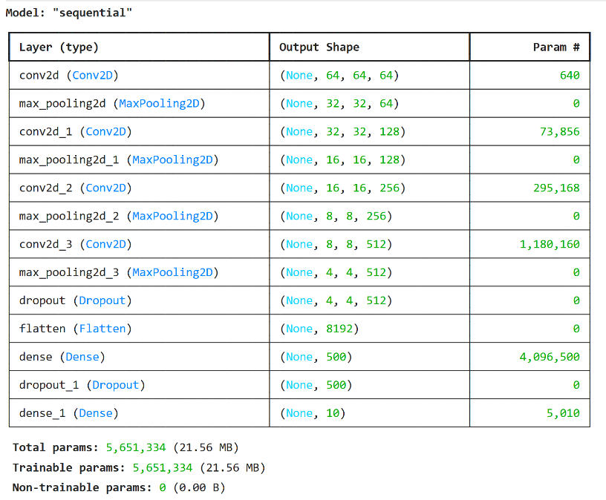**Model Architecture** The model architecture for the distracted driver detection system is designed to effectively extract and classify features from input images, ensuring high accuracy in detecting various driving behaviors. The architecture follows a sequential model comprising several layers, starting with four convolutional layers (Conv2D), each followed by a max-pooling layer (MaxPooling2D). These convolutional layers, with 64, 128, 256, and 512 filters respectively, are responsible for detecting edges, textures, and other significant features within the images. The max-pooling layers reduce the spatial dimensions of the feature maps, which helps in minimizing computational complexity and avoiding overfitting. Following these layers, a dropout layer is introduced to further prevent overfitting by randoml y setting 50% of the neurons to zero during training. The feature maps are then flattened into a 1D vector by the flatten layer, which is passed through a dense layer with 500 units and ReLU activation to learn complex representations. Another dropout layer is applied before the final dense layer with 10 units and a softmax activation function, which outputs the probabilities for each of the ten classes of distracted driving behaviors. The model, totaling 5,651,334 parameters, is meticulously designed to balance complexity and performance, ensuring robust classification of driver behaviors for enhanced road safety.

**Accuracy Graphs**

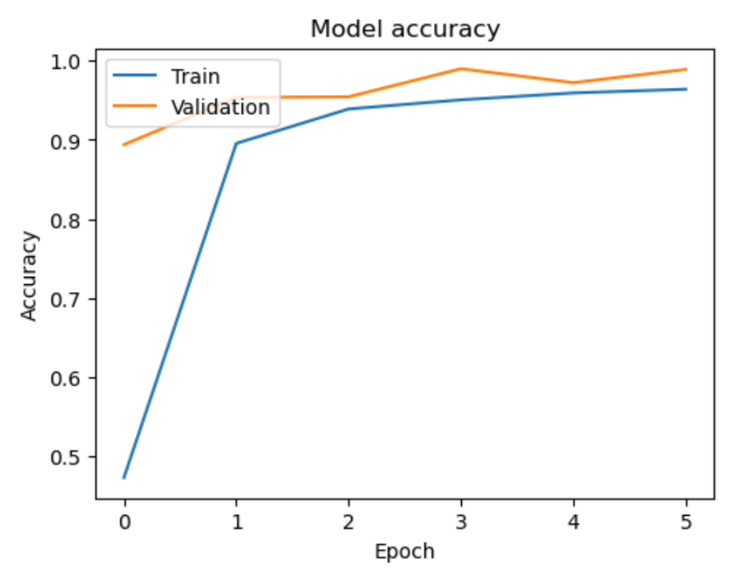The accuracy graph illustrates the performance of the model over five training epochs, showcasing both training and validation accuracy. Initially, the training accuracy increases sharply, indicating that the model is quickly learning from the data. By the third epoch, the training accuracy approaches 1.0, demonstrating that the model has effectively learned the training data. The validation accuracy also shows a consistent upward trend, stabilizing around 0.98 after the second epoch. This indicates that the model generalizes well to unseen data, maintaining high accuracy and suggesting that overfitting is well-controlled. The close alignment between training and validation accuracy curves further supports the model's’robustness and reliability in classifying distracted driving behaviors.

**Loss Graph**

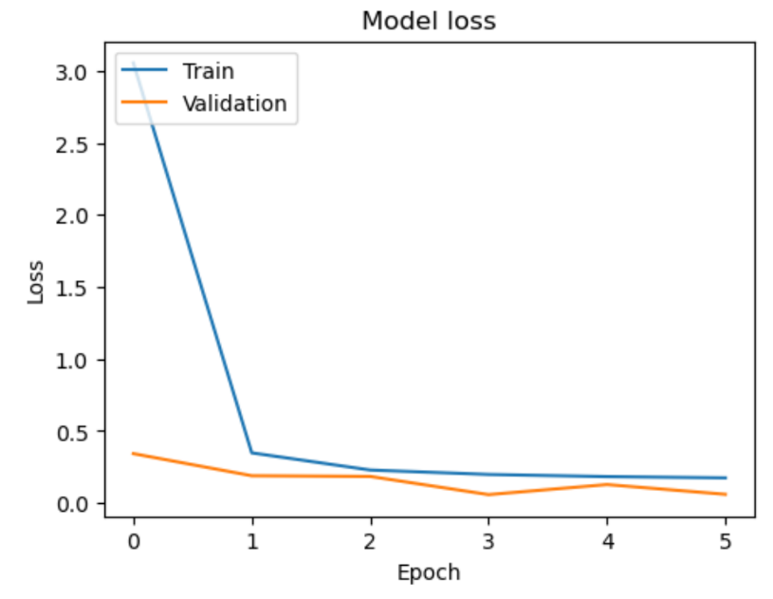The loss graph provides insights into the model's learning process over five training epochs, showing both training and validation loss. Initially, there is a steep decline in training loss, indicating that the model is rapidly learning and minimizing errors. By the second epoch, the training loss significantly decreases and stabilizes near zero, reflecting the model's efficiency in learning the training data. The validation loss also shows a consistent downward trend, stabilizing at a low value, which suggests that the model maintains its performance on unseen data without overfitting. The close convergence of training and validation loss values further confirms the model's robustness and its ability to generalize well across different datasets, reinforcing the effectiveness of the implemented architecture and training methodology.

**Conclusion**

The implementation of cameras on insured vehicles provides a robust solution for enhancing road safety and improving insurance processes. The project successfully demonstrates the feasibility of using ANN models to monitor and classify driver behaviors in real-time. The system not only aids in reducing accidents but also streamlines claims processing and fraud detection. Future work will focus on expanding the system's capabilities to include night vision, facial recognition, and dynamic camera detection to further enhance its effectiveness.