**Car Dealership System**

**Group Number: 02**

**Group Members:**

|  |  |
| --- | --- |
| Student Id | Student Name |
| 19101069 | Md. Mahbubur Rahman Raad |
| 19101088 | Md. Mehtabul Islam Shafin |
| 19101076 | Sayem Kader Chowdhury |

Date of Submission: 8th May 2021

# Introduction

Car Dealership System is an online platform where Car companies, brand new car importers and reconditioned car importers can list their cars for sale, with adequate information, and prices, for the buyers. Buyers can sign up to the platform, view items up for sale, request additional information, and contact with the shop for further clarification.

# Motivation

The system will make car shops more accessible to the customers, streamline communication between the shops and customers, and overall be a secure, better, more time and cost saving way to shop cars.

# System Description

* **Project Sponsor:**

Md. Hasan (Managing Director of BARVIDA (Bangladesh Reconditioned Vehicles Importers and Dealers Association))

* **Business Need:**

This project has been greenlighted by BARVIDA to streamline communication between the customers and the car shops, as well as increase car sell figures through better shopping experience provided by the system.

* **Business requirements:**

Both the clients and the sellers will be able to access the system through the web, as well as an application. The system will have clients who wants to search for and buy cars. The specific functionality that the system should have are listed below,

* + Allow clients to self-register.
  + Clients will be able to search for cars from the inventory.
  + Allow clients to book cars.
  + Allow clients to interact with sellers.
  + Ensure secured payment system.
* **Business Value:**

The system targets to attract sellers through a much more convenient shopping experience. It expects more car sells as it will make shopping easier because customers will have access to all the information related to the car from their home, customers can shop from anywhere and it will decrease customer’s nuisance as he/she will not have to be physically present at the shop to personally inspect the car. Estimated tangible values as follows,

* ৳ 1,25,00,000 from reduced employee numbers.
* ৳ 3,91,00,000 from increased car sells.
* ৳ 23,67,000 from reduced physical car showroom builds.
* ৳ 5,30,000 from new businesses (shops) registering to the system.
* **Special issues and constraints:**
* The system should have top-level security clearance as it involves high amount transactions.
* The system should be operational before summer, as we see an increase in car purchases in summer.
* The system should be abiding by government-mandated import tax law(s).

# Requirement analysis

### 1. Authentication:

**Functional Requirement:**

1. FR1.1: Customers must register to the system in order to access the system.
2. FR1.2: Customers must provide valid Bangladeshi NID (National Identification Card) number and personal information such as First Name, Last Name, Date of Birth, e-mail address in order to create an account.

**Non-Functional Requirement:**

1. NFR1.1: Registration response time should not exceed 15 seconds.
2. NFR1.2: The system will have a two-factor authentication system through e-mail or personal phone number.
3. NFR1.3: 10 failed password attempts will result in a locked account.
4. NFR1.4: Users can request for password reset if they forget their password, an automated generated password will be sent to their email.

### 2. Contact:

**Functional Requirement:**

1. FR2.1: Users must be logged in, in order to contact the sellers.
2. FR2.2: Users will have the choice to either chat or call the sellers.
3. FR2.3: Clients may call the sellers only on workdays, and on office time.
4. FR2.4: Users will be able to like, or comment on the items.

**Non-Functional Requirements:**

1. NFR2.1: Chat response time must not exceed 2 seconds.
2. NFR2.2: Sellers will not be able to access the customer's cell number unless the customer calls sellers first.

### 3. Payment Gateway Integration

**Functional Requirement:**

1. FR3.1: Clients will be able to select his/her desired payment method, out of several payment methods embedded to the system such as, bKash, Nagad, Online Banking, or cash on delivery.
2. FR3.2: Advertisers may promote their banking system through promo codes for a fixed percentage of discounts on each purchase.

**Non-Functional Requirements:**

1. NFR3.1: Users will be penalized if they cancel a cash on delivery order.
2. NFR3.2: Users can earn points through each purchase, which can be redeemed during their next purchase through discounts.

### 4. Delivery Integration

**Functional Requirement:**

1. FR4.1: Clients may select their desired time-slot and date to inspect and test-drive their purchase before delivery.
2. FR4.2: The system will have an embedded calendar for client’s increased accessibility.

**Non-Functional Requirements:**

1. NFR4.1: Clients will get a text or e-mail reminder a day before the date of inspection and test drive.
2. NFR4.2: Both clients and buyers will be able to reschedule with both party’s consent.

### Non-Functional:

#### 1. Operational:

* The system will be accessible through web browsers and will have a pc as well as a mobile version.
* The system will have an application which will run on operating system(s) android, and iOS.

#### 2. Performance:

* The system should be able to host at least 500 users at a time.
* The system should be able to list at least 3000 items at once.
* System’s response time should not exceed 2 seconds.
* The system should be operational 24/7.

#### 3. Security:

* Sellers will not be able to access clients information.
* The system should ensure clients anonymity from other users.
* The system must ensure secure online payments through encryption.

#### 4. Cultural & Political:

* Total cost of the car will include the government mandated TAX on the vehicle.
* The system should publish annual sales numbers, show profits and losses to its shareholders.

# Design diagram

This section includes all the diagrams that comprises our Car Dealership System.

# Use Case Diagram

A use case diagram is a diagram where it identifies the usesof the system based on the cases. In our use case diagram, we have three users (The Customer, The Seller and The Merchant), and we have shown the use cases of the concerned users in the following diagram.

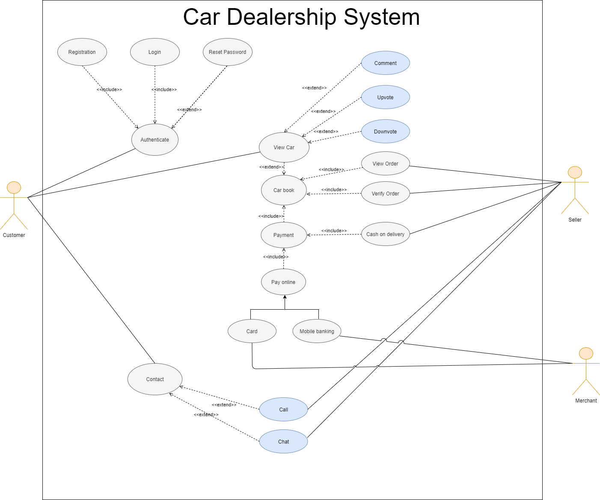

*Figure 1: Use Case Diagram*

# Class Diagram:

In software engineering, a class diagram in the Unified Modeling Language is a type of static structure diagram that describes the structure of a system by showing the system's classes, their attributes, operations, and the relationships among objects. In our Class Diagram, we have shown the classes of our system, the relationships, and the necessary information regarding this.

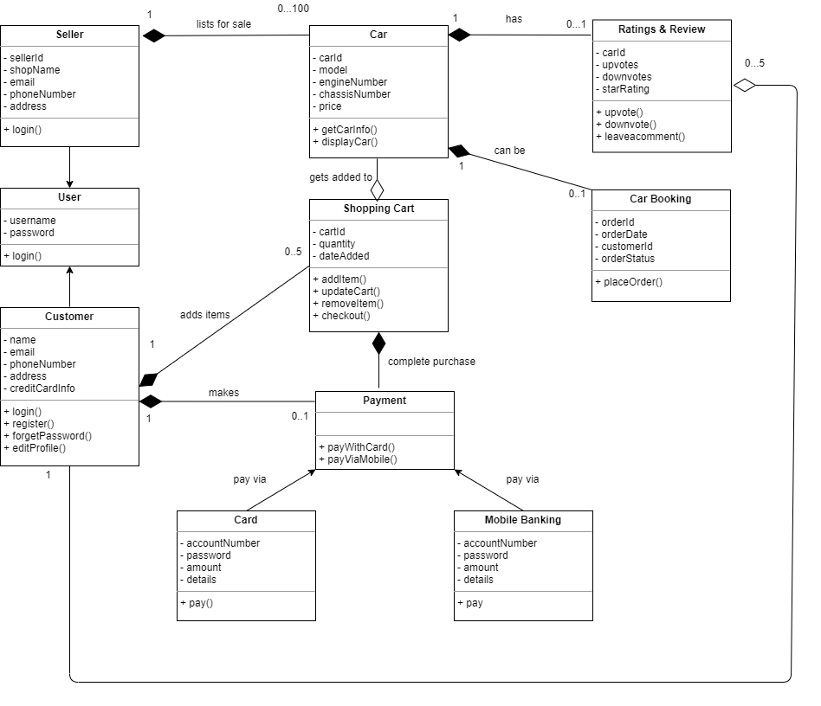

*Figure 2: Class Diagram*

# Sequence Diagram:

A sequence diagram simply depicts interaction between objects in a sequential order.

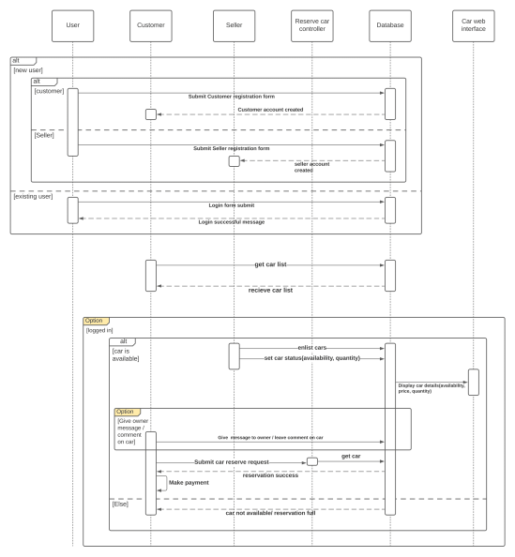

*Figure 3: Sequence Diagram*

# Activity Diagram:

Activity diagrams are graphical representations of workflows of stepwise activities and actionswith support for choice, iteration, and concurrency. The behaviors coordinated by these models can be initiated because other behaviors finish executing, because objects and data become available, or because events occur external to the flow.

In our Activity Diagram, we have done it in three parts.

1. The first part shows the system admin’s role and highlights on the login, registration, and authentication tasks.

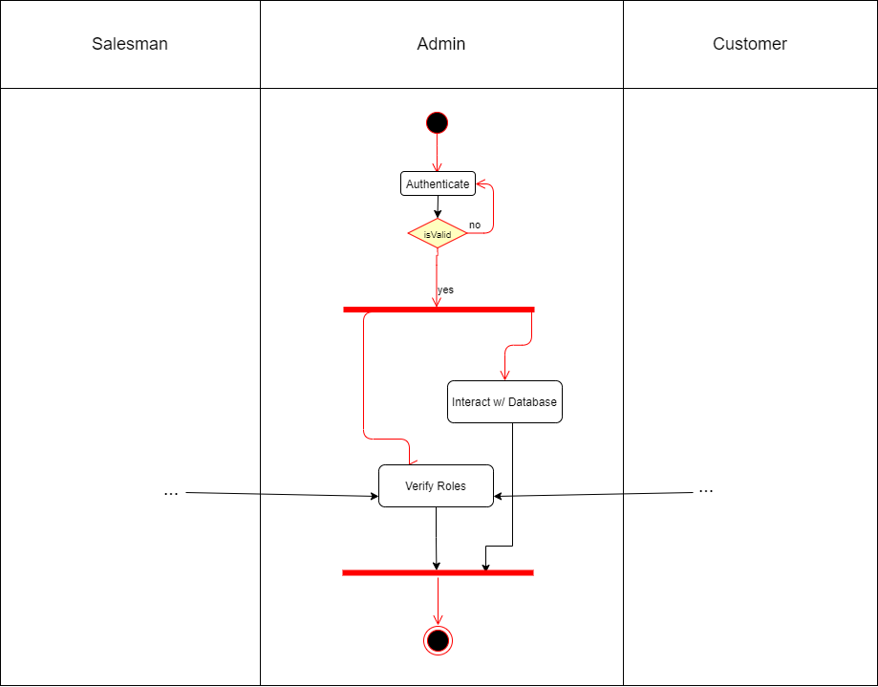

*Figure 4.1: Activity Diagram part – 1 of 3*

2. The second part focuses on the system from a customer’s perspective, his/her interactions with the system.

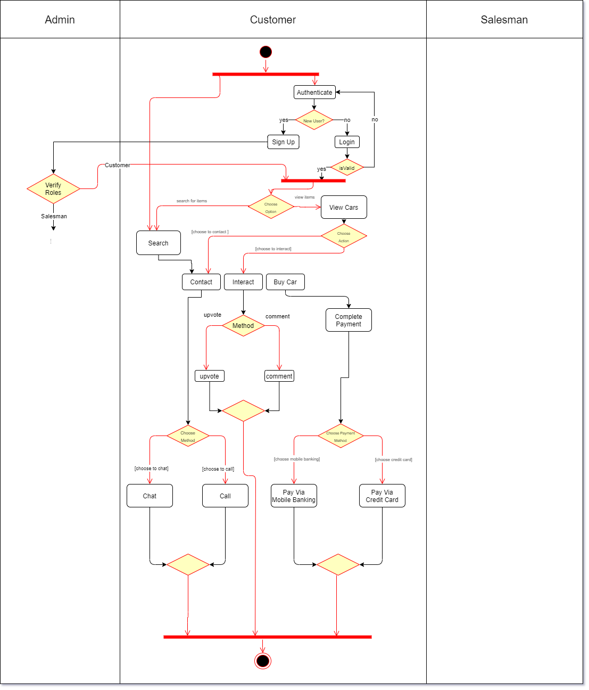

*Figure 4.2: Activity Diagram part – 2 of 3*

3. Finally, the third part shows the system from the seller’s perspective.

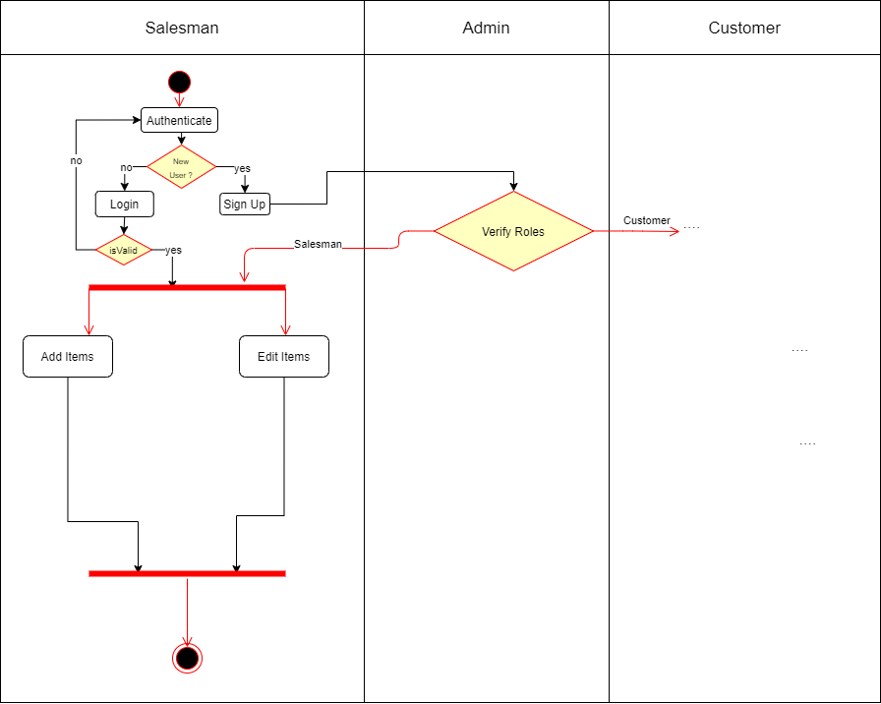

*Figure 4.3: Activity Diagram part – 3 of 3*

# State- Machine Diagram:

State machine diagrams depict the various states that an object may be in and the transitions between those states. We have shown our states in three parts.

**State 1.0 - Login State:**

This state diagram represents the login functionality of the online car dealership system. When a user enters the site, the user will be prompt with a dialog box where he/she will have to enter their credentials and password to login into the system. If the given user data is authentic then the user will receive a "Login Successful” message and will be directed to the homepage. If the user data does not match the credentials that he/she entered before, then user will be redirected to the login page to again enter the data.

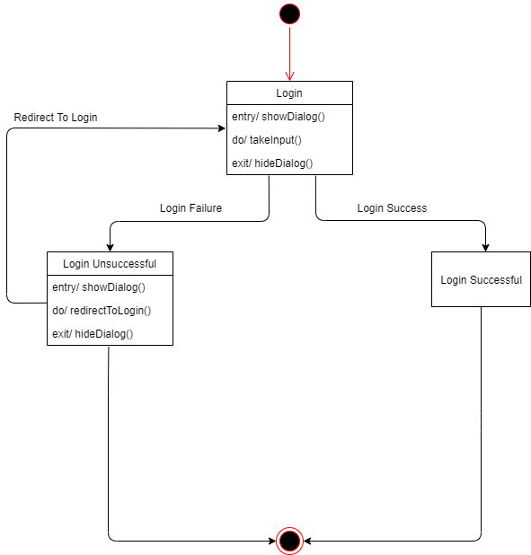

*Figure 5.1: State-Machine Diagram - Login State*

**State 1.1 – Buy State:**

In this state, we see a customer browsing our homepage, and potentially choosing an item from the homepage or search for it. Upon finding the desired item, a customer can choose to book it for a test drive, can buy it without a test drive, or can interact with the item through upvotes or downvotes, (denotes the item’s popularity), comment on the item or choose to communicate with the seller through chat, which will be hosted by the site, or call, in that case the system will provide the seller’s contact number. If the customer buys the item, he will be directed to a secured payment page where he can complete the payment process.

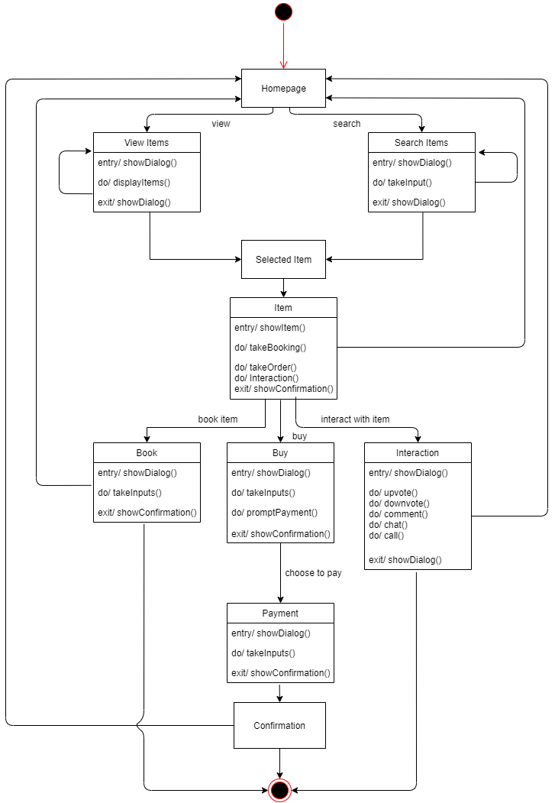

*Figure 5.2: State-Machine Diagram - Buy State*

**State 1.2 - Interaction State:**

A potential customer can interact with the item through upvotes (denotes how popular the particular item is), or downvotes (decreases popularity), or comment on the item. Upvotes and comments will be visible to every users and guests of the site to ensure safe marketing and help users judge the item better. An user can also choose to communicate directly with the seller through chat, which will be hosted by the site, or call, in that case the system will provide the seller’s contact number.

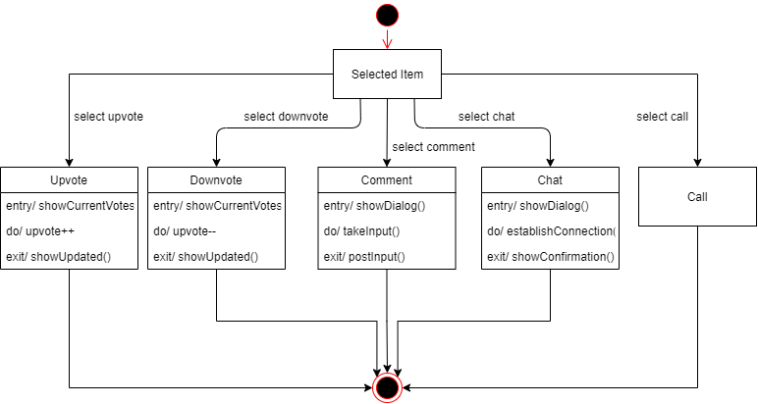

*Figure 5.3: State-Machine Diagram - Interaction State*

**State 1.3 – Payment State:**

This state diagram represents the payment procedure that a client encounters in the online car dealership system. When a client chooses to purchase a car then he/she will be redirected to the payment page. Where the user will be prompt with payment options such as "Mobile Banking", "Cash on Delivery" and "Card". From there if the client chooses to do "Mobile Banking" or "Card" he/she will be redirected to a secure window where he/she will be prompt with all the mobile banking or credit/visa card operators and upon giving the right information a success message will appear. In the "Cash on Delivery" option the client will pay with cash when he successfully receives the car which he ordered.

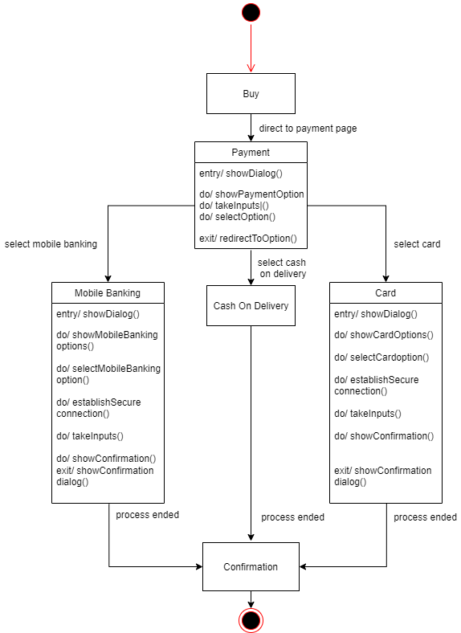

*Figure 5.4: State-Machine Diagram - Payment State*

# Data-Flow Diagram

A data flow diagram (DFD) is a graphical representation of the movement of data between external entities, processes, and data stores within a system.

We have showed the DFD in level 0 and level 1 below.

**Level-0 Data Flow Diagram:**

The Level – 0 Diagram shows the main process which comprises our Car Dealership System.

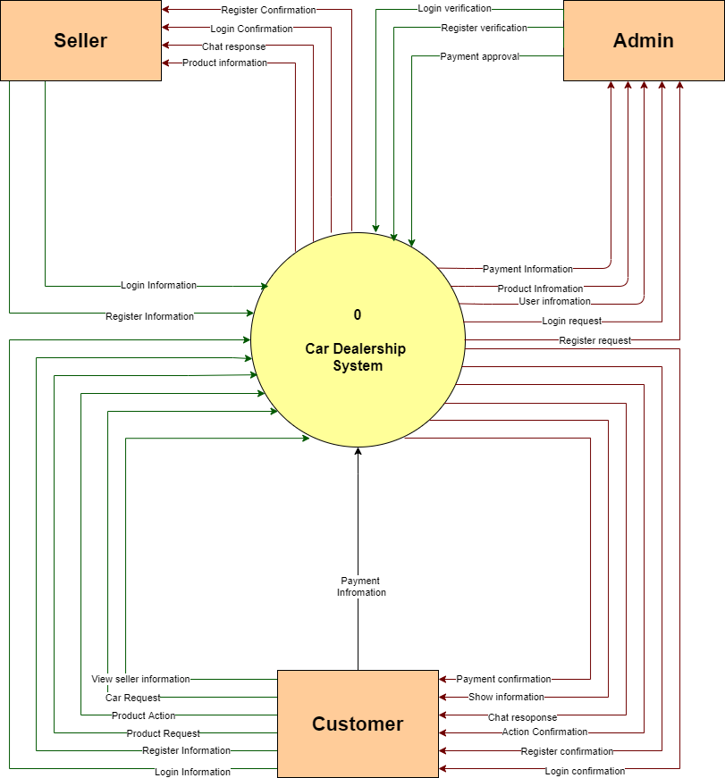

*Figure 6.1: Data Flow Diagram (DFD) Level – 0*

**Level-1 Data Flow Diagram:**

The Level – 1 Diagram shows all the processes which comprises a single process in our Car Dealership System. We have included four main processes i.e. the Login process, the View Product process, the Interaction process which includes buy, book, upvotes, downvotes, interact with the seller through chat and call, and finally, the payment process.

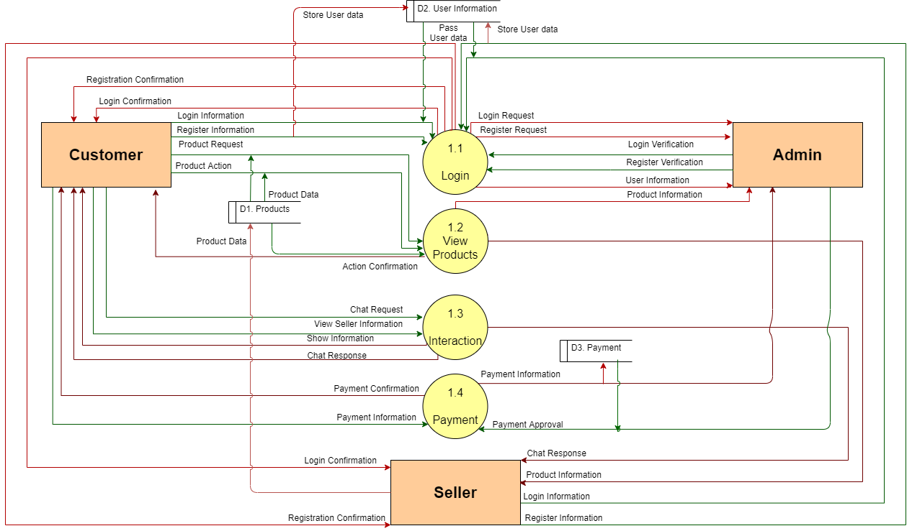

*Figure 6.2: Data Flow Diagram (DFD) Level – 1*

# Windows Navigation Diagram

Window navigation diagrams model the navigation paths between the windows in a GUI (Graphical User Interface) or the pages of a Web site. Our Windows Navigation System shows the windows, forms and one pop-up window which comprises our website.

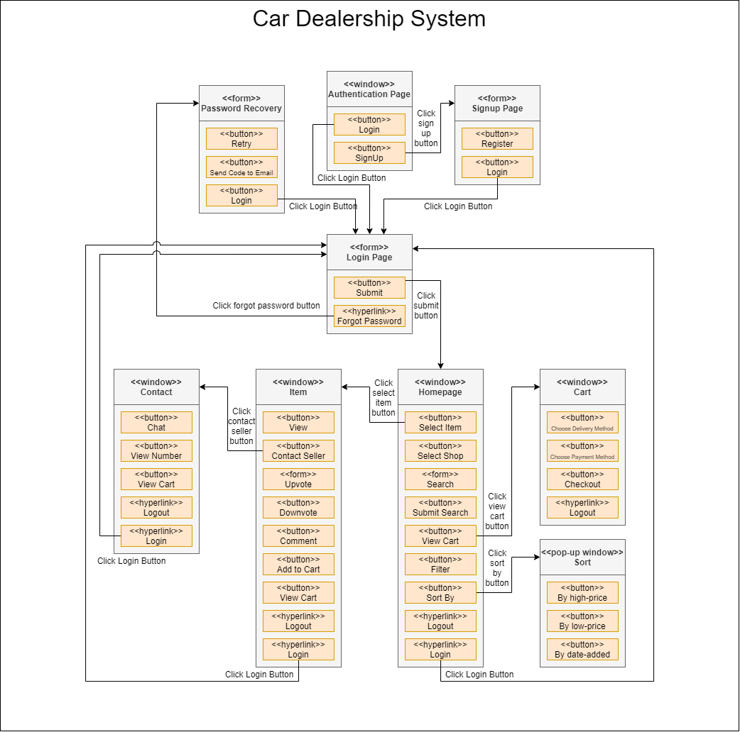

*Figure 7.0: Windows Navigation Diagram*

# Conclusion

To conclude, our Car Dealership System will make car shops more accessible to the customers, as well as customers more within the reach of the car shops. Our goal is to streamline communication between the shops and customers, and overall be a secure, better, more time and cost saving way to shop cars. We have made every decision keeping our customers in mind, and we believe our users will like how we have planned to set up the system.

The End