**Car Dealership System**

**Lab – 07: State-Machine Diagram**

**Group Number: 02**

**Group Members:**

|  |  |
| --- | --- |
| Student Id | Student Name |
| 19101069 | Md. Mahbubur Rahman Raad |
| 19101088 | Md. Mehtabul Islam Shafin |
| 19101076 | Sayem Kader Chowdhury |

Date of Submission: 15th April 2021

**State 1.0 - Login State:**

This state diagram represents the login functionality of the online car dealership system. When a user enters the site, the user will be prompt with a dialog box where he/she will have to enter their credentials and password to login into the system. If the given user data is authentic then the user will receive a "Login Successful” message and will be directed to the homepage. If the user data does not match the credentials that he/she entered before, then user will be redirected to the login page to again enter the data.

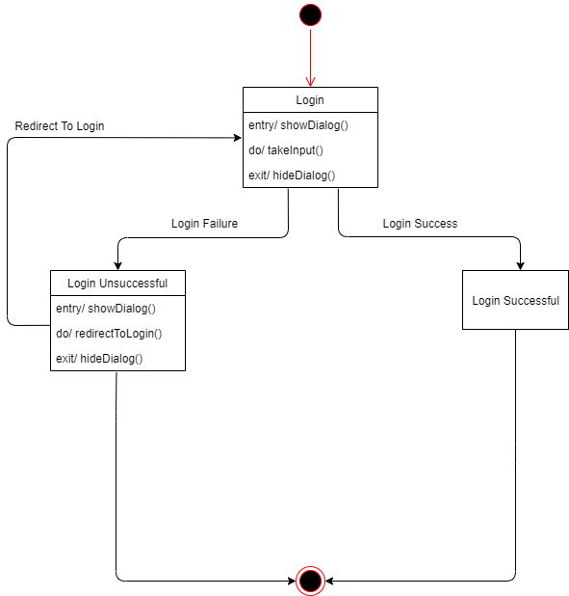

*Diagram 1.0: Login State*

**State 1.1 – Buy State:**

In this state, we see a customer browsing our homepage, and potentially choosing an item from the homepage or search for it. Upon finding the desired item, a customer can choose to book it for a test drive, can buy it without a test drive, or can interact with the item through upvotes or downvotes, (denotes the item’s popularity), comment on the item or choose to communicate with the seller through chat, which will be hosted by the site, or call, in that case the system will provide the seller’s contact number. If the customer buys the item, he will be directed to a secured payment page where he can complete the payment process.

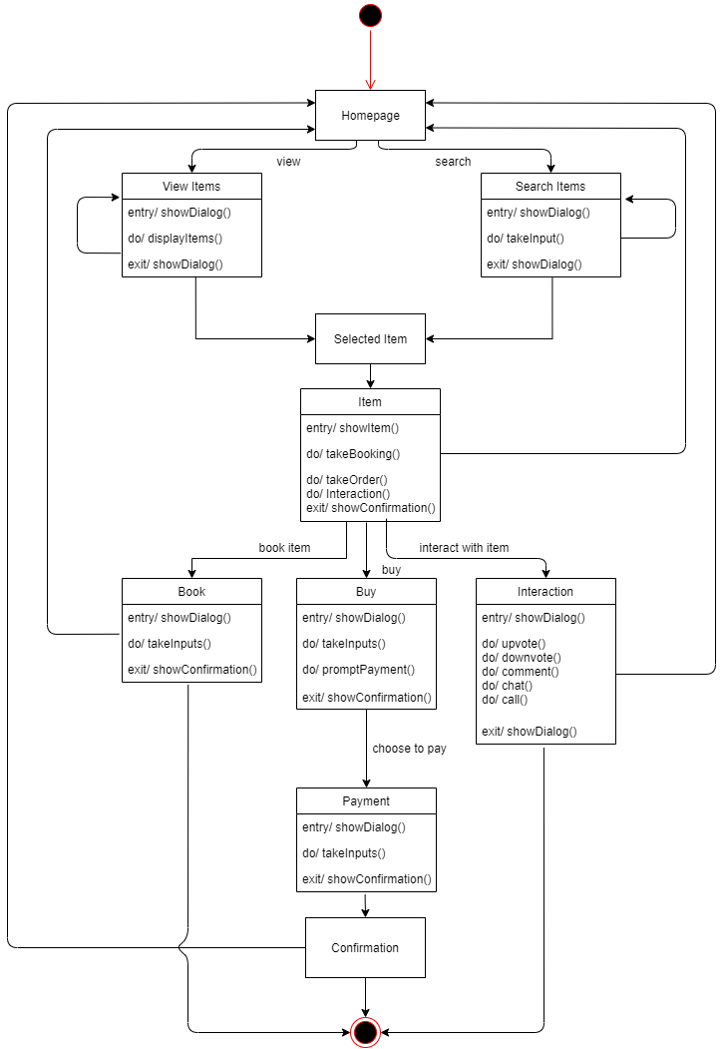

*Diagram 1.1: Buy State*

**State 1.2 - Interaction State:**

A potential customer can interact with the item through upvotes (denotes how popular the particular item is), or downvotes (decreases popularity), or comment on the item. Upvotes and comments will be visible to every users and guests of the site to ensure safe marketing and help users judge the item better. An user can also choose to communicate directly with the seller through chat, which will be hosted by the site, or call, in that case the system will provide the seller’s contact number.

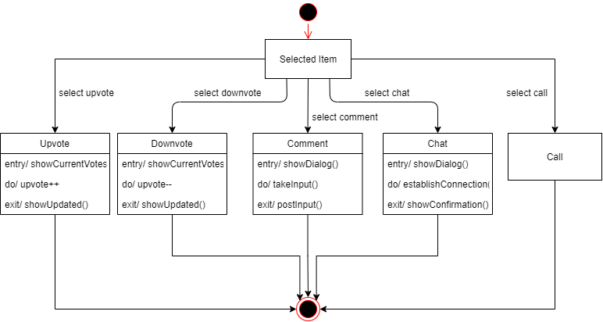

*Diagram 1.2: Interaction State*

**State 1.3 – Payment State:**

This state diagram represents the payment procedure that a client encounters in the online car dealership system. When a client chooses to purchase a car then he/she will be redirected to the payment page. Where the user will be prompt with payment options such as "Mobile Banking", "Cash on Delivery" and "Card". From there if the client chooses to do "Mobile Banking" or "Card" he/she will be redirected to a secure window where he/she will be prompt with all the mobile banking or credit/visa card operators and upon giving the right information a success message will appear. In the "Cash on Delivery" option the client will pay with cash when he successfully receives the car which he ordered.

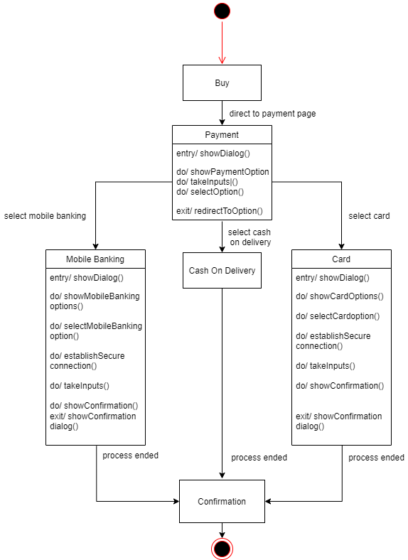

*Diagram 1.3: Payment State*