**Assignment 21.1:**

Count the number of blank lines in a text file, by using accumulators

Sample file:

Hello World

It’s a sunny day

<blank_line>

When will it rain?

Will it rain today!

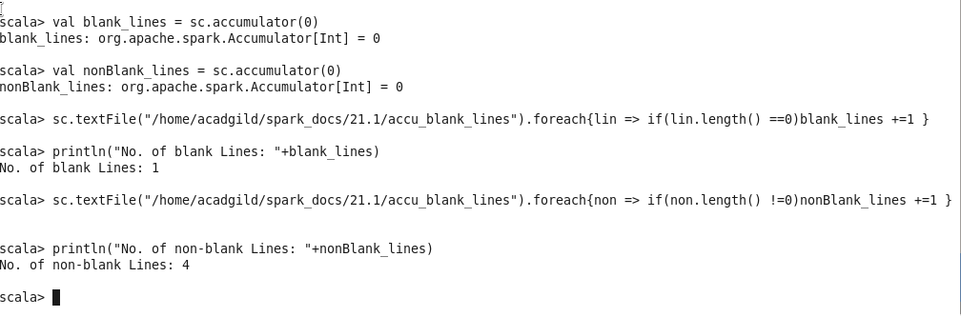

* Creating the accumulators that can hold the count of blank lines and non blank lines.
* Then by iterating through each line in the input file with For Each we set the count values of number of blank lines & Non-blank lines in the accumulators respectively