**Assignment 21.2:**

Problem Statement

1) Join of two or more data sets is one of the most widely used operations you do with

your data, but in distributed systems it can be a huge headache. In general, since your

data are distributed among many nodes, they have to be shuffled before a join that

causes significant network I/O and slow performance.

2) Fortunately, if you need to join a large table with relatively small tables you can avoid

sending all data of the large table over the network. This type of join is called map-side

join in Hadoop community. In other distributed systems, it is often called replicated

or broadcast join.

The fact table can be very large, while dimension tables are often quite small.

Let’s use the following sample data (one fact and two dimension tables):

We need to join the fact and dimension tables to get the following result:

Seattle New York Delta Airlines 418 7:00

San Francisco Los Angeles American Airlines 1250 7:05

San Francisco New York Virgin America 12 7:05

New York Los Angeles Delta Airlines 424 7:10

Los Angeles Seattle Delta Airlines 5737 7:10

Code & Output:

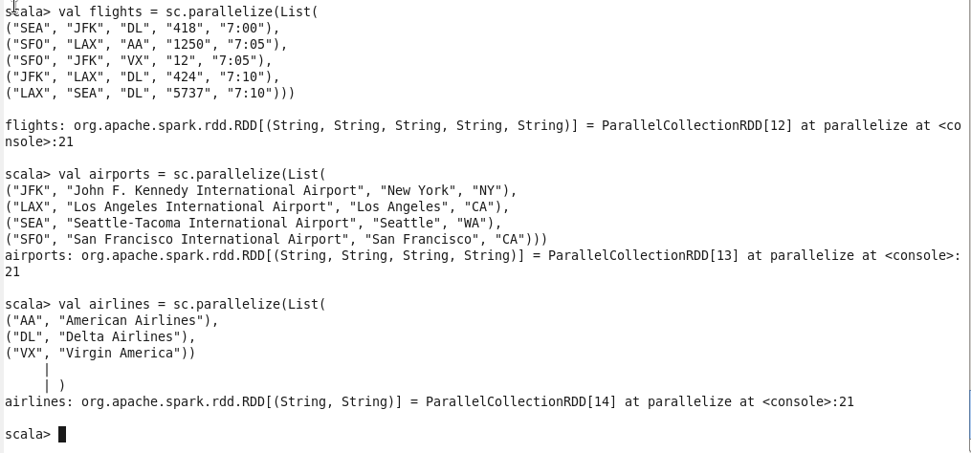

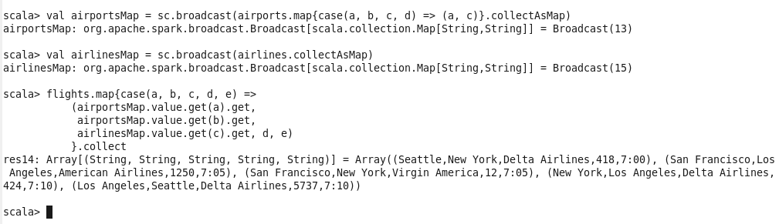

* We create two separate RDD’s for each table Airports & Airlines which are the dimension tables after which converted those to two separate maps & broadcasted for further execution.
* In Airports table we have taken only two columns which are needed to produce the result.
* On the Flights RDD by using map function we compute to get the expected result.