Raag Patel and Ranjan Karki

1. Great introduction, it is easy and useful to include the exact number of homes in the study.
2. For Analysis question 1 it is useful to update the number of homes used since we are now only dealing with 3 neighborhoods.
3. 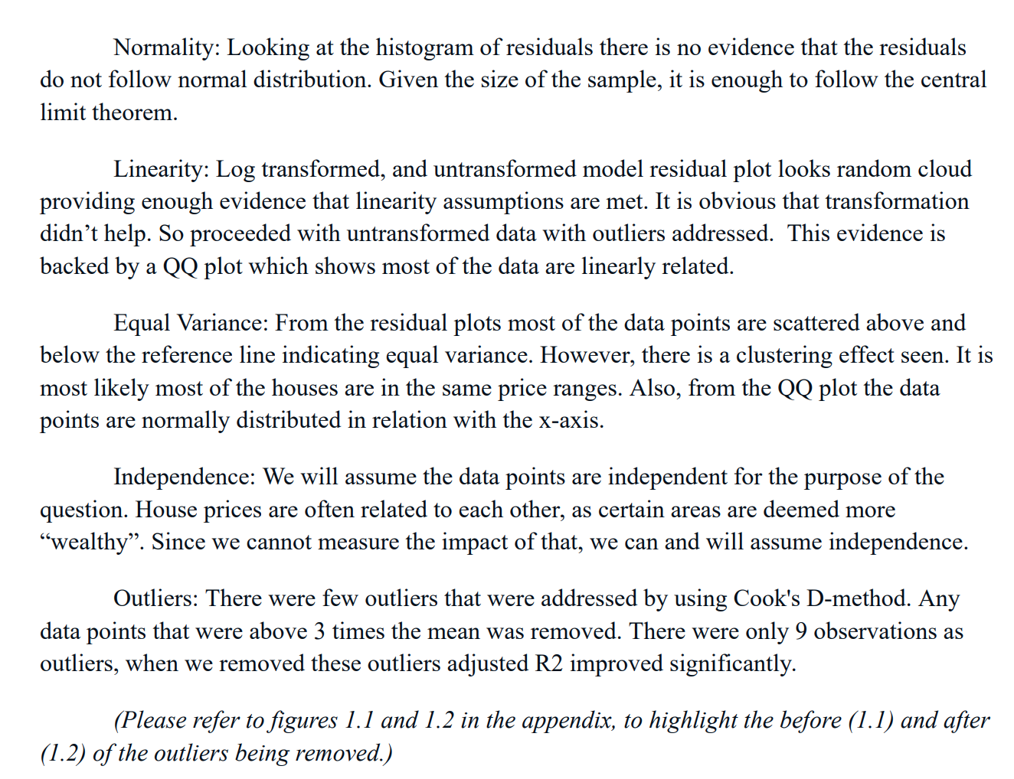

It will be useful to reference where these plots are in the appendix while addressing each one …. (ie. In the Normality section … in the linearity section… or at the beginning of this section rather than at the end.

**Note that the CLT is not needed in the normality section as we are not testing the mean of the residuals.**

1. 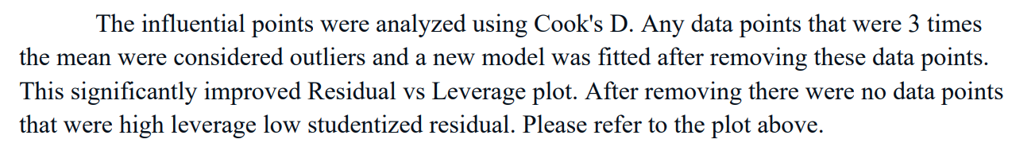

**This is equivalent to saying, we removed the points that the model was not modeling well in order to improve the model. While it is true, the model goodness of fit statistics improved, it is also very very likely that the usefulness of the model in a practical setting greatly deteriorated. What will happen to the houses in the test dataset that are similar to the ones you deleted? Answer: they will not be fit well.**

1. **GREAT JOB ON THE SHINY APP!!!**
2. **GREAT JOB WITH THE FORMAT OF YOUR PAPER. I should have said this earlier. The presentation is very organized, clean and professional.**
3. 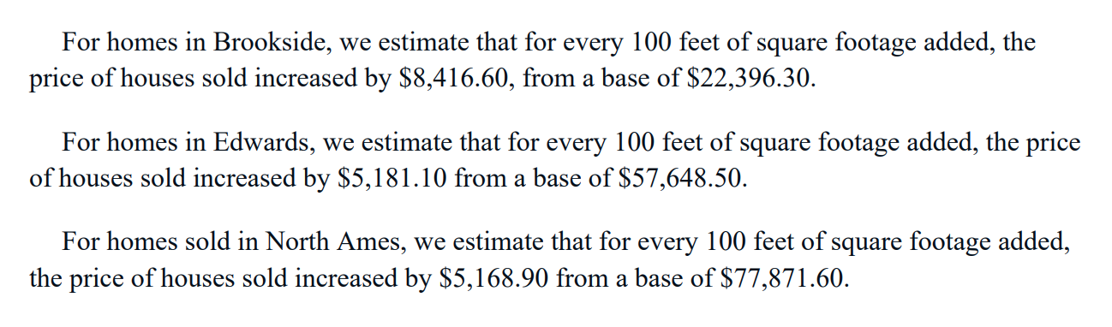

**Need some tweaking here…. For example… for Brookside:**

**“For homes in Brookside, we estimate that for every 100 feet of square footage added the *mean* sale price of houses increased by $8,416,60.” *And then give a 95% confidence interval.***

***Analysis Question 2:***

***As far as writing style, we should minimize usage of vague terms such as “things” and “everything” in favor of specifically what they are referring to… “all the feature” etc. One quote was, “we had to compare it to everything else” … be more specific … what is “everything else”? Also the paragraph ends with “The model yielded solid results.” I think this is ok, but unnecessary … I’d let the reader determine how useful the model is and just give the numbers. Some may also find use of terms like “solid” to be a little too informal. I don’t think I am one of them… but you have to write a large audience.***

***Good job breaking down the results of your prediction efforts.***

***You mention here that:***

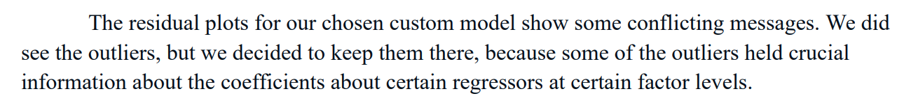

***And***

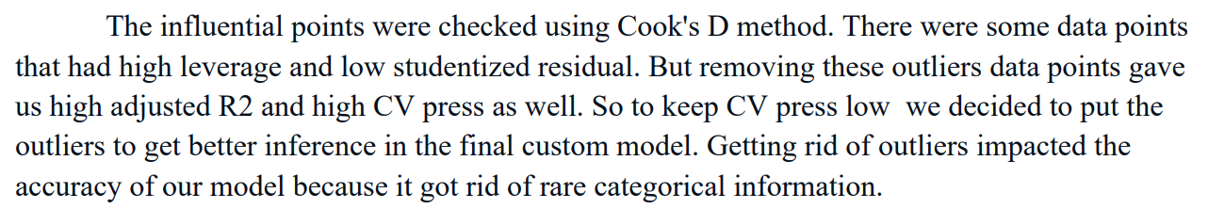

***My reply is: “Exactly”.***

***This is what I was referring to in the first part of the paper.***

***Good job overall, Please let me know if you have any questions. 92***