* **The problem Flow Chart:**

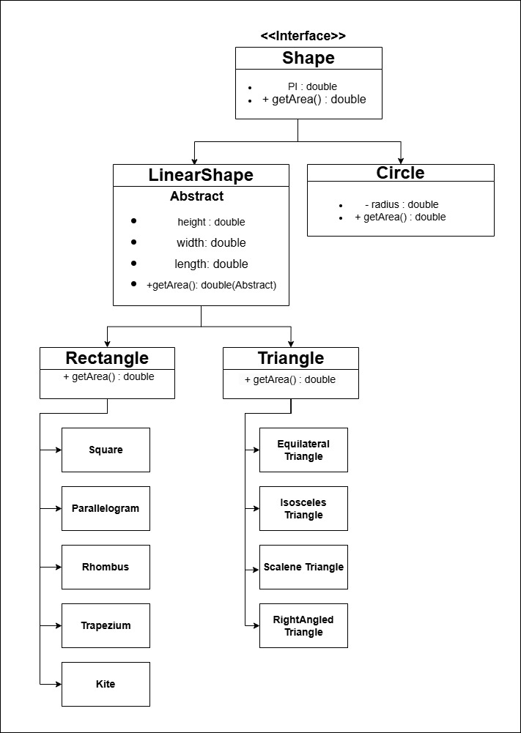

* **The Code Input in Java :**

**Shape.aava**

package bd.edu.bubt.cse;  
  
public interface Shape {  
 public static final double PI = 3.1416;  
 double getArea();  
}

**Circle.java**

package bd.edu.bubt.cse;  
  
public class Circle implements Shape {  
 private double radius;  
  
 public Circle(double radius){  
 this.radius = radius;  
 }  
  
  
 public double getArea() {  
 return PI * radius * radius;  
 }  
  
 public double getRadius() {  
 return radius;  
 }  
}

**LinearShape.java**

package bd.edu.bubt.cse;  
  
public abstract class LinearShape implements Shape{  
 protected double length;  
 protected double width;  
 protected double height;  
  
 public LinearShape(double length, double width, double height){  
 this.length = length;  
 this.width = width;  
 this.height = height;  
 }  
}

**Rectangle.java**

package bd.edu.bubt.cse;  
  
public class Rectangle extends LinearShape {  
 public Rectangle(double length, double width){  
 super(length, width, 0);  
 }  
  
   
 public double getArea() {  
 return length * width;  
 }  
}

**Square.java**

package bd.edu.bubt.cse;  
  
public class Square extends Rectangle {  
 private double side;  
  
 public Square(double side){  
 super(side, side);  
 this.side = side;  
 }  
}

**Parallelogram.java**

package bd.edu.bubt.cse;  
  
public class Parallelogram extends LinearShape {  
 private double base;  
 private double height;  
  
 public Parallelogram(double base, double height) {  
 super(base, 0, height);  
 this.base = base;  
 this.height = height;  
 }  
  
   
 public double getArea() {  
 return base * height;  
 }  
}

**Rhombus.java**

package bd.edu.bubt.cse;  
  
public class Rhombus extends LinearShape {  
 private double base;  
 private double height;  
  
 public Rhombus(double base, double height){  
 super(base, 0, height);  
 this.base = base;  
 this.height = height;  
 }  
  
   
 public double getArea() {  
 return base * height;  
 }  
}

**Trapezium.java**

package bd.edu.bubt.cse;  
  
public class Trapezium extends LinearShape {  
 private double a, b, height;  
  
 public Trapezium(double a, double b, double height){  
 super(a, b, height);  
 this.a = a;  
 this.b = b;  
 this.height = height;  
 }  
  
   
 public double getArea() {  
 return ((a + b) / 2) * height;   
 }  
}

**Kite.java**

package bd.edu.bubt.cse;  
  
public class Kite extends LinearShape {  
 private double d1, d2;  
  
 public Kite(double d1, double d2){  
 super(d1, d2, 0);   
 this.d1 = d1;  
 this.d2 = d2;  
 }  
   
 public double getArea() {  
 return (d1 * d2) / 2;  
 }  
}

**Triangle.java**

package bd.edu.bubt.cse;  
  
public class Trangle extends LinearShape{  
  
 public Trangle(double length, double width, double height){  
 super(length, width, height);  
 }  
  
  
 public double getArea() {  
 return 0.5 * length * height;  
 }  
}

**EquilateralTriangle.java**

package bd.edu.bubt.cse;  
  
public class EquilateralTriangle extends Trangle {  
 public EquilateralTriangle(double side){  
 super(side, 0, (Math.sqrt(3)/2) * side);  
 }  
  
  
 public double getArea() {  
 return (Math.sqrt(3)/4) * length * length;  
 }  
}

**IsoscelesTriagle.java**

package bd.edu.bubt.cse;  
  
public class IsoscelesTriangle extends Trangle {  
 public IsoscelesTriangle(double base, double height){  
 super(base, 0, height);  
 }  
}

**ScaleneTriangle.java**

package bd.edu.bubt.cse;  
  
public class ScaleneTriangle extends Trangle {  
 private double sideB, sideC;  
  
 public ScaleneTriangle(double a, double b, double c){  
 super(a, 0, 0);  
 this.sideB = b;  
 this.sideC = c;  
 }  
  
   
 public double getArea() {  
 double s = (length + sideB + sideC) / 2;   
 return Math.sqrt(s * (s - length) * (s - sideB) * (s - sideC));  
 }  
}

**RightAngledTriangle.java**

package bd.edu.bubt.cse;  
  
public class RightAngledTriangle extends Trangle {  
 public RightAngledTriangle(double base, double height){  
 super(base, 0, height);  
 }  
  
   
 public double getArea() {  
 return 0.5 * length * height;  
 }  
}

**Main.java**

package bd.edu.bubt.cse;  
  
public class Main {  
 public static void main(String[] args) {  
 Shape circle = new Circle(5);  
 Shape triangle = new Trangle(10, 0, 6);  
 Shape rectangle = new Rectangle(8, 4);  
 Shape square = new Square(6);  
 Shape parallelogram = new Parallelogram(10, 5);  
 Shape rhombus = new Rhombus(8, 6);  
 Shape trapezium = new Trapezium(10, 6, 5);  
 Shape kite = new Kite(8, 6);  
  
 Shape equilateral = new EquilateralTriangle(6);  
 Shape isosceles = new IsoscelesTriangle(10, 8);  
 Shape scalene = new ScaleneTriangle(7, 8, 9);  
 Shape rightAngled = new RightAngledTriangle(6, 8);  
  
 System.out.println("Circle Area: " + circle.getArea());  
 System.out.println("General Triangle Area: " + triangle.getArea());  
 System.out.println("Rectangle Area: " + rectangle.getArea());  
 System.out.println("Square Area: " + square.getArea());  
 System.out.println("Parallelogram Area: " + parallelogram.getArea());  
 System.out.println("Rhombus Area: " + rhombus.getArea());  
 System.out.println("Trapezium Area: " + trapezium.getArea());  
 System.out.println("Kite Area: " + kite.getArea());  
  
 System.out.println("Equilateral Triangle Area: " + equilateral.getArea());  
 System.out.println("Isosceles Triangle Area: " + isosceles.getArea());  
 System.out.println("Scalene Triangle Area: " + scalene.getArea());  
 System.out.println("Right-angled Triangle Area: " + rightAngled.getArea());  
 }  
}

* 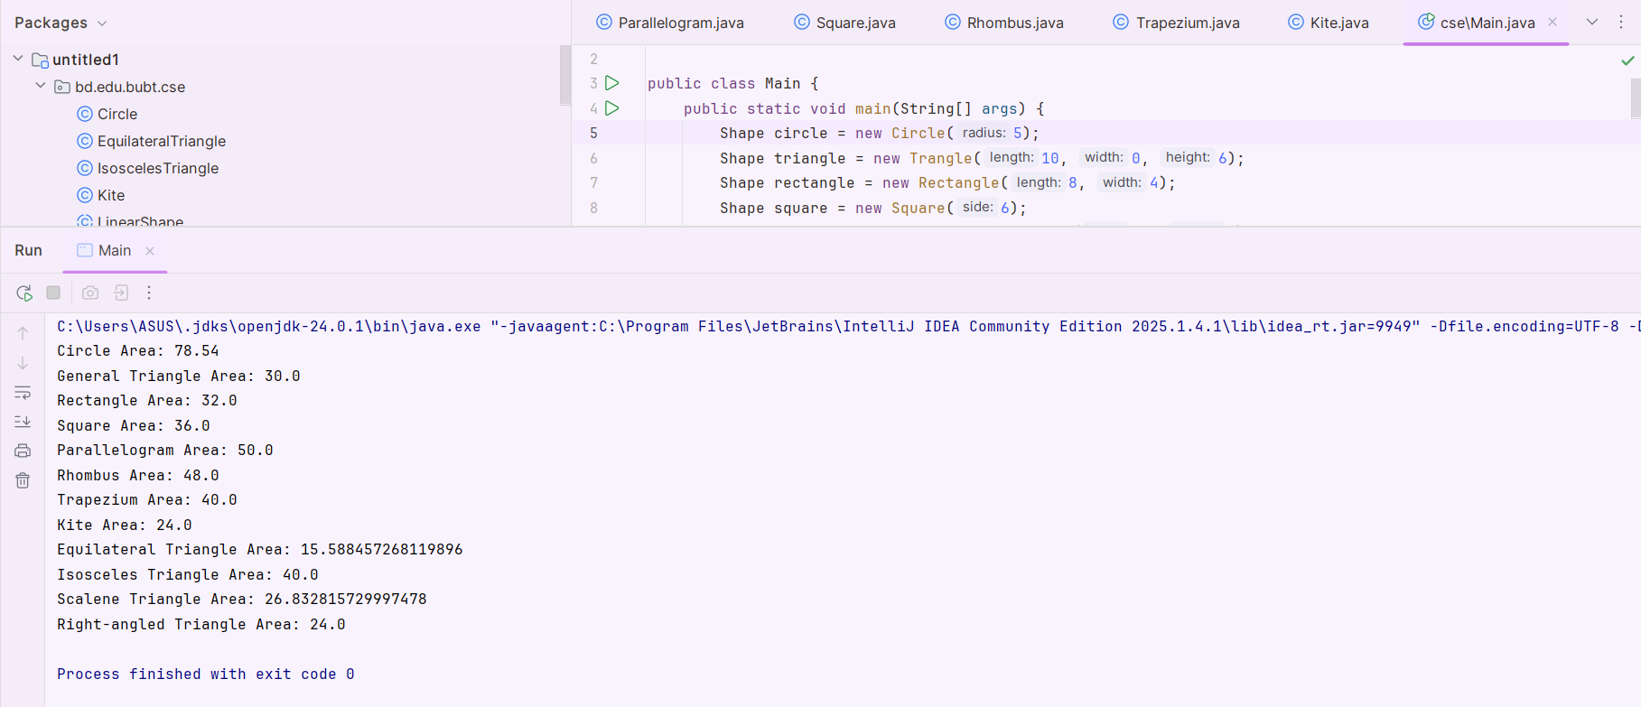**The Output:**
* **Conclusion:**

This project is designed using **Object-Oriented Programming (OOP)** principles to model different **geometric shapes** and calculate their areas.

1. **Shape Interface** – defines the contract (getArea()) that every shape must implement. This ensures **abstraction** and **polymorphism**.
2. **Circle Class** – directly implements Shape and calculates area using the formula:
$$Area=πr^{2}$$

3. **LinearShape (Abstract Class)** – acts as a **base class** for all polygon-based shapes that have length, width, or height. It enforces code reuse and provides a consistent structure.
4. **Rectangle Class** – extends LinearShape and calculates area as:
$$Area=length*width$$

5. **Square Class** – a special type of rectangle with all sides equal, passing (side, side) to the rectangle’s constructor.
6. **Parallelogram Class** – uses **base × height** to calculate area.
7. **Rhombus Class** – uses the **base × height** formula (since it’s a special parallelogram).
8. **Trapezium Class** – calculates area using:

$$Area=\frac{\left(a+b\right)}{2}*height$$

where a and b are the lengths of parallel sides.

1. **Kite Class** – uses diagonals for calculation:

$Area=\frac{d1*d2}{2}$

​​

1. **Triangle Hierarchy** – The Trangle base class calculates a general triangle’s area using 0.5 × base × height. Its specializations override the formula:
   * **Equilateral Triangle** → $\sqrt{\frac{3}{4}}$ $a^{2}$

*
   * **Isosceles Triangle** → $\frac{1}{2}base*height$
   * **Scalene Triangle** → **Heron’s Formula**
   * **Right-angled Triangle** → $\frac{1}{2}base*height$
2. **Main Class** – creates objects of all shapes, stores them in Shape references, and prints their areas. This demonstrates **polymorphism**, because the correct getArea() implementation is chosen at runtime based on the actual object type.