PG : RO-ED AI Agent
Myanmar Import PDF Data Extraction Pipeline
STEP-BY-STEP USER GUIDE

Version  v1.0 | Online | Access URL  https://roed-docintel.citygpt.xyz

Deployed For  Pahtama Group (PG) | Last Updated  March 26, 2026

1. Overview
The RO-ED AI Agent is an intelligent document processing pipeline designed for Pahtama Group's Myanmar import operations. It automates extraction of structured data from import PDFs — eliminating manual data entry, reducing errors, and producing ready-to-use Excel and CSV exports.

Key Capabilities
- Automatically classifies each page as TEXT or IMAGE
- Extracts product line items: name, duty rate, unit price, tax %, quantity, exchange rate
- Extracts 16 customs declaration header fields (Declaration No, Importer, dates, etc.)
- Runs OCR on scanned/image pages for full data capture
- Detects duplicate PDFs — prevents re-processing the same document
- Validates all fields, calculates completeness and accuracy scores
- Exports results to Excel and CSV with one click

Performance Benchmark

100.0%  Accuracy | ~93s  Avg Processing | $0.0108  Cost per Job | 22/22  Fields Valid

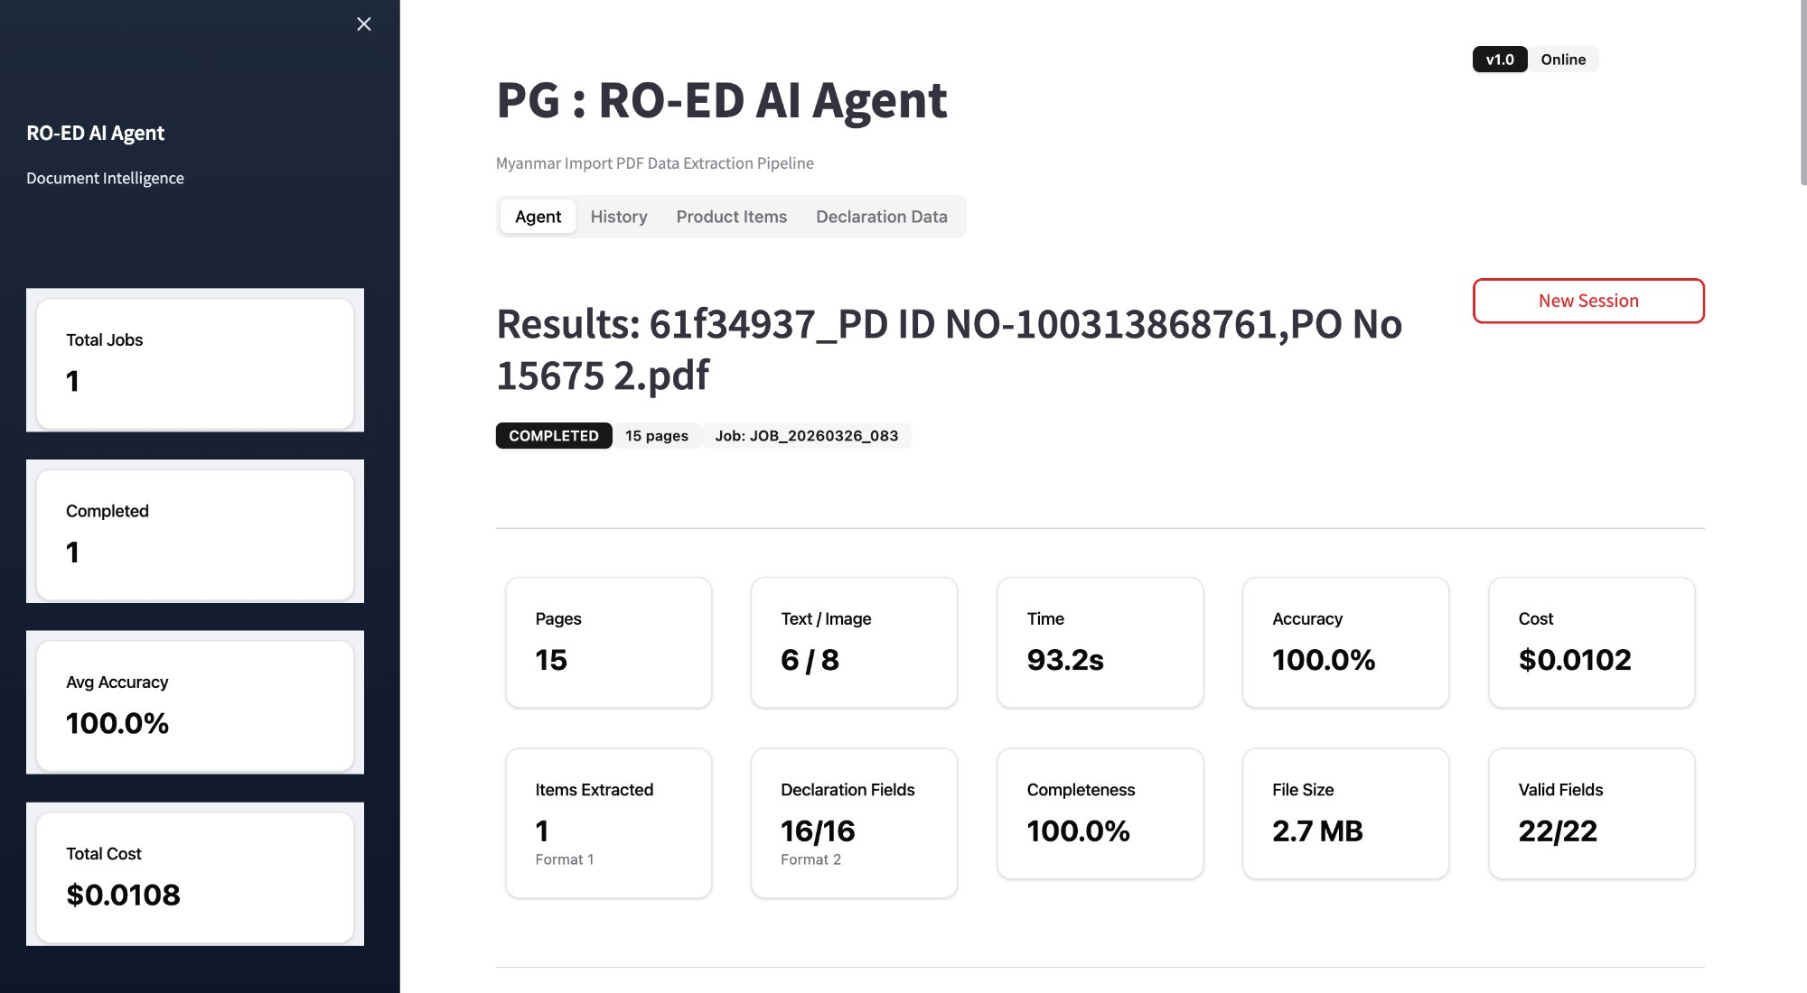
Figure: Agent Tab — Completed job with 100% accuracy and full metrics

2. Understanding the Interface
The agent has a clean 4-tab layout. The left sidebar shows your cumulative totals across all sessions.

Navigation Tabs

Agent | History | Product Items | Declaration Data

Agent | Main upload area. Upload your PDF here to start a new job. Shows live processing logs and completed results.
History | View all past jobs with status, accuracy, cost, and date. Filter by date range, status, or PDF name.
Product Items | Consolidated table of all extracted product line items across all jobs. Download as CSV or Excel.
Declaration Data | All 16 customs declaration header fields extracted from each PDF. Download as CSV or Excel.

Left Sidebar — Cumulative Totals
- Total Jobs — total PDFs submitted across all sessions
- Completed — successfully processed jobs
- Avg Accuracy — average extraction accuracy across all jobs
- Total Cost — total API cost incurred

3. Step-by-Step: Processing a PDF
Follow these steps every time you process a new Myanmar import PDF.

STEP  01 | Open the Agent  Navigate to https://roed-docintel.citygpt.xyz in your browser. You will land on the Agent tab by default.

STEP  02 | Start a New Session  Click the 'New Session' button in the top-right corner. This resets the upload form and clears any previous result.

STEP  03 | Upload Your PDF  Drag and drop your import PDF into the upload area, or click to browse. After upload a confirmation toast appears bottom-right: 'Uploaded: [filename]'.

STEP  04 | Monitor Live Processing  The agent automatically starts. You will see a progress bar (Step X/10) and a live console log showing per-page classification in real time.

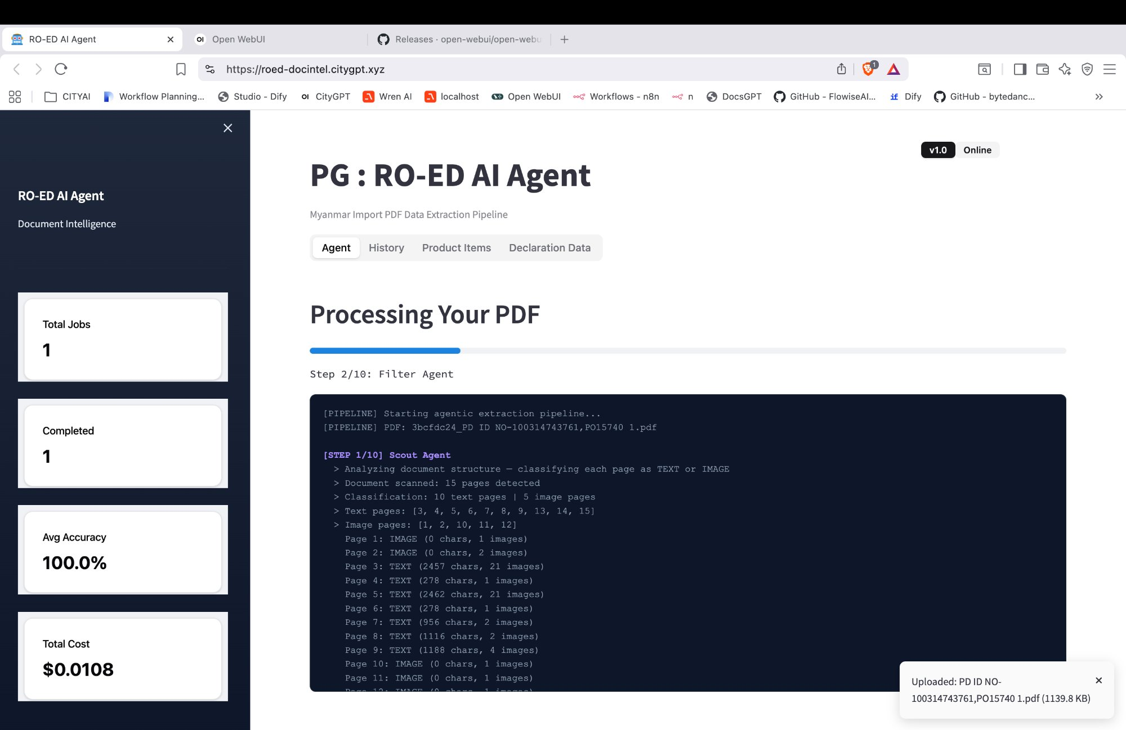
Figure: Processing Your PDF — live console log showing Scout Agent page classification

STEP  05 | Wait for Completion  Processing takes 60–120 seconds. Do not close the browser tab. The progress bar fills left to right through all 10 pipeline steps.

STEP  06 | Review Results  When complete, the panel shows: Job ID, COMPLETED badge, pages, Text/Image split, Time, Accuracy %, Cost, Items Extracted, Declaration Fields, Completeness %, and Valid Fields.


Figure: Completed job results — 15 pages, 100% accuracy, 16/16 declaration fields, 22/22 valid fields

STEP  07 | Check Extraction Details  Scroll down to see the Page Classification Map (green T = text, orange I = image badges per page), the 7-stage Processing Pipeline, and the Product Line Items with all extracted fields.

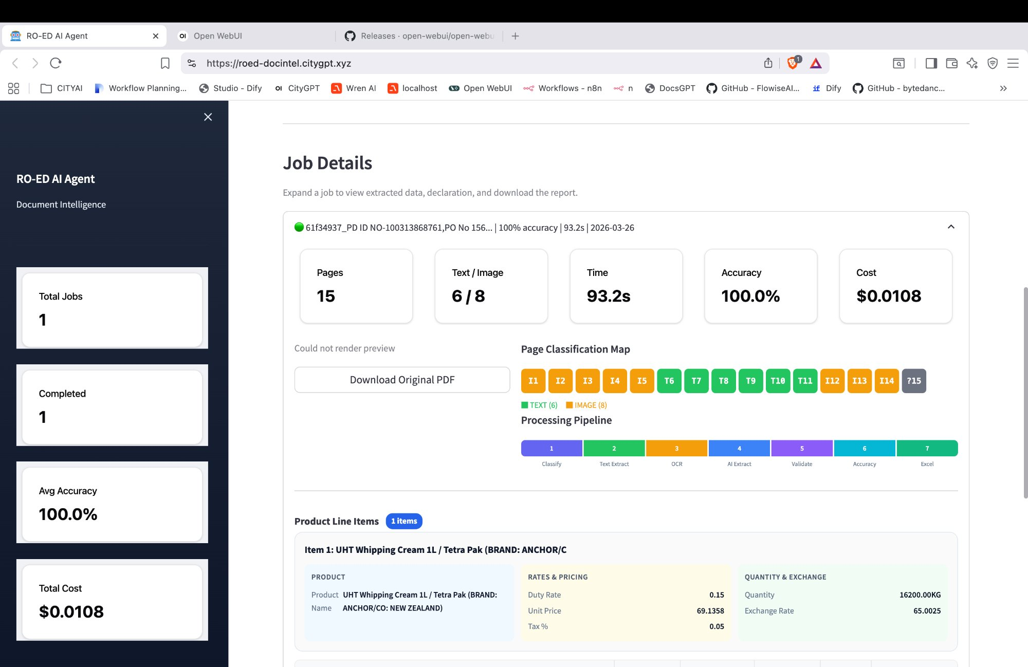
Figure: Job Details — Page Classification Map, Processing Pipeline, and extracted Product Line Items

STEP  08 | Download Your Data  Switch to Product Items or Declaration Data tabs for structured table views, then click 'Download CSV' or 'Download Excel'.

⚠ Important: If you upload the same PDF twice, the agent shows a 'Duplicate PDF Detected' screen. See Section 8 for your options.

4. The 7-Step Processing Pipeline
Every PDF runs through this structured 7-stage pipeline. Understanding the stages helps you interpret live logs and diagnose issues.

1 | 2 | 3 | 4 | 5 | 6 | 7
Classify | Text Extract | OCR | AI Extract | Validate | Accuracy | Excel

1 | Classify (Scout Agent) | Scans all pages and classifies each as TEXT (has selectable characters) or IMAGE (scanned). Determines which pages need OCR.
2 | Text Extract | Directly extracts text from TEXT-classified pages using the PDF's embedded text layer. Fast and highly accurate.
3 | OCR | Applies optical character recognition to IMAGE-classified pages — converts scanned stamps, handwriting, and printed tables into machine-readable text.
4 | AI Extract | Core AI step. Understands document structure and extracts: product names, rates, quantities, declaration numbers, importers, dates, and all structured fields.
5 | Validate | Validates all extracted fields for format correctness, completeness, and logical consistency. Flags missing or suspect values.
6 | Accuracy | Calculates the accuracy score: (valid fields / total fields) x 100%. A score of 100% means every field was successfully extracted and validated.
7 | Excel Export | Packages all extracted data into a downloadable Excel workbook and CSV file, ready for SAP, ERP systems, or further analysis.

5. Extracted Data Fields

5.1 Product Line Items
One record created per product found in the import document (6 fields).

Field | Description
Product Name | Full description incl. brand and origin (e.g., UHT Whipping Cream 1L / Tetra Pak — ANCHOR/CO: NEW ZEALAND)
Duty Rate | Import duty rate as decimal (e.g., 0.15 = 15%)
Unit Price | Price per unit in USD (e.g., 69.1358)
Tax % | Additional tax rate applied (e.g., 0.05 = 5%)
Quantity | Total quantity in KG (e.g., 16200.00 KG)
Exchange Rate | MMK exchange rate used (e.g., 65.0025)

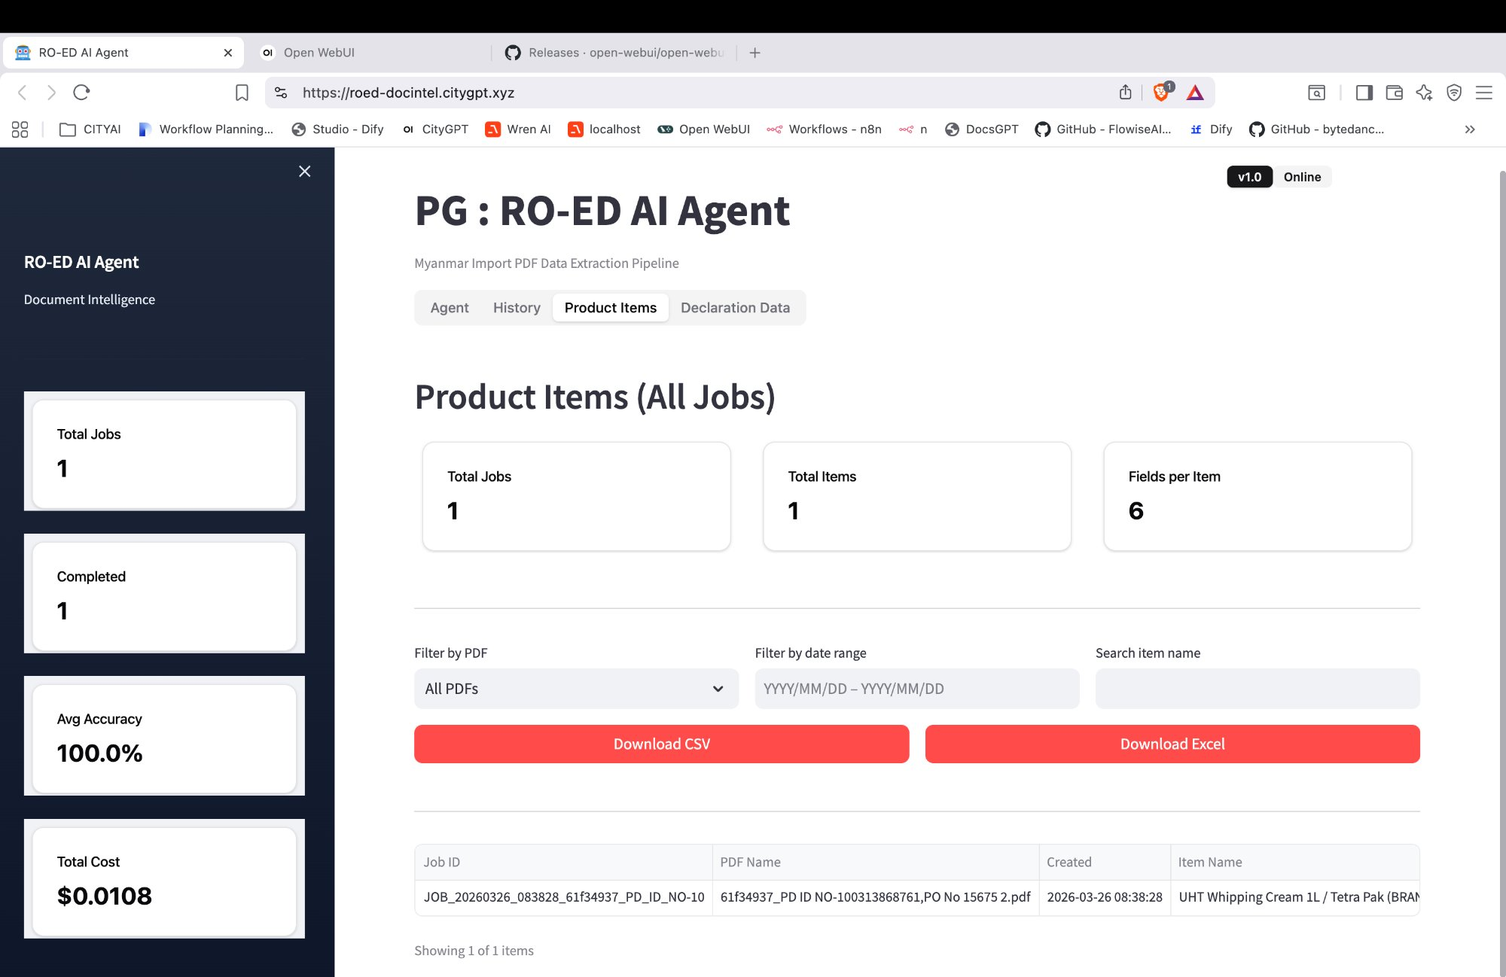
Figure: Product Items Tab — consolidated table with Download CSV / Excel buttons

5.2 Declaration Header Fields (16 fields)
One record per customs declaration. Includes Declaration No, Declaration Date, Importer name/code, Consignee, Exporter, Port of origin, HS codes, CIF value, total tax amounts, Agent name, office codes, and document references.

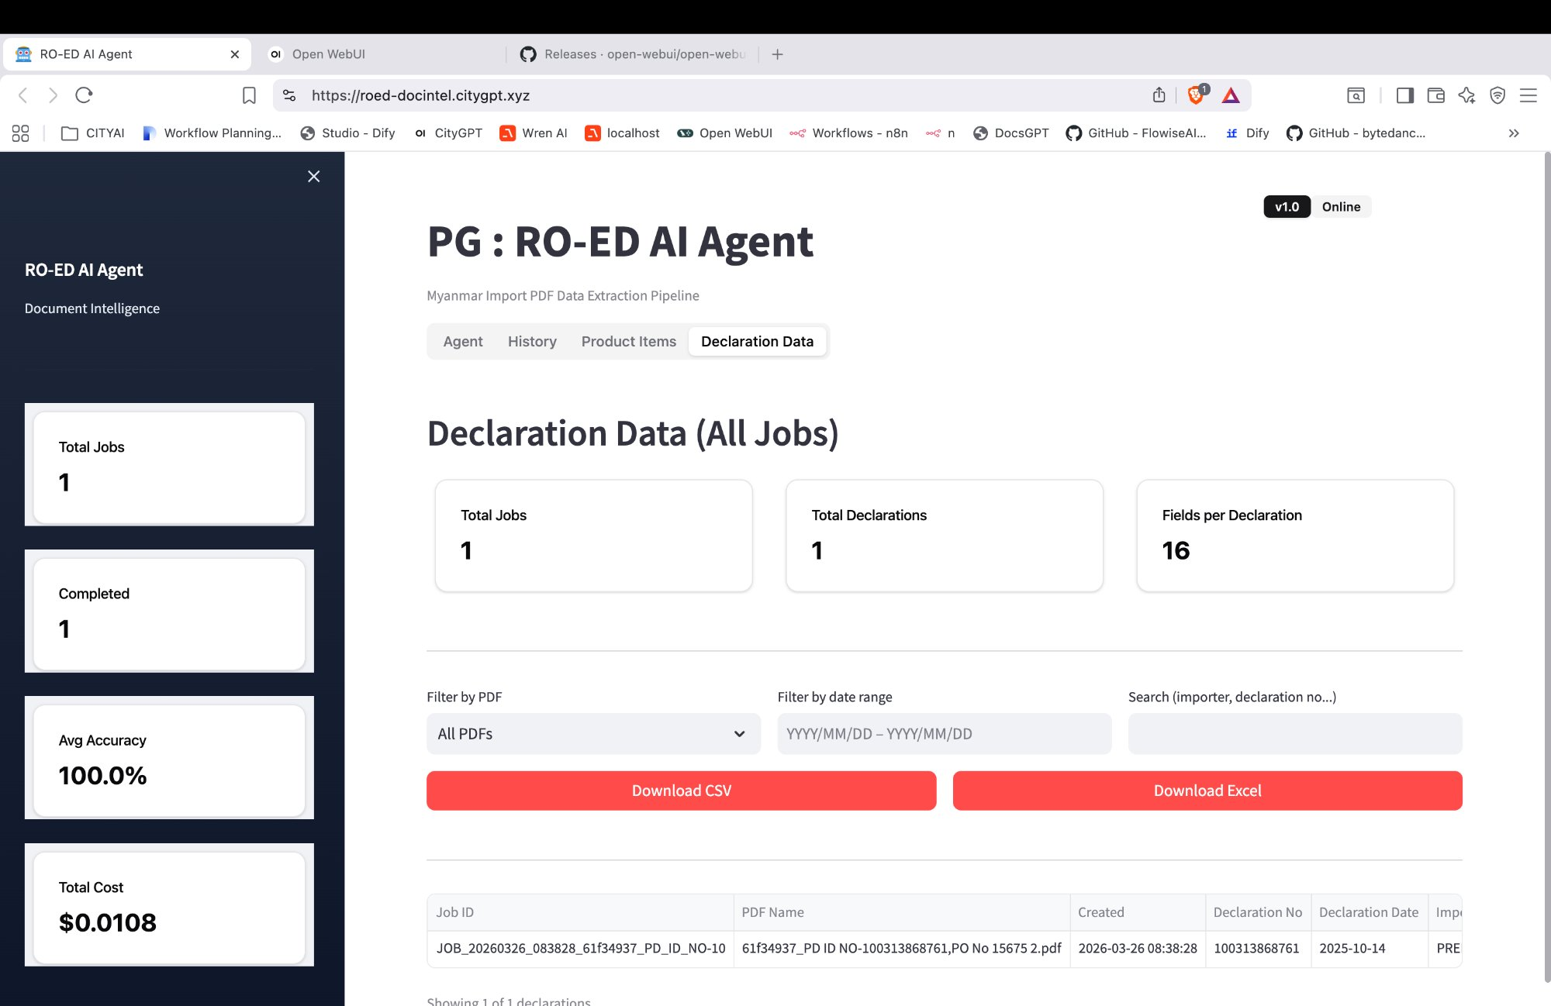
Figure: Declaration Data Tab — 16 declaration fields extracted per job

6. Viewing Job History
The History tab gives a full audit trail of every PDF processed by the agent.

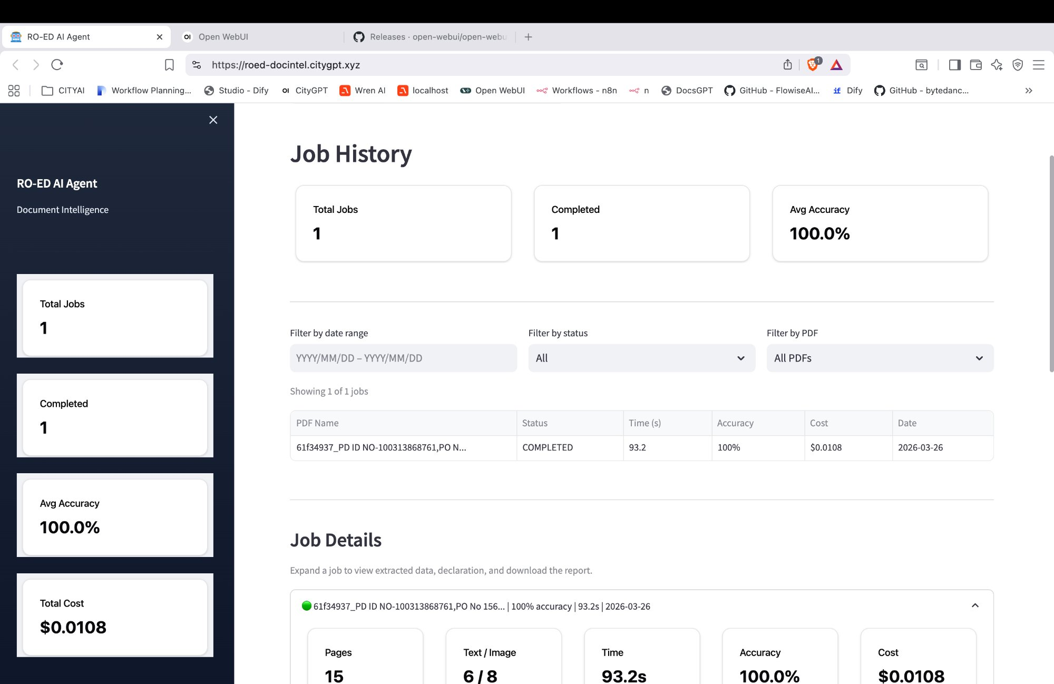
Figure: History Tab — job list with status, accuracy, cost, and date filters

History Tab Features
- Summary cards: Total Jobs, Completed count, Average Accuracy across all jobs
- Filter by date range, status (All / Completed / Failed / Processing), and PDF name
- Sortable table columns: PDF Name | Status | Time (s) | Accuracy | Cost | Date
- Expand any row in the Job Details panel to see full metrics and classification map
- Download the original PDF directly from the expanded job panel

7. Downloading Extracted Data
Extracted data is available in two formats: CSV (general use) and Excel (compatible with SAP / ERP systems). Both tabs support filtering before download.

Product Items Export
- Click the Product Items tab.
- Optionally filter by PDF name, date range, or search for a specific item.
- Click 'Download CSV' or 'Download Excel'.
- File contains: Job ID, PDF Name, Created timestamp, and all 6 product fields.

Declaration Data Export
- Click the Declaration Data tab.
- Optionally filter by PDF name, date range, or search by importer/declaration number.
- Click 'Download CSV' or 'Download Excel'.
- File contains: Job ID, PDF Name, Created timestamp, and all 16 declaration fields.

💡 Note: Both exports include data from ALL jobs by default. Use the date range and PDF filter to narrow down to a specific submission or time period.

8. Duplicate PDF Detection
The agent has built-in duplicate detection to prevent accidental re-processing and unnecessary API cost.

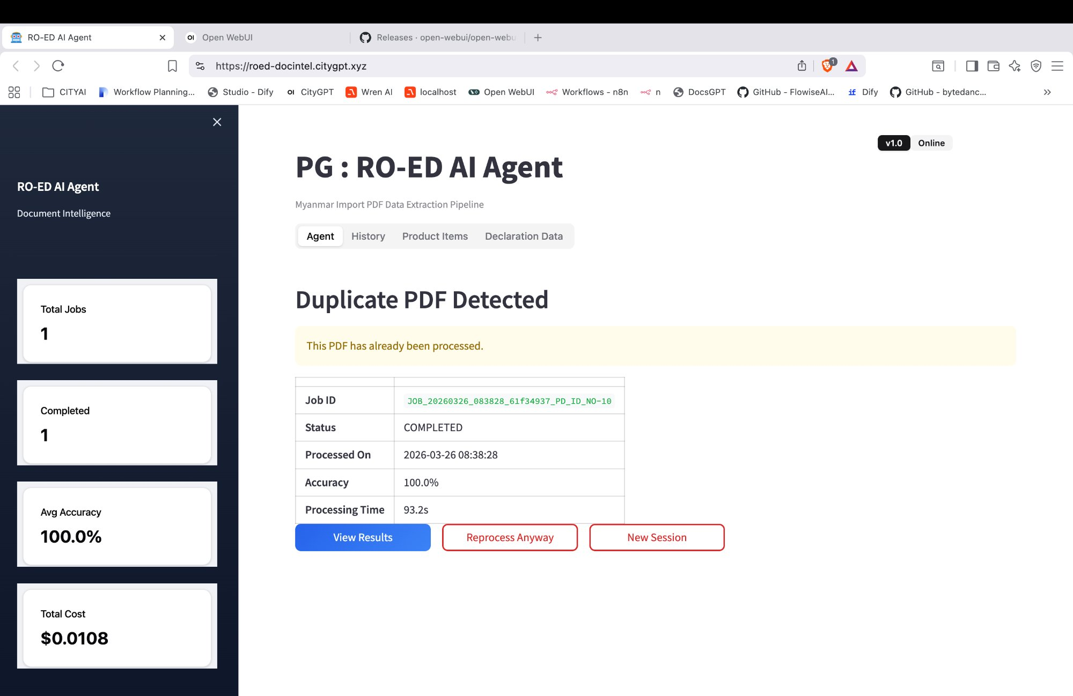
Figure: Duplicate PDF Detected — shows original Job ID, status, accuracy, and your action options

Your Options When a Duplicate is Detected
View Results | Jump to the previous job's results. Recommended — no additional cost incurred.
Reprocess Anyway | Force a fresh extraction. Use only if the previous result had errors or the pipeline has been updated. Incurs API cost.
New Session | Return to the upload screen to process a different PDF. No processing occurs.

9. Troubleshooting

Issue | Recommended Action
Accuracy below 90% | Check Page Classification Map. Many orange (IMAGE) pages may indicate low-res scans. Request a higher-quality PDF from the supplier.
Processing stuck / no progress | Wait up to 3 minutes. If still frozen, refresh the page and check History — the job may have completed in the background.
'Could not render preview' | Normal — PDF preview is not supported in v1.0. Data extraction is unaffected.
Grey '?15' badge on classification map | The last page could not be classified — may be blank or an embedded attachment. Check the original PDF.
Missing fields in exported data | Completeness below 100% means some fields were not found. The document may use a non-standard layout — escalate to the AI Platform team.
Duplicate detected but PDF has changed | Use 'Reprocess Anyway' to force a fresh extraction of the updated document.
Agent shows 'Offline' | The service may be restarting. Wait 2–3 minutes and refresh. If still offline, contact the AI Platform team.

10. Quick Reference Card

Process a PDF — Quick Steps  1. Open roed-docintel.citygpt.xyz  2. Click 'New Session'  3. Drag & drop your PDF  4. Wait for COMPLETED (~90s)  5. Review results & metrics  6. Download CSV / Excel | Key Facts  URL: roed-docintel.citygpt.xyz  Version: v1.0 (Online)  Avg cost per PDF: ~$0.01  Avg processing time: 60–120 seconds  Pipeline stages: 7 (Classify to Excel)  Declaration fields: 16 | Item fields: 6

For support, contact the AI Platform Team — CityGPT / Pahtama Group

