City Agent Aria
Deployment & Scaling Guide — 100 to 1000 users (40% concurrent)
Infrastructure sizing, cost, the scaling journey, and how to scale without losing data or chat history.

1. The one rule
The box is not the bottleneck. There is no local AI model — every LLM call is remote (OpenRouter). App workers spend their time waiting on the network, so CPU and RAM stay low. The real ceiling is the LLM concurrency cap plus your OpenRouter rate tier, and the Postgres connection count (the “pool-math” wall).
“40% concurrent” means 40% of total users are active at peak (1000 users → 400 active). People read each answer for 15–60s before asking again, so in-flight requests ≈ active ÷ 7 (400 active → ~57 in flight). The zero-LLM Q&A cache serves repeat questions, cutting cold load ~40–60%.

2. Architecture
Users hit one load balancer (nginx or ALB), which round-robins across stateless app replicas. A single leader-gated worker runs all ingest + background jobs. Postgres holds every piece of data; page images live on disk or S3; the LLM is remote.
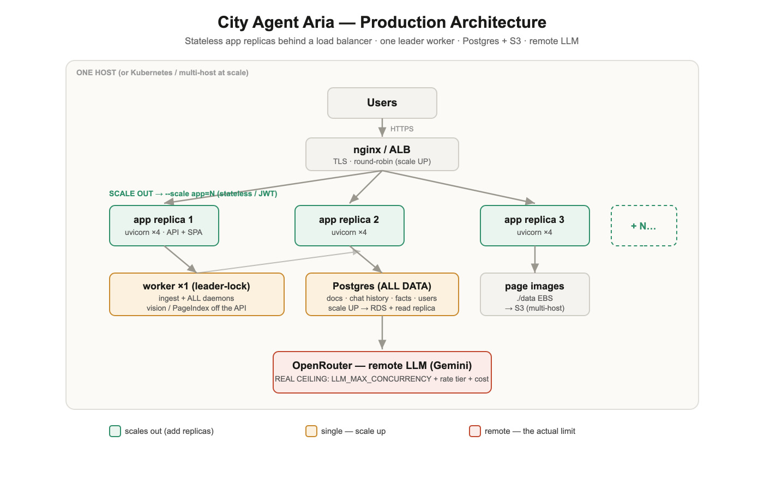
- App replicas — stateless (JWT auth, rate-limits/state in Postgres). Run N copies, rebuild anytime; they hold no data.
- Worker ×1 — ingest + daemons. Exactly one runs them (Postgres advisory leader-lock), even with many replicas.
- Postgres — the single source of truth: documents, chat history (conversations + messages), facts, users, analytics.
- data/ or S3 — rendered page images. OpenRouter (Gemini) is the only heavy dependency, and it is remote.

3. Where every piece of data lives
Containers are disposable; Postgres and data/ are not. You can rebuild and scale app containers freely.
Data | Stored in | Survives rebuild/scale? | Lost if…
Documents, pages, outline | Postgres | Yes | PG volume deleted
Chat history (conversations, messages) | Postgres | Yes | PG volume deleted
Facts, Q&A bank, users, roles, sectors | Postgres | Yes | PG volume deleted
Page images (PNG) | data/ (or S3) | Yes | data/ deleted
App code / config | container image | rebuilt each deploy | — (no data here)
Secrets, flags | .env (gitignored) | Yes (on host) | host wiped

4. Sizing: 100 → 1000 users (40% concurrent)
WEB_CONCURRENCY = 4 throughout. LLM_MAX_CONCURRENCY is burst-sized to the in-flight peak (never above your OpenRouter tier). AWS = on-demand; Reserved/Savings Plan ≈ −40%. LLM cost assumes gemini-flash-lite, ~3500 tokens/answer, ~10 q/user/day, 40% cache hit.
Users | Active | In-flight | App tier | app= | Database | Images | PG_MAX | LLM_MAX | $/mo
100 | 40 | 6 | 1× t3.xlarge | 2 | on-box / db.t3.small | local | 200 | 30 | ~145
250 | 100 | 14 | 1× m5.xlarge | 3 | RDS db.t3.medium | local | 200 | 40 | ~296
500 | 200 | 29 | 2× m5.xlarge + ALB | 5 | RDS m5.large Multi-AZ | S3 | 300 | 60 | ~773
750 | 300 | 43 | 2-3× m5.xlarge + ALB | 7 | + read replica | S3 | 300 | 80 | ~809
1000 | 400 | 57 | 3× m5.xlarge + ALB | 9 | m5.large MAZ + replica | S3 | 400 | 100 | ~845
Pool-math invariant (must always hold): replicas × WEB_CONCURRENCY × DB_POOL_MAX + 15 < PG_MAX_CONNECTIONS. At 1000 users: 9 × 4 × 8 + 15 = 303 < 400. ✓
Generate any point live: python3 scripts/scale_plan.py --users 1000 --concurrency 0.4 --cache 0.5 --tier 100

5. The scaling journey

Stage 1 — 100 (single host)
One t3.xlarge runs nginx + 2 app replicas + worker + Postgres. STORAGE=local. Deploy: docker compose -f docker-compose.prod.yml up -d --scale app=2.

Stage 2 — ~250 (split the database off)
Move Postgres to managed RDS (db.t3.medium) for automated backups + point-in-time recovery. App + worker stay on one box. Point DATABASE_URL at RDS, --scale app=3. Still STORAGE=local.

Stage 3 — ~500 (multi-host = cattle)
The app now spans more than one machine, so: STORAGE=s3 (page images must be shared — a bind mount cannot be cross-host), an ALB in front of the fleet, and RDS Multi-AZ for failover. --scale app=5, PG_MAX=300.

Stage 4 — 750 → 1000 (add replicas + scale DB reads)
Add app replicas (--scale app=7…9) across 2-3 m5.xlarge. Add an RDS read replica so dashboards/analytics read off it and the writer stays free. Raise PG_MAX=400 and LLM_MAX_CONCURRENCY to match the ~57 in-flight peak — confirming your OpenRouter tier permits it. The worker stays a single instance at every stage; scale ingest up (WORKER_VISION_WORKERS), never out.

6. Where the limits bite (scale triggers)
Symptom under load | Cause | Fix
p95 latency climbing | LLM slots saturated | ↑ LLM_MAX_CONCURRENCY (vs tier); ↑ cache hit-rate
OpenRouter 429s | rate tier exceeded | raise OpenRouter tier; approve more Q&A cache pairs
“too many connections” | pool-math violated | ↓ DB_POOL_MAX or ↑ PG_MAX_CONNECTIONS
DB CPU high | dashboard reads | add an RDS read replica
ingest queue backing up | vision throughput | ↑ WORKER_VISION_WORKERS; dedicated worker host
app CPU pegged (rare) | many concurrent streams | --scale app=N+1
Cost insight: AWS is roughly flat from 500→1000 (~$700–850) — you add cheap replicas, not bigger boxes. The variable cost and the throughput wall are both the LLM ($15 → $145/mo) and your OpenRouter tier. The single biggest lever on both is the Q&A cache — keep it on (AUTO_QA_SERVE_ENABLED=1).

7. Scale without losing data
All data lives in Postgres + data//S3, never in app containers. These are all safe (no data loss): up -d --build --force-recreate, --scale app=N, restart, and down (without -v).
Never run in production (data loss): down -v (deletes the Postgres volume = all data + chat), docker volume rm …_docsensei_pg, or rm -rf ./data.

8. Go-live checklist
- APP_ENV=production + a strong JWT_SECRET (≥32 chars) — the boot guard enforces it.
- TLS: certs mounted, :443 enabled, PUBLIC_URL=https://… (also unlocks PWA install).
- scripts/backup.sh scheduled in cron AND one restore drill passed (or RDS automated backups + PITR).
- Dev credentials rotated; AUTO_QA_SERVE_ENABLED=1 (cache on for cost).
- python3 scripts/smoke.py returns GO; watch the first hour on the Performance, System and Vitals dashboards.

Companion files: docs/DEPLOYMENT.md, docs/SCALING.md, docs/SCALING_100_1000.md, docs/SMOKE_TEST.md, scripts/scale_plan.py, scripts/smoke.py.

