Infrastructure Requirements
City Agent Aria — internal SOP / runbook assistant
Deployment: single dedicated EC2 instance (self-hosted) + Amazon S3 for document storage.

1. Overview
City Agent Aria is a containerised web application (web UI + API + a background document-ingestion worker + a PostgreSQL database), deployed with Docker Compose on ONE dedicated EC2 instance. Uploaded documents and rendered page images are stored in Amazon S3. The application uses no local AI model — all inference is a remote HTTPS call to our LLM provider (OpenRouter) — so the instance is lightweight and I/O-bound.
Managed services used: EC2, EBS and S3 only. No RDS, no Redis/ElastiCache, no load balancer, and no vector database at this stage.

2. Architecture
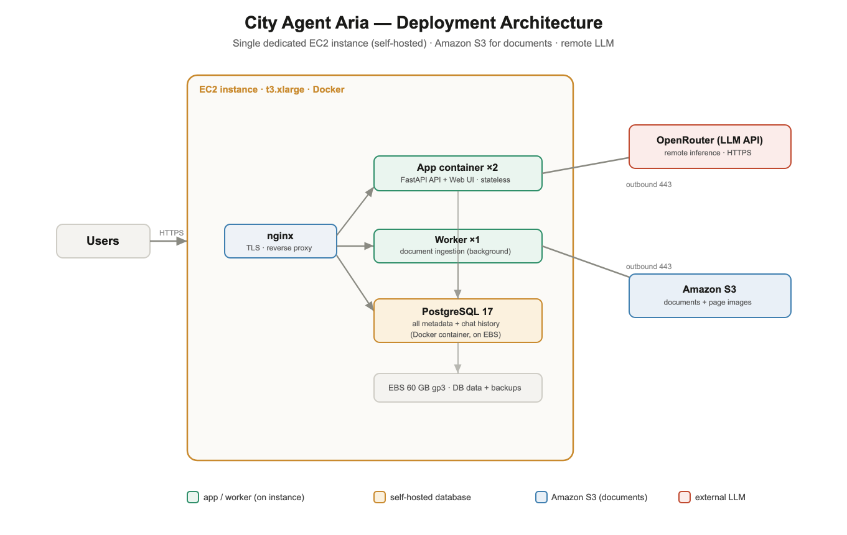
All application components run on the single instance. The only outbound traffic is HTTPS to the LLM provider and to Amazon S3.

3. Compute (EC2)
Item | Requirement
Instance type | t3.xlarge (4 vCPU / 16 GB RAM) for 100–300 users
Upgrade path | m5.xlarge if 500+ users on the single instance
Operating system | Amazon Linux 2023 or Ubuntu 22.04 LTS
Required software | Docker + Docker Compose
Availability (pilot) | Single instance, single-AZ (acceptable initially)

Capacity — which instance handles how many users
The application is I/O-bound (all inference is remote), so a single instance serves a large user base. “Peak active” assumes ~40% of users are online at once; real in-flight requests are far fewer, and the built-in answer cache serves repeat questions with no LLM call.
Total users | Peak active | Instance | App copies | Database | Docs | Deployment
up to 100 | ~40 | t3.large / t3.xlarge | 2 | on-instance PostgreSQL | S3 | single instance
up to 300 | ~120 | t3.xlarge | 2–3 | on-instance PostgreSQL | S3 | single instance (recommended start)
up to 500 | ~200 | m5.xlarge | 3–5 | on-instance or RDS | S3 | single large instance
up to 1000 | ~400 | 2× m5.xlarge + ALB (or m5.2xlarge) | 5–9 | RDS Multi-AZ | S3 | Option 2 (load-balanced)
Throughput ceiling: the limit is the LLM concurrency setting + your OpenRouter rate tier — not the server. The instance rarely needs a CPU/RAM upgrade; you scale by adding app copies. Cost stays roughly flat from 500 to 1000 users because you add small replicas rather than a bigger box.

4. Storage
4.1 EBS (block storage on the instance)
Item | Requirement
Volume | 1 × 60 GB gp3
Contents | PostgreSQL data files + local database backups
Encryption | Encryption at rest enabled

4.2 Amazon S3 (document / image storage)
Item | Requirement
Bucket | one private bucket, e.g. aria-documents-prod (same region)
Contents | uploaded documents + rendered page images
Public access | Blocked
Encryption | Default encryption enabled (SSE-S3 or SSE-KMS)
Versioning | Recommended (guards accidental delete/overwrite)
Access method | IAM role attached to the EC2 instance (no stored keys)
IAM permissions | s3:GetObject, PutObject, DeleteObject, ListBucket — this bucket only
Network | S3 VPC gateway endpoint recommended

5. Database
- PostgreSQL 17, run as a Docker container ON the EC2 instance (self-hosted — no Amazon RDS). Data persisted to the EBS volume.
- Stores ALL structured data: document metadata & text, chat history (conversations + messages), knowledge/facts, users, roles, groups, analytics, and configuration.
- No external cache (Redis) and no vector database are required — the retrieval design is vectorless and self-contained.

6. Networking & Security
Direction | Port / target | Purpose
Inbound | 443 (HTTPS) | application access
Inbound | 80 | redirect to 443 only
Inbound | 22 (SSH) | restricted to office IP / bastion only
Outbound | 443 → OpenRouter | LLM inference (required)
Outbound | 443 → Amazon S3 | document/image storage (VPC endpoint preferred)
TLS + domain: a hostname such as aria.<ourdomain> is required. Please confirm the certificate source (AWS ACM or Let's Encrypt) and DNS ownership. Security group denies all except the ports above.

7. Backups
Data | Method | Owner
Database | Daily automated pg_dump via cron on the instance | Application team
Documents / images | S3 durability + bucket versioning | AWS-managed
Optional DR | Nightly EBS snapshot + DB dump copy to a second location | Infra team

8. External Dependencies
- OpenRouter (LLM API) over HTTPS — the only external inference dependency.
- Amazon S3 — document/image storage.
No other third-party services are contacted.

9. Provisioning Checklist (please confirm / provide)
- AWS region (nearest our users — e.g. ap-southeast-1).
- EC2 instance — t3.xlarge (or m5.xlarge), chosen OS, Docker + Compose installed.
- EBS — 60 GB gp3, encryption at rest enabled.
- S3 bucket — name, encryption, versioning, public access blocked.
- IAM instance role — scoped S3 permissions on that bucket (or access keys if role not possible).
- S3 VPC gateway endpoint — can it be enabled.
- Domain / DNS / TLS — hostname, certificate source, DNS ownership.
- Environments — production only, or a separate staging instance as well.
- Access — who holds SSH/IAM access; who patches the OS.
- Go-live date / maintenance window.

10. Installation & Setup (step by step)
What is being installed: one EC2 instance running Docker containers — the web app (×2), a background worker, and PostgreSQL — behind nginx, with documents stored in Amazon S3.
Have ready before you start: the EC2 instance (Section 3) with Docker installed, the S3 bucket + IAM instance role (Section 4.2), access to the application code repository, an OpenRouter API key, and a domain + TLS certificate (Section 6).
Step 1 — Install Docker on the server. Why: the application runs entirely as Docker containers.
sudo apt update && sudo apt install -y docker.io docker-compose-plugin
sudo usermod -aG docker $USER # then log out and back in
Step 2 — Get the application code. Why: the repository contains the build definition and the compose files.
git clone <repository-url> aria && cd aria
Step 3 — Configure settings (.env.prod). Why: the app reads secrets and storage config from a .env file, which is never committed to source control.
cp .env.prod.example .env.prod # then edit .env.prod
Set the required values:
Setting | Why it is needed
OPENROUTER_API_KEY | the LLM key — without it, chat and document ingestion do not work
JWT_SECRET | signs login tokens; must be a strong 64-character random string
APP_ENV = production | enables the production security guard (refuses to start on a weak secret)
PUBLIC_URL | your HTTPS domain — used for login / SSO redirects
SUPERADMIN_EMAIL / _PASSWORD | the first administrator account, created on first boot
STORAGE = s3 + S3_BUCKET | store documents / page images in S3 (Section 4.2)
Note: with the IAM instance role attached (Section 4.2), no S3 keys are needed — the app uses the instance role automatically.
Step 4 — Build and start the application. Why: builds the app image and launches all containers. On first boot the database schema is created automatically and the super-admin is seeded from .env.
docker compose -f docker-compose.prod.yml build
docker compose -f docker-compose.prod.yml up -d --scale app=2
This starts PostgreSQL, two app containers, the worker, and nginx — all on the one instance.
Step 5 — Set up HTTPS (TLS). Why: login and SSO require HTTPS; browsers block sign-in over plain HTTP. Point your domain (Section 6) at the instance and install the certificate — via AWS ACM (with a load balancer) or Let's Encrypt on nginx.
Step 6 — Schedule database backups. Why: the database is self-hosted, so backups are our responsibility. Add a daily cron job.
30 2 * * * cd /opt/aria && ./scripts/backup.sh # daily at 02:30
Step 7 — Verify before opening to users. Why: confirm the system is healthy end-to-end.
curl -s https://aria.<ourdomain>/api/health # expect {"status":"ok"}
python3 scripts/smoke.py # end-to-end check, expect GO
Then open the site, sign in as the super-admin, upload a document under Sources, and ask a question in Chat to confirm the answer cites the source page.
Step 8 — Go live. Share the URL. Users sign in; administrators manage documents and access under Settings.

11. Scale-out (future — for awareness)
Beyond ~500 users we will move to a load-balanced, multi-instance design: an Application Load Balancer → an Auto Scaling Group of app instances → Amazon RDS (Multi-AZ) → the SAME S3 bucket. The application is already built for this (stateless application tier, single background worker), so the transition is a configuration change, not redevelopment. This will be raised separately when we approach that scale.

12. Indicative Monthly Cost (on-demand, for budgeting)
Item | Approx.
EC2 t3.xlarge | ~$120
EBS 60 GB gp3 | ~$5
S3 (documents, low volume) | ~$3–10
AWS subtotal | ~$130–140 / month (≈ −40% with a Reserved Instance / Savings Plan)
LLM usage (OpenRouter) | ~$25–50 / month at 100–300 users

Prepared by Rahul Gupta. Please contact us with any questions before provisioning.

