PRODUCT UPDATE · PLAIN-LANGUAGE BRIEF
Legal Scout — What We Changed & Why
A guide for the legal team. What the assistant does now, how it works, and the safeguards that keep every draft under an attorney's control.
Myanmar corporate-law automation · Every output is a draft for attorney review

IN ONE MINUTE
What this update is about
Legal Scout drafts Myanmar corporate-law documents — resolutions, consents, DICA filings — from the company and people information you already hold. This release rebuilt the whole experience so it is faster to use, clearer to follow, and safer to trust.
The assistant now works like a careful junior colleague: it reads your registers, asks you when it is unsure instead of guessing, follows written procedures, drafts the document field by field in front of you, and hands it over for your review. Nothing is filed or finalised without a lawyer.
THE POINT OF THIS RELEASE
The changes are about trust and clarity — not just looks. You can see every step the assistant took, answer its questions in the chat, and confirm who signs before a single word is drafted.

THE BIG PICTURE
How a document gets drafted now
Every request follows the same transparent path. You can watch each stage happen and step in at the points that matter.
YOU ASK | → | UNDERSTAND | → | MATCH TEMPLATE | → | READ REGISTER | → | ASK YOU  IF UNSURE | → | CONFIRM SIGNERS | → | DRAFT | → | ATTORNEY REVIEW

From a plain-language request to an attorney-approved document.
BUILT-IN SAFEGUARD
The final step is never skipped. Legal Scout produces a draft for attorney review — it does not file, sign, or send anything on its own.

WHAT THE TEAM ASKED FOR
The features you requested, delivered
These are the changes the team asked for during review, in order of what matters most day to day. (The design refresh and the new skills library come at the end.)
1. The assistant asks you in chat — it does not guess
The biggest change. When something is ambiguous — which template to use, who signs a document — Legal Scout now stops and asks you with a clickable question card right in the conversation. You choose the answer, and it continues. No more silent assumptions.
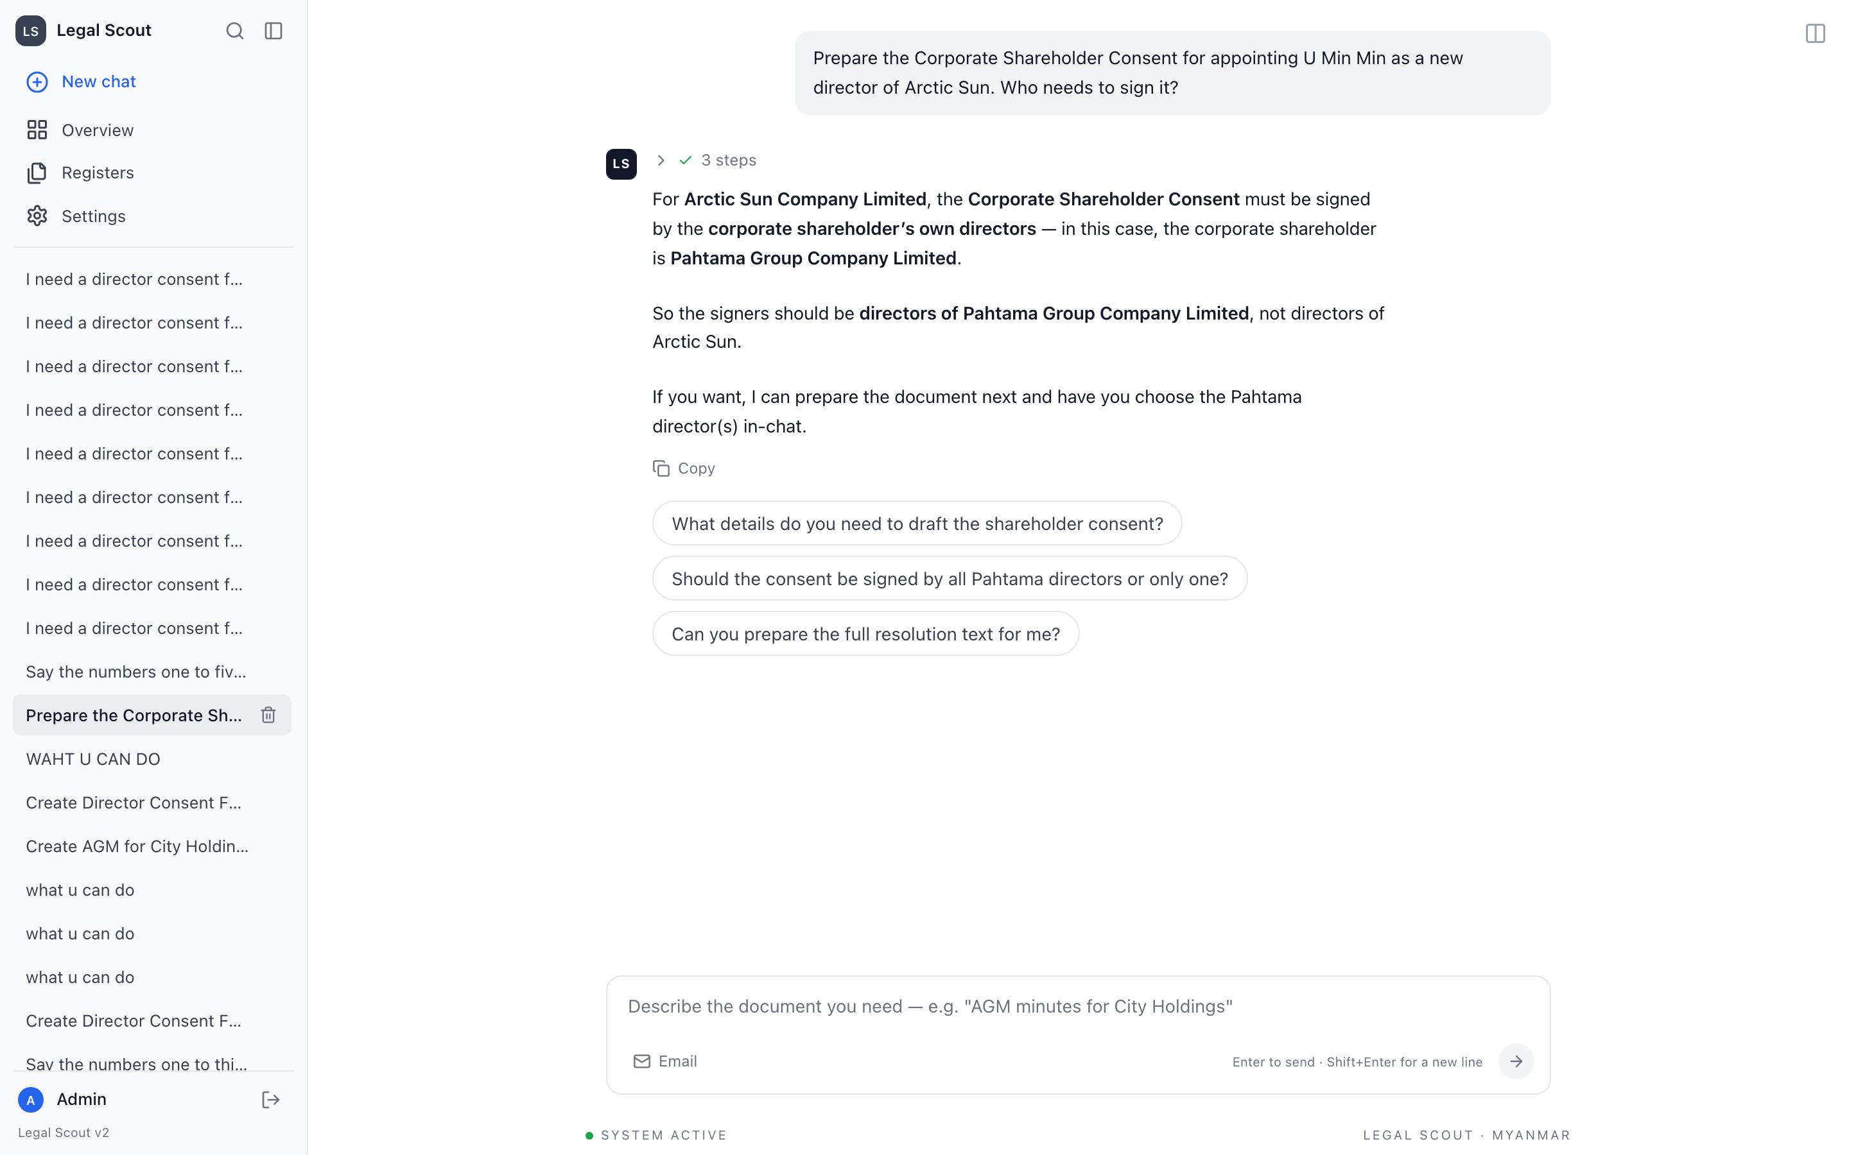
The assistant explains who must sign, then offers clickable follow-up questions — you choose, it does not assume.
2. A proper People Register for signers
Directors and approved signers now live in an organised register. When a document needs a signature, the assistant confirms the correct person from this register rather than typing in a name it invented.
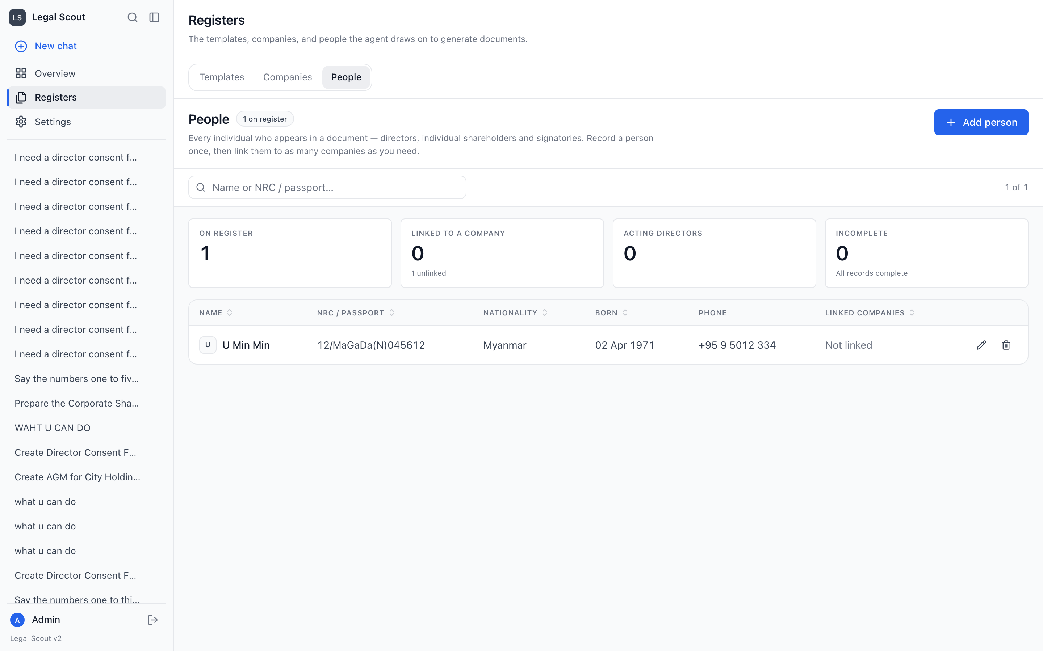
The People Register — every director and signatory recorded once, with the details a document needs.
3. The Company Register drives every draft
Company names, registration numbers and shareholdings — sourced from DICA — are read straight from the register. The assistant does not re-key or guess these details, so the facts on the page match the record.
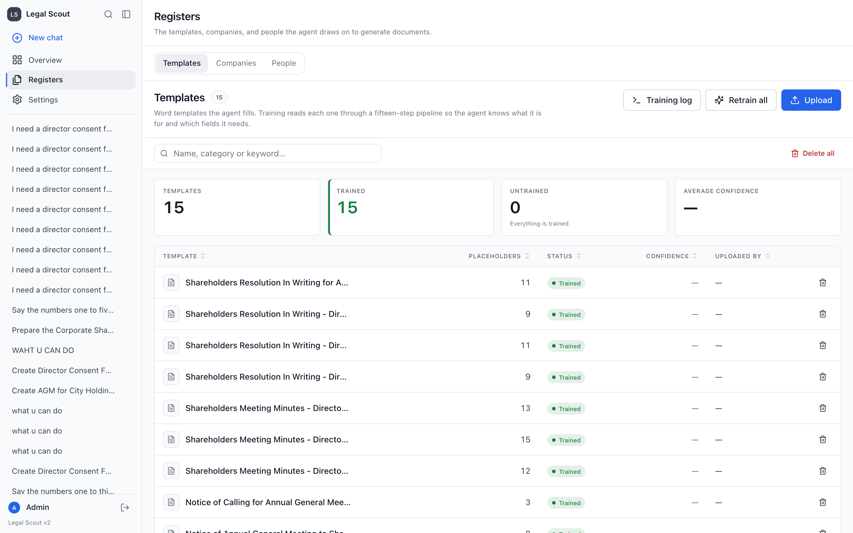
The register of trained document templates the assistant fills from company data — 15 templates, all trained.
4. You watch the assistant work
Replies now appear live, as if typed, and show the steps taken along the way — understanding the request, matching a template, reading the register. You follow the reasoning instead of staring at a blank screen.
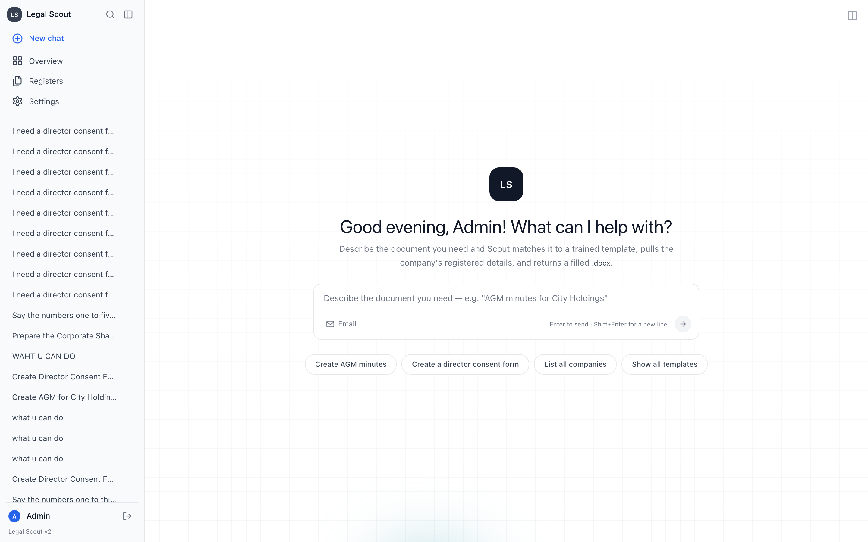
The chat home — describe the document you need in plain language and the assistant takes it from there.
5. Watch the document build, then review it
A side panel fills in each field of the document as it is drafted, then opens the finished draft for you to read and edit. Nothing is hidden until the end.
6. It finishes the job — no empty replies
If a task is interrupted or you answer a mid-way question, the assistant picks up exactly where it left off and completes the work, rather than stopping with a blank message.
7. The signing rule is enforced automatically
For a corporate shareholder's consent, the shareholder company's own directors sign — never the new company's board. This rule is built in and the assistant confirms the signers before drafting. (See the dedicated section below.)
8. Personal data is kept out of drafts
Phone numbers, emails and home addresses that appear in company extracts are deliberately never carried into a draft. Public-facing pages show only invented sample data.
9. Tidier admin screens
Overview, Registers and Settings are now clean tabbed pages — dashboards, documents, emails, users and knowledge each in their own tab, instead of one dense screen.
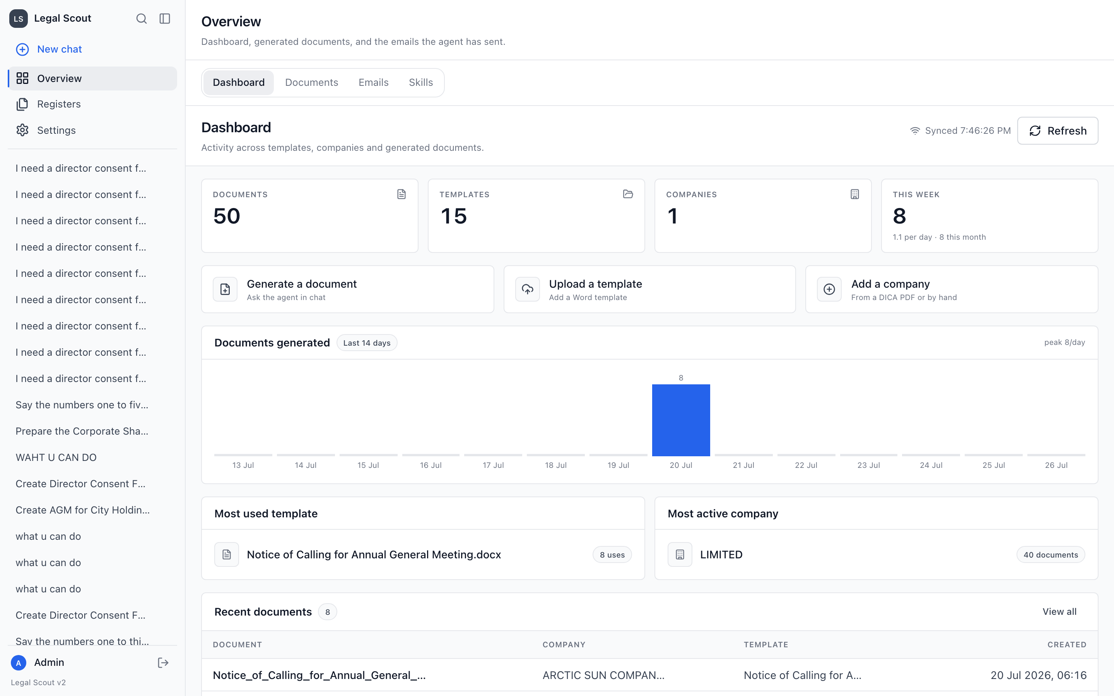
The admin Overview dashboard — documents, templates, companies and recent activity at a glance.
10. An access-control gap was closed
A page that should have been staff-only could previously be reached directly by web address. The permission check was fixed so restricted pages are properly restricted.
WHERE THE ANSWERS COME FROM
The three sources behind every draft
Good drafts need good sources. Legal Scout reads from three organised sources rather than free-form notes — so names, numbers and signers are correct.
COMPANY REGISTER  names · numbers · shareholdings (DICA) | + | PEOPLE REGISTER  directors & approved signers | + | TEMPLATES & PLAYBOOKS  15 templates · 12 legal skills

↓
RESULT
Legal Scout combines all three into an accurate draft for attorney review — nothing on the page is invented.

THE ONE RULE TO REMEMBER
Who signs a corporate shareholder's consent
This is the most important legal safeguard we built in, because getting it wrong is a real filing risk.
SIGNING RULE — ENFORCED AUTOMATICALLY
When a company's shareholder is another company, that shareholder's consent is signed by the shareholder company's own directors — never by the new company's board. Legal Scout confirms the signers from the People Register and will not guess them.

In practice: if Golden Lotus Trading is owned by Emerald Holdings, the consent is signed by Emerald Holdings' directors — and the assistant asks you to confirm exactly who, before drafting. (Golden Lotus and Emerald are fictional examples.)
ADDED CAPABILITY
New: a library of legal playbooks (skills)
Think of skills as written procedure notes the assistant keeps on a shelf. It always knows the titles, but only reads a note in full when the current task calls for it — which keeps it focused and avoids mixing up unrelated rules.
KNOWS THE LIST  (12 titles) | → | TASK NEEDS ONE? | → | OPENS THAT  PLAYBOOK | → | APPLIES IT  TO THE DRAFT

Playbooks are loaded only when relevant — the assistant stays on point.
- 12 playbooks seeded — adapted from Anthropic's public legal skill set plus Myanmar corporate-law practice.
- Managed in the admin panel — a Skills tab lists them; more can be added over time.
- No black box — each playbook is written text you can read and audit.
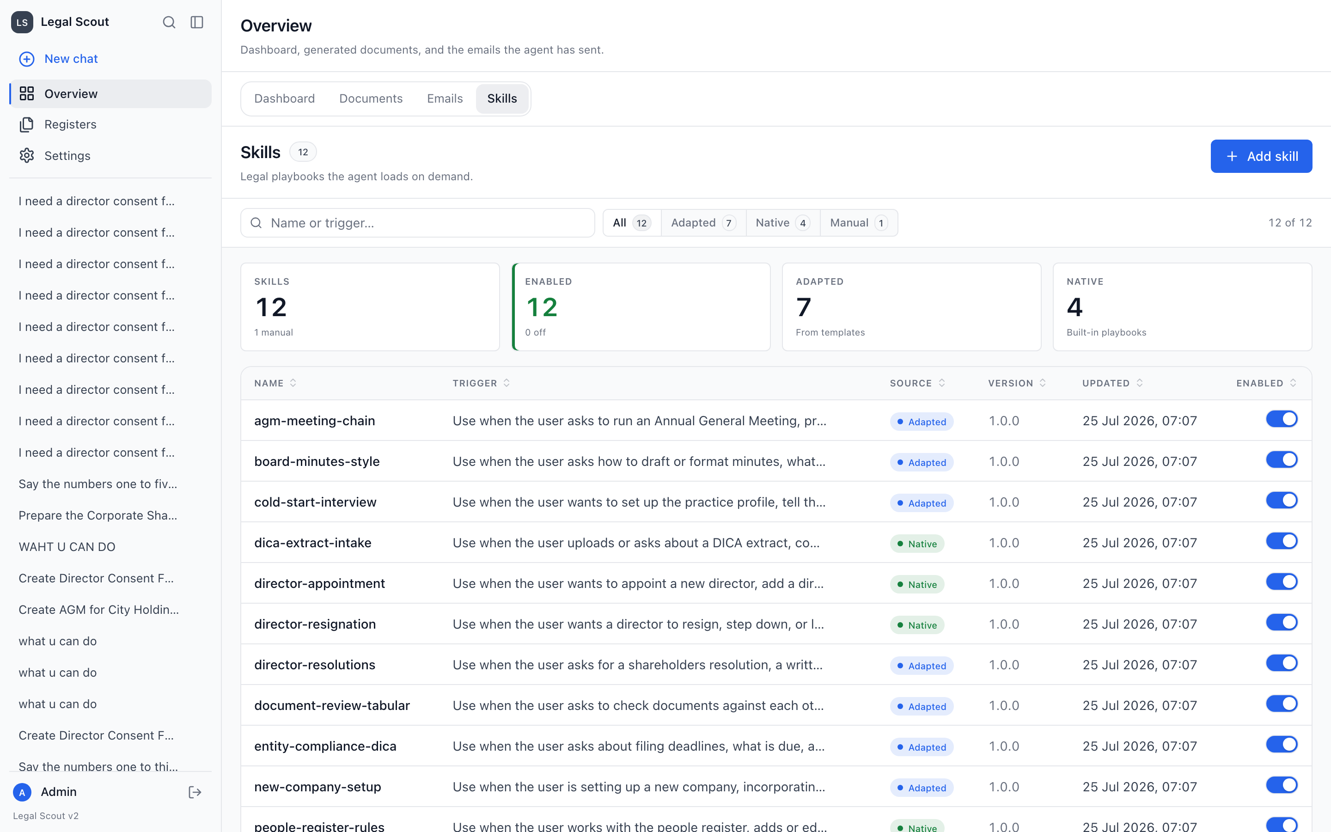
The Skills tab — 12 legal playbooks, each with the situation that triggers it and an on/off switch.
LOOK & FEEL
Last: a cleaner, calmer workspace
The whole interface was rebuilt to match the City Holdings house style — the same look and feel as CityAgent Insights.
- Simple navigation — four places only: New chat, Overview, Registers, Settings.
- A polished sign-in page — matching the house design, with a live demo panel that uses invented sample data only — no real client details.
- Consistent typography and spacing — one clean typeface, comfortable density, light and dark modes.
- Fixed the small frustrations — pages scroll properly, the New chat button always starts fresh, and empty replies are gone.
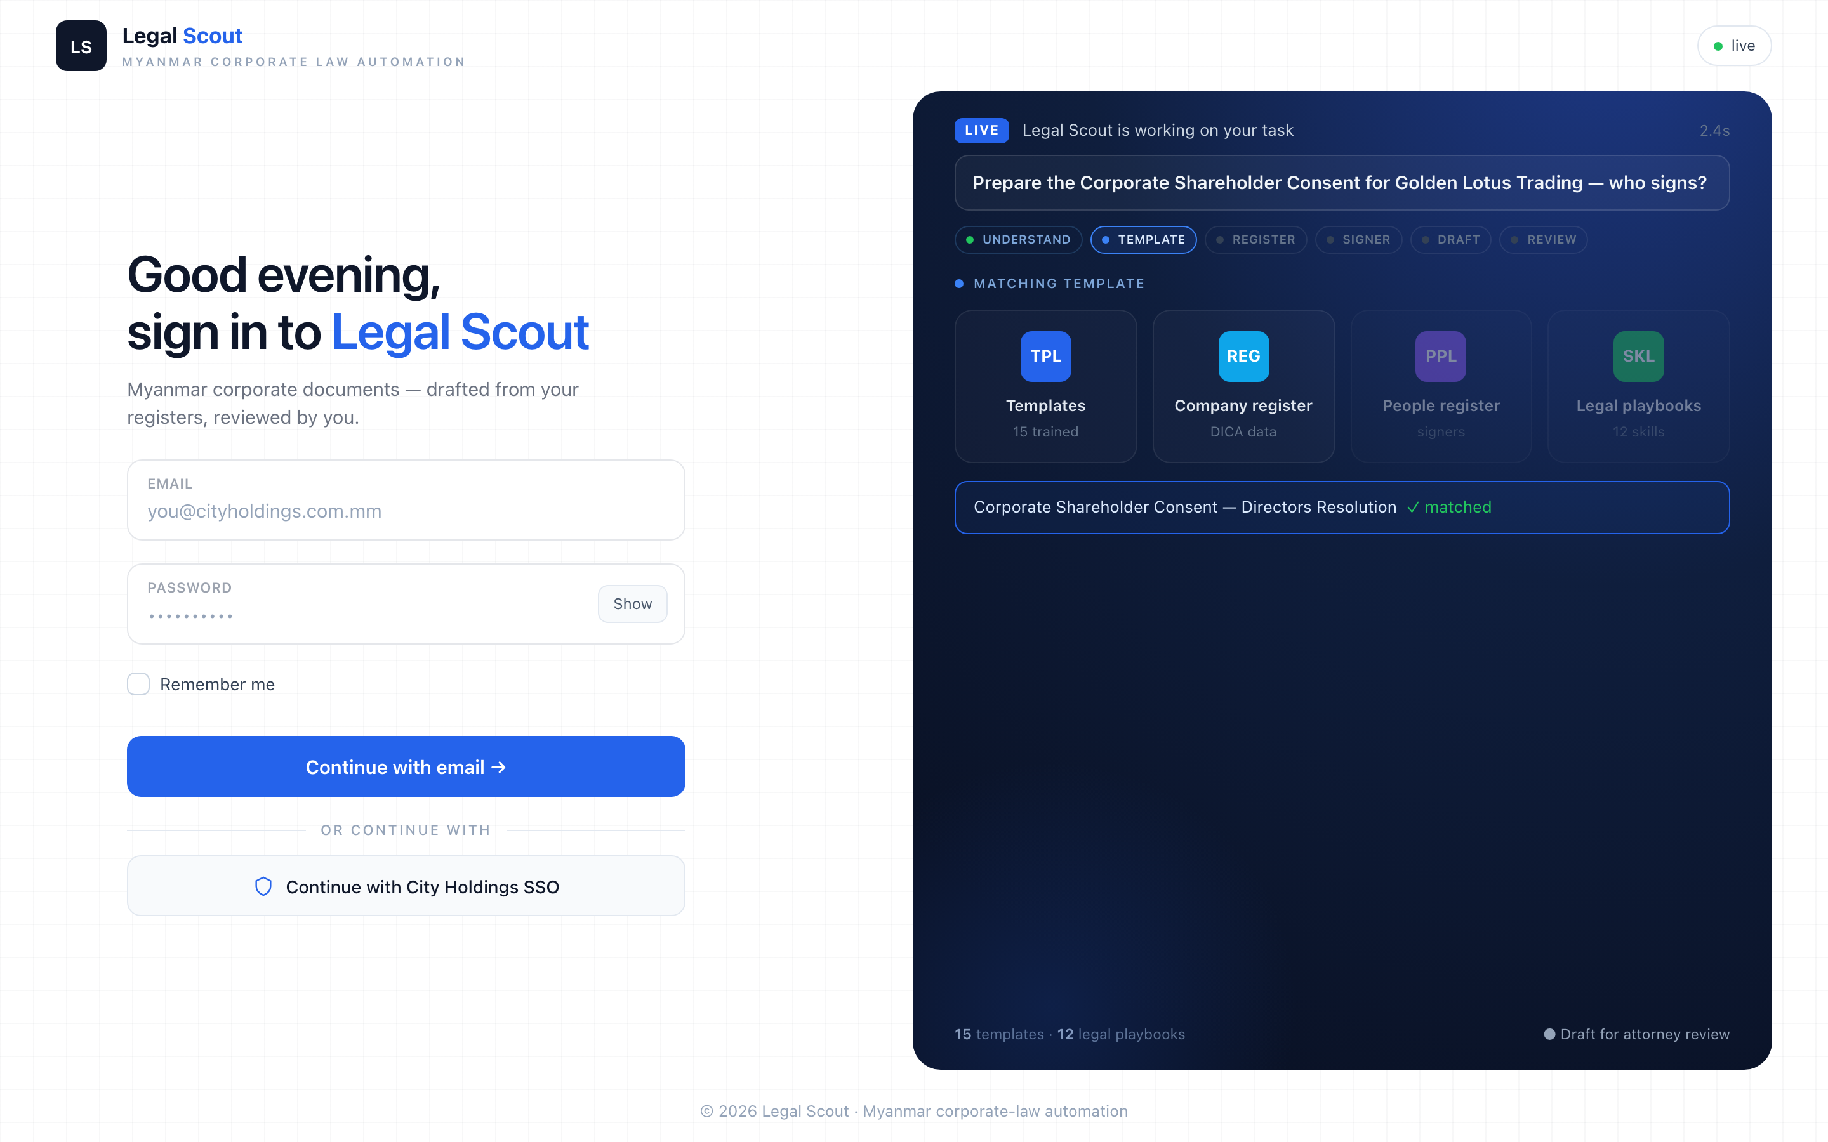
The new sign-in page — the demo panel on the right uses invented sample data only.
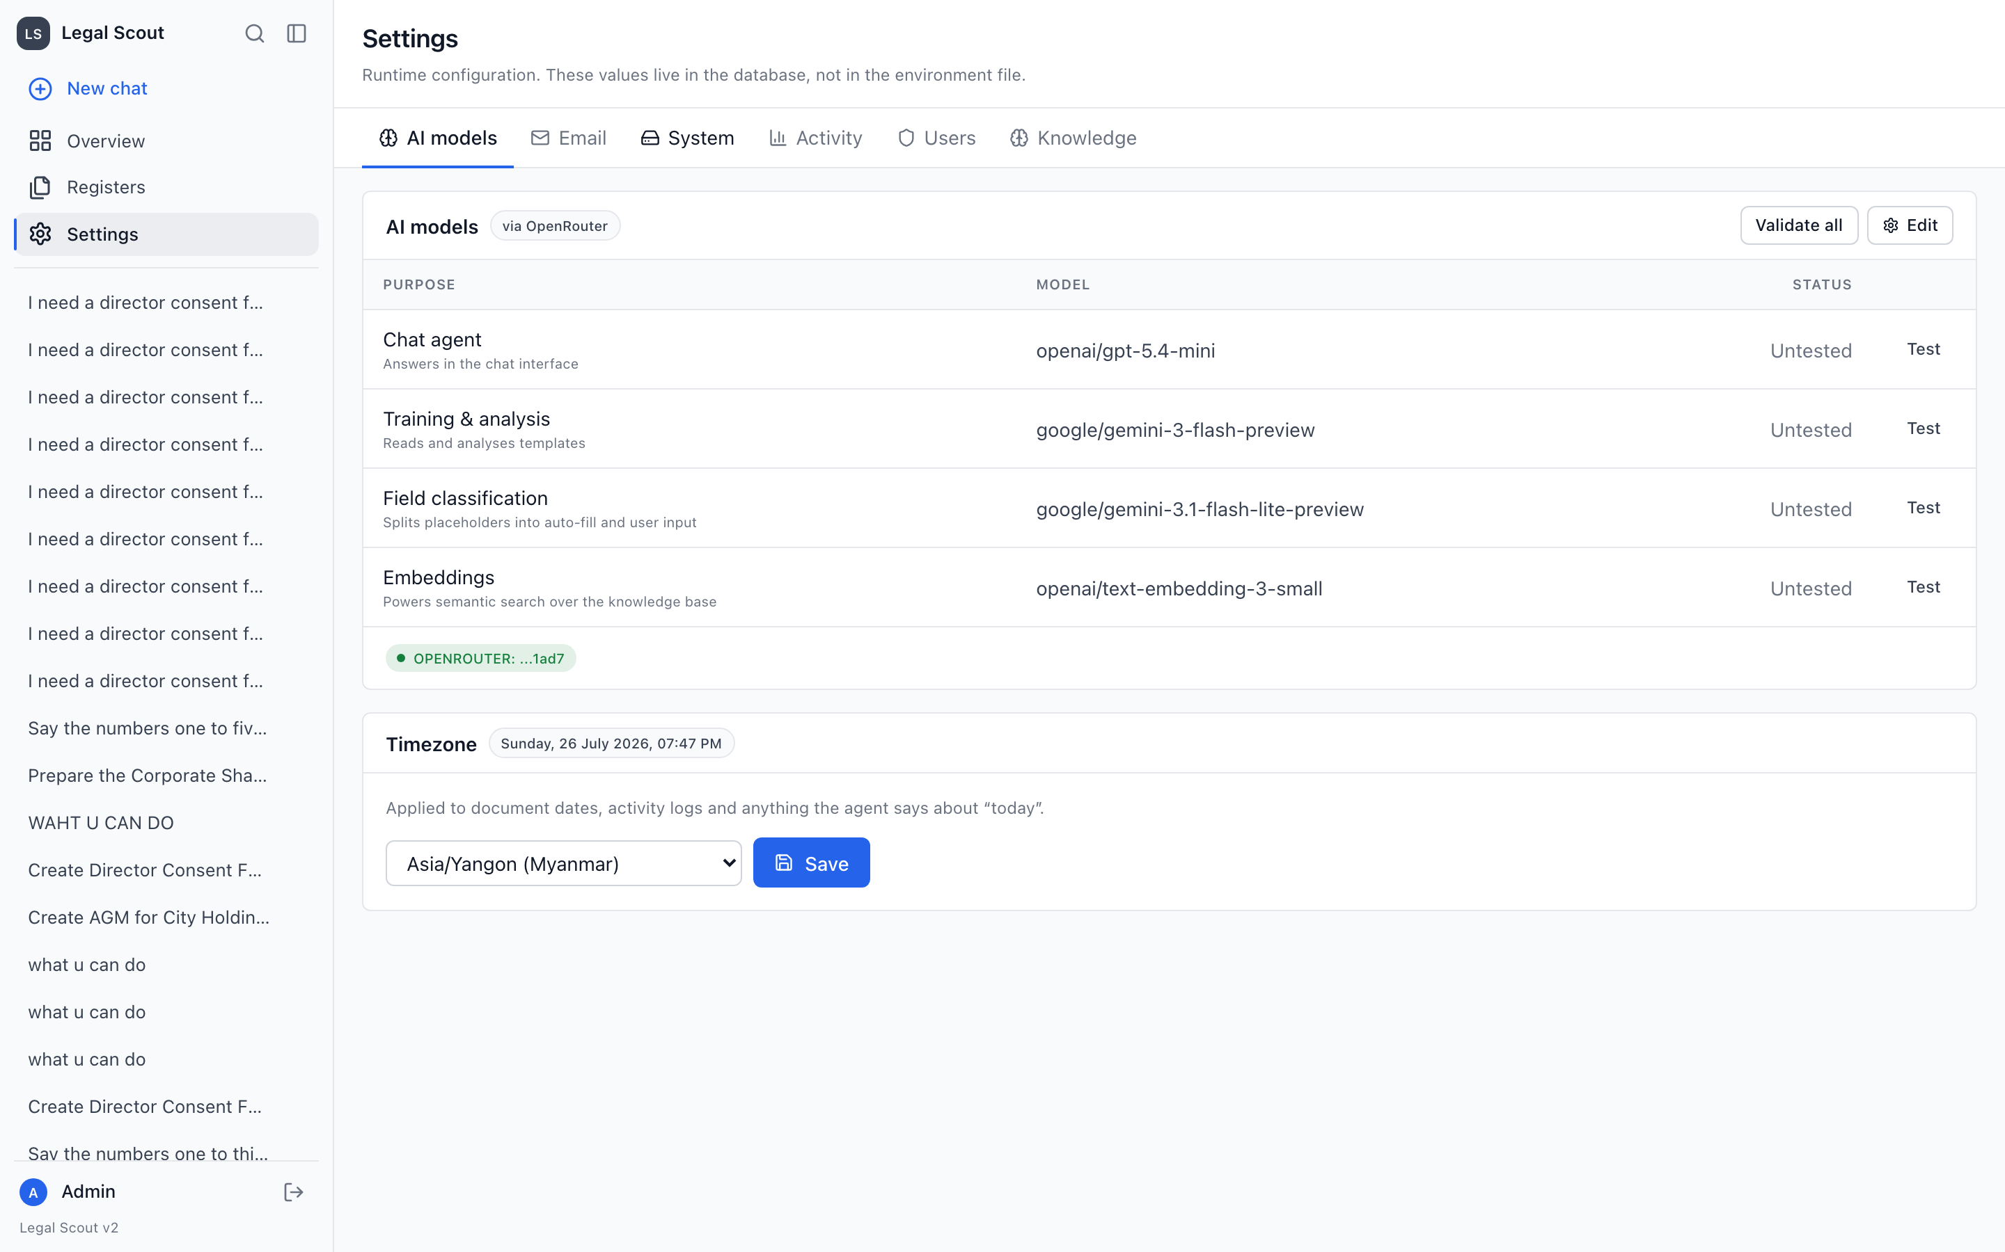
Settings — a clean tabbed page for models, email, users, knowledge and more.
BEFORE & AFTER
What actually changed for you
AREA | BEFORE | NOW
Getting an answer | Wait, then a wall of text appears at once | Streams live and shows each step
When unsure | Assistant guessed and moved on | Asks you in chat; you pick the answer
Who signs | Could be filled in incorrectly | Confirmed from the register, following the rule
Legal know-how | General knowledge only | 12 written playbooks, loaded on demand
Seeing the document | Delivered at the end | Builds field by field in a live panel
Admin screens | Dense single pages | Tidy tabbed pages
Personal data | Risk of copying private details | Personal details deliberately excluded

THE BOTTOM LINE
What you can rely on
- You stay in control — the assistant asks before it assumes, and you answer in the chat.
- Every step is visible — from understanding the request to filling each field.
- Sources are real — drafts come from your registers, not guesswork.
- The rules are built in — signing requirements and privacy limits are enforced, not optional.
- A lawyer always signs off — every output is a draft for attorney review.

Legal Scout · Myanmar corporate-law automation
Prepared as a plain-language brief for the legal team. Sample names shown throughout (Golden Lotus Trading, Emerald Holdings) are fictional and used for illustration only.

