REQUIREMENTS · WHAT WAS ASKED & HOW WE FIXED IT
Legal Scout — Your Requests, Delivered
Every change the legal team asked for, written as: what you requested, and exactly what we built to answer it. Please read and confirm the list is complete.

PLEASE CONFIRM
The requirements we recorded
Below is every requirement we captured from the team's review, in priority order. Check that the list is complete and correct — if anything is missing, tell us and we will add it.
# | REQUIREMENT | SOURCE
1 | The assistant asks in chat when unsure (no guessing) | Requested by team
2 | A People Register for directors and approved signers | Requested by team
3 | Drafts driven by the Company Register (DICA data) | Requested by team
4 | Watch the assistant work — live replies and visible steps | Requested by team
5 | A live panel that builds the document, then opens it to review | Requested by team
6 | No empty replies — the assistant finishes the job | Requested by team
7 | The corporate-shareholder signing rule enforced automatically | Requested by team
8 | Personal data kept out of drafts | Requested by team
9 | Tidier, tabbed admin screens | Requested by team
10 | An access-control gap closed (staff-only pages restricted) | Requested by team
+ | A library of 12 legal playbooks (skills) | Added capability
+ | A cleaner, house-style interface | Design refresh

HOW TO READ THIS DOCUMENT
Each requirement below is shown twice: an amber box with what you asked for, and a green box with what we built. A screenshot follows where it helps show the feature working.

REQUESTED BY THE TEAM
Each request, and how we answered it
1. The assistant must ask in chat — not guess
YOU ASKED FOR | When something is unclear — which template, who signs — the assistant should stop and ask the team, not make a silent assumption.
WHAT WE DELIVERED | It now pauses and shows a clickable question card inside the conversation. You pick the answer and it continues from there. No more silent guessing.

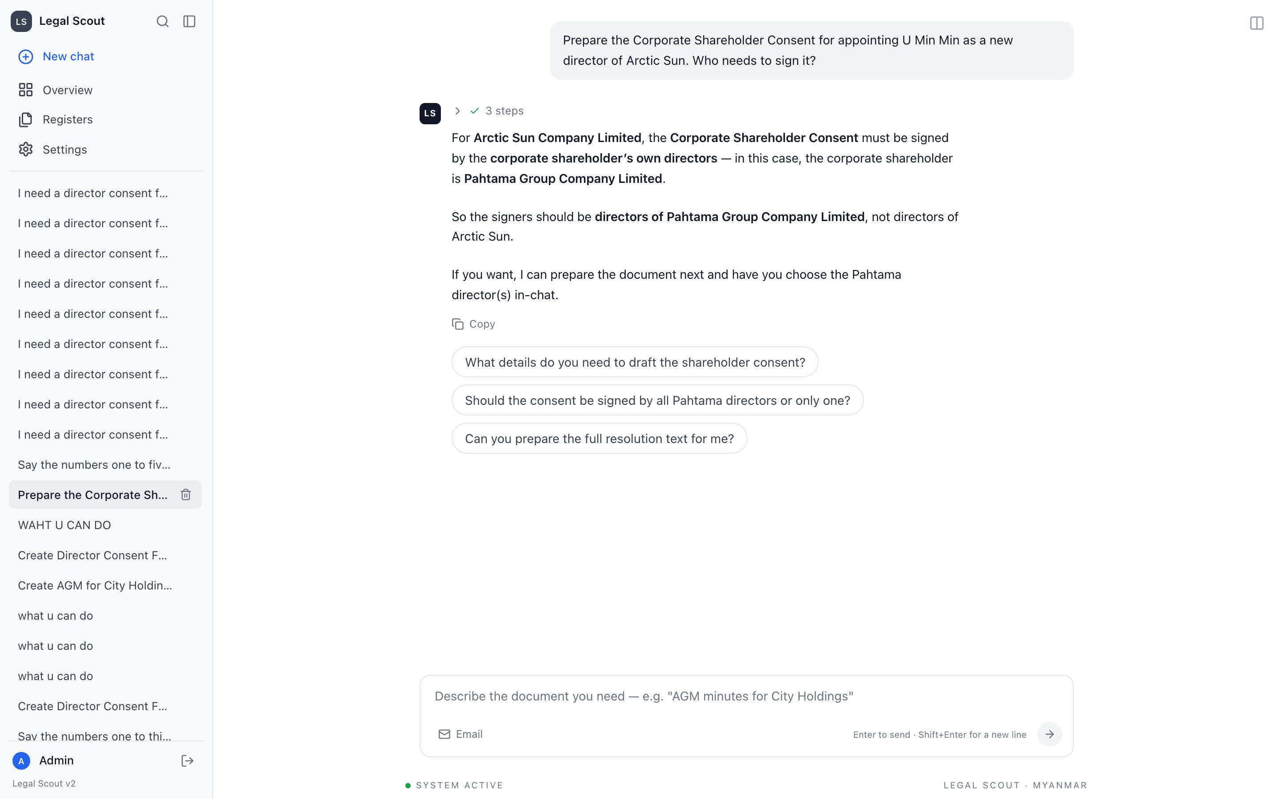
The assistant states who must sign, then offers clickable follow-up questions for you to choose.
2. A People Register for signers
YOU ASKED FOR | Directors and approved signers should be recorded properly, so signatures use a real, known person — not an invented name.
WHAT WE DELIVERED | Built a dedicated People Register. When a document needs a signature, the assistant confirms the person from this register instead of typing a made-up name.

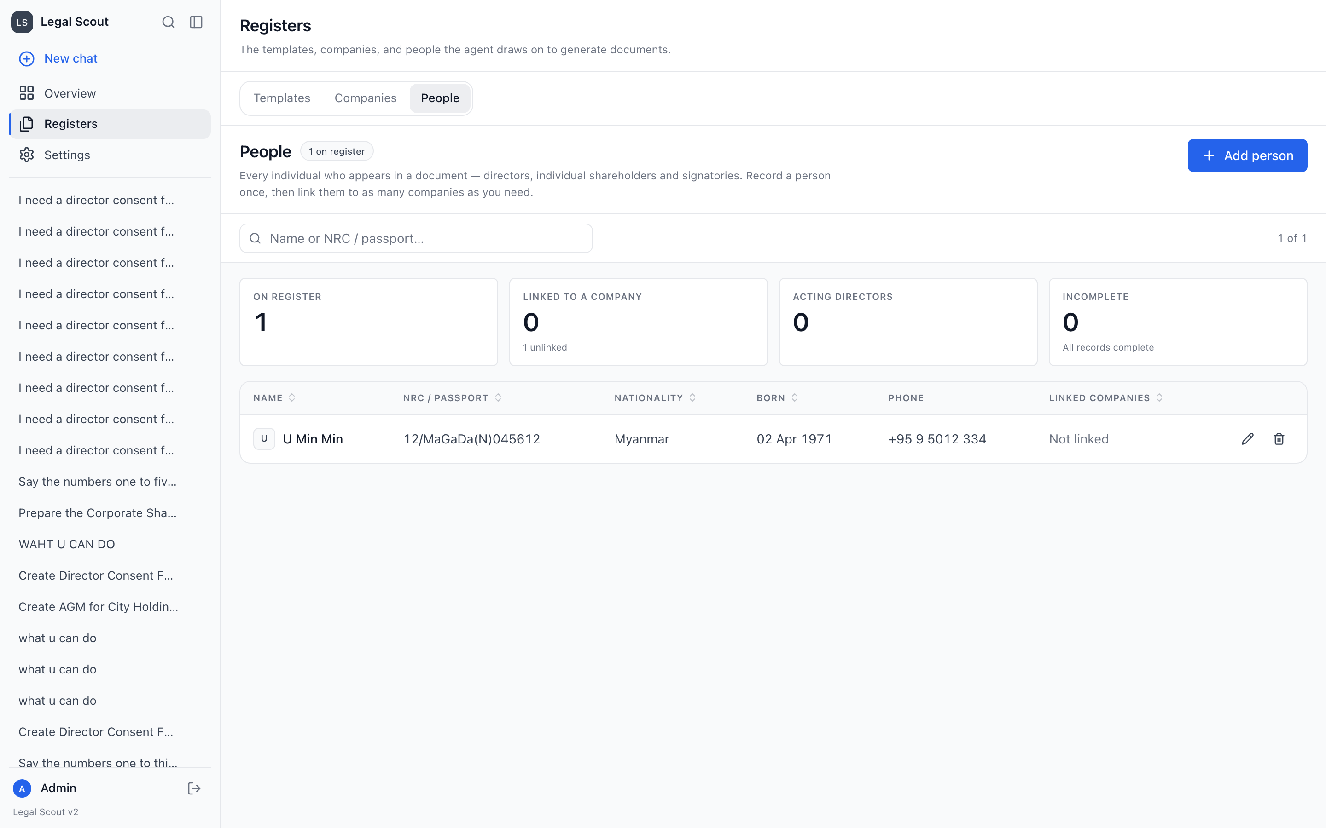
The People Register — each director and signatory recorded once, with the details a document needs.
3. Drafts must come from the Company Register
YOU ASKED FOR | Company names, registration numbers and shareholdings should be read from the DICA record, not re-typed or guessed.
WHAT WE DELIVERED | Every draft now reads these facts straight from the Company Register, so what appears on the page matches the record.

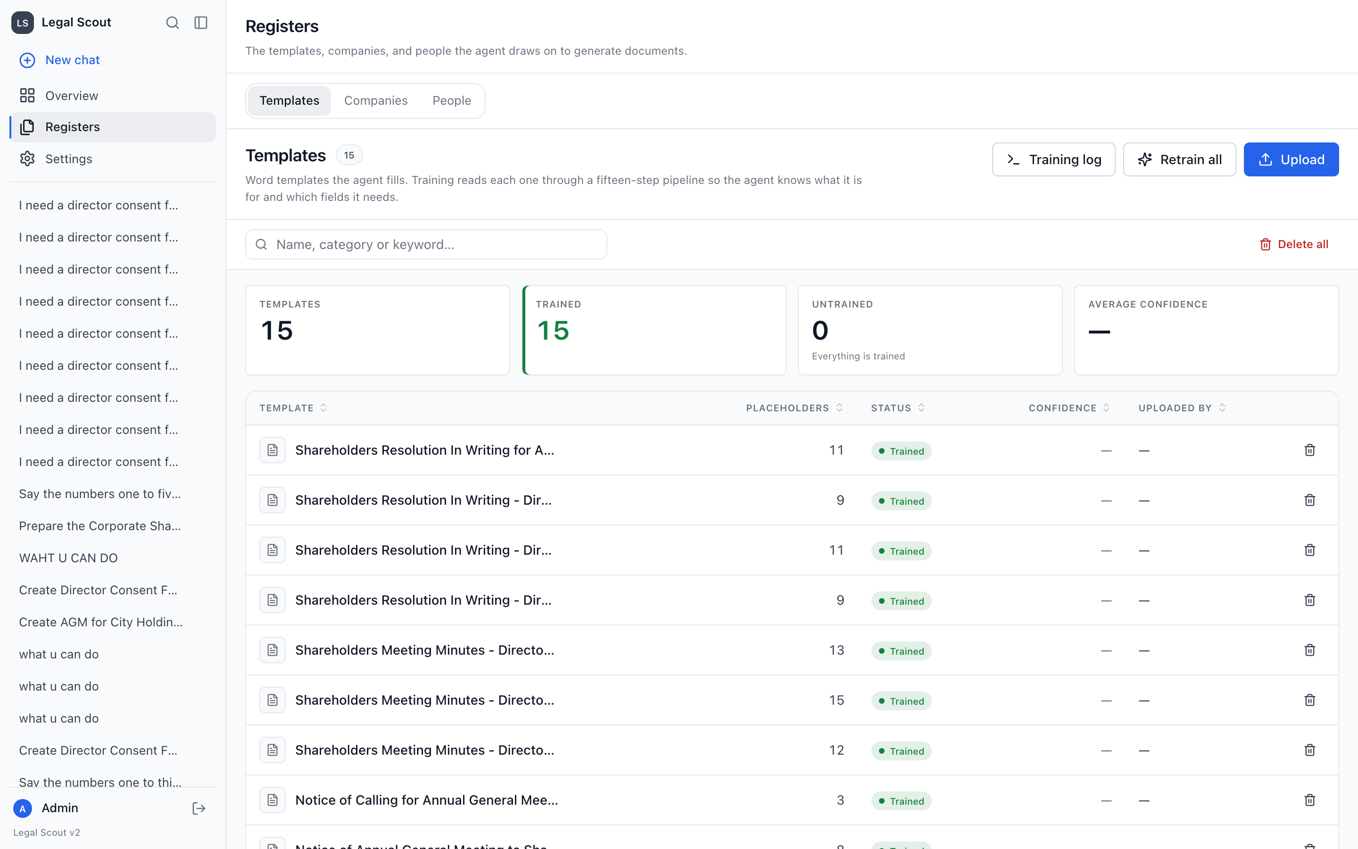
The trained templates the assistant fills from company-register data — 15 templates, all trained.
4. Let the team watch the assistant work
YOU ASKED FOR | Instead of waiting for a wall of text, the team wanted to see the assistant thinking and the steps it takes.
WHAT WE DELIVERED | Replies now stream live, as if typed, and show each step — understanding the request, matching a template, reading the register.

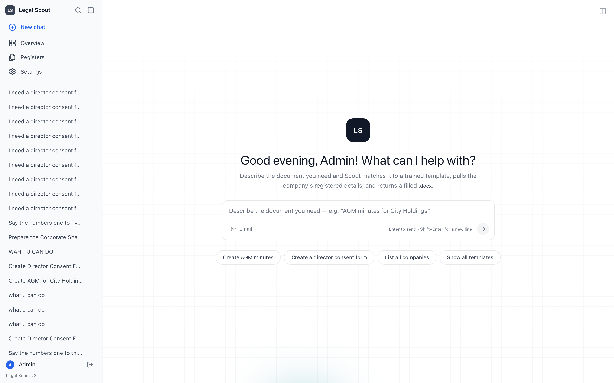
The chat home — describe the document you need in plain language and watch the assistant work through it.
5. Show the document being built, then let us review it
YOU ASKED FOR | The team wanted to see the document take shape and read the finished draft before anything is considered done.
WHAT WE DELIVERED | A side panel fills in each field as it is drafted, then opens the finished draft for you to read and edit. Nothing is hidden until the end.

6. No empty replies — finish the job
YOU ASKED FOR | Sometimes the assistant stopped with a blank message or did not complete a task. That had to stop.
WHAT WE DELIVERED | It now resumes exactly where it left off — including after you answer a mid-way question — and completes the work rather than going quiet.

7. Enforce the corporate-shareholder signing rule
YOU ASKED FOR | For a corporate shareholder's consent, the shareholder company's own directors must sign — never the new company's board. This must be automatic.
WHAT WE DELIVERED | The rule is built in. The assistant confirms the correct signers from the People Register before drafting, and will not guess them.

THE RULE IN PLAIN TERMS
If Golden Lotus Trading is owned by Emerald Holdings, the consent is signed by Emerald Holdings' directors — and the assistant asks you to confirm exactly who, before drafting. (Golden Lotus and Emerald are fictional examples.)

8. Keep personal data out of drafts
YOU ASKED FOR | Phone numbers, emails and home addresses that appear in company extracts should never end up in a draft.
WHAT WE DELIVERED | These fields are deliberately excluded from every draft, and public-facing pages show only invented sample data.

9. Tidier admin screens
YOU ASKED FOR | The admin area was one dense screen and hard to navigate; the team wanted it organised.
WHAT WE DELIVERED | Overview, Registers and Settings are now clean tabbed pages — dashboards, documents, emails, users and knowledge each in their own tab.

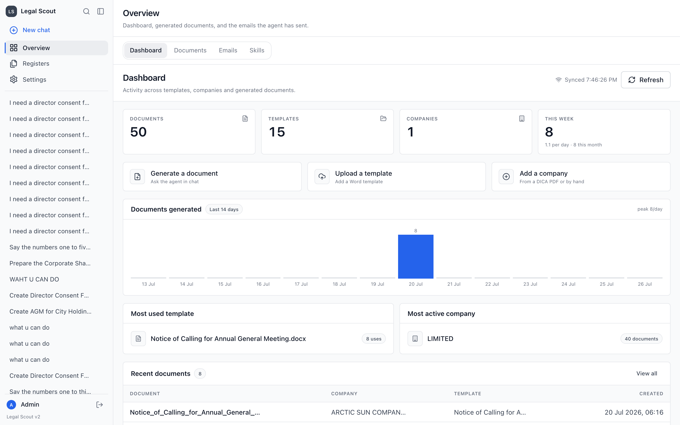
The admin Overview dashboard — documents, templates, companies and recent activity at a glance.
10. Close the access-control gap
YOU ASKED FOR | A staff-only page could be reached directly by typing its web address. That needed fixing.
WHAT WE DELIVERED | The permission check was corrected so restricted pages are properly restricted, whichever way they are reached.

ADDED CAPABILITY (NOT REQUESTED, BUT DELIVERED)
A library of legal playbooks
Beyond the requested list, we added a shelf of written procedure notes — 'skills'. The assistant always knows the titles, but only reads a note in full when the task calls for it.
- 12 playbooks seeded — adapted from Anthropic's public legal skill set plus Myanmar corporate-law practice.
- Managed in the admin panel — a Skills tab lists them; more can be added over time.
- No black box — each playbook is written text you can read and audit.
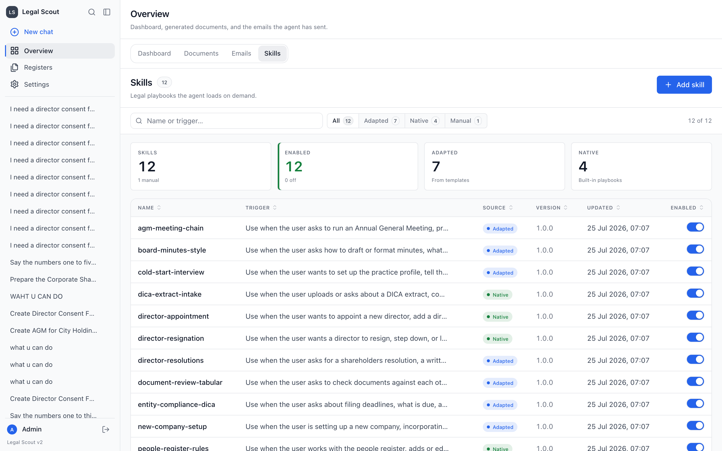
The Skills tab — 12 legal playbooks, each with the situation that triggers it and an on/off switch.
DESIGN REFRESH (THE LAST POINT)
A cleaner, calmer workspace
The interface was rebuilt to match the City Holdings house style — the same look and feel as CityAgent Insights.
- Simple navigation — four places only: New chat, Overview, Registers, Settings.
- A polished sign-in page — matching the house design, with a demo panel using invented sample data only — no real client details.
- Consistent typography and spacing — one clean typeface, comfortable density, light and dark modes.
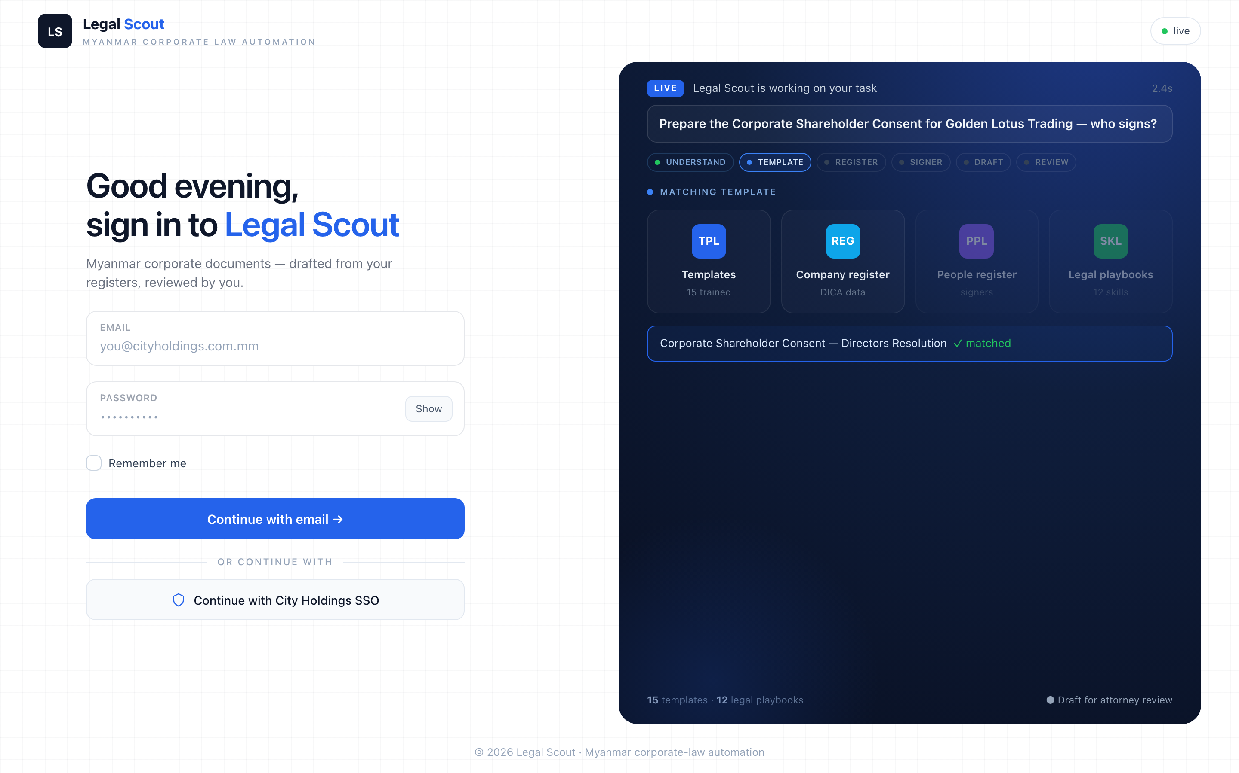
The new sign-in page — the demo panel on the right uses invented sample data only.
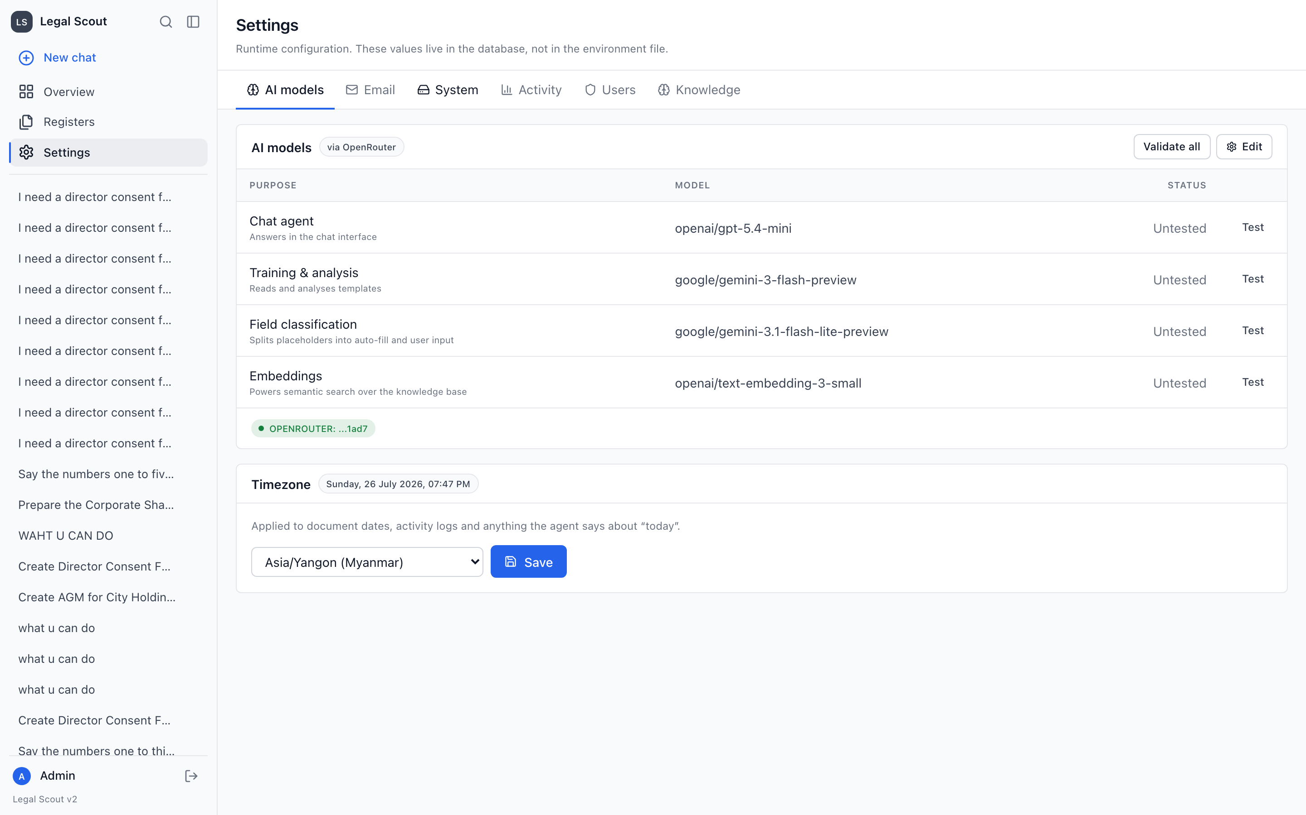
Settings — a clean tabbed page for models, email, users, knowledge and more.
THE BOTTOM LINE
What you can rely on
- Every requested change was delivered — the ten team requests above are all built and live.
- You stay in control — the assistant asks before it assumes, and you answer in the chat.
- Sources are real — drafts come from your registers, not guesswork.
- The rules are built in — signing requirements and privacy limits are enforced, not optional.
- A lawyer always signs off — every output is a draft for attorney review.

Legal Scout · Myanmar corporate-law automation
Prepared as a plain-language requirements brief for the legal team. Please confirm the requirement list on page 1 is complete. Sample names (Golden Lotus Trading, Emerald Holdings) are fictional and used for illustration only.

