City Care Agent
Who can sign in, and how accounts are managed
Version 1.7.0 | 21 August 2026 | citycareagent.citygpt.xyz

The short answer
No. A person having a Keycloak account does not give them access to City Care Agent.
There are two independent reasons, and either one alone is enough:
- Keycloak sign-in is switched OFF in production today. The option is built, configured and tested, but it is disabled, so no Keycloak account can be used to sign in at all.
- Even if it were switched on, authenticating only proves who someone is. It does not grant access. Every new account arrives unapproved, and an administrator must approve it before any page will load.
The same is true of Active Directory, which IS switched on in production: an AD user who signs in successfully still cannot use the console until someone approves them.

How signing in works
There are three ways an account can be authenticated. All three end at the same place: a row in the user table, keyed by email address.
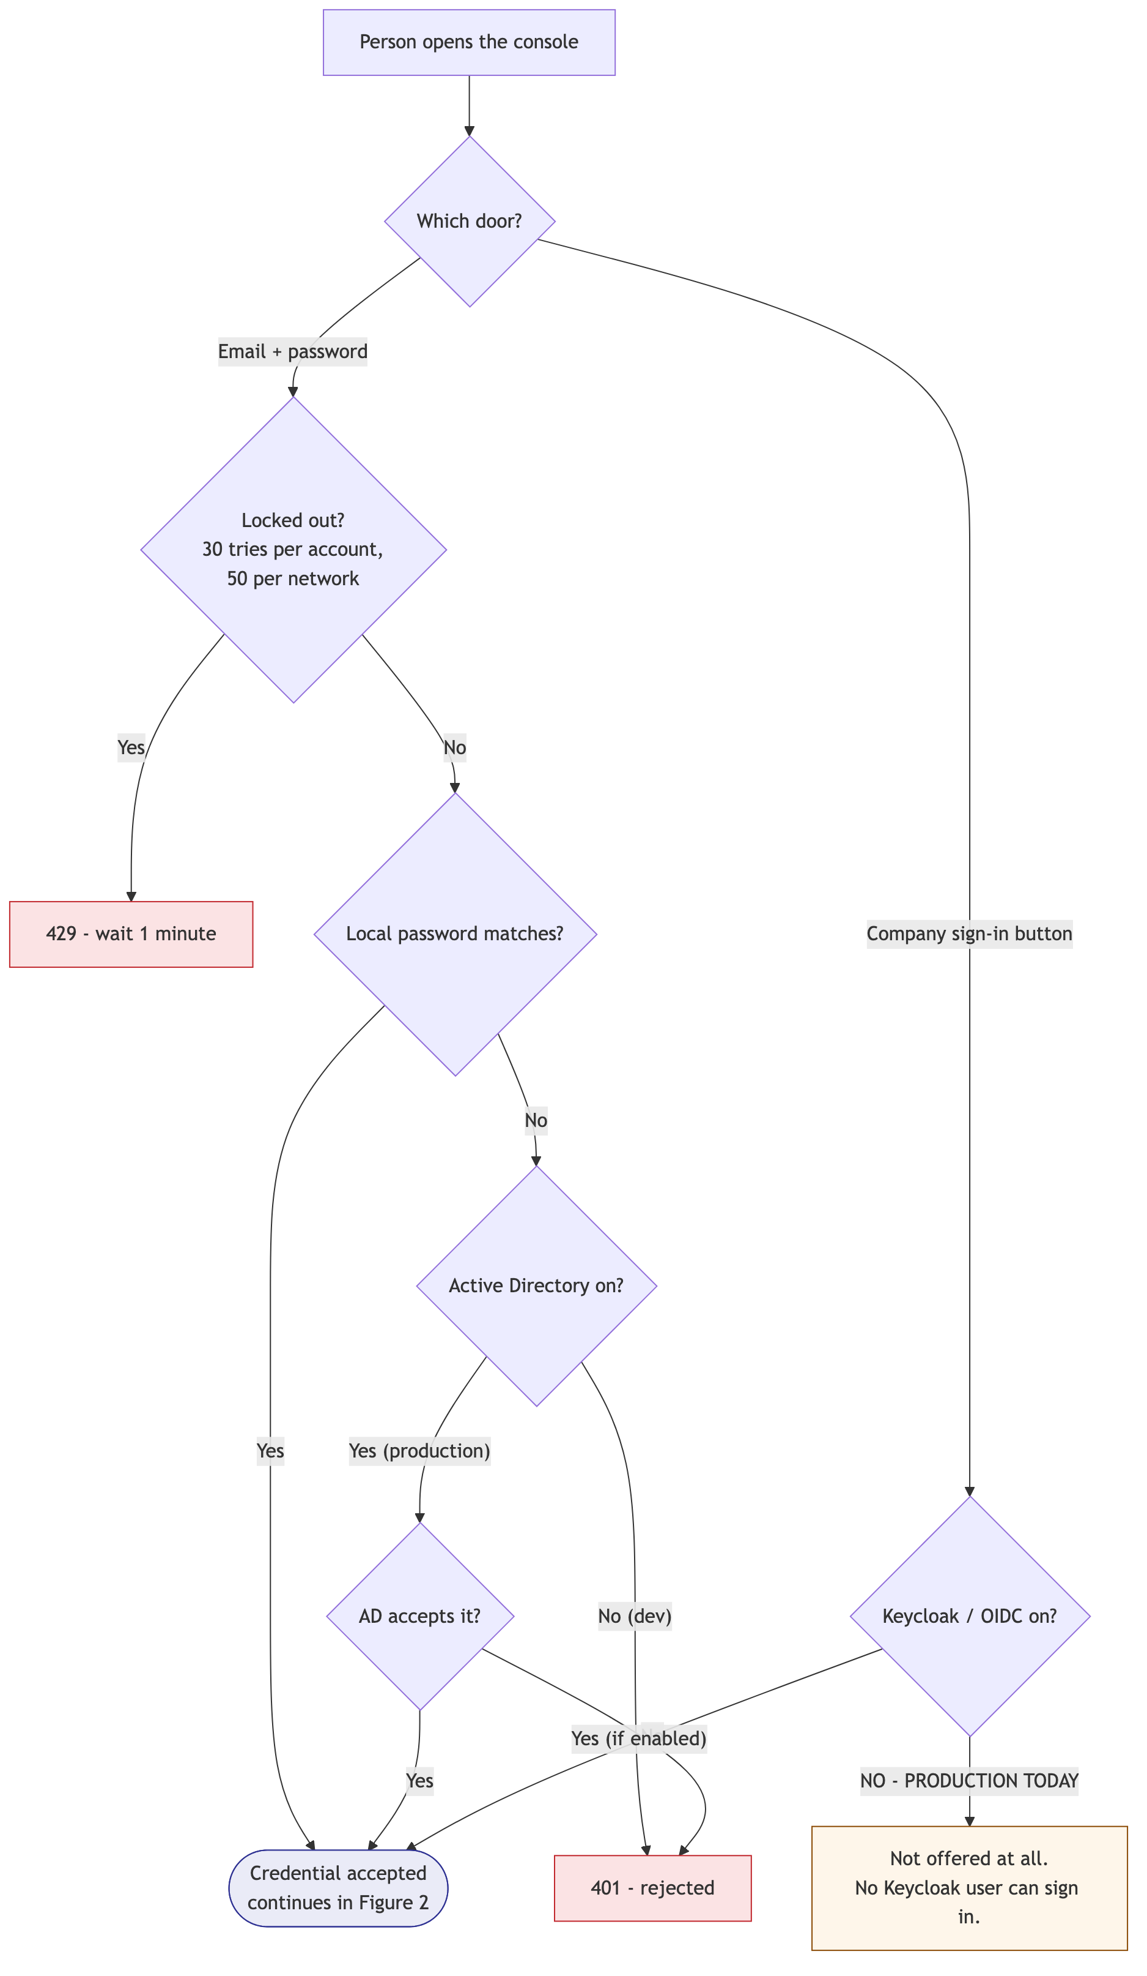
Figure 1 — The three doors, and where each one can be refused. Note the Keycloak branch.

Which account, once the credential is accepted
Accounts are matched by EMAIL ADDRESS, not by which system authenticated them. If the same person signs in by password today and through Active Directory tomorrow, they are one account with one role, not two.
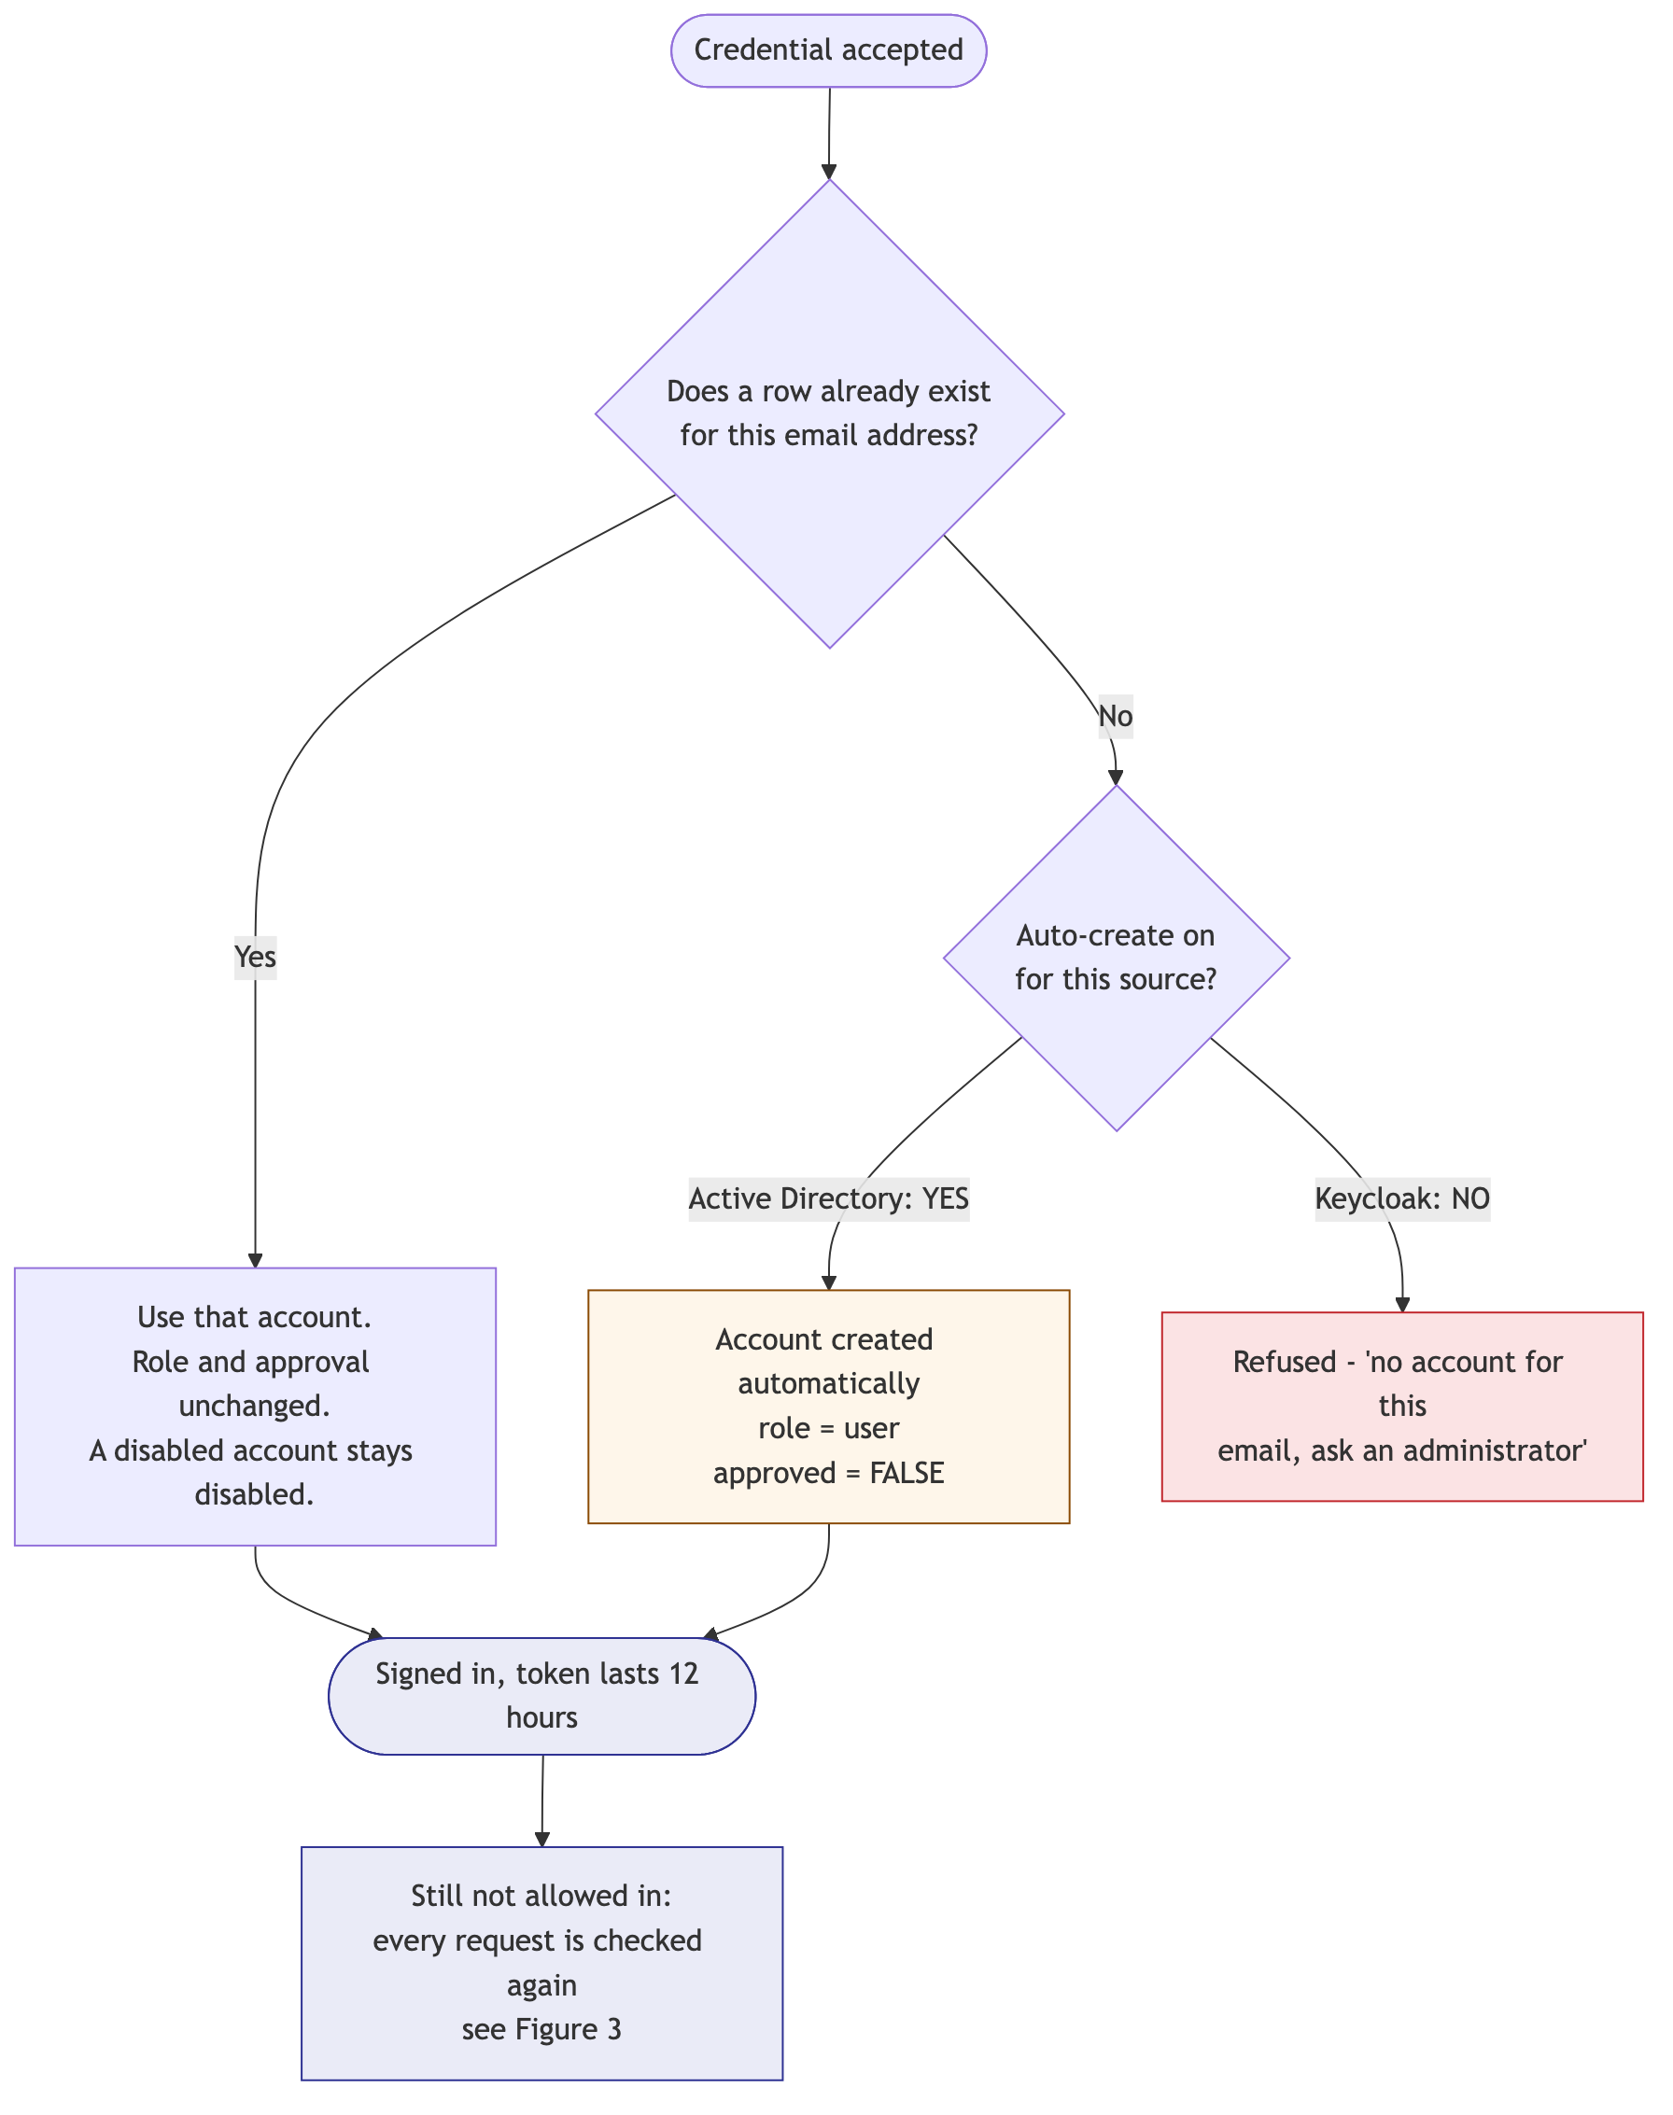
Figure 2 — Resolving a credential to an account. Automatic creation lands unapproved.
This has a consequence worth stating plainly: an existing account is never rewritten by an external sign-in. A disabled account stays disabled, and a role is never changed by the directory.

What happens after sign-in
Being signed in is not the same as being allowed in. Two further checks run on EVERY request, not once at sign-in:
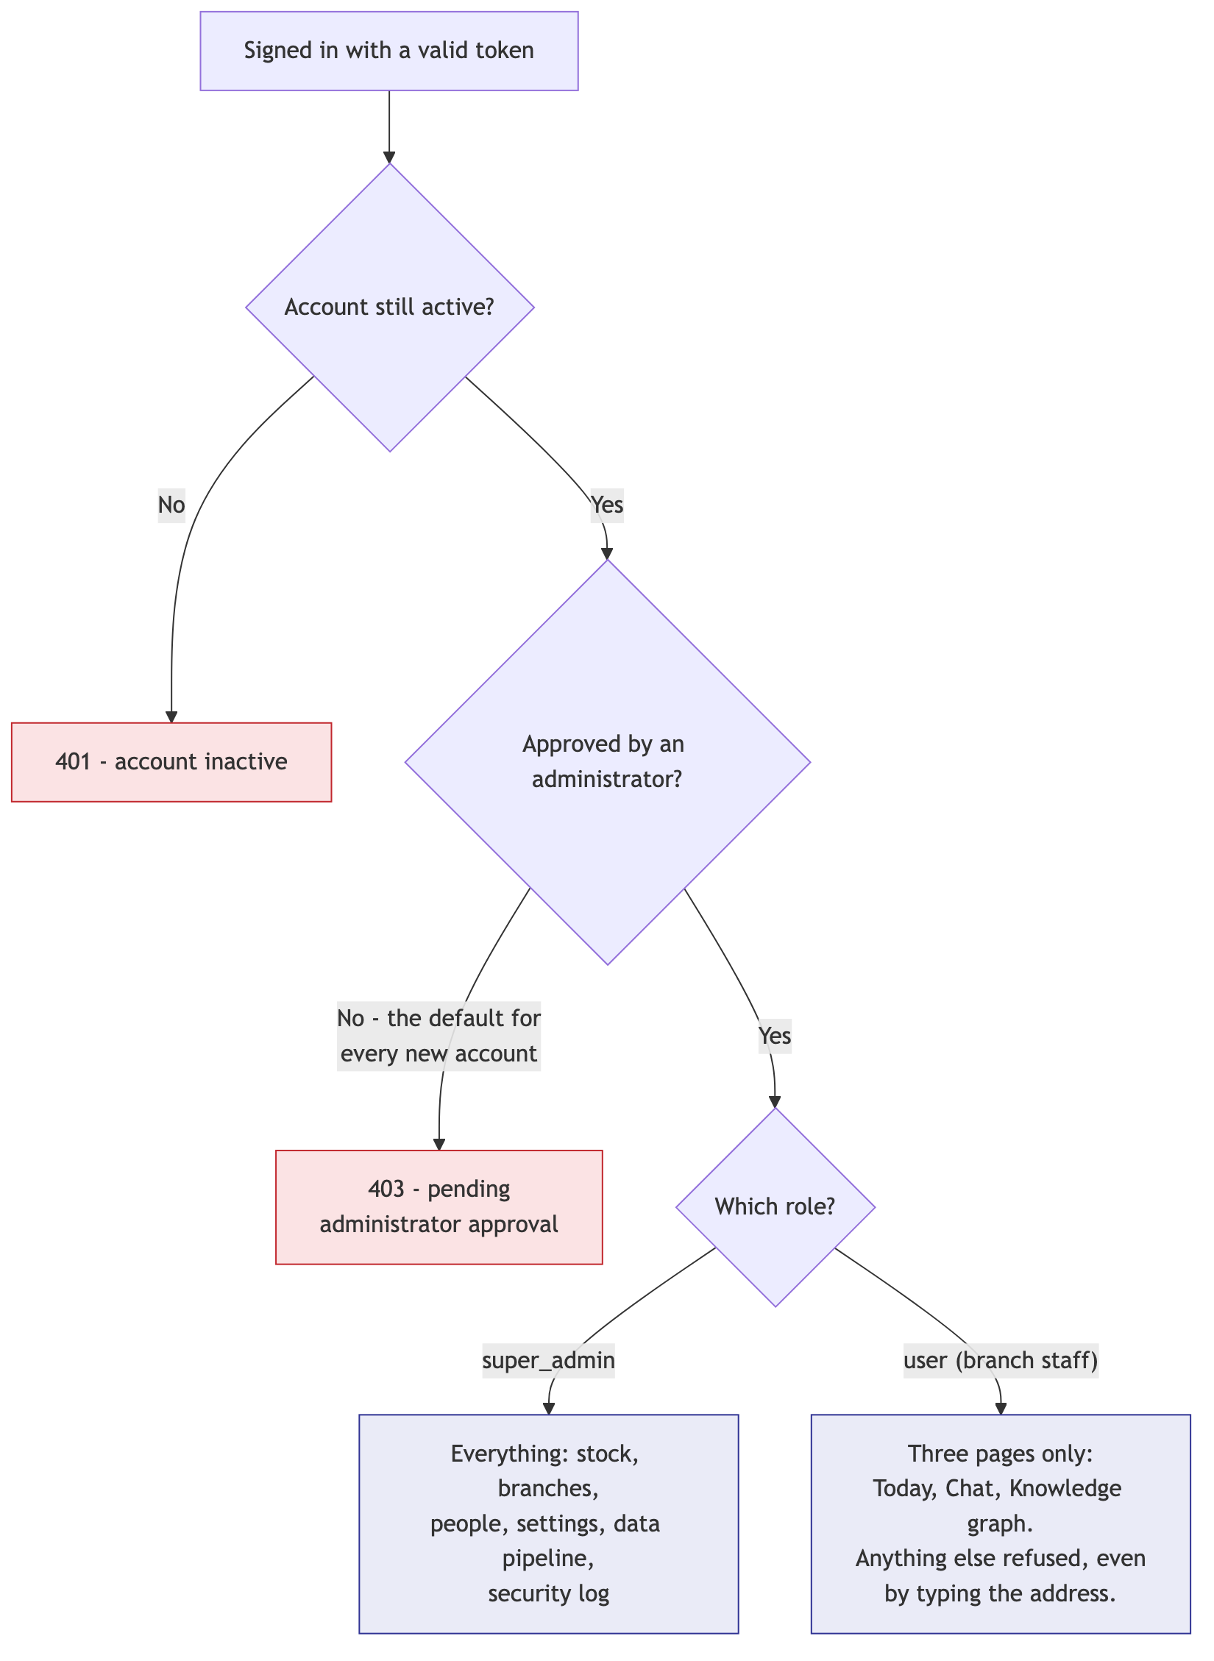
Figure 3 — The two gates every request passes, and what each role may reach.
Both checks are re-read from the database on every single request. Removing someone's approval, or deactivating them, takes effect immediately — they do not keep access until their session expires.

A worked example: an Active Directory user
This is the path that matters most in production, because AD sign-in is switched on and set to create accounts automatically.
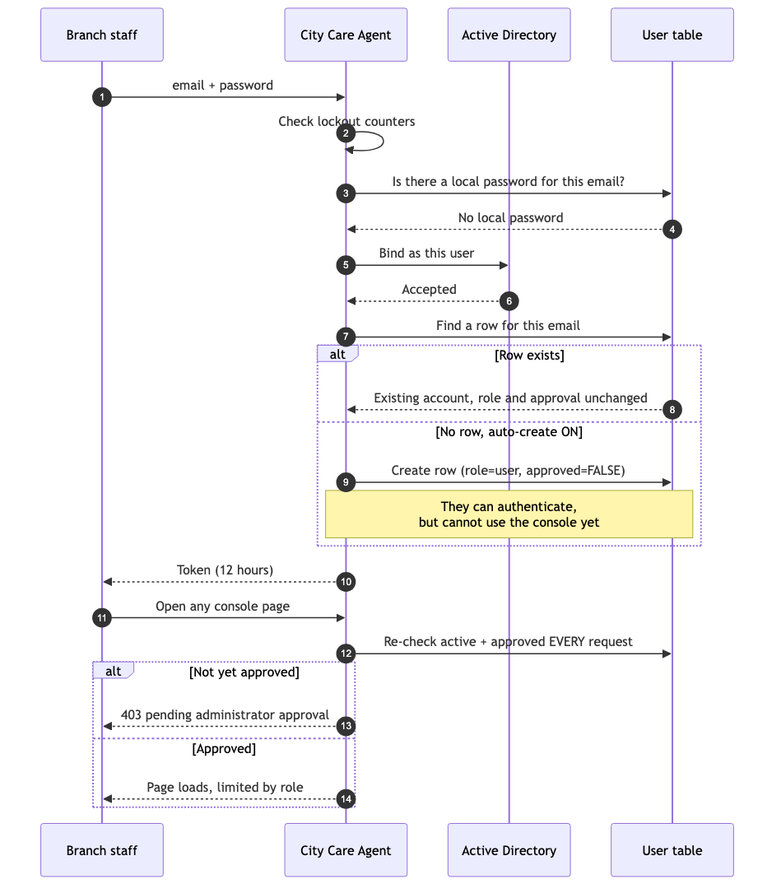
Figure 4 — An AD user signing in for the first time. The account is created but not usable.
Automatic creation is deliberately limited. A row made this way is always given the lowest role and always left unapproved. It cannot be used to reach anything until an administrator acts.

What is switched on today
Read from the running production system on 21 August 2026.
Setting | Production | What it means
Sign-in mode | hybrid | Password and directory sign-in both accepted
Keycloak / OIDC | OFF | No Keycloak user can sign in
Keycloak auto-create | off | Would not matter while OIDC is off
Active Directory | ON (10.16.73.150) | AD users may authenticate
AD auto-create | ON | First AD sign-in creates an unapproved account
New account role | user | Three pages only
New account approved | FALSE | Blocked until an administrator approves
Session length | 12 hours | Then sign in again
Lockout | 30 tries per account, 50 per network | Then 1 minute lock

Accounts that exist in production today:
Email | Role | Active | Approved | Signed in via
admin@cityholdings.com.mm | super_admin | yes | yes | password
rahulgupta@cityholdings.com.mm | user | yes | yes | Active Directory

The two roles
 | Super admin | User (branch staff)
Today / dashboard | Yes | Yes
Chat with the assistant | Yes | Yes
Knowledge graph | Yes | Yes
Stock and catalogue | Yes | No
Branches | Yes | No
Data file transfer | Yes | No
People and settings | Yes | No
Security log | Yes | No
Hide or show a branch | Yes | No

A user cannot reach a page they are not given by typing its address. The restriction is enforced on the server for every request, not by hiding menu items.

If you want Keycloak sign-in enabled
It is a settings change, not a development task. Two decisions come with it:
- Whether an unknown Keycloak user should have an account created automatically, as AD does today, or be refused until an administrator creates one. Refusing is the stricter option and is the current default.
- Who approves new accounts, and how quickly. Until someone approves, a new person can sign in but sees only a message telling them the account is pending.

Questions this document answers
- Can any Keycloak user log in? No — Keycloak sign-in is switched off, and approval would still be required.
- Can any Active Directory user log in? They can authenticate, and an account is created for them, but they cannot use the console until approved.
- What can a new person see before approval? Nothing. Every page returns 'pending administrator approval'.
- If someone leaves, how fast does access stop? Immediately on the next request, once they are deactivated or unapproved.
- Does signing in through the directory change someone's permissions? No. Roles are held in City Care Agent and are never altered by the directory.

