-- 1. List of all customers

SELECT * FROM Customers;

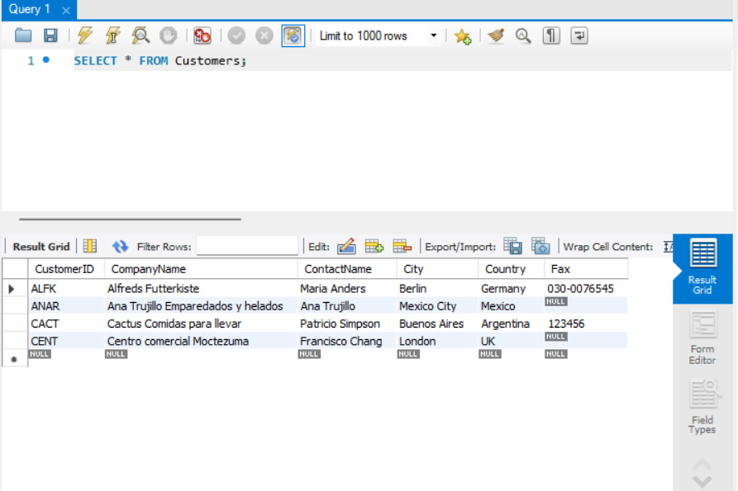

-- 2. Customers where company name ends with 'N'

SELECT * FROM Customers WHERE CompanyName LIKE '%N';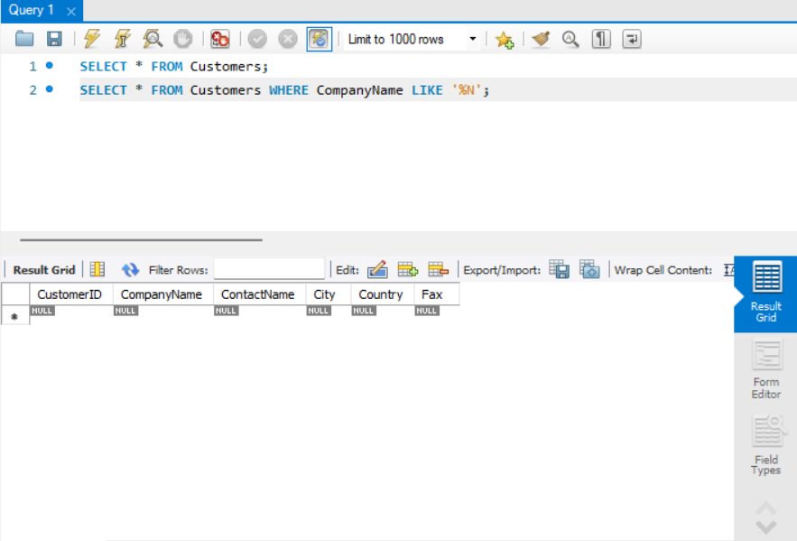

-- 3. Customers in Berlin or London

SELECT * FROM Customers WHERE City IN ('Berlin', 'London');

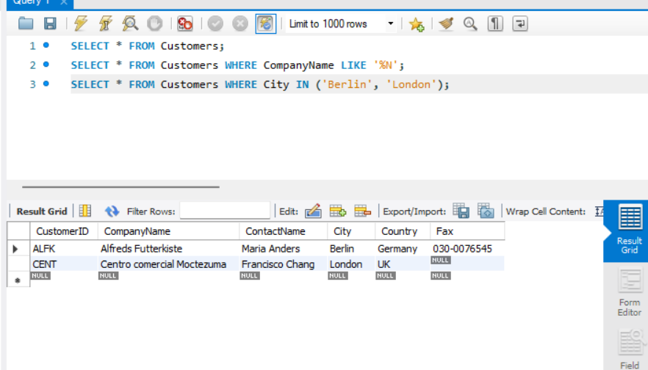

-- 4. Customers in UK or USA

SELECT * FROM Customers WHERE Country IN ('UK', 'USA');

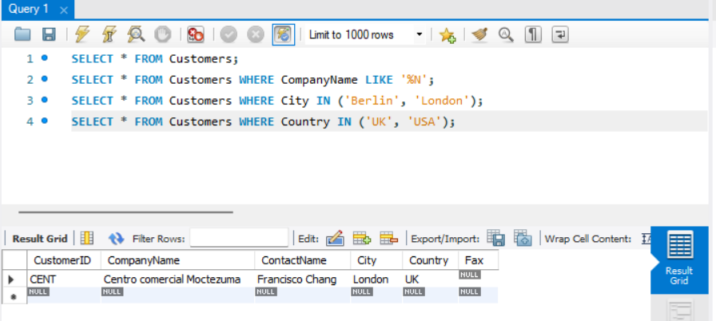

-- 5. All products sorted by name

SELECT * FROM Products ORDER BY ProductName;

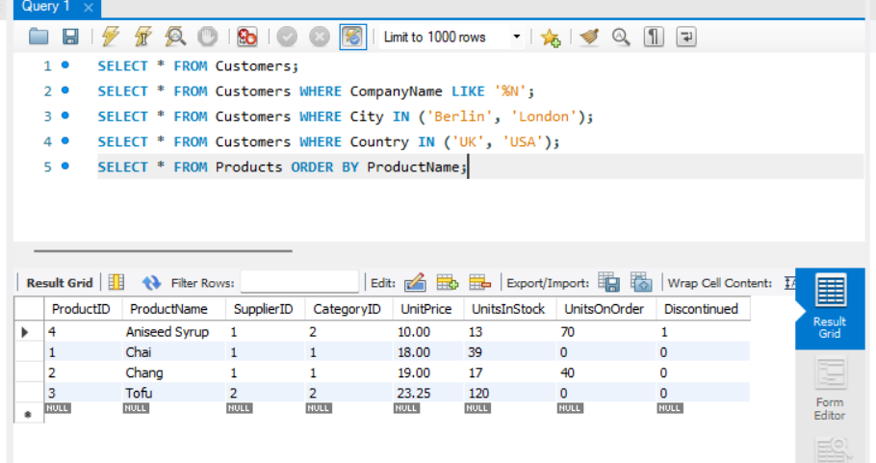

-- 6. Products where name starts with 'A'

SELECT * FROM Products WHERE ProductName LIKE 'A%';

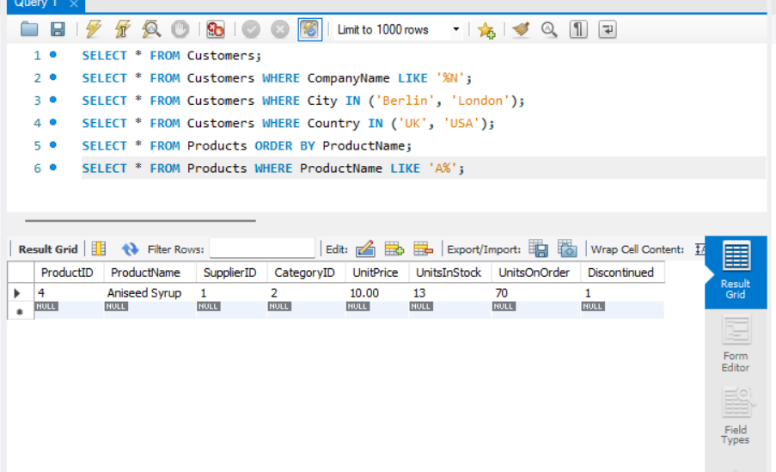

-- 7. Customers who placed an order

SELECT DISTINCT c.*

FROM Customers c

JOIN Orders o ON c.CustomerID = o.CustomerID;

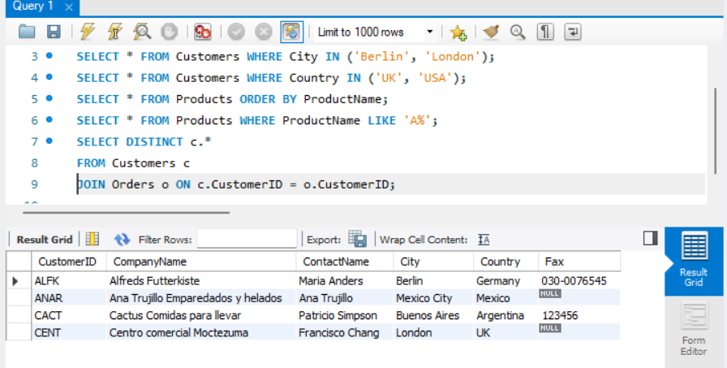

-- 8. Customers in London who bought Chai

SELECT DISTINCT c.*

FROM Customers c

JOIN Orders o ON c.CustomerID = o.CustomerID

JOIN Order_Details od ON o.OrderID = od.OrderID

JOIN Products p ON od.ProductID = p.ProductID

WHERE c.City = 'London' AND p.ProductName = 'Chai';

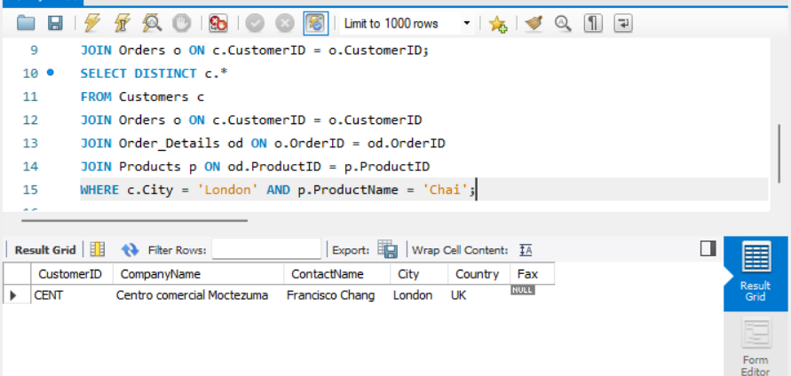

-- 9. Customers who never placed an order

SELECT * FROM Customers

WHERE CustomerID NOT IN (SELECT DISTINCT CustomerID FROM Orders);

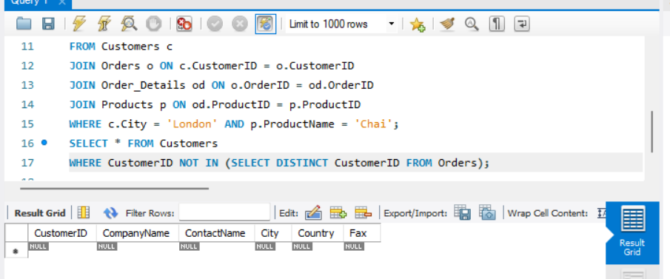

-- 10. Customers who ordered Tofu

SELECT DISTINCT c.*

FROM Customers c

JOIN Orders o ON c.CustomerID = o.CustomerID

JOIN Order_Details od ON o.OrderID = od.OrderID

JOIN Products p ON od.ProductID = p.ProductID

WHERE p.ProductName = 'Tofu';

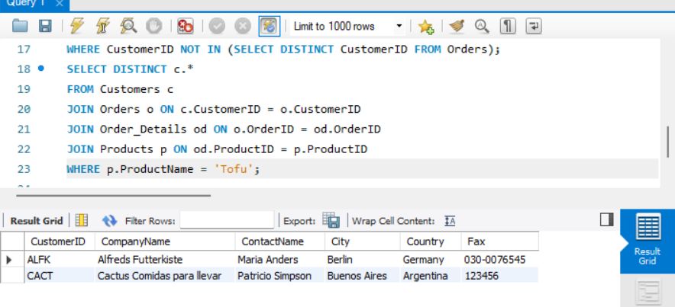

-- 11. First order in the system

SELECT * FROM Orders ORDER BY OrderDate LIMIT 1;

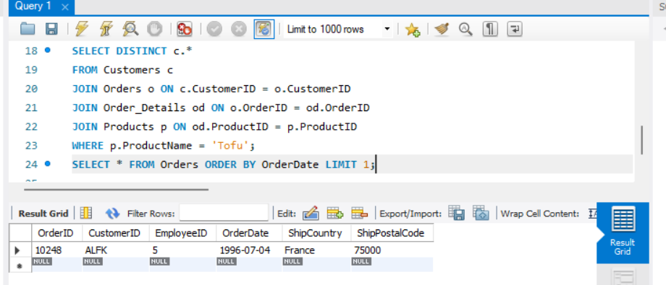

-- 12. Most expensive order (by total)

SELECT o.OrderID, o.OrderDate, SUM(od.UnitPrice * od.Quantity) AS Total

FROM Orders o

JOIN Order_Details od ON o.OrderID = od.OrderID

GROUP BY o.OrderID

ORDER BY Total DESC

LIMIT 1;

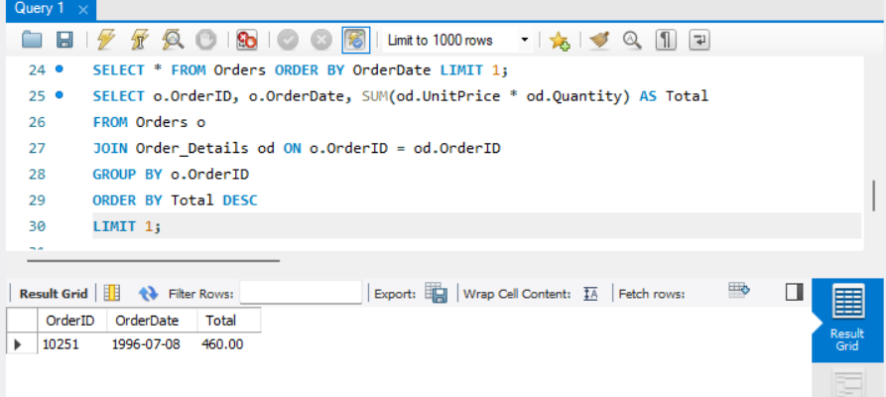

-- 13. Each order’s average quantity

SELECT OrderID, AVG(Quantity) AS AvgQty

FROM Order_Details

GROUP BY OrderID;

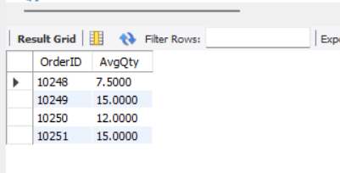

-- 14. Each order's min and max quantity

SELECT OrderID, MIN(Quantity) AS MinQty, MAX(Quantity) AS MaxQty

FROM Order_Details

GROUP BY OrderID;

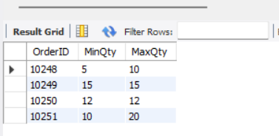

-- 15. All managers and number of employees reporting to them

SELECT m.EmployeeID AS ManagerID, CONCAT(m.FirstName, ' ', m.LastName) AS ManagerName, COUNT(e.EmployeeID) AS NumEmployees

FROM Employees m

LEFT JOIN Employees e ON m.EmployeeID = e.ReportsTo

GROUP BY m.EmployeeID;

-- 16. Orders with total quantity > 300

SELECT OrderID, SUM(Quantity) AS TotalQty

FROM Order_Details

GROUP BY OrderID

HAVING TotalQty > 300;

-- 17. Orders placed on or after 1996-12-31

SELECT * FROM Orders WHERE OrderDate >= '1996-12-31';

-- 18. Orders shipped to Canada

SELECT * FROM Orders WHERE ShipCountry = 'Canada';

-- 19. Orders with order total > 200

SELECT o.OrderID, SUM(od.UnitPrice * od.Quantity) AS Total

FROM Orders o

JOIN Order_Details od ON o.OrderID = od.OrderID

GROUP BY o.OrderID

HAVING Total > 200;

-- 20. Countries and sales made in each country

SELECT ShipCountry, SUM(od.UnitPrice * od.Quantity) AS TotalSales

FROM Orders o

JOIN Order_Details od ON o.OrderID = od.OrderID

GROUP BY ShipCountry;

-- 21. Customer contact names and number of orders

SELECT c.ContactName, COUNT(o.OrderID) AS NumOrders

FROM Customers c

LEFT JOIN Orders o ON c.CustomerID = o.CustomerID

GROUP BY c.ContactName;

-- 22. Customers with more than 3 orders

SELECT c.ContactName, COUNT(o.OrderID) AS NumOrders

FROM Customers c

JOIN Orders o ON c.CustomerID = o.CustomerID

GROUP BY c.ContactName

HAVING NumOrders > 3;

-- 23. Discontinued products ordered between 1997-01-01 and 1998-01-01

SELECT DISTINCT p.*

FROM Products p

JOIN Order_Details od ON p.ProductID = od.ProductID

JOIN Orders o ON od.OrderID = o.OrderID

WHERE p.Discontinued = 1

AND o.OrderDate BETWEEN '1997-01-01' AND '1998-01-01';

-- 24. Employees and their supervisors

SELECT e.EmployeeID, e.FirstName, e.LastName, m.FirstName AS ManagerFirstName, m.LastName AS ManagerLastName

FROM Employees e

LEFT JOIN Employees m ON e.ReportsTo = m.EmployeeID;

-- 25. Employee sales total

SELECT e.EmployeeID, CONCAT(e.FirstName, ' ', e.LastName) AS EmployeeName,

SUM(od.UnitPrice * od.Quantity) AS TotalSales

FROM Employees e

JOIN Orders o ON e.EmployeeID = o.EmployeeID

JOIN Order_Details od ON o.OrderID = od.OrderID

GROUP BY e.EmployeeID;

-- 26. Employees whose first name contains 'a'

SELECT * FROM Employees WHERE FirstName LIKE '%a%';

-- 27. Managers with more than 4 employees reporting

SELECT m.EmployeeID, CONCAT(m.FirstName, ' ', m.LastName) AS ManagerName, COUNT(e.EmployeeID) AS NumEmployees

FROM Employees m

JOIN Employees e ON m.EmployeeID = e.ReportsTo

GROUP BY m.EmployeeID

HAVING NumEmployees > 4;

-- 28. Orders and product names

SELECT o.OrderID, p.ProductName

FROM Orders o

JOIN Order_Details od ON o.OrderID = od.OrderID

JOIN Products p ON od.ProductID = p.ProductID;

-- 29. Orders placed by the best customer (highest total sales)

SELECT o.*

FROM Orders o

WHERE o.CustomerID = (

SELECT CustomerID

FROM Orders o2

JOIN Order_Details od2 ON o2.OrderID = od2.OrderID

GROUP BY CustomerID

ORDER BY SUM(od2.UnitPrice * od2.Quantity) DESC

LIMIT 1

);

-- 30. Orders by customers without Fax number

SELECT o.*

FROM Orders o

JOIN Customers c ON o.CustomerID = c.CustomerID

WHERE c.Fax IS NULL;

-- 31. Postal codes where Tofu was shipped

SELECT DISTINCT o.ShipPostalCode

FROM Orders o

JOIN Order_Details od ON o.OrderID = od.OrderID

JOIN Products p ON od.ProductID = p.ProductID

WHERE p.ProductName = 'Tofu';

-- 32. Product names shipped to France

SELECT DISTINCT p.ProductName

FROM Products p

JOIN Order_Details od ON p.ProductID = od.ProductID

JOIN Orders o ON od.OrderID = o.OrderID

WHERE o.ShipCountry = 'France';

-- 33. Products and categories for supplier 'Specialty Biscuits, Ltd.'

SELECT p.ProductName, c.CategoryName

FROM Products p

JOIN Categories c ON p.CategoryID = c.CategoryID

JOIN Suppliers s ON p.SupplierID = s.SupplierID

WHERE s.CompanyName = 'Specialty Biscuits, Ltd.';

-- 34. Products never ordered

SELECT * FROM Products

WHERE ProductID NOT IN (SELECT DISTINCT ProductID FROM Order_Details);

-- 35. Products with UnitsInStock < 10 and UnitsOnOrder = 0

SELECT * FROM Products

WHERE UnitsInStock < 10 AND UnitsOnOrder = 0;

-- 36. Top 10 countries by sales

SELECT o.ShipCountry, SUM(od.UnitPrice * od.Quantity) AS TotalSales

FROM Orders o

JOIN Order_Details od ON o.OrderID = od.OrderID

GROUP BY o.ShipCountry

ORDER BY TotalSales DESC

LIMIT 10;

-- 37. Number of orders each employee has taken for customers with CustomerIDs between 'A' and 'AO'

SELECT e.EmployeeID, COUNT(o.OrderID) AS NumberOfOrders

FROM Employees e

JOIN Orders o ON e.EmployeeID = o.EmployeeID

JOIN Customers c ON o.CustomerID = c.CustomerID

WHERE c.CustomerID BETWEEN 'A' AND 'AO'

GROUP BY e.EmployeeID;

-- 38. Order date of most expensive order

SELECT o.OrderDate

FROM Orders o

JOIN Order_Details od ON o.OrderID = od.OrderID

GROUP BY o.OrderID

ORDER BY SUM(od.UnitPrice * od.Quantity) DESC

LIMIT 1;

-- 39. Product name and total revenue

SELECT p.ProductName, SUM(od.UnitPrice * od.Quantity) AS Revenue

FROM Products p

JOIN Order_Details od ON p.ProductID = od.ProductID

GROUP BY p.ProductName

ORDER BY Revenue DESC;

-- 40. SupplierID and number of products offered

SELECT SupplierID, COUNT(ProductID) AS NumberOfProducts

FROM Products

GROUP BY SupplierID;

-- 41. Top 10 customers by total business

SELECT c.CustomerID, c.ContactName, SUM(od.UnitPrice * od.Quantity) AS TotalSpent

FROM Customers c

JOIN Orders o ON c.CustomerID = o.CustomerID

JOIN Order_Details od ON o.OrderID = od.OrderID

GROUP BY c.CustomerID

ORDER BY TotalSpent DESC

LIMIT 10;

-- 42. Total revenue of the company

SELECT SUM(UnitPrice * Quantity) AS TotalRevenue

FROM Order_Details;