**COVID Spread Tracking App**

Table of Contents

Stakeholders 2

Updates 2

Business Objective 2

Vision Statement 2

Return on Investment 2

Risks 2

Timeline 3

Future State 3

Functional Requirements 3

Workflow (Use Case) 3

UI 3

Non-Functional Requirements 4

Backend 4

Messaging Format 4

SRE 4

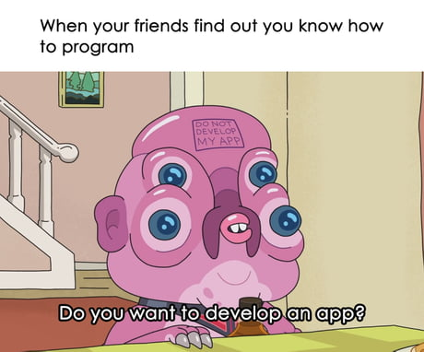

# Stakeholders

|  |  |
| --- | --- |
| Unit | Representative |
| UI | Sahrish Kanwal |
| Backend | Andrey Merdeev |
| Messaging | <TBD> |

# Updates

|  |  |  |
| --- | --- | --- |
| Date | Version | Update |
| May--10’21 | V 0.1 | First draft |
|  |  |  |

# Business Objective <TBD>

## Vision Statement

* **For** smartphone users
* **Who** **are concerned with stopping / eliminating--eradicated the decease**
* **The** COVID Spread Tracking App
* **Is** a cross platform application
* **That** will allow to track dynamically position of people with defined `coronaStatus` {negative, positive, unknown} ( or probability)
* **Unlike** (think about competitor’s disadvantage)
* **Our product** (think about our advantages of your app)
* **Motivation**elimination of smallpox

## Return on Investment <TBD>

Describe pricing model here if needed. For example: we will sell our app for USD1 to 10K clients by Q4, or we will distribute it for free and integrate with add providers, 1 click = USD 0.01, etc… / government contract

## Risks <TBD>

* Put risks here, for example:
* Not always having mobile device in the person nearest vicinity \epsilon
* Not having available / reliable test
* End of pandemic
* Unwillingness of people to share their data
* **Not having access to enough computational recourses (only works if full sys operating --- emergent property)**

# **Timeline**

|  |  |  |
| --- | --- | --- |
| Scope | Date | Description |
| Ideation | May | Create spec, think about architecture, allocate roles |
| Implementation |  |  |
| Testing |  |  |
| Prod Release | **July** |  |
| etc |  |  |
|  |  |  |

# Future State

## Functional Requirements`

### Workflow (Use Case)

|  |  |  |
| --- | --- | --- |
| Workflow | Task | Phase |
| Workflow 1 | track TS (Time Series) data for the user’s phone {position, time} | MVP |
|  |  |  |
| Workflow k | Description + sketch |  |
| research COVID spreading (x, t) | Get real time data of COVID spreading (**x, t).** |  |
|  |  |  |
|  |  |  |

### UI

|  |  |  |
| --- | --- | --- |
| Scope | Task | Phase |
| Component 1 | put data into system {coronaStatus, date/time} | MVP |
|  |  |  |
| Component k | Description + sketch |  |
|  |  |  |
|  |  |  |
|  |  |  |

## Non-Functional Requirements

### Backend

|  |  |  |
| --- | --- | --- |
| Scope | Task | Phase |
| Component 1 | Description + proposed design | MVP |
|  |  |  |
| Component k | Description + proposed design |  |
|  |  |  |
|  |  |  |
|  |  |  |

### Messaging Format

|  |  |  |
| --- | --- | --- |
| Scope | Task | Phase |
| Component 1 | Description + proposed design | MVP |
|  |  |  |
| Component k | Description + proposed design |  |
|  |  |  |
|  |  |  |
|  |  |  |

### SRE

|  |  |  |
| --- | --- | --- |
| Scope | Task | Phase |
| SLA | Description + values | MVP |
| SLI | Description |  |
| SLO | Description + values |  |
|  |  |  |
|  |  |  |
|  |  |  |

// 1.4.1. Requirements Classification

// 1.4.2. Conceptual Modeling

// 1.4.3. Architectural Design and Requirements Allocation

// 1.4.4. Requirements Negotiation

// 1.4.5. Formal Analysis

Developed in C++ or Java and must include a GUI with graphical simulation of the displays and buttons.

1. For next week prepare a detailed Project Plan for our practical term project! (Remember your Software Engineering and Safety Critical Systems lectures!) It should contain:

• Process model

• Team organization

• Task distribution in the team: Who is doing what in detail!

Plan for requirements management, especially how to gather information about the application field!

• Get an idea of possible Use Cases!

• Schedule with milestones

• Risks to the project

• Software Configuration Management for the software

• . . . (Whatever else makes sense!)

2. Please start with the specification file and get acquainted! Document your progress!

**3. Please prepare a document of 2 pages per group!**

For next week the framework of a project is necessary. We’ll discuss de- tails in the exercises.