Marks/ Grade Awarded
(Office Use Only)


ASSIGNMENT COVER PAGE

Course and Module Information
Course Name | BACHELOR OF INFORMATION TECHNOLOGY (System Administration)
Module Name | Introduction to Web Design
Module Code | SD1004
Lecturer Name | Mr. Abdulla Gasim
Batch No. | BIT-SA-A10
Assignment Title (where applicable) | Forging Elite Fitness Online: A Case Study on the Titan Gym Web Experience
Total number of pages including this cover page | 10
Due Date | 27-11-2025

Student (s) Declaration
I/ We declare that:
- I/We understand what is meant by plagiarism.
- The implication of plagiarism has been explained to me/ us by the College.
- This assignment is all my/ our own work and I/we have acknowledged any use of the published and unpublished works of other people.
- No part of this assignment has been written for me/us by any other person(s) except where such collaboration has been authorized by the Lecturer concerned.
Note: A soft copy (PDF format) of the assignment shall be submitted via Moodle. The attachment of this statement on electronically submitted assignments will be deemed to have the same authority as a signed statement.

Student (s) Information |  |  | Office Acknowledgement
Full Name | Student ID | Signature | Office Acknowledgement
Mohamed Abdulla | CYX29603 |  | Office Acknowledgement

Marker’s Feedback
Strengths:

Weaknesses:

Suggestions:

Marks
Report
Presentation
TOTAL
Marks Awarded:
Marker’s Name: |  | Student Acknowledgement
Signature: |  | Student’s Signature
Date: |  | Date:

Contents
Introduction 5
Methodology 6
Analysis 7
Conclusions 9
References 10
Acknowledgements 10

Forging Elite Fitness Online: A Case Study on the Titan Gym Web Experience

Introduction
The case study outlines how the website for "TITAN GYM" - a made-up high-end gym launched in 2025 - was designed and built. This project focused on building a flexible, multi-section site meant to act as an online base for existing users as well as people interested in joining.
The main goal was to meet user demands like quick schedule checks, price details on memberships, or finding info about instructors. To cover these points, seven separate web pages were built - home, courses, staff, join us, times, company background, sign-in - all tied through a shared dark-themed layout.
The study showed the design worked well by using bright green highlights on black, giving a sense of power and motion. In addition, it applied up-to-date coding tools like HTML5, CSS3, along with JavaScript to build an easier-to-use website that runs smoothly on different screens.

Methodology
Development Approach The project used the "Content-First" methodology coupled with "Responsive Design". This guaranteed that the hierarchy of information - what the user needs to see first - dictated layout.
Tools and Technologies:
- HTML5 was used for semantic structuring of content, with tags such as <nav>, <section>, and <footer> to ensure accessibility and SEO readiness.
- CSS3: I used CSS Variables (:root) for color management; for example, --primary-color: #0aff0a;. It is a good methodology for making global style updates from a single location, just like a professional development environment.
- JavaScript: Vanilla JavaScript was chosen for implementation instead of heavy frameworks to maintain lightweight performance. Key scripts include IntersectionObserver for scroll animations and a custom slider logic for the hero section.
- External Assets: FontAwesome 6.4.0 was utilized for intuitive iconography. Google Fonts - Oswald and Roboto - were implemented to define the typographic hierarchy.
Design approach: This look follows the dark interface style common in fitness and gaming apps. The colors used - black (0a0a0a) together with bright green (0aff0a) - were picked to suggest power along with up-to-date design

Analysis
Visual Architecture and Typography: The website uses a dual-font system to create a clear visual hierarchy.
- Headings -Oswald: The headings are typeset in a bold and condensed sans-serif font. This echoes the sturdy and strong nature reminiscent in all gym equipment.
- Body (Roboto): A highly readable geometric sans-serif font is used for paragraphs, ensuring that dense information, such as the text from about.html, will remain legible.
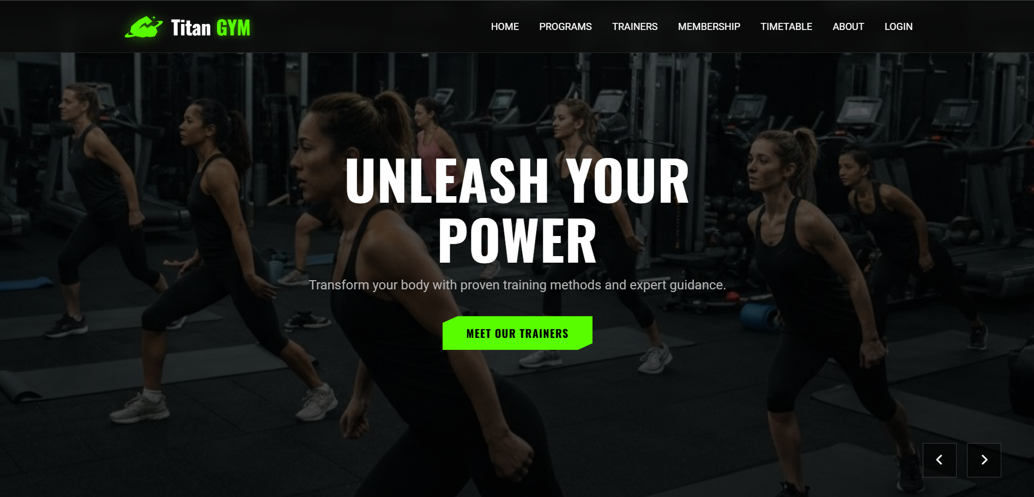 UX and navigation are crucial for retaining users. I implemented a position: fixed navbar that remains accessible as the user scrolls.
- The "Hamburger" menu appeared on devices below 768px thanks to script.js; instead of staying flat, it folded downward as a dropdown so cramped displays wouldn't stretch awkwardly.
- Interaction Design: The ".hidden-element" CSS class works alongside JavaScript’s IntersectionObserver to trigger animations when scrolling. As users move down the page, items gradually appear while shifting upward slightly. This mimics natural motion, creating a feeling of continuous progress. Visual feedback like this supports smoother navigation by reflecting real-world dynamics.

Info setup (the Schedule). Inside timetable.html, showing a detailed plan proved tricky.
- Solution: A semantic was chosen; however, distinct classes like .class-cell.strength or .class-cell.cardio were included to enable visual differentiation through color. While the base structure stays clean, these additions help highlight different types of data clearly across cells.
- By showing 'Strength' in red, while using green for 'Cardio', the design helps users quickly spot their preferred workout. Visual cues reduce mental effort needed to process the timetable. Instead of reading each item, people rely on color for faster decisions. This method speeds up navigation without confusion or extra steps.
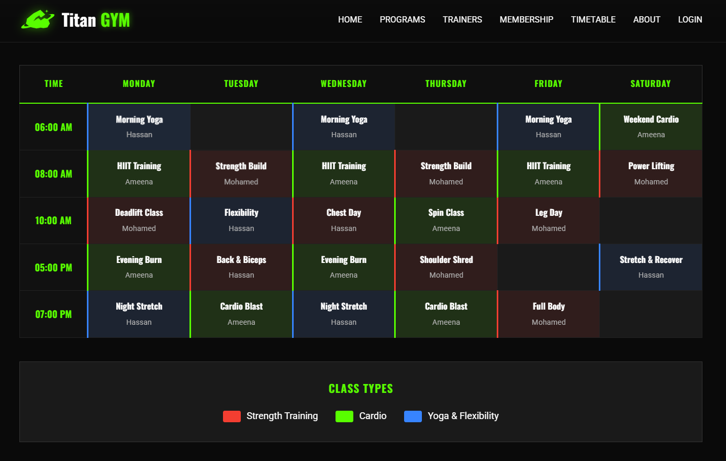

Functional Design: Membership plus Sign-In The membership.html uses CSS Grid with cards. A glow effect on the PRO plan guides choices - this nudges people to pick it, thanks to subtle visual cues. Mid-tier looks best due to contrast. The login.html focuses on simplicity, using minimal elements so users aren't sidetracked while signing in.

Conclusions
The website for TITAN GYM fulfills key goals expected from a current business site meant to promote services. Despite this, it keeps branding uniform across pages - providing straightforward navigation plus strong visuals that support recognition. Although simple, the layout ensures users find details without confusion; at the same time, design choices reflect identity clearly through color and structure.
Key Learnings
- The strength of CSS variables lies in simplifying color management across sites - using them beats writing fixed hex codes. Instead of repeating values, one central definition controls hues everywhere through dynamic updates and easier maintenance.
- Forscrollanimations, IntersctionObserver works better than watching window.onscroll- this one often slows things down because it triggers too frequently during scrolling.
- Writing clear HTML isn’t only about neat code- it shapes how smoothly you can design layouts using Flexbox or Grid.
For future upgrades, turning the prototype into a working app means linking login.html to a database - like SQL or Firebase - to manage real user logins. The following phase involves setting up secure validation through a server-side system instead of static pages. Using live data storage helps verify credentials properly rather than relying on mock checks. A key move forward is integrating an authentication method that supports sign-up, login, and password recovery features. Connecting these elements ensures users can access personalized content safely over time.

References
Browse fonts. (n.d.). Google Fonts. Retrieved November 20, 2025, from https://fonts.google.com/
Font awesome. (n.d.). Fontawesome.com. Retrieved November 20, 2025, from https://fontawesome.com/
HTML tutorial. (n.d.). W3schools.com. Retrieved November 20, 2025, from https://www.w3schools.com/html/default.asp
Intersection Observer API. (n.d.). MDN Web Docs. Retrieved November 20, 2025, from https://developer.mozilla.org/en-US/docs/Web/API/Intersection_Observer_API

Acknowledgements
I’m really grateful to my lecturer for being patient while guiding me through tricky parts. Because he always took time to reply, understanding tough HTML or CSS ideas got way easier. His clear explanations helped a lot when building things step by step.
Fair enough, I tip my hat to the folks behind opensource – along side MDN Web Docs and W3Schools for laying out clear guides that helped me fix bugs and keep things up to speed online.

